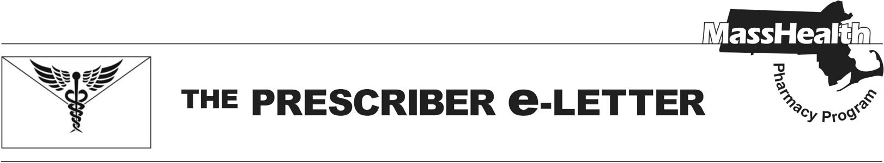
The Prescriber e-Letter,

Upcoming Changes in MassHealth and Health Safety Net (HSN) Management of NPH Insulin – Effective July 1, 2026

MassHealth currently covers Novolin® N (insulin NPH) without prior authorization (PA) and Humulin® N (insulin NPH) with PA. Effective July 1, 2026, MassHealth will require PA for Novolin® N (insulin NPH) and remove PA from Humulin® N (insulin NPH). Additionally, Humulin® N (insulin NPH) will be added to the MassHealth Brand Preferred Over Generic List (BOGL).
Effective July 1, 2026 – Changes to MassHealth Management
- Novolin® N (insulin NPH) will require PA
- Humulin® N (insulin NPH) will no longer require PA

Novolin® N (insulin NPH) and Humulin® N (insulin NPH) contain the same active medication and are identical in dosing and administration frequency; however, they are not considered interchangeable at the pharmacy level. As a result of this change, MassHealth patients prescribed Novolin® N (insulin NPH) will need a new prescription for Humulin® N (insulin NPH), or have their provider submit a PA for continued use of Novolin® N (insulin NPH). For those that require Novolin® N (insulin NPH), prior authorizations must document an appropriate diagnosis and an inadequate response, adverse reaction, or contraindication to Humulin® N (insulin NPH).
Effective July 1, 2026 – Changes to HSN Management
Humulin® N (insulin NPH) will be added to the MassHealth Brand Preferred Over Generic List (BOGL). As a result, Humulin® N (insulin NPH) will be available without PA for HSN patients.

The MassHealth Drug List is on the MassHealth Pharmacy Program website at www.mass.gov/masshealth/pharmacy.

The Prescriber e-Letter is an update designed to enhance the transparency and efficiency of the MassHealth drug prior-authorization (PA) process and the MassHealth Drug List. Each issue highlights key clinical information and updates to the MassHealth Drug List. The Prescriber E-Letter was prepared by the MassHealth Drug Utilization Review Program and the MassHealth Pharmacy Program.
________________________________________________________________________________________________

Please send any suggestions or comments to prescribereletter@massmail.state.ma.us

