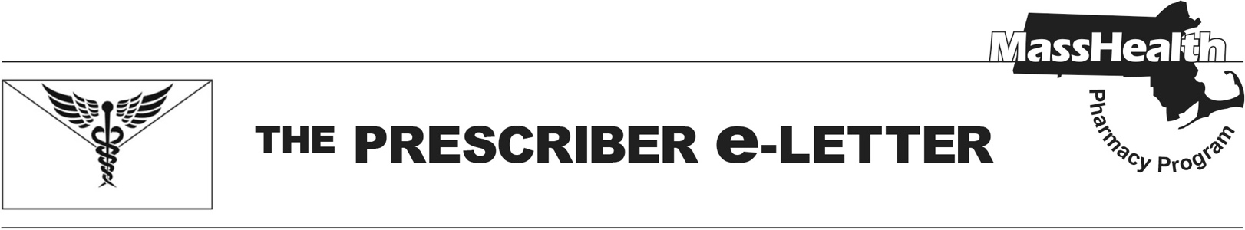
Volume 16, Issue 7, May 2026

MassHealth Changes to Management of Anti-Obesity Medications Effective July 1, 2026
Important upcoming changes will impact how MassHealth covers weight-loss medications for all plans. In accordance with anticipated forthcoming changes to MassHealth regulations at 130 CMR 406.413(B): Drug Exclusions, MassHealth will no longer pay for drugs used only for the treatment of obesity or overweight.

Effective July 1, 2026, the drugs listed below in Table 1 will no longer be covered for MassHealth members when used only for the treatment of obesity or overweight. This applies to all members, whether enrolled in Fee for Service (FFS); managed care organizations (MCOs); Program of All-inclusive Care for the Elderly (PACE); accountable care partnership plans (ACPP); primary care accountable care organizations (PCACOs); and Primary Care Clinician (PCC), Senior Care Options (SCO), or One Care plans.

Table 1. Anti-Obesity Medications

Anti-Obesity Medications*
benzphetamine
diethylpropion, diethylpropion extended-release
Saxenda (liraglutide)
Xenical (orlistat)
phendimetrazine, phendimetrazine extended-release
Lomaira, Adipex-P (phentermine capsule, tablet)
phentermine/topiramate extended-release
Wegovy (semaglutide)
Zepbound (tirzepatide)
*Any drug being used off label for weight loss is not payable for MassHealth patients.

End-Dating of Prior Authorizations Submitted Before February 17, 2026, and Review of New Prior Authorizations
All prior authorizations (PAs) for weight loss medications submitted before February 17, 2026, will be end-dated for June 30, 2026, regardless of indication, and will need to be resubmitted and approved to receive paid claims beyond that date.
Medically accepted indications for use of a weight loss medication beyond that date include the following.
- Body mass index (BMI) >27 kg/m² and established cardiovascular disease to reduce the risk of major adverse cardiovascular events (MACE)
- BMI >30 kg/m² and moderate-to-severe obstructive sleep apnea (OSA)
- Metabolic dysfunction-associated steatohepatitis (MASH)
- Members <21 when deemed medically necessary under Early and Periodic Screening, Diagnostic, and Treatment (EPSDT) requirements
Members enrolled in PACE, SCO, or OneCare plans are expected to seek access via Medicare for the indications listed above.

Effective July 1, 2026, Wegovy® (semaglutide) will be the sole preferred drug for all other medically accepted indications.
Effective July 1, 2026, Zepbound® (tirzepatide) will no longer be a preferred drug. PAs for continued treatment with Zepbound® (tirzepatide) beyond June 30, 2026, will require a trial of Wegovy® (semaglutide) for all patients.

To ease the transition, members with an approved PA for Zepbound® (tirzepatide), for a medically accepted indication, that extends beyond June 30, 2026, will have their PA replaced with an approved PA for Wegovy® (semaglutide) for the remainder of the original Zepbound® (tirzepatide) authorization. A new prescription for Wegovy® (semaglutide) will be required.

Please see Table 2 for guidance on the dosing conversions when switching patients to Wegovy® (semaglutide).

Table 2. Dosing Conversions for Injectable Non-Diabetic GLP-1 and GLP-1/GIP Medications¹
Medication Comparative Dose (mg)
Liraglutide once daily | 0.6 | 1.2 | 1.8-3 | - | - | - | - | - | -
Semaglutide once weekly | - | 0.25 | 0.5 | 1 | 2-2.4 | 2.4 | 2.4 | 2.4 | 2.4
Tirzepatide once weekly | - | - | 2.5 | - | 5 | 7.5 | 10 | 12.5 | 15
GLP-1=glucagon-like peptide-1, GIP=glucose-dependent insulinotropic polypeptide

References
- Whitley HP, Trujillo JM, Neumiller JJ; Special Report: Potential Strategies for Addressing GLP-1 and Dual GLP-1/GIP Receptor Agonist Shortages. Clin Diabetes 1 July 2023; 41 (3): 467–473

The Prescriber e-Letter is an update designed to enhance the transparency and efficiency of the MassHealth drug prior authorization (PA) process and the MassHealth Drug List. Each issue highlights key clinical information and updates to the MassHealth Drug List. The Prescriber E-Letter was prepared by the MassHealth Drug Utilization Review Program and the MassHealth Pharmacy Program.

