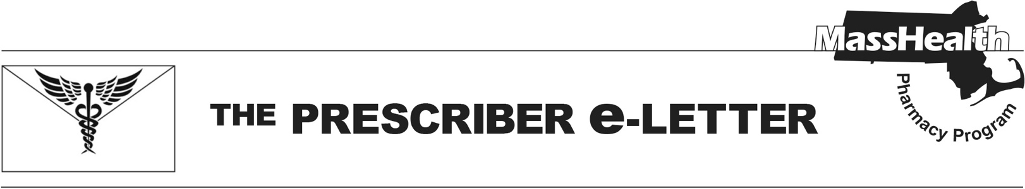
The Prescriber e-Letter,
Volume 14, Issue 7, November 2024

Upcoming Changes to MassHealth Coverage of Thyroid Agents
Effective January 6, 2025, Tirosint® (levothyroxine capsule and solution), and generic levothyroxine capsule will be designated as non-covered agents requiring prior authorization (PA).
- Effective January 6th, 2025, MassHealth is removing Tirosint® (levothyroxine capsule and solution) from the Brand Preferred Over Generic List. Tirosint® (levothyroxine capsule and solution) and generic levothyroxine capsules will now require PA.
- MassHealth members currently receiving Tirosint® (levothyroxine capsule and solution) or generic levothyroxine capsules may switch to a levothyroxine agent available without PA (see table below) or prescribers may submit a PA for the evaluation of medical necessity over other covered products.
- The manufacturers of Tirosint® (levothyroxine capsule and solution) and generic levothyroxine capsules no longer participate in the Medicaid Drug Rebate Program. As a result, MassHealth will no longer cover claims for these manufacturers’ products.
- To aid in transitioning MassHealth members taking Tirosint® (levothyroxine capsule and solution) and generic levothyroxine capsule to a covered product, MassHealth will continue to cover these products until January 6th, 2025. After this, prescribers may submit a PA to evaluate for medical necessity if a member is not a candidate for levothyroxine products that do not require PA.
- Information regarding coverage of thyroid agents is available on the MassHealth Drug List and summarized below.

MassHealth Coverage of Thyroid Agents Effective January 6, 2025
Drugs that require PA | Drugs that do NOT require PA
Tirosint® (levothyroxine capsule, solution) | Cytomel® # (liothyronine)  Ermeza® (levothyroxine solution)  Euthyrox® # (levothyroxine tablet)  Levo-T® # (levothyroxine tablet)  Levoxyl® # (levothyroxine tablet)  Synthroid® # (levothyroxine tablet)  Thyquidity® (levothyroxine solution)  Unithroid® # (levothyroxine tablet)
# This is a brand-name drug with FDA "A"-rated generic equivalents. PA is required for the brand, unless a particular form of that drug (for example, tablet, capsule, or liquid) does not have an FDA "A"-rated generic equivalent.

The Prescriber e-Letter is an update designed to enhance the transparency and efficiency of the MassHealth drug prior-authorization (PA) process and the MassHealth Drug List. Each issue highlights key clinical information and updates to the MassHealth Drug List. The Prescriber E-Letter was prepared by the MassHealth Drug Utilization Review Program and the MassHealth Pharmacy Program.

_________________________________________________________________________________________________
Please send any suggestions or comments to prescribereletter@massmail.state.ma.us

