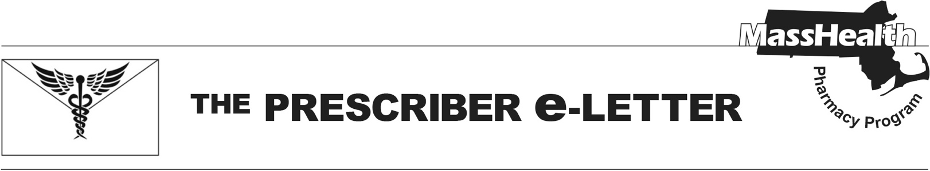
Volume 15, Issue 9, June 2025

Updates to Brixadi® (buprenorphine) Coverage and New Legislation on Overdose Reversal Drugs

Update on Brixadi® (buprenorphine) Coverage Effective July 1, 2025

MassHealth is issuing a correction to Prescriber e-Letter Issue 6, April 2025. Effective July 1, 2025, Brixadi® (buprenorphine) will no longer require prior authorization (PA) and will be designated as a preferred drug on the MassHealth Drug List.

New Legislative Requirements for Opioid Reversal Drugs

An Act Relative to Treatments and Coverage for Substance Use Disorder and Recovery Coach Licensure, Chapter 285 of the Acts of 2024, expands access to opioid reversal drugs (emergency opioid antagonists or EOAs) to enhance patient safety and address opioid-related overdoses. These measures aim to ensure broader access to life-saving opioid reversal drugs and enhance education and availability for at-risk patients. Key provisions include:

- Hospital Requirements. Hospitals must educate patients on EOAs and prescribe or dispense at least two doses of EOAs to patients with a history of overdose, opioid use, or opioid use disorder (OUD) upon discharge.
- Substance Use Disorder (SUD) Treatment Facilities. SUD treatment facilities are required to educate patients on EOAs and dispense two doses of EOAs to patients upon discharge.
- Pharmacy Requirements. Pharmacies in areas with high incidences of overdoses must maintain a sufficient and consistent supply of EOAs. This includes stocking EOAs approved for over-the-counter sale in addition to those requiring a prescription. Pharmacies unable to comply due to insufficient supply must report to the Department of Public Health (DPH).
  - Although MassHealth generally requires a prescription before it will cover drugs, there is a standing order that allows pharmacists to dispense naloxone without an individual prescription. Please refer to the standing order for naloxone at www.mass.gov/doc/naloxonestanding-order-1/download and M.G.L. c. 94C, § 19B for further information.
  - MassHealth covers EOAs such as naloxone without cost-sharing or prior authorization.

Additional information regarding drug coverage can be found on the MassHealth Drug List.
References
- Sublocade® (buprenorphine extended-release) injection, for subcutaneous use [package insert]. North Chesterfield, VA: Indivior PLC; 2025.
- Brixadi® [package insert]. Plymouth Meeting (PA): Braeburn Pharmaceuticals; 2023 May.
- An Act Relative to Treatments and Coverage for Substance Use Disorder and Recovery Coach Licensure, Chapter 285 of the Acts of 2024, Available at: https://malegislature.gov/Laws/SessionLaws/Acts/2024/Chapter285
- Fact Sheet: An Act Relative to Treatments and Coverage for Substance Use Disorder and Recovery Coach Licensure. Senate Press Room: Commonwealth of Massachusetts. Dec 14, 2024. Available at: Press Room

The Prescriber e-Letter is an update designed to enhance the transparency and efficiency of the MassHealth drug prior-authorization (PA) process and the MassHealth Drug List. Each issue highlights key clinical information and updates to the MassHealth Drug List. The Prescriber E-Letter was prepared by the MassHealth Drug Utilization Review Program and the MassHealth Pharmacy Program.

