WATER DAMAGE ASSESSMENT

Lillian M. Jacobs Elementary School
180 Harborview Road
Hull, Massachusetts

Prepared by:
Massachusetts Department of Public Health
Bureau of Environmental Health
Indoor Air Quality Program
February 2018

BACKGROUND
Building: | Lillian M. Jacobs Elementary School
Address: | 180 Harborview Road, MA
Assessment Coordinated via: | Hull Health Department and Hull School Department
Reason for Request: | Water damage/mold concerns
Date of Assessment: | February 5, 2018
Massachusetts Department of Public Health/Bureau of Environmental Health (MDPH/BEH) Staff Conducting Assessment: | Cory Holmes, Environmental Analyst/Inspector, Indoor Air Quality (IAQ) Program
Date of Building Construction: | 1968
Building Description: | A multi-story, brick-faced building originally constructed in the late 1960s. The building underwent complete renovations in 2006

METHODS
Please refer to the IAQ Manual and appendices for methods, sampling procedures, and interpretation of results (MDPH, 2015).

RESULTS and DISCUSSION

Microbial/Moisture Concerns
This assessment was prompted by concerns focused on water penetration in the gym. The assessment occurred on a Monday morning after a Sunday of steady rain (reportedly heavy at times). At the time of assessment, water was noted dripping from the ceiling along the west wall (Pictures 1 through 3) and collecting into a small puddle on the gym floor (Picture 4). In addition, building occupants reported that water has penetrated the ceiling near the air handling unit during heavy rain/wind events (Picture 5). No water was observed under the gym air handling unit on the day of the assessment.
No porous building materials (e.g., carpet, ceiling tiles, gypsum drywall) are located in areas of puddling water. The water impacted materials are wooden floor (semi-porous), metal and masonry. School officials reported that they are in the process of identifying a Firestone® certified roofing contractor who will evaluate and make repairs as needed.

CONCLUSIONS and RECOMMENDATIONS
In view of the findings at the time of the visit, the following recommendations are made:
- Continue with plans to obtain a certified roofing contractor to evaluate and make repairs to prevent further leaks.
- In the interim, monitor for continued leaks and catch in containers (e.g., buckets/mop) to prevent damage to the floor. Avoid storing porous materials such as furniture or paper in these areas.
- Post “hazard/wet floor” signs as needed, to prevent injury to occupants/staff.
- For more information about mold consult the US EPA’s “Mold Remediation in Schools and Commercial Buildings” published by the US Environmental Protection Agency (US EPA, 2008) (https://www.epa.gov/mold/mold-remediation-schools-and-commercial-buildings-guide)
- Refer to resource manual and other related IAQ documents located on the MDPH’s website for further building-wide evaluations and advice on maintaining public buildings. These documents are available at: http://mass.gov/dph/iaq.

REFERENCES
MDPH. 2015. Massachusetts Department of Public Health. Indoor Air Quality Manual: Chapters I-III. Available at: http://www.mass.gov/eohhs/gov/departments/dph/programs/environmental-health/exposure-topics/iaq/iaq-manual/.
US EPA. 2008. Mold Remediation in Schools and Commercial Buildings. US Environmental Protection Agency, Office of Air and Radiation, Indoor Environments Division, Washington, D.C. EPA 402-K-01-001. http://www.epa.gov/mold/mold-remediation-schools-and-commercial-buildings-guide.

Picture 1
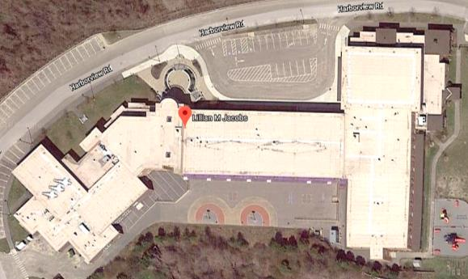
Area of gym (arrow) where active leak was observed
Picture 2
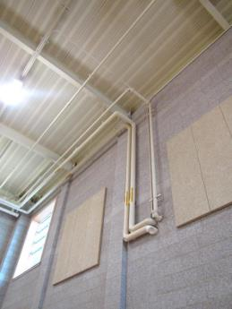
Bracket indicates area of leaks inside gym
Picture 3
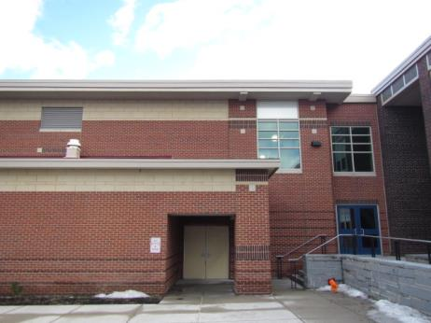
Exterior view of leaking area of gym
Picture 4
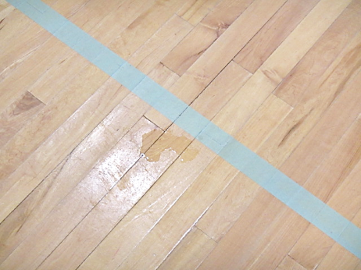
Puddling of water in gym after rain event
Picture 5
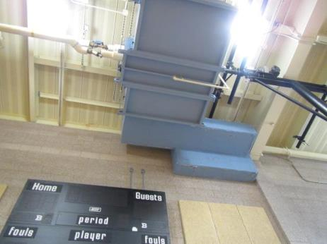
Area of ceiling (bracket) near air handling unit, where leaks reportedly occur

