INDOOR AIR QUALITY ASSESSMENT

James L. Mulcahey Middle School
28 Clifford Street
Taunton, Massachusetts

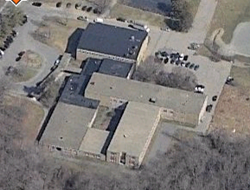

Prepared by:
Massachusetts Department of Public Health
Bureau of Environmental Health
Indoor Air Quality Program
March 2008

Background/Introduction
At the request of a parent and the City of Taunton Board of Health (TBOH), the Massachusetts Department of Public Health (MDPH), Bureau of Environmental Health (BEH) provided assistance and consultation regarding indoor air quality concerns at the James L. Mulcahey Middle School (MMS) located at 28 Clifford Street, Taunton, Massachusetts. The request was prompted by occupant complaints of headaches, dizziness and nausea, primarily in 5th grade classroom 37.
On January 13, 2008, a visit to conduct an indoor air quality assessment was made to the MMS by Cory Holmes, an Environmental Analyst in BEH’s Indoor Air Quality (IAQ) Program. Mr. Holmes was accompanied for portions of the assessment by Mr. Kevin Duquette and Mr. Robert Buker of the TBOH.
The school is a one-story brick building that was constructed in the early 1950s, with a two-story addition built in the 1980s. The building contains general classrooms, science classrooms, computer rooms, a gymnasium, kitchen, cafeteria/auditorium, library, music/band rooms, office space and a wood shop. The majority of building materials (e.g., mechanical ventilation, ceilings, windows) are original to the construction of each section of the building respectively.

Methods
Air tests for carbon monoxide, carbon dioxide, temperature and relative humidity were conducted with the TSI, Q-Trak, IAQ Monitor, Model 8551. Air tests for airborne particle matter with a diameter less than 2.5 micrometers were taken with the TSI, DUSTTRAK™ Aerosol Monitor Model 8520. MDPH staff also performed visual inspection of building materials for water damage and/or microbial growth.

Results
The school houses approximately 540 middle school students in grades 5 to 8 and approximately 50 staff members. Tests were taken during normal operations at the school and results appear in Table 1.

Discussion
Ventilation
It can be seen from Table 1 that carbon dioxide levels were above 800 parts per million (ppm) in 16 of 28 areas at the time of the assessment, which can indicate poor air exchange in these areas. It is also important to note that several classrooms had open windows and/or were empty/sparsely populated, which can greatly reduce carbon dioxide levels. Carbon dioxide levels would be expected to be higher with full occupancy and with windows closed.
Fresh air in classrooms is supplied by unit ventilator (univent) systems (Pictures 1 and 2). A univent draws air from the outdoors through a fresh air intake located on the exterior wall of the building (Pictures 3 and 4) and returns air through an air intake located at the base of the unit (Figure 1). Fresh and return air are mixed, filtered, heated and provided to classrooms through an air diffuser located in the top of the unit. Univents are original to the each portion of the building (20 + years old for the 1980s wings; 50 + years in the original building). Efficient function of such equipment can be difficult to maintain since compatible replacement parts are often unavailable. Univents were found operating weakly or deactivated or non-functional in a number of areas. Therefore, no (or limited) means to provide mechanical ventilation existed in these classrooms at the time of the assessment. Univents were found obstructed by various items (Picture 5). In order for univents to provide fresh air as designed, intakes/returns must remain free of obstructions. Importantly, these units must remain “on” and be allowed to operate while rooms are occupied.
Exhaust ventilation in classrooms is provided by wall or ceiling vents ducted to rooftop motors (Pictures 6 through 9). In a previous correspondence, Adam Vickstrom of the TBOH discovered during a site visit that the exhaust ventilation system in classroom 37 was deactivated, limiting air circulation. At the time of the BEH assessment, these exhaust vents were reactivated and operating. Exhaust vents were functional throughout the school; however, a number of them were obstructed (Pictures 10 and 11). As with univents, exhaust vents must be activated and remain free of obstructions. In several classrooms, exhaust vents are located near hallway doors (Pictures 6 and 7). When classroom doors are open, exhaust vents will tend to draw air from the hallway instead of the classroom, reducing the effectiveness of the exhaust vent to remove common environmental pollutants. Without adequate supply and exhaust ventilation, excess heat and environmental pollutants can build up and lead to indoor air/comfort complaints.
Mechanical ventilation in interior rooms and common areas (e.g., gym, auditorium) is provided by rooftop or ceiling-mounted air-handling units (AHUs). Fresh air is distributed via ceiling-mounted air diffusers and ducted back to AHUs via ceiling or wall-mounted return vents.
To maximize air exchange, the MDPH recommends that both supply and exhaust ventilation operate continuously during periods of school occupancy. In order to have proper ventilation with a mechanical supply and exhaust system, the systems must be balanced to provide an adequate amount of fresh air to the interior of a room while removing stale air from the room. It is recommended that HVAC systems be re-balanced every five years to ensure adequate air systems function (SMACNA, 1994). The date of the last balancing of these systems was not available at the time of the assessment.
The Massachusetts Building Code requires a minimum ventilation rate of 15 cubic feet per minute (cfm) per occupant of fresh outside air or have openable windows in each room (SBBRS, 1997; BOCA, 1993). The ventilation must be on at all times that the room is occupied. Providing adequate fresh air ventilation with open windows and maintaining the temperature in the comfort range during the cold weather season is impractical. Mechanical ventilation is usually required to provide adequate fresh air ventilation.
Carbon dioxide is not a problem in and of itself. It is used as an indicator of the adequacy of the fresh air ventilation. As carbon dioxide levels rise, it indicates that the ventilating system is malfunctioning or the design occupancy of the room is being exceeded. When this happens, a buildup of common indoor air pollutants can occur, leading to discomfort or health complaints. The Occupational Safety and Health Administration (OSHA) standard for carbon dioxide is 5,000 parts per million parts of air (ppm). Workers may be exposed to this level for 40 hours/week, based on a time-weighted average (OSHA, 1997).
The MDPH uses a guideline of 800 ppm for publicly occupied buildings. A guideline of 600 ppm or less is preferred in schools due to the fact that the majority of occupants are young and considered to be a more sensitive population in the evaluation of environmental health status. Inadequate ventilation and/or elevated temperatures are major causes of complaints such as respiratory, eye, nose and throat irritation, lethargy and headaches. For more information concerning carbon dioxide, consult Appendix A.
Temperature measurements ranged from 72º F to 82º F, which were above the MDPH recommended comfort range in a few areas surveyed. The MDPH recommends that indoor air temperatures be maintained in a range of 70º F to 78º F in order to provide for the comfort of building occupants. In many cases concerning indoor air quality, fluctuations of temperature in occupied spaces are typically experienced, even in a building with an adequate fresh air supply. Chronic heat complaints were reported in the library, nurse’s suite and the reading specialists’ office. It is difficult to control temperature and maintain comfort with vintage mechanical ventilation equipment and/or without operating the ventilation equipment as designed (e.g., univents deactivated, univents/exhaust vents obstructed).
The relative humidity measured in the building ranged from 23 to 35 percent, which was below the MDPH recommended comfort range in all areas at the time of the assessment. The MDPH recommends a comfort range of 40 to 60 percent for indoor air relative humidity. Relative humidity levels in the building would be expected to drop during the winter months due to heating. The sensation of dryness and irritation is common in a low relative humidity environment. Low relative humidity is a very common problem during the heating season in the northeast part of the United States.

Microbial/Moisture Concerns
In order for building materials to support mold growth, a source of water exposure is necessary (e.g., roof/plumbing leaks). A previous roof leak reportedly occurred in the vicinity of classroom 29. Water damaged ceiling plaster and wall panels were observed in this area (Picture 12).
Identification and elimination of water moistening building materials is necessary to control mold growth. Materials with increased moisture content over normal concentrations may indicate the possible presence of mold growth. BEH staff conducted moisture testing of materials in a number of areas likely impacted by water damage. Ceiling plaster and wall panels in this area were found to have low (i.e., normal) moisture content at the time of the assessment (Table 1), indicating they were dry. However, elevated (i.e., saturated) moisture content and visible mold growth was observed behind vinyl wall covering directly below the area of leakage (Pictures 13 and 14). Vinyl wallpaper is a water impermeable material that can retain moisture.
At the time of the assessment, Mr. Holmes recommended to Principal Christel Torres that she coordinate with the Taunton School Department maintenance department to schedule remediation of the water damaged/mold colonized materials and that in order to best protect occupants, any remediation of water-damaged/mold contaminated materials be done during unoccupied periods and in a manner consistent with recommendations in “Mold Remediation in Schools and Commercial Buildings” published by the US Environmental Protection Agency (US EPA, 2001). This information was subsequently communicated with the TBOH.
It is important to note that moisture content of materials is a real-time measurement of the conditions present in the building at the time of the assessment. Repeated water damage to porous building materials (e.g., GW, ceiling tiles, and carpeting) can result in microbial growth. The US Environmental Protection Agency (US EPA) and the American Conference of Governmental Industrial Hygienists (ACGIH) recommend that porous materials be dried with fans and heating within 24 to 48 hours of becoming wet (US EPA, 2001; ACGIH, 1989). If not dried within this time frame, mold growth may occur. Once mold has colonized porous materials, they are difficult to clean and should be removed/discarded.
Numerous other areas had water-damaged/missing ceiling tiles and damaged ceiling/wall plaster and efflorescence (i.e., mineral deposits), which are evidence of chronic water penetration from either the roof or plumbing system (Pictures 15 through 18/Table1). Active roof leaks were reported in the cafeteria, which were being addressed by a roofing contractor. Water-damaged ceiling tiles can provide a source of mold and should be replaced after a water leak is discovered and repaired. Efflorescence is a characteristic sign of water damage to building materials, but it is not mold growth. As moisture penetrates and works its way through building materials (e.g., plaster), water-soluble compounds dissolve, creating a solution. As this solution moves to the surface, the water evaporates, leaving behind white, powdery mineral deposits.
Missing/damaged/loose caulking was observed around windows and exterior wall panels (Pictures 19 through 23). Chronic water damage and air infiltration was noted around windows. Water penetration through window frames can lead to mold growth under certain conditions. Repairs of window leaks are necessary to prevent further water penetration, drafts and pest entry.
Several classrooms had a number of plants. Moistened plant soil and drip pans can be a source of mold growth. Plants should be equipped with drip pans; the lack of drip pans can lead to water pooling and mold growth on windowsills. Plants are also a source of pollen. Plants should be located away from the air stream of ventilation sources to prevent the aerosolization of mold, pollen or particulate matter throughout the classroom.

Other IAQ Evaluations
Indoor air quality can be negatively influenced by the presence of respiratory irritants, such as products of combustion. The process of combustion produces a number of pollutants. Common combustion emissions include carbon monoxide, carbon dioxide, water vapor and smoke (fine airborne particle material). Of these materials, exposure to carbon monoxide and particulate matter with a diameter of 2.5 micrometers (μm) or less (PM2.5) can produce immediate, acute health effects upon exposure. To determine whether combustion products were present in the school environment, BEH staff obtained measurements for carbon monoxide and PM2.5.
Carbon monoxide is a by-product of incomplete combustion of organic matter (e.g., gasoline, wood and tobacco). Exposure to carbon monoxide can produce immediate and acute health affects. Several air quality standards have been established to address carbon monoxide and prevent symptoms from exposure to these substances. The MDPH established a corrective action level concerning carbon monoxide in ice skating rinks that use fossil-fueled ice resurfacing equipment. If an operator of an indoor ice rink measures a carbon monoxide level over 30 ppm, taken 20 minutes after resurfacing within a rink, that operator must take actions to reduce carbon monoxide levels (MDPH, 1997).
The American Society of Heating Refrigeration and Air-Conditioning Engineers (ASHRAE) has adopted the National Ambient Air Quality Standards (NAAQS) as one set of criteria for assessing indoor air quality and monitoring of fresh air introduced by HVAC systems (ASHRAE, 1989). The NAAQS are standards established by the US EPA to protect the public health from six criteria pollutants, including carbon monoxide and particulate matter (US EPA, 2006). As recommended by ASHRAE, pollutant levels of fresh air introduced to a building should not exceed the NAAQS levels (ASHRAE, 1989). The NAAQS were adopted by reference in the Building Officials & Code Administrators (BOCA) National Mechanical Code of 1993 (BOCA, 1993), which is now an HVAC standard included in the Massachusetts State Building Code (SBBRS, 1997). According to the NAAQS, carbon monoxide levels in outdoor air should not exceed 9 ppm in an eight-hour average (US EPA, 2006).
Carbon monoxide should not be present in a typical, indoor environment. If it is present, indoor carbon monoxide levels should be less than or equal to outdoor levels. On the day of assessment, outdoor carbon monoxide concentrations were non-detect (ND) (Table 1). Carbon monoxide levels measured in the school were also ND.
The US EPA has established NAAQS limits for exposure to particulate matter. Particulate matter is airborne solids that can be irritating to the eyes, nose and throat. The NAAQS originally established exposure limits to particulate matter with a diameter of 10 μm or less (PM10). According to the NAAQS, PM10 levels should not exceed 150 microgram per cubic meter (μg/m³) in a 24-hour average (US EPA, 2006). These standards were adopted by both ASHRAE and BOCA. Since the issuance of the ASHRAE standard and BOCA Code, US EPA established a more protective standard for fine airborne particles. This more stringent PM2.5 standard requires outdoor air particle levels be maintained below 35 μg/m³ over a 24-hour average (US EPA, 2006). Although both the ASHRAE standard and BOCA Code adopted the PM10 standard for evaluating air quality, MDPH uses the more protective PM2.5 standard for evaluating airborne particulate matter concentrations in the indoor environment.
Outdoor PM2.5 concentrations were measured at 31 μg/m³ (Table 1). PM2.5 levels measured in the school were between 19 to 34 μg/m³ (Table 1), which were below the NAAQS PM2.5 level of 35 μg/m³ and close to background levels in some areas. Frequently, indoor air levels of particulates (including PM2.5) can be at higher levels than those measured outdoors. A number of mechanical devices and/or activities that occur in schools can generate particulate during normal operations. Sources of indoor airborne particulates may include but are not limited to particles generated during the operation of fan belts in the HVAC system, cooking in the cafeteria stoves and microwave ovens; use of photocopiers, fax machines and computer printing devices; operation of an ordinary vacuum cleaner and heavy foot traffic indoors. A likely source of airborne particulates was observed in the woodshop. Although the woodshop is equipped with a mechanical wood dust collection system, the system was found in disrepair, with damaged ductwork and gaskets and in some cases held together with duct tape (Pictures 24 through 26).
Indoor air concentrations can be greatly impacted by the use of products containing volatile organic compounds (VOCs). In an effort to identify materials that can potentially increase indoor VOC concentrations, BEH staff examined classrooms for products containing these respiratory irritants. Several classrooms contained dry erase boards and dry erase board markers. Materials such as dry erase markers and dry erase board cleaners may contain VOCs, such as methyl isobutyl ketone, n-butyl acetate and butyl-cellusolve (Sanford, 1999), which can be irritating to the eyes, nose and throat. Cleaning products were also found on countertops and in unlocked cabinets beneath sinks in some classrooms (Picture 27). Like dry erase materials, cleaning products contain VOCs and other chemicals that can be irritating to the eyes, nose and throat of sensitive individuals.
Other conditions that can affect indoor air quality were observed during the assessment. In several classrooms, items were observed on windowsills, tabletops, counters, bookcases and desks. The large number of items stored in classrooms provides a source for dusts to accumulate. These items (e.g., papers, folders, boxes) make it difficult for custodial staff to clean. Items should be relocated and/or be cleaned periodically to avoid excessive dust build up. In addition, these materials can accumulate on flat surfaces (e.g., desktops, shelving and carpets) in occupied areas and subsequently be re-aerosolized causing further irritation. Accumulated chalk dust and dry erase particulate were noted in some classrooms (Pictures 28).
Musty odors were detected by BEH staff in the 2nd floor hallway. The source of the odors appeared to be from a non-functional/abandoned water fountain (Picture 29). Water fountains contain drains that are designed with traps in order to prevent sewer odors/gases from penetrating into occupied spaces. When water enters a drain, the trap fills and forms a watertight seal. Without a periodic input of water (e.g., every other day), traps can dry, breaking the watertight seal. Without a watertight seal, odors or other material can travel up the drain and enter the occupied space.
Finally, occupants had concerns regarding damaged building materials that make up cabinets along the exterior wall of the wood shop (Picture 30). The material was not labeled therefore it was unclear whether it contained asbestos. At the time of the assessment, BEH staff recommended that the material be identified and if found to contain asbestos, be remediated in conformance with Massachusetts asbestos remediation and hazardous waste disposal laws.

Conclusions/Recommendations
The conditions related to indoor air quality problems at the MMS raise a number of issues. The general building conditions, maintenance, work hygiene practices and the condition of HVAC equipment, if considered individually, present conditions that could degrade indoor air quality. When combined, these conditions can serve to further degrade indoor air quality. Some of these conditions can be remedied by actions of building occupants. Other remediation efforts will require alteration to the building structure and equipment. For these reasons, a two-phase approach is required for remediation. The first consists of short-term measures to improve air quality and the second consists of long-term measures that will require planning and resources to adequately address the overall indoor air quality concerns.

The following short-term measures should be considered for implementation:
- Remove water damaged portion of GW in classroom 29. This measure will remove actively growing mold colonies that may be present. Conduct remediation activities in a manner consistent with recommendations in “Mold Remediation in Schools and Commercial Buildings” published by the US Environmental Protection Agency (US EPA, 2001). This document can be downloaded from the US EPA website: http://www.epa.gov/iaq/molds/mold_remediation.html.
- Once work is completed, ensure that the area is thoroughly cleaned and disinfected with an appropriate antimicrobial. Dust and particulates resulting from remediation efforts should be wet mopped/wiped and/or vacuumed with a HEPA filtered vacuum cleaner.
- Operate all ventilation systems throughout the building (e.g., gym, locker rooms, cafeteria, classrooms) continuously during periods of school occupancy and independent of thermostat control. To increase airflow in classrooms, set univent controls to “high”.
- Remove all blockages from univents and exhaust vents to ensure adequate airflow.
- Ensure classroom doors remain closed to maximize air exchange.
- Consider adopting a balancing schedule of every 5 years for all mechanical ventilation systems, as recommended by ventilation industrial standards (SMACNA, 1994).
- Consider applying a tinted film to library windows (and other areas) to reduce solar glare/radiant heat.
- For buildings in New England, periods of low relative humidity during the winter are often unavoidable. Therefore, scrupulous cleaning practices should be adopted to minimize common indoor air contaminants whose irritant effects can be enhanced when the relative humidity is low. To control for dusts, a high efficiency particulate arrestance (HEPA) filter equipped vacuum cleaner in conjunction with wet wiping of all surfaces is recommended. Avoid the use of feather dusters. Drinking water during the day can help ease some symptoms associated with a dry environment (throat and sinus irritations).
- Ensure roof/window leaks are repaired and remove/replace any remaining water-stained ceiling tiles.
- Remove all loose/hanging ceiling tiles to prevent falling hazards.
- Seal around windows and exterior wall panels to prevent water penetration, drafts and pest entry.
- Relocate or consider reducing the amount of materials stored in classrooms to allow for more thorough cleaning of classrooms. Clean items regularly with a wet cloth or sponge to prevent excessive dust build-up.
- Replace missing ceiling tiles.
- Replace damaged ductwork and gaskets to local wood dust collection system in wood shop to reduce airborne particulates.
- Clean chalk and dry erase board trays to prevent accumulation of materials.
- Identify and remediate cabinet material along exterior wall in wood shop in conformance with Massachusetts asbestos remediation and hazardous waste disposal laws (if necessary).
- Store cleaning products properly and out of reach of students. Ensure spray bottles are properly labeled. All cleaning products used at the facility should be approved by the school department with MSDS’ available at a central location.
- Repair, remove or cap abandoned water fountain on 2nd floor; or ensure water is poured into the drain every other day (or as needed) to maintain the integrity of the trap.
- Clean carpeting annually or semi-annually in soiled high traffic areas as per the recommendations of the Institute of Inspection, Cleaning and Restoration Certification (IICRC). Copies of the IICRC fact sheet can be downloaded at: http://www.cleancareseminars.com/carpet_cleaning_faq4.htm (IICRC, 2005)
- Consider adopting the US EPA (2000) document, “Tools for Schools”, as an instrument for maintaining a good indoor air quality environment in the building. This document is available at: http://www.epa.gov/iaq/schools/index.html.
- Refer to resource manual and other related indoor air quality documents located on the MDPH’s website for further building-wide evaluations and advice on maintaining public buildings. These documents are available at: http://mass.gov/dph/indoor_air.

The following long-term measures should be considered:
  - Contact an HVAC engineering firm for an assessment of the ventilation system (e.g., controls, air intake louvers, thermostats). Based on the age, physical deterioration and availability of parts for ventilation components, such an evaluation is necessary to determine the operability and feasibility of repairing/replacing the equipment.
  - Consider total removal/replacement of ceiling tile system.
  - Repair/replace loose/broken windowpanes and missing or damaged window caulking building-wide to prevent water penetration through window frames.

References
ACGIH. 1989. Guidelines for the Assessment of Bioaerosols in the Indoor Environment. American Conference of Governmental Industrial Hygienists, Cincinnati, OH.

ASHRAE. 1989. Ventilation for Acceptable Indoor Air Quality. American Society of Heating, Refrigeration and Air Conditioning Engineers. ANSI/ASHRAE 62-1989
BOCA. 1993. The BOCA National Mechanical Code/1993. 8th ed. Building Officials & Code Administrators International, Inc., Country Club Hills, IL.

IICRC. 2005. Carpet Cleaning FAQ 4 Institute of Inspection, Cleaning and Restoration Certification. Institute of Inspection Cleaning and Restoration, Vancouver, WA.

MDPH. 1997. Requirements to Maintain Air Quality in Indoor Skating Rinks (State Sanitary Code, Chapter XI). 105 CMR 675.000. Massachusetts Department of Public Health, Boston, MA.
OSHA. 1997. Limits for Air Contaminants. Occupational Safety and Health Administration. Code of Federal Regulations. 29 C.F.R 1910.1000 Table Z-1-A.

Sanford. 1999. Material Safety Data Sheet (MSDS No: 198-17). Expo® Dry Erase Markers Bullet, Chisel, and Ultra Fine Tip. Sanford Corporation. Bellwood, IL.

SBBRS. 1997. Mechanical Ventilation. State Board of Building Regulations and Standards. Code of Massachusetts Regulations. 780 CMR 1209.0

SMACNA. 1994. HVAC Systems Commissioning Manual. 1st ed. Sheet Metal and Air Conditioning Contractors’ National Association, Inc., Chantilly, VA.

US EPA. 2000. Tools for Schools. Office of Air and Radiation, Office of Radiation and Indoor Air, Indoor Environments Division (6609J). EPA 402-K-95-001, Second Edition. http://www.epa.gov/iaq/schools/tools4s2.html

US EPA. 2001. “Mold Remediation in Schools and Commercial Buildings”. Office of Air and Radiation, Indoor Environments Division, Washington, DC. EPA 402-K-01-001. March 2001. Available at: http://www.epa.gov/iaq/molds/mold_remediation.html

US EPA. 2006. National Ambient Air Quality Standards (NAAQS). US Environmental Protection Agency, Office of Air Quality Planning and Standards, Washington, DC. http://www.epa.gov/air/criteria.html.
Picture 1

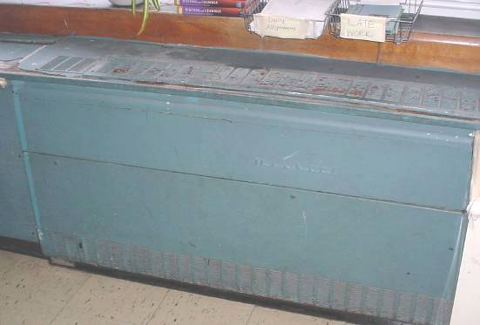

Original 1950s Vintage Univent

Picture 2

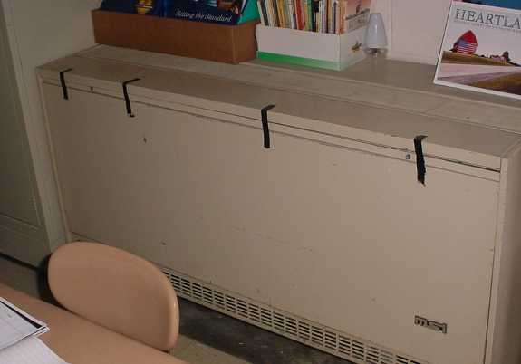

1980s Vintage Univent, Note Masking Tape Securing Front Cover
Picture 3

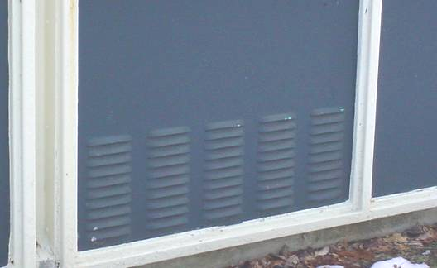

Univent Fresh Air Intake for 1950s Unit

Picture 4

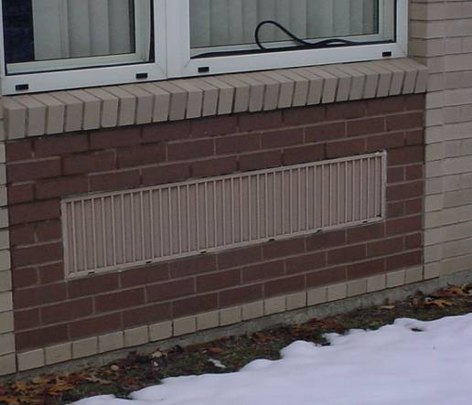

Univent Fresh Air Intake for 1950s Unit, Also Note Loosened Strip Caulking for Windows
Picture 5



Screen Obstructing Univent Airflow

Picture 6

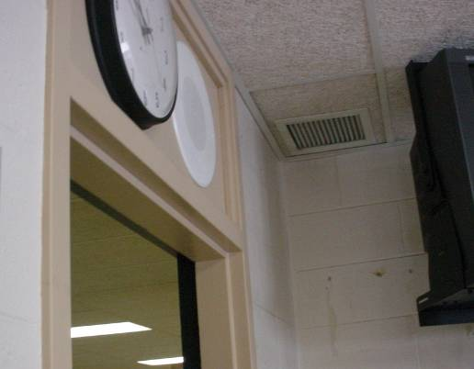

Classroom Exhaust Vent, Note Proximity to (Open) Hallway Door
Picture 7

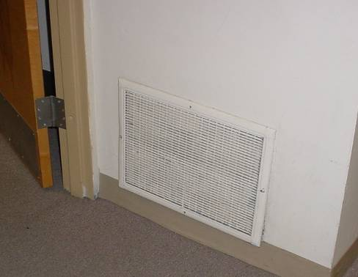

Wall-Mounted Exhaust Vent, Note Proximity to (Open) Hallway Door

Picture 8

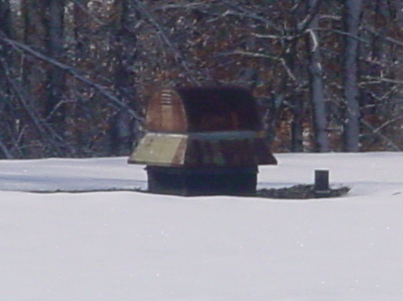

Rooftop Exhaust Motor
Picture 9

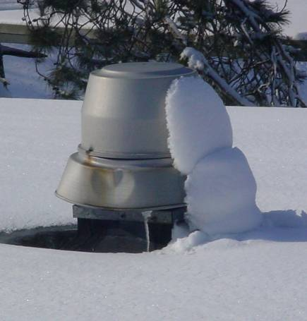

Rooftop Exhaust Motor

Picture 10

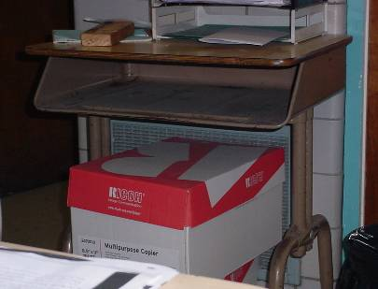

Exhaust Partially Obstructed by Boxes
Picture 11

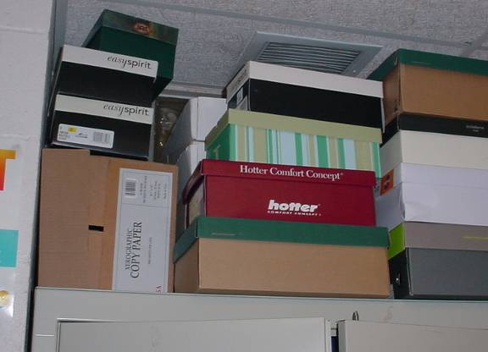

Ceiling-Mounted Exhaust Vent Partially Obstructed by Items

Picture 12

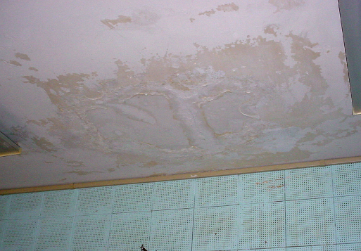

Water Damaged Ceiling Plaster and Wall Panels in Classroom 29
Picture 13

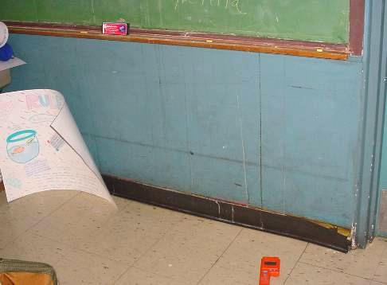

Section of Gypsum Wallboard in Classroom 29 behind Vinyl Wallpaper Directly below
Leak in Previous Picture

Picture 14

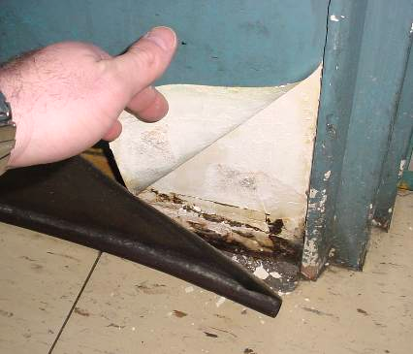

Close-up of Section of Gypsum Wallboard in Classroom 29 behind Vinyl Wallpaper Directly below Leak in Previous Picture, Dark Stains Indicate Mold Growth
Picture 15

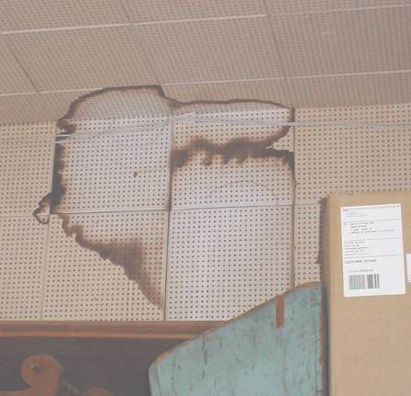

Water Damaged Ceiling and Wall Panels in Wood Shop

Picture 16

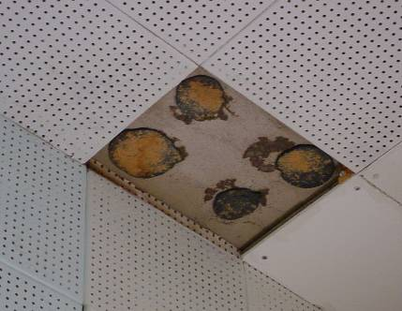

Missing/Water Damaged Ceiling tile
Picture 17

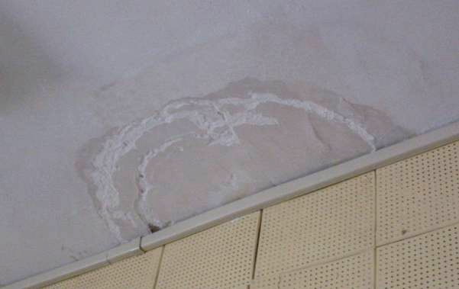

Water Damaged Ceiling Plaster and Efflorescence

Picture 18

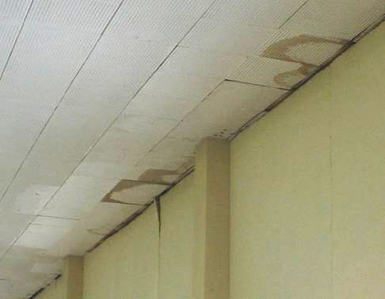

Water Damaged Ceiling Tiles along Exterior Wall
Picture 19

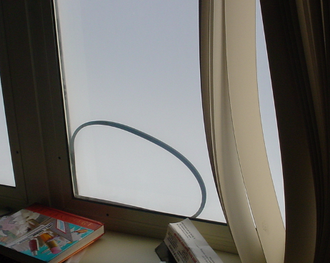

Loose/Damaged Window Caulking

Picture 20

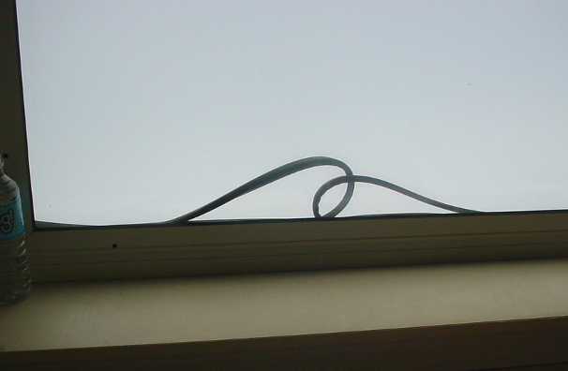

Loose/Damaged Window Caulking
Picture 21

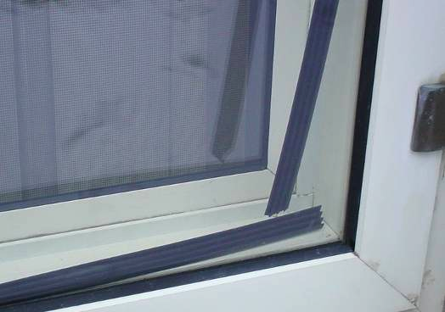

Loose/Damaged Window Caulking

Picture 22

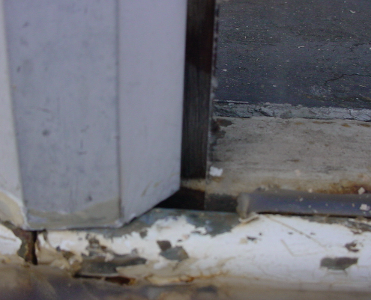

Missing Caulking Spaces between Glass Pane and Window Frame
Picture 23

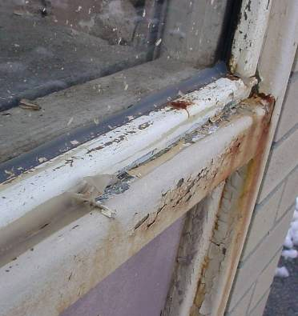

Missing Damaged Caulking around Exterior Wall Panels

Picture 24

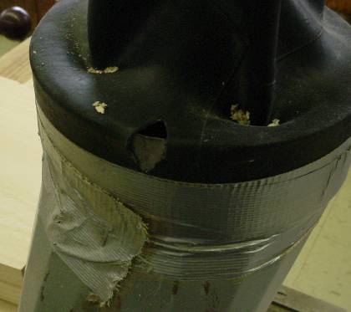

Local Exhaust System in Woodshop in Disrepair, Note Hole in Gasket and Duct Tape
Picture 25

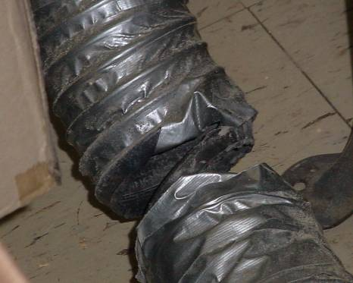

Damaged Flexible Duct to Woodshop Local Exhaust System

Picture 26

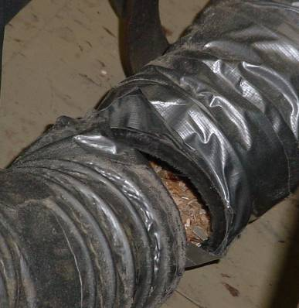

Damaged Flexible Duct to Woodshop Local Exhaust System, Note Wood Dust/Debris in Duct
Picture 27

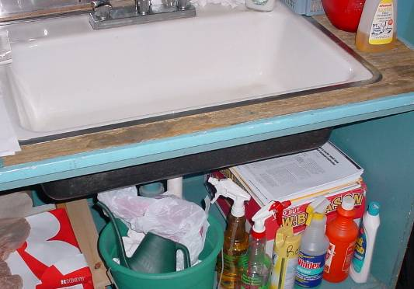

Spray Cleaning Chemicals under Classroom Sink

Picture 28

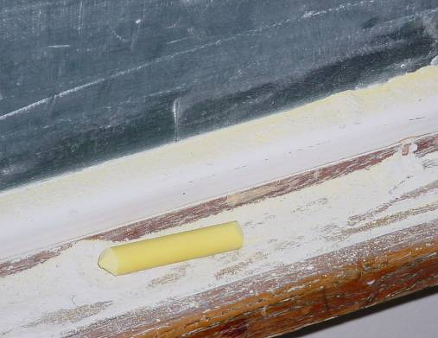

Accumulated Chalk Dust
Picture 29

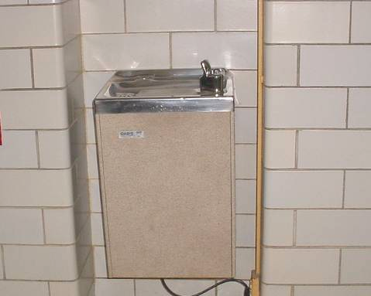

Non-Functional/Abandoned Water Fountain, 2nd Floor Hallway

Picture 30

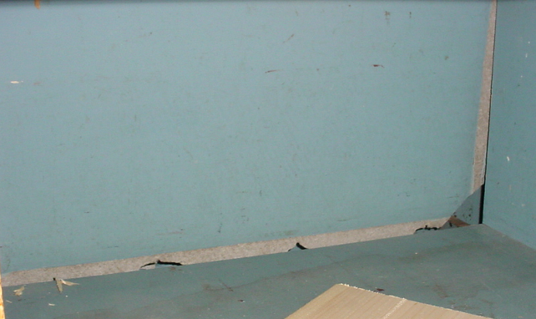

Damaged Cabinet Material in Wood Shop
Location/ Room | Occupants  in Room | Temp  (°F) | Relative  Humidity  (%) | Carbon  Dioxide  (ppm) | Carbon Monoxide  (ppm) | TVOCs  (ppm) | PM2.5  (µg/m3) | Windows  Openable | Ventilation |  | Remarks
 |  |  |  |  |  |  |  |  | Supply | Exhaust | Remarks
background |  | <32 | 40 | 372 | ND | ND | 31 |  |  |  | Cold, cloudy
37 | 18 | 75 | 31 | 1218 | ND | ND | 28 | Y | Y | Y | PF, DEM, DO
38 | 22 | 75 | 25 | 694 | ND | ND | 29 | Y | Y | Y | Windows open, DEM
35 | 12 | 72 | 29 | 1174 | ND | ND | 24 | Y | Y | Y | UV-off, CD, plants, bee/wasp nest
36 | 0 | 76 | 27 | 871 | ND | ND | 23 | Y | Y | Y | 12 occupants at lunch 2 mins, CD
31 | 1 | 74 | 26 | 746 | ND | ND | 25 | Y | Y | Y | 12 occupants gone 5 mins, DEM, PF, UV-obstructed
33 | 0 | 72 | 25 | 713 | ND | ND | 25 | Y | Y | Y | Exhaust missing grate, occupants at lunch, DEM
32 | 19 | 74 | 31 | 1600 | ND | ND | 21 | Y | Y | Y | PF, terrarium
Men’s Restroom |  |  |  |  |  |  |  | Y | Y  door undercut | Y | No paper towels
Women’s Restroom |  |  |  |  |  |  |  | Y | Y  door undercut | Y
Library | 12 | 79 | 26 | 835 | ND | ND | 24 | Y | Y | Y | PF, heat issues, exhaust off/blocked
Reading Specialists | 1 | 79 | 25 | 672 | ND | ND | 19 | Y | Y | N | UV-off, heat issues, 4 occupants gone 30 mins, PF
2nd Floor Hallway |  |  |  |  |  |  |  |  |  |  | WD CTs, musty odors-water fountain dry trap?
Library Work Room | 0 | 80 | 27 | 888 | ND | ND | 25 | Y | N | N | PF, peeling paint
28 | 0 | 75 | 25 | 850 | ND | ND | 32 | Y | Y | Y | Window open, UV-off, occupants at lunch, plants, PF, WD CP
30 | 23 | 78 | 26 | 1058 | ND | ND | 24 | Y | Y | Y | WD/MTs, PF
14  Wood Shop | 9 | 76 | 26 | 726 | ND | ND | 32 | Y | Y | Y | Numerous WD CTs and wall tiles-low (i.e., normal) moisture content, occupant concerns of damaged cabinet material, damaged flexible ductwork for wood dust collection system,
13 | 0 | 74 | 25 | 507 | ND | ND | 28 | Y | Y | Y | UV-off,
11 | 23 | 75 | 35 | 1886 | ND | ND | 34 | Y | Y | Y | UV-off, exhaust-blocked, WD CTs along window frames, DEM
12 | 4 | 76 | 28 | 910 | ND | ND | 26 | Y | Y | Y | PF, DEM, UV-off, WD/MTs along window frames
9 | 8 | 77 | 25 | 747 | ND | ND | 29 | Y | Y | Y | WD CTs along window frames, DEM
10 | 5 | 73 | 23 | 496 | ND | ND | 22 | Y | Y | Y | Windows open, UV-off, DEM
Nurse | 3 | 82 | 27 | 611 | ND | ND | 29 | Y | N | N | Heat issues
8 | 14 | 75 | 25 | 860 | ND | ND | 28 | Y | N | N | Plants, DEM, window open
Copy Room | 0 | 76 | 25 | 606 | ND | ND | 30 | Y | N | Y | Local exhaust in restroom
7 Computer Room | 25 | 77 | 29 | 1323 | ND | ND | 22 | Y | Y | Y | Supply-weak, no AC
6 Computer Room | 1 | 79 | 23 | 595 | ND | ND | 22 | Y | Y | Y | Supply-weak, WD CTs along window frames, no AC, PF
Gym | 23 | 75 | 25 | 567 | ND | ND | 29 | Y | Y | Y | AHUs ceiling-mounted
Cafeteria | ~200 | 75 | 26 | 812 | ND | ND | 25 | Y | Y | Y | WD around ceiling diffuser, AHU ceiling-mounted
25 | 17 | 77 | 32 | 1503 | ND | ND | 31 | Y | Y | Y | UV-weak, WD CT along window frames, DO
27 | 20 | 75 | 28 | 1330 | ND | ND | 24 | Y | Y | Y | UV-off, reportedly broken, DEM, PF
29 | 25 | 77 | 26 | 1010 | ND | ND | 28 | Y | Y | Y | UV-weak, DO, WD CP-roof leak-low (i.e., normal) moisture content, WD wall tiles-low (i.e., normal) moisture content, wall behind vinyl wall paper-high (i.e., elevated) moisture content-visible mold growth behind wall paper
Perimeter/  Exterior |  |  |  |  |  |  |  |  |  |  | Spaces wall panels, missing/damaged caulking windows & wall panels, bee/wasps nests-rear

