Occupational Lung Disease Bulletin

Massachusetts Department of Public Health

Occupational Health Surveillance Program, 250 Washington Street, Boston, MA 02108

Tel: (617) 624-5632  Fax: (617) 624-5696  www.mass.gov/dph/bhsre/ohsp/ohsp.htm

SENSOR
January 2005

Dear Health Care Provider,
In this issue, we provide a case study of an auto body shop worker exposed to isocyanates. The case study, previously presented by Dr. William Beckett and the American Thoracic Society, describes a classic case of occupational asthma (OA). Following the case description are questions posed to highlight some of the key issues related to diagnosis of work-related asthma. Since 1992, the Occupational Health Surveillance Program (OHSP) has received reports of 24 cases of asthma related to isocyanate exposure.
Remember to report suspected and confirmed cases of work-related asthma to OHSP by phone, fax or mail. To receive your Bulletin by e-mail, send a message, with the word “Bulletin” in the subject line to Occupational.Asthma@state.ma.us.

Sincerely,
Elise Pechter MPH, CIH

Asthma in an Auto Body Shop Worker
A case study by William S. Beckett., MD., MPH
University of Rochester School of Medicine and Dentistry
A 24-year-old male auto body shop worker presents with a 4-year history of slowly progressive respiratory complaints which include chest tightness, wheeze, cough productive of minimal white phlegm, and dyspnea. Over the last 4 months, the patient has awakened from sleep twice weekly. His use of albuterol metered dose inhaler has gradually increased to a current level of 10-12 puffs daily. The past medical history is unremarkable, with no history of childhood asthma. He is a smoker with no history of substance abuse. He started working in the auto body shop roughly 4½ years ago, at which time he was symptom-free. Detailed occupational history, including review of Material Safety Data Sheets (MSDS), suggests the use of polyurethane (two-component, hexamethylene di-isocyanate or HDI) spray paints. No seasonal symptoms or home precipitants are reported. The physical examination suggests a normal oropharynx and prolonged expiratory phase on chest auscultation. His prebronchodilator spirometry was within normal limits according to ATS criteria. His methacholine challenge test confirmed hyper-reactive airways. He was asked to maintain a record of his peak expiratory flow rates at least four times daily for 2 weeks, both on and off work. The peak flow graph is shown in Figure 1.
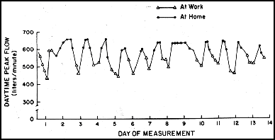
Figure 1. Auto body shop worker peak expiratory flow rates collected over a two-week period
QUESTIONS:
Question 1:
Of the following, which ONE is the most likely diagnosis for this case?
- Non-occupational asthma
- Occupational asthma (OA)
- Industrial bronchitis
- Airway irritation without asthma
- Metal or polymer fume fever
Question 2:
Which ONE of the following is LEAST helpful in making a diagnosis of isocyanate-induced occupational asthma?
- Occupational history
- Material Safety Data Sheets
- Nonspecific inhalation challenge by methacholine
- Skin test for immediate hypersensitivity
- Peak expiratory flow rate records both at home and at work
Question 3: (more than one answer may be correct)
Which of the following is/are NOT true regarding occupational asthma caused by isocyanates?
- This is a common cause of reactive airways dysfunction syndrome (RADS) at the workplace.
- Incidence of this disease may be declining in the United States.
- Improvement of symptoms away from work occurs early in the course of this disease.
- This affects only some of those exposed to isocyanates.
- Smoking may increase the predisposition to this disease.
Question 4:
Which ONE of the following workplace corrective measures is LEAST helpful for occupational asthma caused by sensitizers?
- Material substitution (e.g., change paints)
- Engineering controls (e.g., local exhaust ventilation)
- Personal protective equipment (e.g., respirator)
- Transfer to non-exposed worksite

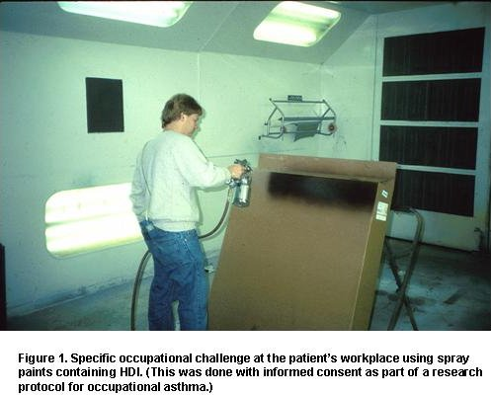

ANSWERS:
Question 1: The correct answer is 2.
A diagnosis of asthma is supported by history, physical examination, and methacholine challenge test. The occupational relationship is supported by occupational history, MSDS, and peak flows. Diurnal variability in peak expiratory flow rates >20% on days at work, but not on days away from work, is consistent with OA (see Figure 1).

Question 2: The correct answer is 4.
Skin testing has not proved useful for diagnosis of isocyanate-induced occupational asthma.

Question 3: The correct answers are 1 and 5.
Isocyanates are compounds that cause OA with latency. They usually do not cause RADS. RADS is asthma that occurs after a single exposure to high levels of an irritating vapor, fume, or smoke and persists after the initial episode. Tobacco smoking increases the risk of sensitization and asthma for several low-molecular-weight chemicals such as acid anhydrides, but not for isocyanates.

Question 4: The correct answer is 3.
Complete avoidance of exposure remains the most effective treatment of sensitizer-induced OA. Early removal is associated with a better medical outcome. Ventilation will reduce exposure. Personal protective equipment (respirator) often fails to provide adequate protection from sensitizers, and should only be used when other control measures are not practicable. Supplied air respirators would be the most effective personal protective equipment.

Isocyanate WRA Cases Reported to SENSOR
March 1992 - December 2004 (n = 24)*
*based on provisional data
Manufacturing 14  Sporting Goods 5  Plastic Products 2  Adhesive and Sealant 2  Industrial Machinery 2  Other 3 | Services 6  Automotive Repair 4  Other 2  Public Admin 3  Other 1

Work-Related Asthma Cases Reported to
Massachusetts SENSOR
September  2004 | October  2004 | November  2004 | Total  (03/92 – 11/04)
3 | 2 | 0 | 993

The official journal publication, published by the American Thoracic Society, was accessed on January 11, 2004 at: http://www.thoracic.org/assemblies/eoh/cases/ansmay03.asp
Chan-Yeung M, Malo JL, Occupational asthma. N Engl J Med 1995; 333(2):107-112.

