Health Reform and
Community Benefit

Jeff Harness/January 16, 2014

So Many Big Questions….

• Why and how is health care changing?

• What is the role of non-profit hospitals?

• What is community benefit?

• What are the community benefits requirements of the


ACA?

• How do I get involved?

2

3

4

The
90%

The
10%

Healthier Less healthy
Improving Population Health:

Focus on the 10%

• Reimbursement changes

• Focus on value (cost and quality) not volume

• Patient satisfaction

• Decrease readmissions

• Patient active in decision making

• Improved coordination and communication
What Does a Transformed Health Care
System Look Like?

•Medical resources not used efficiently

•Patients are discharged from the hospital and given instructions

•Focus on discrete activity

•Focus on individual patient

•Focus on revenue
•Only the sickest patients receive care in the hospital

•Regular contact with patients

•Keeping patient as a customer

•Focus on whole patient

•Focus includes community

•Focus on cost

7

10% 90% 100%

Healthy Environments Policies, Systems, Culture Partners, Coalitions



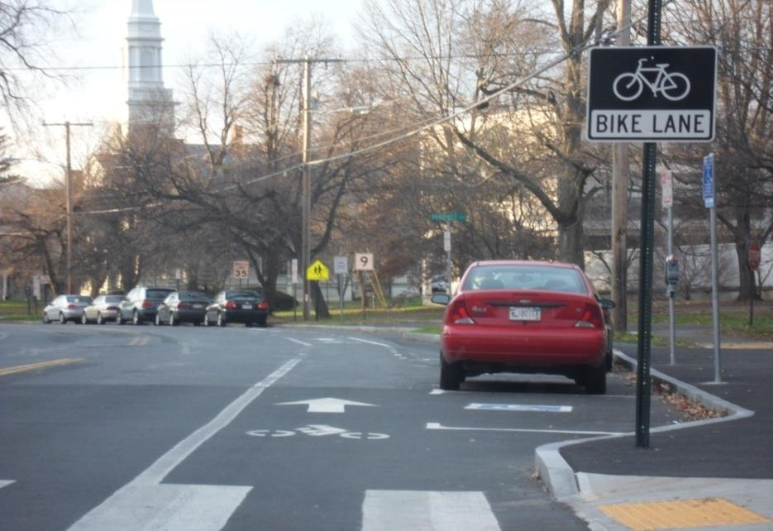

8

Example: COPD

Medical Home

Smoke - Free
Community  Health System |  |  |  | Medical  Care System

Policies
Integration

Wellness Tobacco
Treatment

Medication Oxygen Home Care

Prevention

Community Partnerships
Disease Care

Behavioral Health
Acute & Chronic

Original Adapted by Y. Goldsberry, R. Fedrezzi, D. Bazos, and L. Ayers LaFave from CDC

• Section 9007 of The Patient Protection and Affordable Care Act (ACA) revises the federal tax-exempt status requirements for nonprofit hospitals to ensure that hospitals’ “community benefit” investments (a condition of their tax-exempt status) are transparent, concrete, measurable, and both responsive and accountable to identified community need.

• To this end, the ACA requires hospitals to conduct a “community health needs assessment” (CHNA) and to adopt an “Implementation Strategy.”

10

11

• Fit with strategy

• Compliance with regulations

– Massachusetts Attorney General voluntary community benefit guidelines

– IRS Form 990 Section H requirements

• (community benefit)

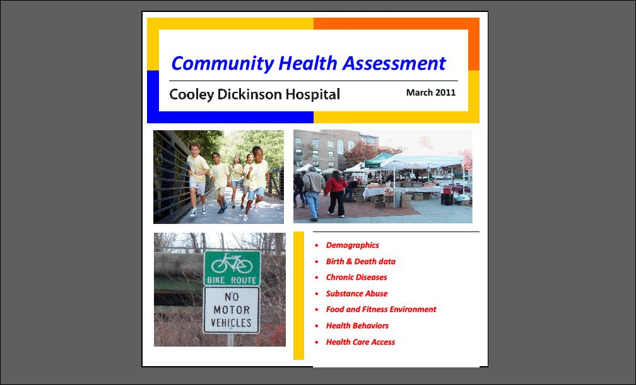

100%

90%

80%

70%

60%

50%

40%

75 years and over

55 to 74 years

35 to 54 years

20 to 34 years

Under 19 years

30%

20%

10%

0%
Hampshire Franklin Amherst Easthampton Northampton Mass

300

250

200

150

100
Heart Disease

Cancer

Cerebrovascular Disease

Injuries

Diabetes

50

0
Hampshire Franklin Amherst Easthampton Northampton Mass

16

17

• Regional Health Survey

• With other hospitals in the Pioneer Valley

• Focus groups (real people who use services)

• Key informant interviews

• Community forums (mix of residents and leaders)

– Easthampton

– Mental Health

– Health Access

• All said transportation

• Easthampton

– Health access; tobacco prevention and treatment

• Mental Health

– Better coordination and communication; patient
centered; bilingual/bicultural staff

• Health Access

– Better coordination and communication; health center
satellite in Amherst

• Based on evidence

• Based on local data

• Assessment of local needs/community engagement

• Includes community partners

• Patient-centered

• Cost-effective

• Measurable outcomes

• Plan and budget approved by the hospital’s board

• Plan made available to the public (website usually)

• Report prior fiscal year results:

• Massachusetts Attorney General’s website

• IRS Form 990 Section H

• Pilot projects in 2014 based on health assessment

– Announce grants and RFPs in December /January

• Develop a shared vision

• Create collective action to improve health

• Work through the big questions:

– Who’s involved? Who leads? Who pays?

– How will we know we’re improving things?
How to Get Involved in Community
Benefit at Your Non-Profit Hospital

• Go to the hospital’s website and review the health
assessment and plan

• Go to the Massachusetts Attorney General’s website and
review community benefit reports

• Meet with the hospital’s community benefits coordinator
and discuss ways to get involved in projects

• Collaborate with the hospital on future health assessments

• Looks for ways to partner on projects

