**INDOOR AIR QUALITY ASSESSMENT**

**Jefferson Elementary School**

**628 Washington Street**

**Franklin, MA**

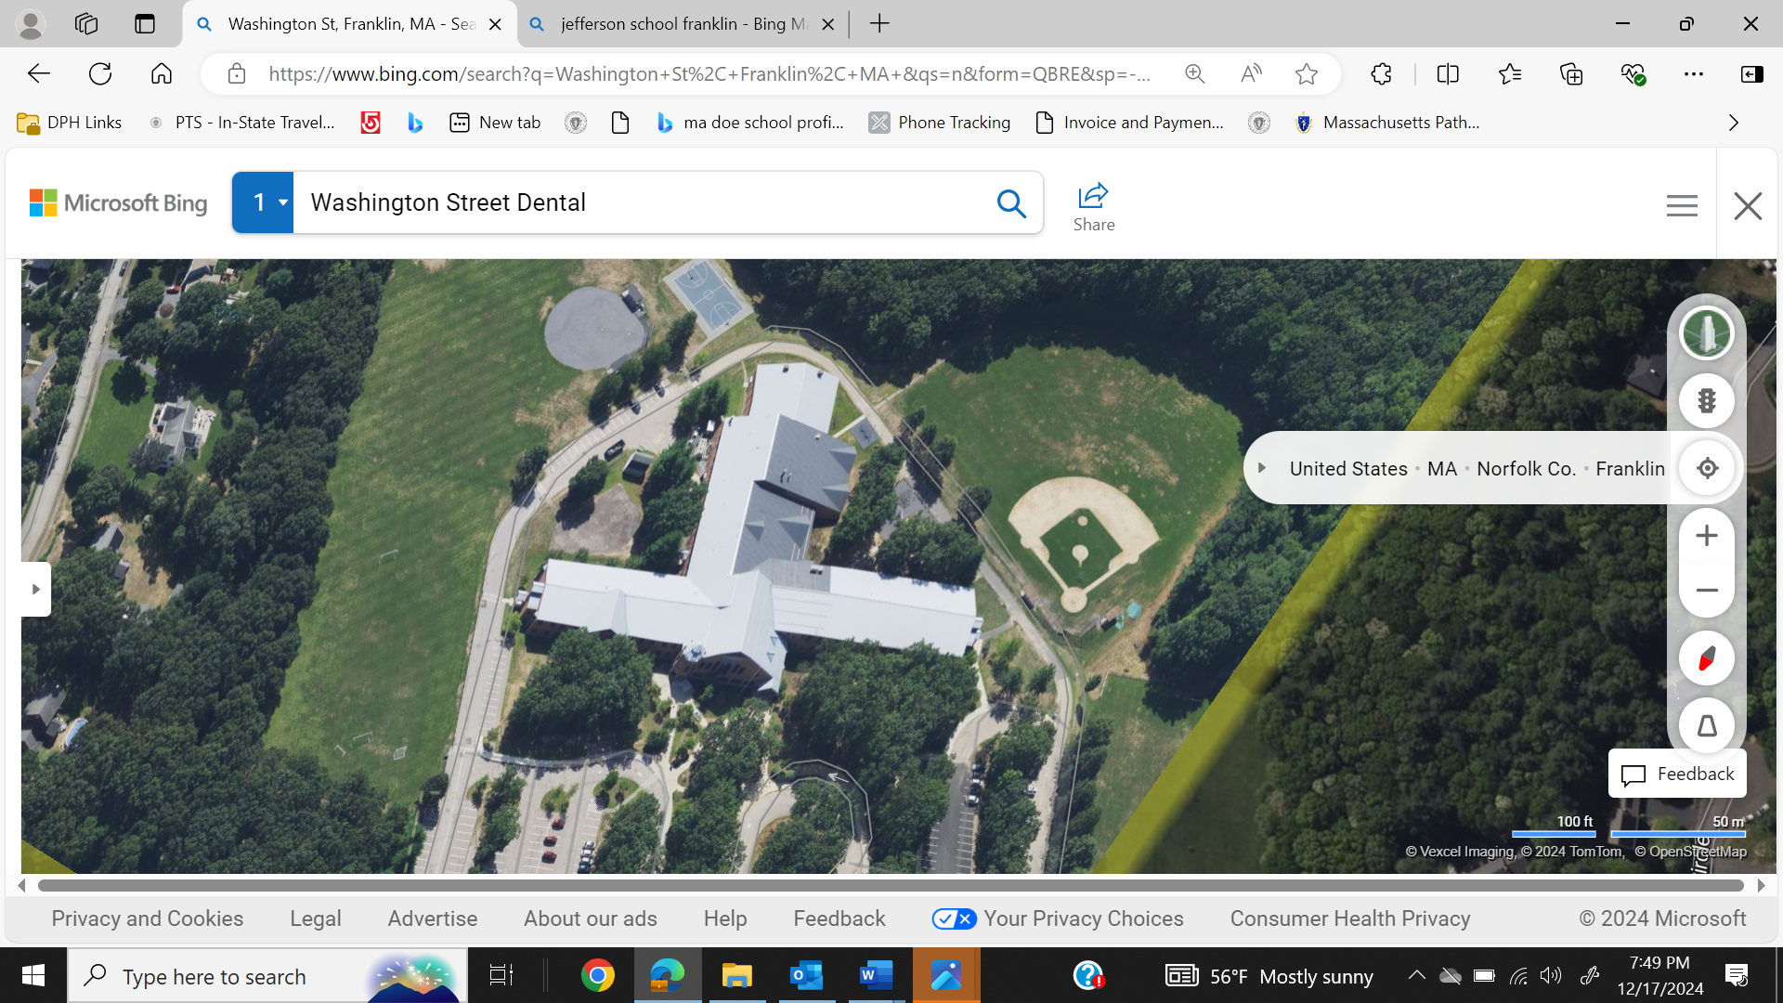

Prepared by:

Massachusetts Department of Public Health

Bureau of Climate and Environmental Health

January 2025

# BACKGROUND

|  |  |
| --- | --- |
| Building: | Jefferson Elementary School (JES) |
| Address: | 628 Washington Street, Franklin, MA |
| Assessment Requested by: | Dr. Tina Rogers, Assistant Superintendent for Teaching and Learning, Franklin Public School District |
| Reason for Request: | Mold odors in main office |
| Date of Assessment: | November 1, 2024 |
| Massachusetts Department of Public Health/Bureau of Climate and Environmental Health (MDPH/BCEH) Staff Conducting Assessment: | Michael Feeney, Senior Bureau Advisor, BCEH |
| Date of Building Construction: | Originally constructed in 1996. |
| Building Description: | The JES is a two-story brick/concrete block building. |
| Windows: | Openable |

# INTRODUCTION

This report is a summary of observations and recommendations regarding water damage and related mold odors reported in this building centering around the administrative office. The office suite is flanked by two hallways, to the east and the west, that lead to classrooms.

**METHODS**

MDPH staff conducted a visual inspection of rooms with reported mold odors to identify sources of moisture that would moisten materials in the building to cause mold growth. Please refer to the IAQ Manual and appendices for methods, sampling procedures, and interpretation of results (MDPH, 2015).

# RESULTS AND DISCUSSION

The following is a summary of indoor air testing results.

* ***Temperature*** was within or close to the MDPH recommended range of 70°F to 78°F in occupied areas tested.
* ***Relative humidity*** was within the MDPH recommended range of 40 to 60% in all areas tested the day of assessment, which is typical of conditions during the heating season.

## Ventilation

The main office of the JES, which is reported to have mold odors, has ceiling-mounted fresh air supply vents that have air chilling capacity. Fresh air in classrooms is supplied by unit ventilators (univents, Picture 1) that have 3 vents: a fresh air intake that draws air from outdoor, a return vent that draws air from indoors and an air diffuser on the top in the cabinet that provides heated fresh air/return air to the occupied space. Univents draw air from the outdoors through a fresh air intake located on the exterior wall of the building and return air through an air intake located at the base of the unit. Fresh and return air are mixed, filtered, heated or cooled and provided to rooms through an air diffuser located in the top of the unit (Figure 1).

Univents serving the original portion of the school may be greater than 25 years old. These units, if they have not been replaced since installation, may be beyond their service life. According to the American Society of Heating, Refrigeration, and Air-Conditioning Engineering (ASHRAE), the service life of this type of unit is 15-20 years, assuming routine maintenance of the equipment (ASHRAE, 1991).

## Microbial/Moisture Concerns

### Odor concerns

MDPH staff examined the building and found all classrooms and office areas free of any sign of visible mold growth or associated odors, including main offices along the front exterior wall of the JES.

Of note is the presence of a univent in the west hallway outside the main office (Picture 2) that is installed behind a wood/stone bench. In general, school hallways and other areas that are intermittently used are equipped with either radiators or fan coil units (FCUs) that recirculate heat without a fresh air supply vent that draws air from outdoors.

The following conditions were noted regarding this west hallway univent:

* A mold/musty odor was noted from this univent.
* The univent has a fresh air intake located below a roof that has no gutter/downspout, which allows rainwater to splash the exterior wall. The brick/stone cement around the univent fresh air intake is discolored indicating chronic water exposure.
* Although a typical univent has a return vent along the bottom to mix with outdoor air, no means of return air could be identified in the stone-wood of the bench surrounding the univent.
* Without a return vent, it is possible this univent is drawing in 100% outdoor air. If so, a significant amount of unconditioned outdoor air can be drawn in and distributed to the building interior, thus increasing relative humidity inside when the humidity is high outdoors.
* If doors or sliding windows to the office that open to the west hallway are propped open, hot, humid air can readily enter the office suite to cause condensation on heating, ventilating, and air conditioning (HVAC) equipment that chills air.
* Windows and doors into the office are roughly opposite the univent in the west hallway, so any mold and associated odors could enter the air-conditioned office suite.
* In order to replace air filters and clean the interior cabinet, a univent typically has a removable front panel. Due to the configuration of the bench, removing the front panel of the univent does not appear to be possible. Since the building was constructed in 1996, it is possible that this univent has no functioning filter or has not been routinely cleaned for over 25 years. Without a functioning filter, outdoor debris can accumulate inside the univent to serve as mold growth media.

Univents are usually installed in classrooms, cafeterias, libraries and other locations that are intended for occupancy for extended time periods. Areas with short-term occupancy would more likely be equipped with either radiators or mechanical systems such as fan coil unit (FCU) which recirculate air to maintain heat. Unlike univents, FCUs are not designed to provide fresh outdoor air.

### Sources of moisture

As described above, the west hallway univent has a fresh air intake located in an exterior wall below a large, sloped roof edge that has no gutter/downspout drain (Picture 3). This univent fresh air intake shows signs of chronic water exposure. The univent is installed behind a large bench which makes access to the univent interior impossible without dissembling the bench. A noticeable mold odor was noted in proximity to the univent, which would be consistent with chronic water exposure, which would moisten accumulated dirt and debris inside this univent. Univents are equipped with air filters to remove airborne particles from drawn in air such as pollen, mold and mold spores. Without filtering, both outdoor debris and indoor dust can accumulate in the univent and if sufficiently moistened, result in mold growth. JES staff reported mold odors/concerns in the office near the hallway univent.

Note that the east hallway does not have any HVAC univent equipment installed. JES staff did not report similar mold concerns in the east hallway.

One sign of long periods of high relative humidity in the JES is the presence of bowed ceiling tiles. If a building experiences high relative humidity indoors over an extended period, moisture exposure may cause ceiling tiles to bow. Bowed ceiling tiles without discoloration/stains are not mold colonized, but are a sign of long-term water vapor exposure, which causes sagging due to the weight of water in the ceiling tile and its effect on binders that hold the tile intact. MDPH staff conducted temperature and relative humidity testing in areas with reported mold odors. Temperature and relative humidity conditions at the time of the visit were not at levels that would cause mold growth in building materials.

Bowing ceiling tiles are often found in rooms with sink or floor drains where the trap has dried out. A trap is a section of pipe below the drain opening that fills with water to form an airtight seal. The airtight seal prevents sewer gas, odors, and water vapor from the drain systems from backing up the drain to enter occupied space. Water evaporates from the trap if plumbing is not used for several days or weeks, depending on ambient conditions. Wetting of all drain traps regularly to maintain the airtight water seal is particularly important when heavy rains occur, which may pressurize combined storm/sanitary sewer systems and force sewer gas and water vapor/odors/pollutants up the drainpipe. Schools are particularly vulnerable to dry drain traps due to the extended summer vacation.

Without wet traps, water vapor can back up the plumbing drains to enter classrooms to elevate humidity and potentially moisten materials that can support mold growth. A number of potential dry drains exist in the JES, including floor drains, kitchen sinks, and restroom sinks.

### Extreme Weather Conditions

It is also important to note that the JES HVAC system is not equipped with chillers to provide cooling during hot weather. In addition to providing cooling, HVAC systems can reduce humidity during operation. Use of dehumidifiers during hot, humid weather on the ground floor may help reduce humidity.

Hot humid summers are becoming more frequent due to climate change. Massachusetts has experienced hot, humid, and rainy summers in 2018, 2021, 2023 and 2024. As an example, July of 2021 was the wettest ever recorded in Massachusetts, and the three-month period from June through August, known as the meteorological summer, was the fourth wettest on record, according to the National Oceanic and Atmospheric Administration’s (NOAA) Centers for Environmental Information (NOAA, 2021). The summer of 2023 was also hot, and wet, being measured as the second rainiest on record (WBUR, 2023). The summer of 2024 also had significant stretches of hot, humid weather. These conditions are challenging for buildings, particularly those without central air conditioning.

Under these weather conditions, public buildings experienced extended periods of water vapor exposure from high relative humidity. When exposed to these conditions, porous materials such as gypsum wallboard, cardboard, carpeting and other materials may become moistened and colonized with mold, particularly if located in areas that are prone to developing condensation, such as floors and walls in contact with the ground (e.g., below grade space). It is recommended that porous material be dried with fans and heating within 24 to 48 hours of becoming wet (US EPA, 2008, ACGIH, 1989).

The guideline “Preventing Mold Growth In Schools During Hot, Humid Weather” <https://www.mass.gov/info-details/preventing-mold-growth-in-massachusetts-schools-during-hot-humid-weather> should be used to minimize the impact of such weather on classroom materials. This includes use of air conditioning and dehumidifiers, ensuring exhaust vents are on and operable, keeping windows closed, and ensuring air can circulate around porous materials.

### Mold Testing Recommendations

The presence of mold found by a test does not necessarily indicate a problem. Visual evidence of mold growth and/or the presence of musty odors are reliable indicators of mold problems that are correlated with health risks in buildings where indoor environmental complaints have been made. Mold spores waft through the indoor and outdoor air continually There is no practical way to eliminate all mold and mold spores in the indoor environment; the way to control indoor mold growth is to control moisture (US EPA, 2024).

There is no means by which to determine whether an individual’s symptoms or reactions were caused by mold by conducting environmental air testing for mold. While mold, spores, and other associated materials can make allergies and asthma symptoms worse, different people react differently to mold and mold spores. In addition to mold, reactions experienced by individuals could be caused by bacteria, other compounds in the air caused by the breakdown of wet building materials, or something different altogether (NIOSH, 2024; California DPH, unknown; Mendell, M. J., Mirer, A. G., Cheung, K., & Douwes, J. 2011; WHO. 2009).

The U.S. Environmental Protection Agency (EPA) does not recommend testing. DPH follows the guidelines contained in the U.S. EPA Mold Remediation in Schools and Commercial Buildings report for cleaning and removing water-damaged materials. US EPA’s guidelines recommend, in most cases, that if visible mold growth is present, mold sampling is not necessary. A number of international, US federal, and state agencies either do not have or recommend against conducting mold testing as part of mold remediation (see **REFERENCES** headings: **Agencies with guidelines recommending against mold testing,** and **Reference from government agencies, industrial hygiene groups and or other environmental professional guidelines that denote that no mold exposure limits have been established for mold in workplace, government buildings or residences).** For **e**xample, the U.S. Department of Housing and Urban Development (HUD) does not recommend conducting environmental mold testing:

*“No matter what kind of mold you have, you need to get rid of it and fix the moisture problems that made it grow. Most experts think it’s better to spend your time and money on cleaning up the problem than testing” (HUD. 2024).*

Multiple worker safety agencies and organizations have no worker safety air levels established for exposure to species of mold. The following agencies and professional industrial hygiene agencies have not established mold exposure levels in the workplace that would justify air testing. The following industrial safety guidelines do not list any mold species and air level concentrations:

* US Occupational Safety And Health Administration has not established any mold Permissible Exposure Limits (PELs) for mold air levels.
* American Conference of Governmental Industrial Hygienists (ACGIH) has no established Threshold Limit Values (TLVs) for mold air levels.
* National Institute of Occupational Safety and Health (NIOSH) has no established Recommended Exposure Limits (RELs) for mold air levels.
* American Industrial Hygiene Association (AIHA) has no established Workplace Environmental Exposure Levels (WEELs) for mold air levels.

Additionally, even if worker safety exposure limits existed for mold, such guidelines **would not apply** to non-employees in a building. These individuals include: students in primary education schools; students in secondary education facilities; adults outside worker ages as defined by OSHA; individuals with chronic health conditions; patients in any medical facility; adults who are invitees, customers, or visitors to the workplace and other members of the general public.

For non-employees, there are **no established mold exposure limits** (international, Federal, or state regulations, building standards or guidelines) on how much mold can exist in air before health impacts are expected for the general population. In addition, the international, Federal, state or building standards agency have not established mold remediation clean-up levels that must be achieved after mold remediation efforts are completed.

This means that even if tests are conducted, there is no way to compare results or determine whether the measured level could cause health effects or meet clean up levels. Multiple federal agencies, including the US EPA, US Department of Housing and Urban Development and the US Federal Emergency Management Agency (FEMA) have not established mold exposure standard or recommend environmental mold testing in any water damage/flood recovery guidelines. With no established workers or general public safety exposure limits, air testing will not influence how mold remediation efforts would be conducted.

To remove mold from buildings, of primary importance is to identify, repair and/ or limiting the moisture source cause damage in the building. Once moisture source is remediated, then discarding and/or cleaning of mold contaminated materials can be completed.

# RECOMMENDATIONS

In view of the findings at the time of the visit, the following recommendations are made:

1. The west hallway univent should be accessed and inspected for mold growth. This univent should be cleaned in a manner consistent with the US EPA’s “Mold Remediation in Schools and Commercial Buildings,” available at: <http://www.epa.gov/mold/mold-remediation-schools-and-commercial-buildings-guide>. Disassembling the west hallway bench and stone around the univent may be necessary.
2. Given its location, consideration should be given to permanently sealing the west hallway univent air intake with exterior wall brickwork installed in a manner to prevent water penetration through this opening.
3. Consider replacing the univent with a radiator or FCU installed to allow heated air circulation.
4. Clean dust/debris from all univents when filters are changed. To prevent mold growth, cleaning of univent dust and debris should occur prior to the beginning of periods of hot, humid weather that occurs during the summer.
5. Ensure that all univents are equipped with filters that have a minimum MERV rating of 8 to remove mold/mold spores and pollen from the univent air stream.
6. Ensure that drains in all sinks and other fixtures have wetted drain traps by pouring water down the drain once a week to maintain airtight seal.
7. If a drain is no longer in use, permanently seal drain opening and deactivate water supply to the sink.
8. Management of buildings in extreme relative humidity and rain can be challenging. The following documents can provide guidance that can be used to reduce the impact of hot, humid weather in buildings:
   1. Mold Growth Prevention During Hot, Humid Weather <https://www.mass.gov/service-details/preventing-mold-growth-in-massachusetts-schools-during-hot-humid-weather> and
   2. Remediation and Prevention of Mold Growth and Water Damage in Public Schools <https://www.mass.gov/service-details/remediation-and-prevention-of-mold-growth-and-water-damage-in-public-schools-and>.
9. Refer to resource manuals and other related IAQ documents for further building-wide evaluations and advice on maintaining public buildings. Copies of these materials are located on the MDPH’s website: <http://mass.gov/dph/iaq>.

# REFERENCES

## General References

ACGIH. 1989. Guidelines for the Assessment of Bioaerosols in the Indoor Environment. American Conference of Governmental Industrial Hygienists, Cincinnati, OH.

ASHRAE. 1991. ASHRAE Applications Handbook, Chapter 33 “Owning and Operating Costs”. American Society of Heating, Refrigeration and Air Conditioning Engineers, Atlanta, GA.

MDPH. 2015. Massachusetts Department of Public Health. Indoor Air Quality Manual: Chapters I-III. Available at: <https://www.mass.gov/lists/indoor-air-quality-manual-and-appendices>.

NOAA. 2021. Summer 2021 neck and neck with Dust Bowl summer for hottest on record. National Oceanic and Atmospheric Administration, 1401 Constitution Avenue NW, Room 5128, Washington, DC 20230 <https://www.noaa.gov/news/summer-2021-neck-and-neck-with-dust-bowl-summer-for-hottest-on-record>.

WBUR. 2023. “It's been a summer of rain and flooding misery in Mass.” WBUR local news. September 12, 2023. <https://www.wbur.org/news/2023/09/12/summer-flooding-rain-massachusetts>.

US EPA. 2008. “Mold Remediation in Schools and Commercial Buildings”. Office of Air and Radiation, Indoor Environments Division, Washington, DC. EPA 402-K-01-001. September 2008. Available at: <http://www.epa.gov/mold/mold-remediation-schools-and-commercial-buildings-guide>.

## Mold Testing References

ACGIH, 1989. Guidelines for the Assessment of Bioaerosols in the Indoor Environment. American Conference of Governmental Industrial Hygienists, Cincinnati, OH

CA DPH, unknown. California Department of Public Health Statement on Building Dampness, Mold, and Health. [California Department of Public Health Statement on Building Dampness Mold and Health](https://www.cdph.ca.gov/Programs/cls/dehl/ehl/CDPH%20Document%20Library/MoldDampStatement2017_ENG.pdf)

HUD. 2024. Help Yourself to a Healthy Home. US Department of Housing and Urban Development. Washington, DC. PAGES and Cover002.indd (hud.gov)

Mendell, M. J., Mirer, A. G., Cheung, K., & Douwes, J. 2011. Respiratory and allergic health effects of dampness, mold, and dampness-related agents: a review of the epidemiologic evidence. Environmental Health Perspectives 119(6):748. <https://pubmed.ncbi.nlm.nih.gov/21269928/>

NIOSH, 2024. [Mold, Testing, and Remediation | Workplace Mold | CDC](https://www.cdc.gov/niosh/mold/testing-remediation/index.html)

US EPA, 2008. “Mold Remediation in Schools and Commercial Buildings”. Office of Air and Radiation, Indoor Environments Division, Washington, DC. EPA 402-K-01-001. September 2008. Available at: <http://www.epa.gov/mold/mold-remediation-schools-and-commercial-buildings-guide>

U.S. EPA, 2024, Frequent Questions on Mold and Moisture, Updated: October 14, 2024. [Mold Frequently Asked Questions | US EPA](https://www.epa.gov/mold/mold-frequently-asked-questions)

WHO, 2009. WHO Guidelines for Indoor Air Quality: Dampness and Mould. World Health Organization Copenhagen: WHO Europe. WHO guidelines for indoor air quality : dampness and mould <https://www.who.int/publications/i/item/9789289041683>

## Agencies with guidelines recommending against mold testing

APHC. Residential Indoor Mold and Residential Mold Air Sample Results What Do They Mean? FACT SHEET 55-026-0319. U.S. Army Public Health Center, Industrial Hygiene Field Services Program, Aberdeen Proving Ground, Maryland.

CA HESIS. 2005. Molds in Indoor Workplaces. California Hazard Evaluation System and Information Service. P.2 Molds in Indoor Workplaces: Fact Sheet for Workers and Employers (ca.gov) Nov. 2005

CDC. 2024. Mold. Centers for Disease Control. Atlanta, GA. [Mold | Mold | CDC](https://www.cdc.gov/mold-health/about/index.html).

CTDPH. 2012. Get The Mold Out: Mold Clean-Up Guidance for Residences Fact Sheet. Connecticut Department of Public Health Environmental & Occupational Health Assessment Program Environmental Health Secon 410 Capitol Avenue, MS # 11EOH. [Get The Mold Out_ fact sheet082012](https://portal.ct.gov/-/media/departments-and-agencies/dph/dph/environmental_health/eoha/pdf/getthemoldoutpdf.pdf)

FEMA, unk. Homeowner’s and Renter’s Guilder o Mold Cleanup after Disasters. <https://www.fema.gov/sites/default/files/documents/fema_hm-cdc-homeowners-and-renters-mold-guide_english.pdf>

Health Canada. Guide to addressing moisture and mould indoors. <https://www.canada.ca/en/health-canada/services/publications/healthy-living/addressing-moisture-mould-your-home.html>

MDHHS. 2010. Mold Fact Sheet. Maine Department of Health and Human Services, Bangor, ME. <https://www.maine.gov/dhhs/mecdc/infectious-disease/epi/disease/documents/pdf/mold.pdf>

MNDPH. 2024. Testing For Mold. [Testing For Mold - MN Dept. of Health (state.mn.us)](https://www.health.state.mn.us/communities/environment/air/mold/moldtest.html)

NHDHHS. 2013. Mold and moisture. New Hampshire Department of Health and Human Services, Concord, NH. [https://www.dhhs.nh.gov/sites/g/files/ehbemt476/files/documents/2021-11/holu-dphs-mold-policy-letter.pdf](https://www.dhhs.nh.gov/sites/g/files/ehbemt476/files/documents/2021-11/holu-dphs-mold-policy-letter.pdf#:~:text=Although%20a%20handful%20of%20states%20have%20passed%20their,when%20ever%20you%20see%20mold%20or%20smell%20mildew.)

NIOSH. 2024. Mold, Testing, and Remediation. National Institute of Occupational Safety and Health, Cincinnati, OH.

NYDOL. Mold Assessment and Remediation in New York State. Mold Assessment and Remediation in New York State. New York Department of Labor. [p227.pdf (ny.gov)](https://dol.ny.gov/system/files/documents/2021/03/p227.pdf)

ODHS. Unk. FAST FACTs: Household Mold. Oregon Department of Human Services, Public Health Division, Office of Environmental Public Health: Toxicology Consulting Services. [Moldfactsheet.pdf (oregon.gov)](https://www.oregon.gov/oha/ph/HealthyEnvironments/TrackingAssessment/EnvironmentalHealthAssessment/Documents/Moldfactsheet.pdf)

OSHA. Mold. US Occupational Safety and Health Administration. [Mold - Recognize Mold Hazards | Occupational Safety and Health Administration (osha.gov)](https://www.osha.gov/mold/hazards)

USAPHC. 2018. Technical Guide 278 Industrial Hygiene Public Health Mold Assessment Guide. US Army Public Health Center, Public Health 6582 Magrath Ave BLDG 2059 Fort Carson, Colorado. <https://ph.health.mil/PHC%20Resource%20Library/TG278.pdf> .

VTDH. 2024. Mold Inside Home and Other Buildings. <https://www.healthvermont.gov/sites/default/files/document/env-hh-mold-indoors.pdf>

WSDH. Unk. Mold. Washington State Department of Health, [Mold | Washington State Department of Health](https://doh.wa.gov/community-and-environment/contaminants/mold)

## References from government agencies, industrial hygiene groups, and/or other environmental professional guidelines that denote that no mold exposure limits have been established for mold in workplace, government buildings or residences.

AIHA. 2019. FAQs About Spore Trap Air Sampling for Mold for Direct Microscopical Examination Mold Analysis Document. American Industrial Hygiene Association, Falls Church, VA. <https://aiha-assets.sfo2.digitaloceanspaces.com/AIHA/resources/FAQs-About-Spore-Trap-Air-Sampling-for-Mold-for-Direct-Examination-Guidance-Document.pdf>

APHC. Residential Indoor Mold and Residential Mold Air Sample Results What Do They Mean? FACT SHEET 55-026-0319. U.S. Army Public Health Center, Industrial Hygiene Field Services Program, Aberdeen Proving Ground, Maryland.

FEMA, unk. Homeowner’s and Renter’s Guilder o Mold Cleanup after Disasters. <https://www.fema.gov/sites/default/files/documents/fema_hm-cdc-homeowners-and-renters-mold-guide_english.pdf>

MDHHS. 2010. Mold Fact Sheet. Maine Department of Health and Human Services, Bangor, ME. <https://www.maine.gov/dhhs/mecdc/infectious-disease/epi/disease/documents/pdf/mold.pdf>

OHHN. 2023. Mold Basics. Ohio Healthy Homes Network, Columbus, Ohio. [Mold Basics | Ohio Healthy Homes Network (ohhn.org)](https://www.ohhn.org/mold-basics/)

WDHS. 2021. Controlling Mold and Moisture Household Mold Guidance for Local Health Professionals Wisconsin Department of Health Services, Indoor Air and Radon Program Division of Public Health, Bureau of Environmental and Occupational Health. <https://www.dhs.wisconsin.gov/publications/p02069.pdf>

WHO, 2009. WHO Guidelines for Indoor Air Quality: Dampness and Mould. World Health Organization Copenhagen: WHO Europe. WHO guidelines for indoor air quality : dampness and mould <https://www.who.int/publications/i/item/9789289041683>

**Figure 1**

**Unit Ventilator (Univent)**

Mixed Air

Air Diffuser

**Outdoors Indoors**

Fan

Heating/Cooling Coil

Air Mixing Plenum

Filter

Outdoor Return

Air Air

Air

Flow

Control

Louvers

**Air Flow**

= Fresh Air/Return Air

= Mixed Air

**Picture 1**

**Picture 1**

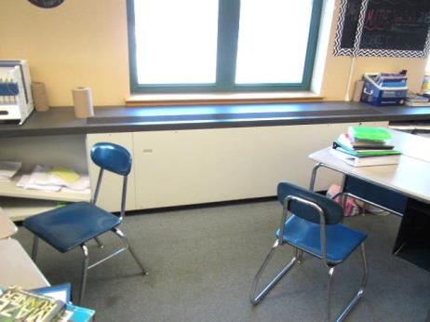

**Example of a univent equipped with a fresh air diffuser on top and return vent on its front**

**(arrow)**

**Picture 2**

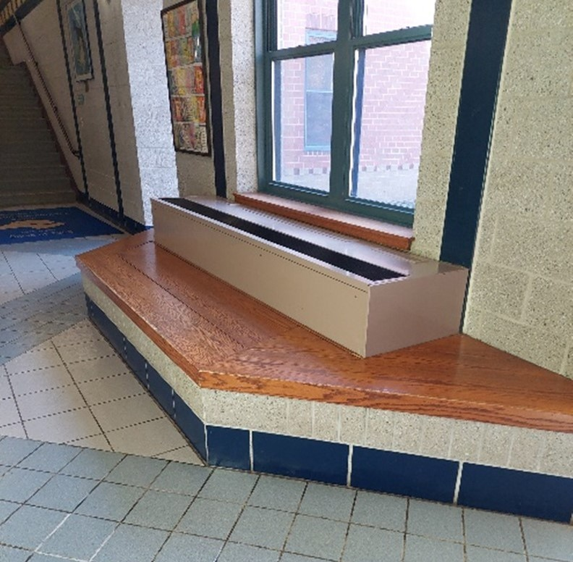

**Hallway univent surrounded by wood/stone benches. Note absence of return air vents in stone below the wood of the bench**

**Picture 3**

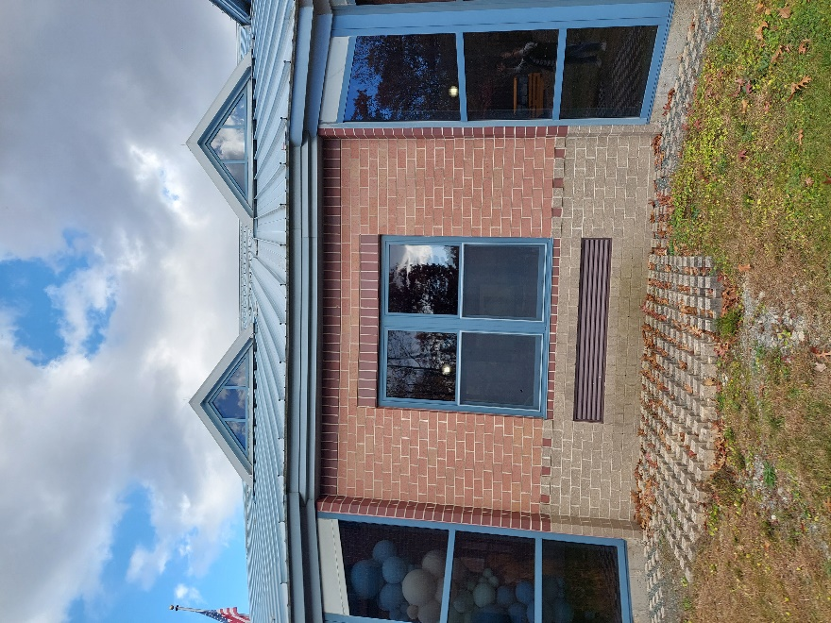

**Hallway fresh air intake below gutter-less roof.**

**Note discolored stone around univent fresh air intake, indicating chronic water exposure**