September 9, 2025
Senator Robyn Kennedy, Chair
Representative Jay Livingstone, Chair
Senator Liz Miranda, Vice Chair
Representative Judith Garcia, Vice Chair
Joint Committee on Children, Families, and Persons with Disabilities
Massachusetts State House, Boston, MA 02133

RE: H.256/S.102 – An Act requiring universal changing stations in public buildings.

Dear Chairwoman Kennedy and Chairman Livingstone and Members of the Joint Committee,

Thank you for your consideration of H.256/S.102 – An Act requiring universal changing stations in public buildings. This legislation is a policy priority for The Massachusetts Developmental Disabilities Council (MDDC). Our Council is an independent state agency dedicated to empowering people with developmental disabilities and their families to enjoy full, productive lives by promoting self-sufficiency, community inclusion, and opportunity. The MDDC works to improve the system of supports for individuals with developmental disabilities and their families by bringing advocates together with policymakers to be sure people with developmental disabilities are included in policy decisions that impact their lives. The MDDC also serves as an objective resource to inform public policy at the local, state and federal levels, to better meet the needs of individuals with developmental disabilities and their families. Our Council can provide expert testimony, data analysis and technical advice to lawmakers and/or legislative committees. We can also participate through the legislative process by sharing research results with policymakers. We also play a critical role in quality assurance and as innovators in the development of person-centered systems.

After thoughtfully reviewing the proposed policy and learning about the experiences of Council members and people from the larger developmental disability community⁴, we have concluded that including universal changing stations in public buildings would be highly beneficial to people with developmental disabilities and their families as well as caregivers. Universal changing stations would support increased opportunities for meaningful community inclusion.

Standard accessible restrooms are not adequate for many people who require assistance with their personal care and toileting needs⁵. While the Americans with Disabilities Act (ADA)

requires accessible features like grab bars and wider stalls, these accommodations do not meet the needs of all people with disabilities⁵. Without adult changing stations, people with mobility limitations are often forced to choose between undignified and unsafe options including having to lay on an unsanitary public restroom floor and/or being changed in confined spaces, such as the back of a car⁵. Some individuals may even resort to restricting their fluid intake to avoid using the restroom, which can result in negative health consequences⁵. For other individuals with developmental and other disabilities the lack of dignified and hygienic public places to fulfill their toileting needs means staying home, limiting opportunities for community participation and potentially leading to social isolation⁵.

There are multiple documented benefits to requiring adult-sized changing stations in public spaces. Having a private and an appropriate surface for personal care removes access barriers and helps promote and ensure community inclusion³. Access is a matter of dignity and respect for our fellow citizens with disabilities and sends a message of equality and respect, affirming that everyone deserves to participate in public life without compromising their personal care³.

Universal adult-sized universal changing stations are important to the safety and health of people with disabilities⁵. For individuals with disabilities who cannot transfer or support themselves, lying on a dirty and unhygienic floor poses a significant health risk, especially for individuals who are more susceptible to infection and disease⁵. A sturdy, clean table reduces the risk of infection and provides a safe space for care. Modern tables that are also height-adjustable make transfers from wheelchairs safer and reduce the risk of injury for both the person and their caregiver⁵.

The presence of adequate restroom facilities is a game-changer for people with disabilities and their families as well as caregivers⁴. The physical demands of assisting an adult with personal care on an inappropriate surface can be strenuous and dangerous. Adjustable tables reduce the risk of back strain and other physical injuries by allowing the caregiver to work at a comfortable and ergonomic height⁴. This reduces stress and makes community outings more manageable⁴.

At least seven states including our northern neighbor, New Hampshire (HB628 in 2019/NH RSA 155:80), have enacted legislation to mandate adult changing stations in certain public facilities¹. This policy aligns with the disability rights movement³ that advocates for equal access for everyone. Providing universal changing stations goes beyond simple legal compliance; it is a matter of social responsibility².

Universal changing tables that accommodate adults are essential for ensuring that people with physical, intellectual, and developmental disabilities can access public spaces with the respect
they deserve. Without them, individuals risk compromising their health and dignity to access public spaces.

Thank you for your consideration,

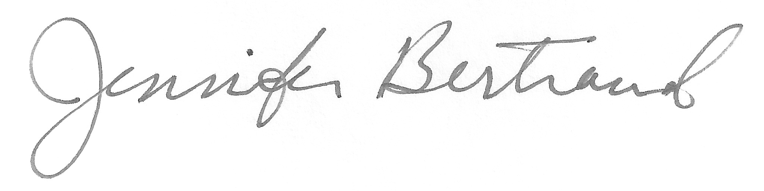
Jennifer Bertrand
Deputy Director, Massachusetts Developmental Disabilities Council
Email: Jennifer.Bertrand@mass.gov

Sources:
- Day. (2024). Which states require adult size changing tables? Day Global Group LLC (DGG). https://dayglobalgroup.com/helpful-resources/f/who-requires-having-universal-adult-size-changing-tables?srsltid=AfmBOooCy6_3NxYg9e162_4FPnk0FmSz2T0kmn60p15BZL9LU3Y80LfY
- Gaunt, J. (2015). Creating Equitable Spaces: Adult Changing Stations Increase Accessibility | We Are Parks and Recreation | Parks & Recreation Magazine | NRPA. Nrpa.org. https://www.nrpa.org/parks-recreation-magazine/2023/september/creating-equitable-spaces-adult-changing-stations-increase-accessibility/
- Geffen Treiman. (2023). No Dignity on the Floor: A Human Rights Argument for Adult-Sized Changing Tables in Public Restrooms in the United States. Health and Human Rights, 25(1), 213. https://pmc.ncbi.nlm.nih.gov/articles/PMC10309150/
- Leys, T. (2024, October 3). More Restrooms Have Adult-Size Changing Tables To Help People With Disabilities - KFF Health News. KFF Health News. https://kffhealthnews.org/news/article/adult-size-changing-tables-public-restrooms-disabilities-access/
- Treiman, G., Cheng, M., & Oswald, M. (2023). “This is not built for me”: A qualitative study of adult-sized changing tables and public restroom accessibility. Disability and Health Journal, 17(1), 101520. https://doi.org/10.1016/j.dhjo.2023.101520

NH RSA 155:80 – To NH’s Universal Changing Station law go to:
https://gc.nh.gov/rsa/html/XII/155/155-80.htm

