INDOOR AIR QUALITY ASSESSMENT

JFK Elementary School
339 Plymouth Street
Holbrook, MA 02343

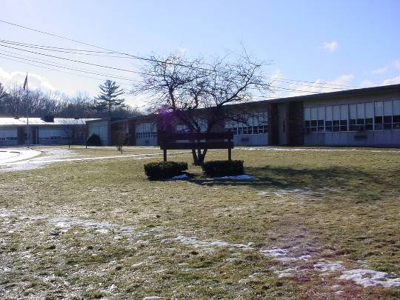

Prepared by:
Massachusetts Department of Public Health
Bureau of Environmental Health
Indoor Air Quality Program
March 2008

Background/Introduction
At the request of the Holbrook Board of Selectmen and the Holbrook Board of Health (HBOH), the Massachusetts Department of Public Health (MDPH), Bureau of Environmental Health (BEH) provided assistance and consultation regarding indoor air quality at each of Holbrook’s public schools. These assessments were jointly coordinated through Kathleen Moriarty, Public Health Agent, HBOH and the Holbrook Public School Department (HPSD).
On January 30, 2008, a visit was made to the JFK Elementary School (JFKES), 339 Plymouth Street, Holbrook, by Cory Holmes and James Tobin, Environmental Analysts in BEH’s Indoor Air Quality (IAQ) Program, to conduct an assessment. BEH staff were accompanied by Barbara McLaughlin, School Principal, Don Quimby, Facilities Manager, HPSD and Ms. Moriarty during the assessment.
The school was built in 1964 and contains 29 general classrooms, small rooms for specialized instruction, a gymnasium, a kitchen, a cafetoria, a library and an art/music room. The majority of building components are original; however four modular classrooms have been added. Two modular classrooms were added in 2005, while the other two were added in November 2006. Windows are openable throughout the building.

Methods
Air tests for carbon monoxide, carbon dioxide, temperature and relative humidity were conducted with the TSI, Q-Trak, IAQ Monitor, Model 8551. Air tests for airborne particle matter with a diameter less than 2.5 micrometers were taken with the TSI, DUSTTRAK™ Aerosol Monitor Model 8520. MDPH staff also performed visual inspection of building materials for water damage and/or microbial growth.

Results
The school houses approximately 430 elementary students in preschool to grade 3 with approximately 45 staff members. Tests were taken during normal operations at the school and results appear in Table 1.

Discussion
Ventilation
It can be seen from Table 1 that carbon dioxide levels were above 800 parts per million (ppm) in 29 of 36 areas at the time of the assessment, with several rooms (including the gym) close to or exceeding 1,500 ppm. These elevated levels of carbon dioxide indicate poor air exchange in the majority of the areas surveyed, mainly due to deactivated mechanical ventilation equipment. It is also important to note that several classrooms had open windows and/or were empty/sparsely populated, which typically can greatly reduce carbon dioxide levels. Carbon dioxide levels would be expected to be higher with full occupancy and with windows closed.
Fresh air is supplied to classrooms by unit ventilator (univent) systems (Picture 1). A univent draws air from the outdoors through a fresh air intake located on the exterior wall of the building (Picture 2) and returns air through an air intake located at the base of the unit (Figure 1). Fresh and return air are mixed, filtered, heated and provided to classrooms through an air diffuser located in the top of the unit. Univents were found obstructed by furniture, books and other materials (Picture 3). In order for univents to provide fresh air as designed, air diffusers, intakes and return vents must remain free of obstructions. Importantly, these units must remain “on” and be allowed to operate while rooms are occupied. Univents are also original 1960s era equipment, making them approximately 40+ years old. Efficient function of such equipment can be difficult to maintain since compatible replacement parts are often unavailable.
Exhaust ventilation in classrooms is provided by wall vents ducted to rooftop motors, which were deactivated at the time of the assessment. Exhaust vents are located in an area partitioned by three panels, which serves as the designated coat area (Picture 4). The panels are undercut to allow air to move freely, however, airflow underneath the panels was blocked by file cabinets and stored materials (Picture 4). Moreover, a number of exhaust vents were obstructed by furniture, coats and bags (Picture 5). As with univents, in order to function properly, exhaust vents must be activated and allowed to operate while rooms are occupied. Without adequate supply and exhaust ventilation, excess heat and environmental pollutants can build up leading to indoor air/comfort complaints.
A wall divides the library and speech rooms, placing the univent in the speech room and the exhaust vent in the library. In order to provide air to the library, a duct extends from the air diffusers atop the univent through a wall to the library (Pictures 6 and 7). Air is exhausted from the speech room by a passive door vent and the undercut of the door from the library. Although this provides some supply air to the library it compromises make-up air capacity to both the speech and library by approximately 50 %.
Ventilation for modular classrooms is provided by wall-mounted AHUs (Picture 8). Fresh air is drawn in through an air intake on the exterior of the building and distributed to classrooms via an air diffuser and drawn back to the AHUs through a return grill. Thermostats control each AHU. All AHUs for modular classrooms were found deactivated (Picture 9) and windows were shut at the time of the assessment, explaining the elevated carbon dioxide levels and lack of air exchange. In one particular modular classroom, carbon dioxide levels were elevated to 2,620 ppm (Table 1). The AHUs were subsequently reactivated by Mr. Quimby, significantly reducing the carbon dioxide level to 754 ppm (Table 1). Furthermore, thermostats for AHUs were set to an “automatic” setting which deactivates the HVAC system at a preset temperature. Therefore, no mechanical ventilation is provided until the thermostat re-activates the system.
To maximize air exchange, the MDPH recommends that both supply and exhaust ventilation operate continuously during periods of school occupancy. In order to have proper ventilation with a mechanical supply and exhaust system, the systems must be balanced to provide an adequate amount of fresh air to the interior of a room while removing stale air from the room. It is recommended that HVAC systems be re-balanced every five years to ensure adequate air systems function (SMACNA, 1994). The last balancing of these systems was at the time of the installation.
The Massachusetts Building Code requires a minimum ventilation rate of 15 cubic feet per minute (cfm) per occupant of fresh outside air or have openable windows in each room (SBBRS, 1997; BOCA, 1993). The ventilation must be on at all times that the room is occupied. Providing adequate fresh air ventilation with open windows and maintaining the temperature in the comfort range during the cold weather season is impractical. Mechanical ventilation is usually required to provide adequate fresh air ventilation.
Carbon dioxide is not a problem in and of itself. It is used as an indicator of the adequacy of the fresh air ventilation. As carbon dioxide levels rise, it indicates that the ventilating system is malfunctioning or the design occupancy of the room is being exceeded. When this happens, a buildup of common indoor air pollutants can occur, leading to discomfort or health complaints. The Occupational Safety and Health Administration (OSHA) standard for carbon dioxide is 5,000 parts per million parts of air (ppm). Workers may be exposed to this level for 40 hours/week, based on a time-weighted average (OSHA, 1997).
The MDPH uses a guideline of 800 ppm for publicly occupied buildings. A guideline of 600 ppm or less is preferred in schools due to the fact that the majority of occupants are young and considered to be a more sensitive population in the evaluation of environmental health status. Inadequate ventilation and/or elevated temperatures are major causes of complaints such as respiratory, eye, nose and throat irritation, lethargy and headaches. For more information concerning carbon dioxide, consult Appendix A.
Temperature measurements in the school ranged from 66º F to 74º F, which were within the MDPH recommended comfort range in the majority of areas surveyed (Table 1). The MDPH recommends that indoor air temperatures be maintained in a range of 70º F to 78º F in order to provide for the comfort of building occupants. In many cases concerning indoor air quality, fluctuations of temperature in occupied spaces are typically experienced, even in a building with an adequate fresh air supply. Chronic heat complaints were reported in the library due to sun exposure, causing solar glare and radiant heat. Further, a computer server in the speech room adds heat to the room, which may cause comfort complaints.
It should be noted that drafts were noted around windows throughout the school (called air infiltration). Cold air infiltration through window systems can make temperature control in rooms difficult to maintain. In addition, it is difficult to control temperature and maintain comfort without operating the ventilation equipment as designed (e.g., AHUs, univents/exhaust vents deactivated/obstructed).
The relative humidity measured in the building ranged from 33 to 46 percent, which was below the MDPH recommended comfort range in some of the areas surveyed (Table 1). The MDPH recommends a comfort range of 40 to 60 percent for indoor air relative humidity. Relative humidity levels in the building would be expected to drop during the winter months due to heating. The sensation of dryness and irritation is common in a low relative humidity environment. Low relative humidity is a very common problem during the heating season in the northeast part of the United States.

Microbial/Moisture Concerns
Several potential sources of water damage/water infiltration were observed in the building. Throughout the school, caulking around the interior and exterior windowpanes was crumbling, missing or damaged (Pictures 10 and 11). As previously mentioned, air infiltration was noted around windows, which has resulted in chronic water penetration illustrated by water damaged ceiling tiles along window frames throughout the building (Pictures 12 and 13). Water penetration through window frames can lead to mold growth under certain conditions. Repairs of window leaks are necessary to prevent further water penetration. Water-damaged ceiling tiles can provide a source of mold and should be replaced after a water leak is discovered and repaired.
The US Environmental Protection Agency (US EPA) and the American Conference of Governmental Industrial Hygienists (ACGIH) recommend that porous materials be dried with fans and heating within 24 to 48 hours of becoming wet (US EPA, 2001; ACGIH, 1989). If not dried within this time frame, mold growth may occur. Once mold has colonized porous materials, they are difficult to clean and should be removed/discarded.
Plants were observed growing in close proximity to a univent fresh air intake along the exterior (Picture 2). Shrubbery and flowering plants can be a source of mold and pollen, and should be located away from fresh air intakes to prevent the aerosolization of mold, pollen or particulate matter throughout the building.
BEH staff examined the building to identify breaches in the building envelope that could provide a source of water penetration. Several potential sources were identified:
- Gutters/downspouts were damaged and emptying against the exterior of the building, allowing rainwater to pool on the ground at the base of the building (Pictures 14 through 17);
- Open utility holes (Picture 18);
- Interior and exterior wall cracks (Picture 19); and
- A tree growing at the base of the exterior wall on the southwest corner of the building (Picture 20).
The conditions listed above can undermine the integrity of the building envelope and create/provide a means of water entry by capillary action into the building through exterior walls, foundation concrete and masonry (Lstiburek & Brennan, 2001). The freezing and thawing action of water during the winter months can create cracks and fissures in the foundation. In addition, they can serve as pathways for insects, rodents and other pests into the building.
Exterior brickwork in several areas was visibly moist and had moss growth on the surface (Pictures 15 and 16). The building has been exposed to a substantial amount of water as a result of damaged gutters/downspouts. Moss growth is a sign of heavy/continuous water exposure which can undermine the structural integrity of the brick and mortar by holding moisture against the building.

Other IAQ Evaluations
Indoor air quality can be negatively influenced by the presence of respiratory irritants, such as products of combustion. The process of combustion produces a number of pollutants. Common combustion emissions include carbon monoxide, carbon dioxide, water vapor and smoke (fine airborne particle material). Of these materials, exposure to carbon monoxide and particulate matter with a diameter of 2.5 micrometers (μm) or less (PM2.5) can produce immediate, acute health effects upon exposure. To determine whether combustion products were present in the school environment, BEH staff obtained measurements for carbon monoxide and PM2.5.
Carbon monoxide is a by-product of incomplete combustion of organic matter (e.g., gasoline, wood and tobacco). Exposure to carbon monoxide can produce immediate and acute health affects. Several air quality standards have been established to address carbon monoxide and prevent symptoms from exposure to these substances. The MDPH established a corrective action level concerning carbon monoxide in ice skating rinks that use fossil-fueled ice resurfacing equipment. If an operator of an indoor ice rink measures a carbon monoxide level over 30 ppm, taken 20 minutes after resurfacing within a rink, that operator must take actions to reduce carbon monoxide levels (MDPH, 1997).
The American Society of Heating Refrigeration and Air-Conditioning Engineers (ASHRAE) has adopted the National Ambient Air Quality Standards (NAAQS) as one set of criteria for assessing indoor air quality and monitoring of fresh air introduced by HVAC systems (ASHRAE, 1989). The NAAQS are standards established by the US EPA to protect the public health from six criteria pollutants, including carbon monoxide and particulate matter (US EPA, 2006). As recommended by ASHRAE, pollutant levels of fresh air introduced to a building should not exceed the NAAQS levels (ASHRAE, 1989). The NAAQS were adopted by reference in the Building Officials & Code Administrators (BOCA) National Mechanical Code of 1993 (BOCA, 1993), which is now an HVAC standard included in the Massachusetts State Building Code (SBBRS, 1997). According to the NAAQS, carbon monoxide levels in outdoor air should not exceed 9 ppm in an eight-hour average (US EPA, 2006).
Carbon monoxide should not be present in a typical, indoor environment. If it is present, indoor carbon monoxide levels should be less than or equal to outdoor levels. On the day of assessment, outdoor carbon monoxide concentrations were non-detect (ND) (Table 1). Carbon monoxide levels measured in the school were also ND.
The US EPA has established NAAQS limits for exposure to particulate matter. Particulate matter is airborne solids that can be irritating to the eyes, nose and throat. The NAAQS originally established exposure limits to particulate matter with a diameter of 10 μm or less (PM10). According to the NAAQS, PM10 levels should not exceed 150 microgram per cubic meter (μg/m³) in a 24-hour average (US EPA, 2006). These standards were adopted by both ASHRAE and BOCA. Since the issuance of the ASHRAE standard and BOCA Code, US EPA established a more protective standard for fine airborne particles. This more stringent PM2.5 standard requires outdoor air particle levels be maintained below 35 μg/m³ over a 24-hour average (US EPA, 2006). Although both the ASHRAE standard and BOCA Code adopted the PM10 standard for evaluating air quality, MDPH uses the more protective PM2.5 standard for evaluating airborne particulate matter concentrations in the indoor environment.
Outdoor PM2.5 concentrations were measured at 25 μg/m³ (Table 1). This level is below the NAAQS PM2.5 level of 35 μg/m³. PM2.5 levels measured in the school ranged between 12 and 28 μg/m³ (Table 1), which were below the NAAQS PM2.5 level of 35 μg/m³ in all areas surveyed. Frequently, indoor air levels of particulates (including PM2.5) can be at higher levels than those measured outdoors. A number of mechanical devices and/or activities that occur in schools can generate particulate during normal operations. Sources of indoor airborne particulates may include but are not limited to particles generated during the operation of fan belts in the HVAC system, cooking in the cafeteria stoves and microwave ovens; use of photocopiers, fax machines and computer printing devices; operation of an ordinary vacuum cleaner and heavy foot traffic indoors.
Indoor air concentrations can be greatly impacted by the use of products containing volatile organic compounds (VOCs). VOCs are carbon-containing substances that have the ability to evaporate at room temperature. Frequently, exposure to low levels of total VOCs (TVOCs) may produce eye, nose, throat and/or respiratory irritation in some sensitive individuals. For example, chemicals evaporating from a paint can stored at room temperature would most likely contain VOCs. In an effort to identify materials that can potentially increase indoor VOC concentrations, BEH staff examined classrooms for products containing these respiratory irritants.
Multiple classrooms contained dry erase boards and related materials. Additionally, each student in some classrooms had their own dry erase boards and markers. Materials such as dry erase markers and dry erase board cleaners may contain VOCs, such as methyl isobutyl ketone, n-butyl acetate and butyl-cellusolve (Sanford, 1999), which can be irritating to the eyes, nose and throat.
The main office contains photocopiers and a laminator (Picture 21). This area is not equipped with local exhaust ventilation to help reduce excess heat and odors. VOCs and ozone can be produced by photocopiers, particularly if the equipment is older and in frequent use. Ozone is a respiratory irritant (Schmidt Etkin, 1992).
Cleaning products were found on countertops and in unlocked cabinets beneath sinks in a number of classrooms. Like dry erase materials, cleaning products contain VOCs and other chemicals (Picture 22). These chemicals can be irritating to the eyes, nose and throat and should be kept out of reach of students.
Other conditions that can affect indoor air quality were observed during the assessment. In several classrooms, items were observed on the floor, windowsills, tabletops, counters, bookcases and desks. The large number of items stored in classrooms provides a source for dusts to accumulate. These items (e.g., papers, folders, boxes) make it difficult for custodial staff to clean. Items should be relocated and/or be cleaned periodically to avoid excessive dust build up. In addition, these materials can accumulate on flat surfaces (e.g., desktops, shelving and carpets) in occupied areas and subsequently be re-aerosolized causing further irritation.
A number of exhaust/return vents, univent air diffusers and personal fans (Pictures 23 and 24) were observed to have accumulated dust. If exhaust vents are not functioning, backdrafting can occur, which can re-aerosolize accumulated dust particles. Re-activated univents and fans can also aerosolize dust accumulated on vents/fan blades.
An accumulation of chalk dust, pencil shavings and dry erase particulate was observed in several classrooms. When windows are opened or univents are operating, these materials can become airborne. Once aerosolized, they can act as irritants to the eyes and respiratory system.
Aquariums and terrariums were located in some classrooms. Aquariums should be properly maintained to prevent microbial/algal growth, which can emit unpleasant odors. Similarly, terrariums should be properly maintained to ensure soil does not become a source for mold growth.
In an effort to prevent scratching from sliding tables, tennis balls had been sliced open and placed on the table legs (Picture 25). Tennis balls are made of a number of materials that are a source of respiratory irritants. Constant wearing of tennis balls can produce fibers and cause TVOCs to off-gas. Tennis balls are made with a natural rubber latex bladder, which becomes abraded when used as a chair leg pad. Use of tennis balls in this manner may introduce latex dust into the school environment. Some individuals are highly allergic to latex (e.g., spina bifida patients) (SBAA, 2001). It is recommended that the use of materials containing latex be limited in buildings to reduce the likelihood of symptoms in sensitive individuals (NIOSH, 1997).
Finally, a number of classrooms had window-mounted air conditioners (ACs) or wall-mounted units (Picture 26). ACs are normally equipped with filters, which should be cleaned or changed as per manufacturer’s instructions to avoid the build-up and re-aerosolization of dirt, dust and particulate matter.

Conclusions/Recommendations
Several issues regarding general building conditions, design and routine maintenance that can affect indoor air quality were observed. The majority of issues listed in the report have been observed in other elementary school environments (clutter, dust control, building maintenance), particularly those built several decades ago. These factors can be associated with a range of IAQ related health and comfort complaints (e.g., eye, nose, and respiratory irritations).
The general building conditions, maintenance, work hygiene practices and the condition of HVAC equipment, if considered individually, present conditions that could degrade indoor air quality. When combined, these conditions can serve to further degrade indoor air quality. Some of these conditions can be remedied by actions of building occupants. Other remediation efforts will require alteration to the building structure and equipment. For these reasons, a two-phase approach is required for remediation. The first consists of short-term measures to improve air quality and the second consists of long-term measures that will require planning and resources to adequately address the overall indoor air quality concerns.

The following short-term measures should be considered for implementation:
- Operate both supply and exhaust ventilation continuously during periods of school occupancy, independent of classroom thermostat control to maximize air exchange.
- Remove all blockages from univents and exhaust vents to ensure adequate airflow (e.g., beneath wall panels Picture 4). Remove coat hooks directly in front of exhaust vents. Consider reconfiguring the layout of some classrooms to facilitate airflow.
- Ensure classroom doors are closed to maximize air exchange.
- Use openable windows in conjunction with mechanical ventilation to facilitate air exchange. Care should be taken to ensure windows are properly closed at night and weekends to avoid the freezing of pipes and potential flooding.
- Consider adopting a balancing schedule of every 5 years for all mechanical ventilation systems, as recommended by ventilation industrial standards (SMACNA, 1994).
- Change filters for air-handling equipment (e.g., univents, AHUs and ACs) as per the manufacturer’s instructions or more frequently if needed. Vacuum interior of units prior to activation to prevent the aerosolization of dirt, dust and particulates. Ensure filters fit flush in their racks with no spaces in between allowing bypass of unfiltered air into the unit.
- Consider applying a tinted film to library windows (and other areas) to reduce solar glare/radiant heat.
- For buildings in New England, periods of low relative humidity during the winter are often unavoidable. Therefore, scrupulous cleaning practices should be adopted to minimize common indoor air contaminants whose irritant effects can be enhanced when the relative humidity is low. To control for dusts, a high efficiency particulate arrestance (HEPA) filter equipped vacuum cleaner in conjunction with wet wiping of all surfaces is recommended. Avoid the use of feather dusters. Drinking water during the day can help ease some symptoms associated with a dry environment (throat and sinus irritations).
- Remove/replace water damaged ceiling tiles.
- Move plants away from univents in classrooms. Avoid over-watering and examine drip pans periodically for mold growth. Disinfect with an appropriate antimicrobial where necessary.
- Repair/replace damaged/missing gutters and downspouts to collect and drain water away from the building.
- Seal open utility holes to prevent water penetration and block insect and rodent pathways into the building.
- Remove tree growing at base of exterior wall on southwest corner of building. Ensure roots did not undermine structural integrity of brick and mortar.
- Consider installing local exhaust ventilation for photocopiers and laminator in main office.
- Store cleaning products properly and out of reach of students. Ensure spray bottles are properly labeled. All cleaning products used at the facility should be approved by the school department with MSDS’ available at a central location.
- Relocate or consider reducing the amount of materials stored in classrooms to allow for more thorough cleaning of classrooms. Clean items regularly with a wet cloth or sponge to prevent excessive dust build-up.
- Clean personal fans, univent air diffusers, return vents and exhaust vents periodically of accumulated dust.
- Clean chalk and dry erase trays to prevent accumulation of materials.
- Clean and maintain aquariums and terrariums to prevent mold growth and associated odors.
- Replace latex-based tennis balls with latex-free tennis balls or glides.
- Consider adopting the US EPA document, “Tools for Schools” to maintain a good indoor air quality environment on the building (US EPA, 2000). This document can be downloaded from the Internet at: http://www.epa.gov/iaq/schools/index.html.
- Refer to resource manuals and other related indoor air quality documents for further building-wide evaluations and advice on maintaining public buildings. These materials are located on the MDPH’s website: http://mass.gov/dph/indoor_air.

The following long-term measures should be considered:
- Contact an HVAC engineering firm for an assessment of the ventilation system’s control system (e.g., controls, air intake louvers, thermostats). Based on the age, physical deterioration and availability of parts for ventilation components, such an evaluation is necessary to determine the operability and feasibility of repairing/replacing the equipment.
- Consider having exterior walls re-pointed and waterproofed to prevent water intrusion. This measure should include a full building envelope evaluation.
- Consider replacing window systems to prevent air infiltration and water penetration.

References
ACGIH. 1989. Guidelines for the Assessment of Bioaerosols in the Indoor Environment. American Conference of Governmental Industrial Hygienists, Cincinnati, OH.
ASHRAE. 1989. Ventilation for Acceptable Indoor Air Quality. American Society of Heating, Refrigeration and Air Conditioning Engineers. ANSI/ASHRAE 62-1989
BOCA. 1993. The BOCA National Mechanical Code/1993. 8th ed. Building Officials and Code Administrators International, Inc., Country Club Hill, IL.

Lstiburek, J. & Brennan, T. 2001. Read This Before You Design, Build or Renovate. Building Science Corporation, Westford, MA. U.S. Department of Housing and Urban Development, Region I, Boston, MA
MDPH. 1997. Requirements to Maintain Air Quality in Indoor Skating Rinks (State Sanitary Code, Chapter XI). 105 CMR 675.000. Massachusetts Department of Public Health, Boston, MA.
OSHA. 1997. Limits for Air Contaminants. Occupational Safety and Health Administration. Code of Federal Regulations. 29 C.F.R 1910.1000 Table Z-1-A.
NIOSH. 1997. NIOSH Alert Preventing Allergic Reactions to Natural Rubber latex in the Workplace. National Institute for Occupational Safety and Health, Atlanta, GA.
Sanford. 1999. Material Safety Data Sheet (MSDS No: 198-17). Expo® Dry Erase Markers Bullet, Chisel, and Ultra Fine Tip. Sanford Corporation. Bellwood, IL.
SBAA. 2001. Latex In the Home And Community Updated Spring 2001. Spina Bifida Association of America, Washington, DC.
SBBRS. 1997. Mechanical Ventilation. State Board of Building Regulations and Standards. Code of Massachusetts Regulations. 780 CMR 1209.0
Schmidt Etkin, D. 1992. Office Furnishings/Equipment & IAQ Health Impacts, Prevention & Mitigation. Cutter Information Corporation, Indoor Air Quality Update, Arlington, MA.
SMACNA. 1994. HVAC Systems Commissioning Manual. 1st ed. Sheet Metal and Air Conditioning Contractors’ National Association, Inc., Chantilly, VA.

US EPA. 2001. Mold Remediation in Schools and Commercial Buildings. US Environmental Protection Agency, Office of Air and Radiation, Indoor Environments Division, Washington, D.C. EPA 402-K-01-001. March 2001.
US EPA. 2006. National Ambient Air Quality Standards (NAAQS). US Environmental Protection Agency, Office of Air Quality Planning and Standards, Washington, DC. http://www.epa.gov/air/criteria.html.
Picture 1

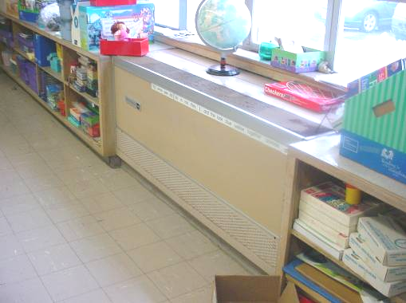

Classroom Univent

Picture 2

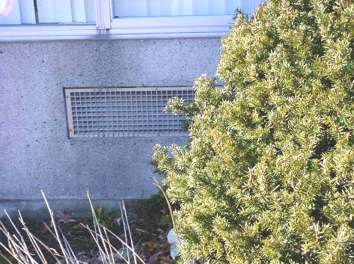

Fresh Air Intake, Note Bush Growing in Front of Intake
Picture 3

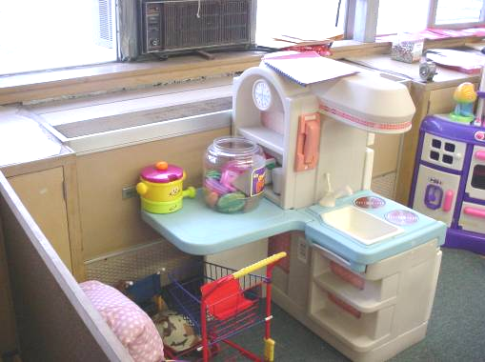

Items Obstructing Univent Return Vent (bottom front of unit)

Picture 4

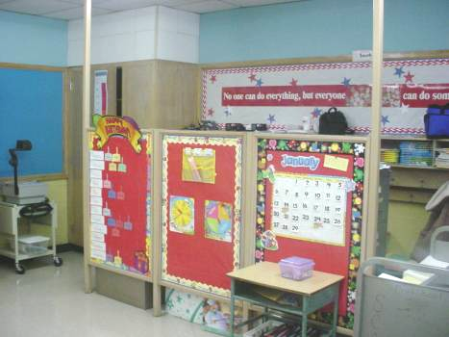

Three Panel Partition, Note Boxes on Floor Obstructing Airflow
Picture 5

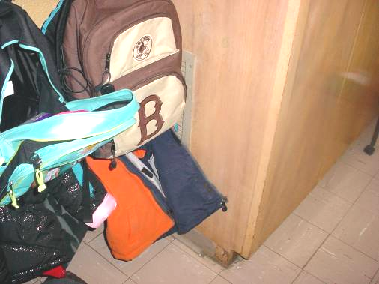

Exhaust Vent Obstructed by Coats and Bags

Picture 6

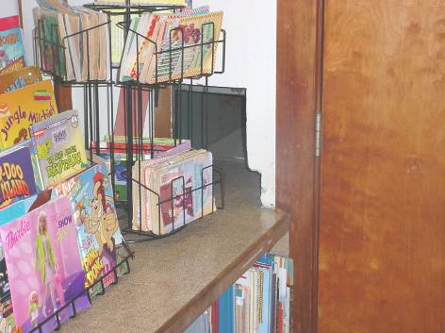

Air Supply Ducted into Library from Speech Room
Picture 7

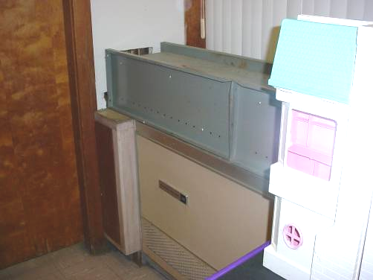

Ducted Univent Leading to Library (From Speech Room)

Picture 8

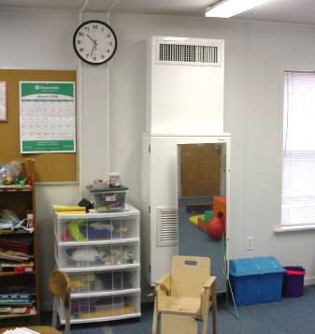

Wall-mounted Air Handling Unit, Note Mirror Blocking Vent
Picture 9

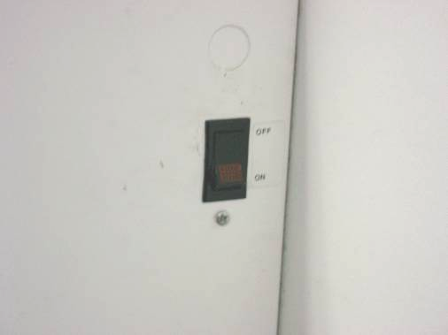

Air Handling Unit for Modular Classroom Switched to “Off”

Picture 10

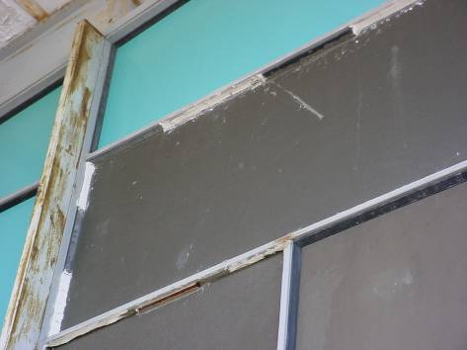

Loose/Damaged Caulking
Picture 11

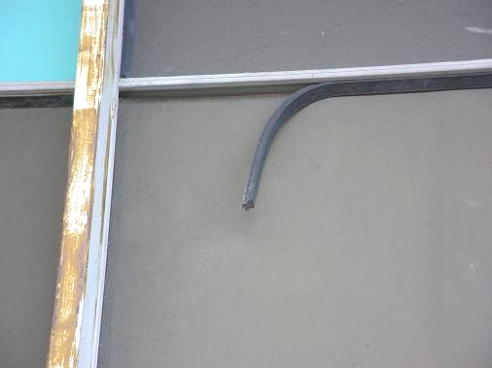

Loose/Damaged Strip Caulking

Picture 12

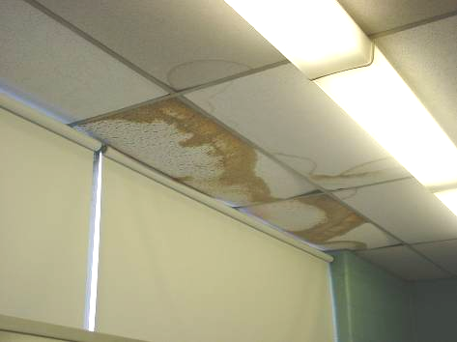

Water-damage to Ceiling Tiles along Windows
Picture 13

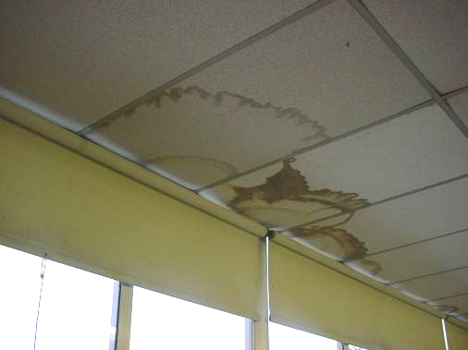

Water-damage to Ceiling Tiles along Window

Picture 14

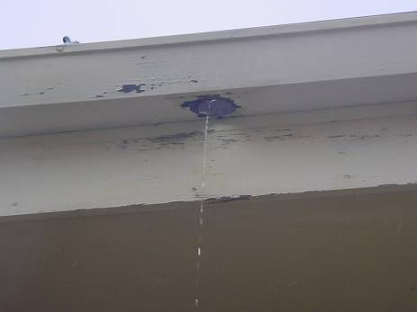

Water Emptying Against Building Hole in Gutter/Missing Downspout
Picture 15

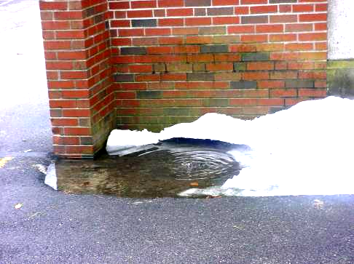

Water Pooling at Base of Building, Note Moss Growth
on Exterior Wall (as Indicated by Dark Staining)

Picture 16

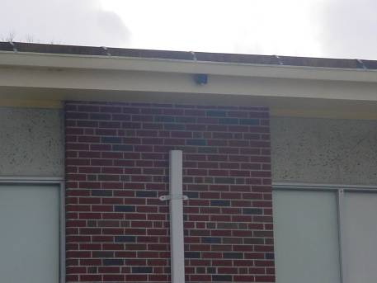

Missing/Damaged Downspout
Picture 17

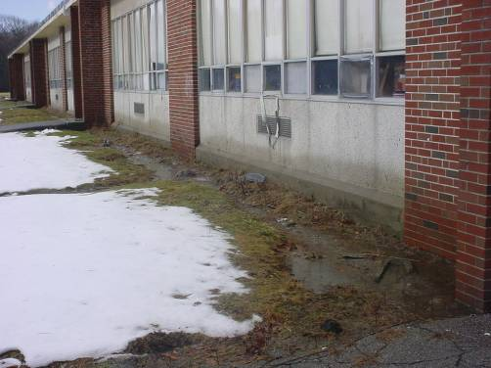

Water Pooling at the Base of Building against Exterior Wall Note Backsplash on Exterior Wall (as Indicated by Dark Staining)

Picture 18

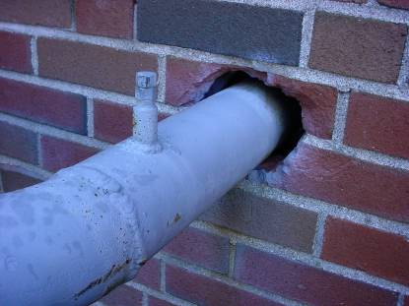

Open Utility Hole
Picture 19

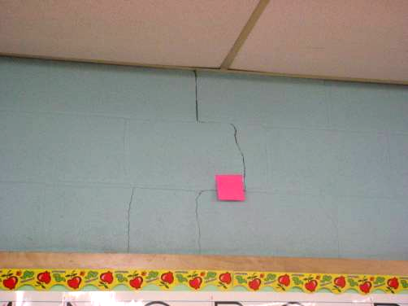

Interior Wall Crack

Picture 20

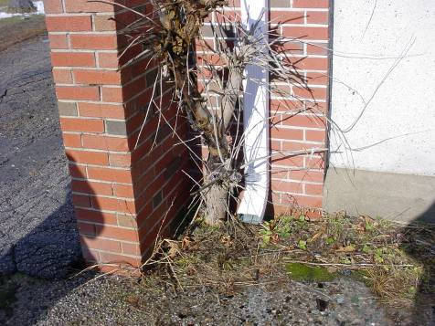

Tree Growing against Foundation/Exterior Walls
Picture 21

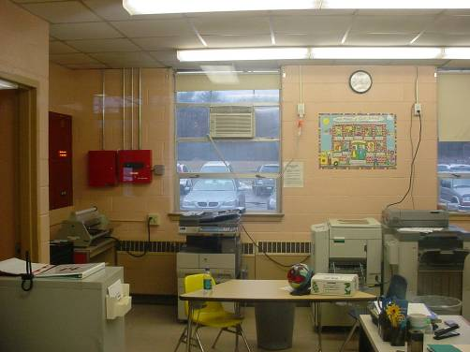

Photocopiers and Laminator in Main Office

Picture 22

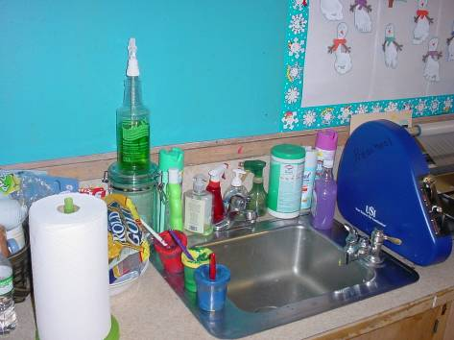

Cleaning Products on Classroom Countertop

Picture 23

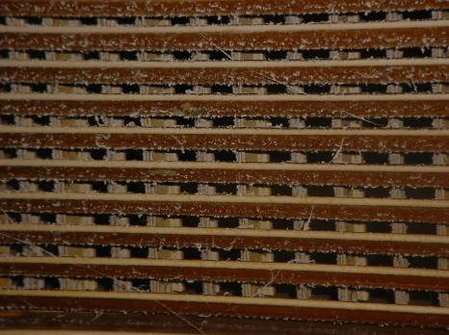

Dirty Exhaust Vent

Picture 24

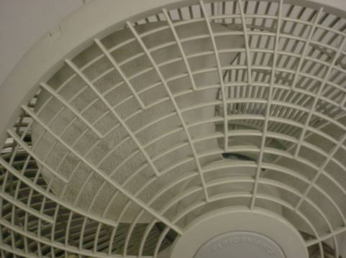

Personal Fan with Dust on Blades
Picture 25

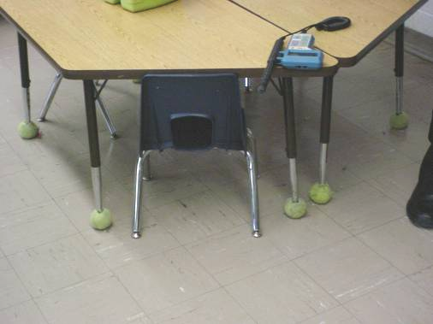

Tennis Balls on Table Legs

Picture 26

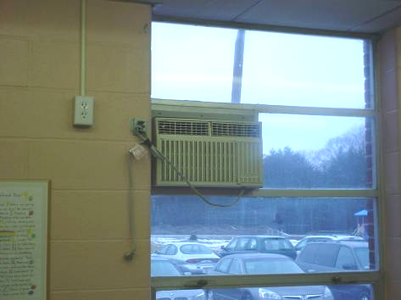

Air Conditioner in Window
Location/ Room | Occupants  in Room | Temp  (°F) | Relative  Humidity  (%) | Carbon  Dioxide  (ppm) | Carbon Monoxide  (ppm) | PM2.5  (µg/m³) | Windows  Openable | Ventilation |  | Remarks
 |  |  |  |  |  |  |  | Supply | Exhaust | Remarks
background |  | 46 | 90 | 341 | ND | 25 |  |  |  | Overcast; Rainy
Art/Music | 32 | 70 | 43 | 1809 | ND | 21 | Y | Y | Y | Ventilation off; DEM; DO
Bathroom for 23 and 25 |  |  |  |  |  |  | N | N | Y | Exhaust off; 4 CT-WD
Cafetorium | 130 | 72 | 39 | 812 | ND | 15 | Y | Y | Y | Exhaust off; Univents blocked by furniture/items; Partitioned storage area with furniture blocking return vent
Guidance Counselor | 6 | 71 | 36 | 1119 | ND |  | Y | N | N
Gym | 1 | 70 | 39 | 1494 | ND | 28 | Y | Y | Y | Exhaust off
Library | 0 | 71 | 33 | 659 | ND | 14 | Y | Y | Y | Exhaust off; Significant CT-WD along windows; Tree outside in front of air intake; Chronic heat issues-solar glare
Main Office | 2 | 71 | 36 | 979 | ND | 18 | Y | N | N | Exhaust off; AC; PCs; Laminator
Nurse | 3 | 73 | 33 | 1093 | ND | 14 | Y | N | N | Exhaust off; AC
OT/PT | 0 | 66 | 46 | 1203 | ND | 14 | Y | Y | Y | Ventilation off; Mirror blocking vent; Carpeting
Psychologist | 1 | 71 | 36 | 1219 | ND | 16 | N | Y | Y | Exhaust off; Passive supply; PF; Deactivate exhaust fan to clean
Speech | 2 | 72 | 37 | 642 | ND | 12 | Y | Y | Y | Exhaust – passive vents in door, undercut doors; 5 CT-WD along windows; 4 CT-WD in room; AC; PF; Computer server adds heat
Teacher’s Room | 8 | 74 | 35 | 969 | ND | 25 | Y | N | Y | Exhaust dusty; AC
ECC (1) | 8 | 71 | 43 | 2620 | ND | 15 | Y | Y | Y | Ventilation off; AC
ECC (1) | 7 | 71 | 44 | 754 | ND | 27 | Y | Y | Y | Ventilation activated
ECC (2) | 4 | 71 | 39 | 1576 | ND | 12 | Y | Y | Y | Ventilation off; Furniture in front of vent; AC
1 | 27 | 72 | 41 | 1660 | ND | 17 | Y | Y | Y | Exhaust off; Univent blocked by desk; CT-WD along windows; Cobwebs; PF
2 | 25 | 72 | 41 | 1840 | ND | 16 | Y | Y | Y | Exhaust off; CT-WD along windows; TB; Items
3 | 24 | 71 | 40 | 1225 | ND | 18 | Y | Y | Y | Exhaust off; TB; Items
4 | 28 | 71 | 42 | 1375 | ND | 20 | Y | Y | Y | Exhaust off; CT-WD along windows
5 | 17 | 72 | 39 | 934 | ND | 24 | Y | Y | Y | Exhaust off; 3 open windows
6 | 0 | 71 | 38 | 851 | ND | 17 | Y | Y | Y | Exhaust off; Univent blocked by desk; CT-WD; CD; DEM; PFs
7 | 3 | 72 | 36 | 550 | ND | 19 | Y | Y | Y | Exhaust off; CT-WD along windows; PF; TB
9 | 4 | 72 | 38 | 644 | ND | 20 | Y | Y | Y | Exhaust off; DEM; TB; PF
11 | 25 | 71 | 41 | 1417 | ND | 28 | Y | Y | Y | Exhaust off; CT-WD along windows; PF
12 | 21 | 72 | 41 | 1303 | ND | 22 | Y | Y | Y | Exhaust off; CT-WD along windows; PF; Spray cleaners
14 | 26 | 73 | 43 | 1601 | ND | 24 | Y | Y | Y | Exhaust off; CT-WD along windows; Items
15 | 0 | 72 | 35 | 875 | ND | 12 | Y | Y | Y | Exhaust off; CT-WD along windows; Wall cracks; DEM; PF; TB; Items
18 | 1 | 71 | 37 | 605 | ND | 13 | Y | Y | Y | Exhaust off; Significant CT-WD along windows; Tree outside in front of air intake; AC; DEM; Damaged caulking around windows
19 | 4 | 71 | 38 | 624 | ND | 24 | Y | Y | Y | Exhaust off; 2 CT-WD; AC; Spray cleaners on sink
20 | 21 | 71 | 39 | 1075 | ND | 15 | Y | Y | Y | Exhaust off; 8 CT-WD along windows; PF; Spray cleaners
20 | 21 | 70 | 41 | 884 | ND | 27 | Y | Y | Y | Exhaust activated
21 | 20 | 70 | 39 | 982 | ND | 13 | Y | Y | Y | Exhaust off; DO; PF
22 | 20 | 72 | 40 | 1104 | ND |  | Y | Y | Y | Exhaust off; 4 CT-WD along windows; DEM
23 | 21 | 70 | 39 | 918 | ND | 21 | Y | Y | Y | Exhaust off; PF
24 | 14 | 70 | 41 | 858 | ND | 19 | Y | Y | Y | Exhaust off; PF; Plants
25 | 17 | 71 | 39 | 1112 | ND | 17 | Y | Y | Y | Exhaust off, blocked by coat racks; Univent return blocked by furniture; DEM; PF; TB
26 | 8 | 68 | 46 | 859 | ND | 26 | Y | Y | Y | Exhaust vent off, completely blocked by file cabinets; Univent blocked by furniture and items; 2 AC; Aqua./terra.; Items; 2 CT-WD
Exterior/ Perimeter |  |  |  |  |  |  |  |  |  | Poor water drainage, water draining on to building  Drainage system disconnected  Loose strip caulking  Open utility hole  Tree growth close to building

