This job aid describes how to

- create a preadmission screening (PAS) request using the MassHealth Provider Online Service Center (POSC); and
- submit the request.

The PAS request authorizes elective/nonemergency acute or chronic hospital stays.

You must have the Provider ID (PID) and Service Location (SL) for both the attending and facility provider to create a PAS request. Click on the Provider tab and enter the national provider identifier (NPI) to obtain the PID and SL.

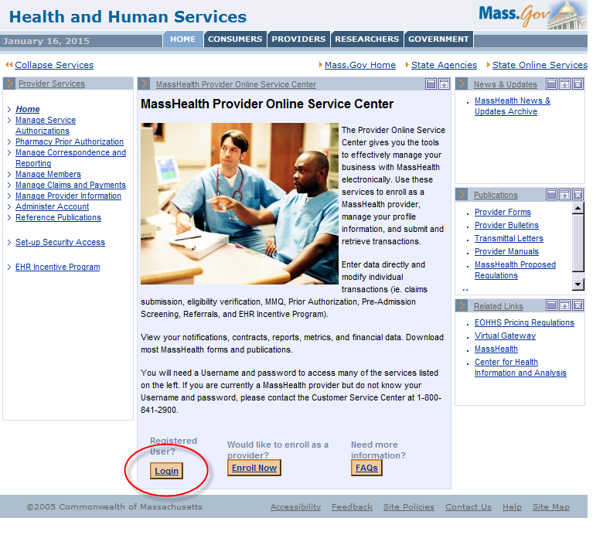
- Click the Login button on the POSC landing page.

- In the Provider Login section, enter your username and password and click Submit.

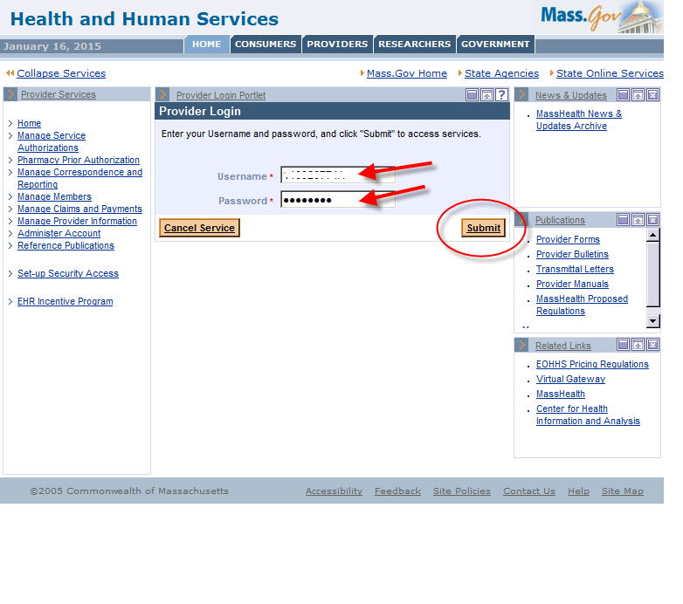

- Click on Manage Service Authorizations on the left section of the page.

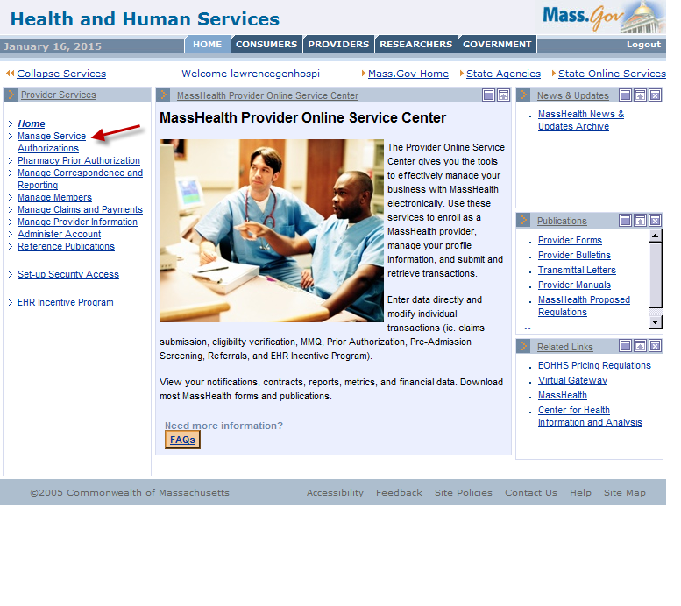

- Click on Enter PAS Request.

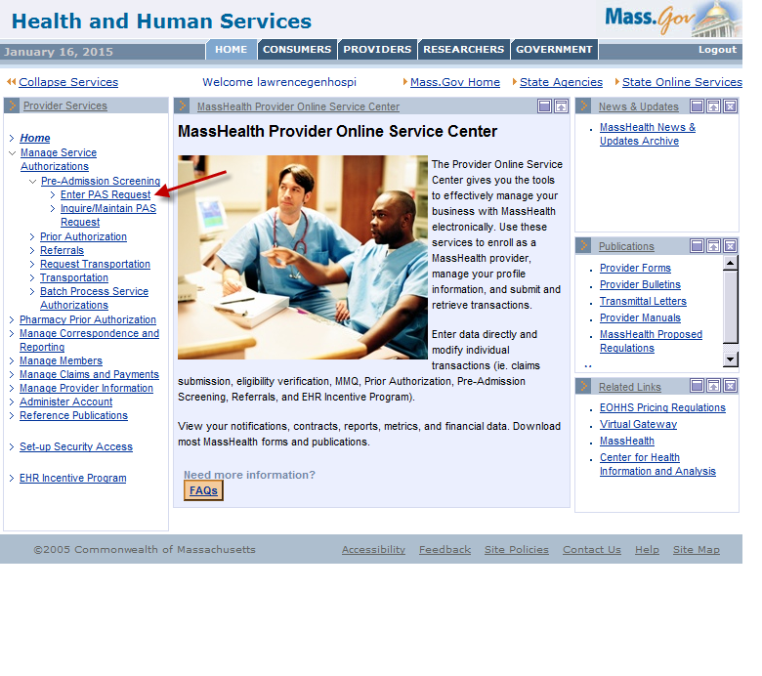
- Enter data on the Base Information page of the PAS Information tab.

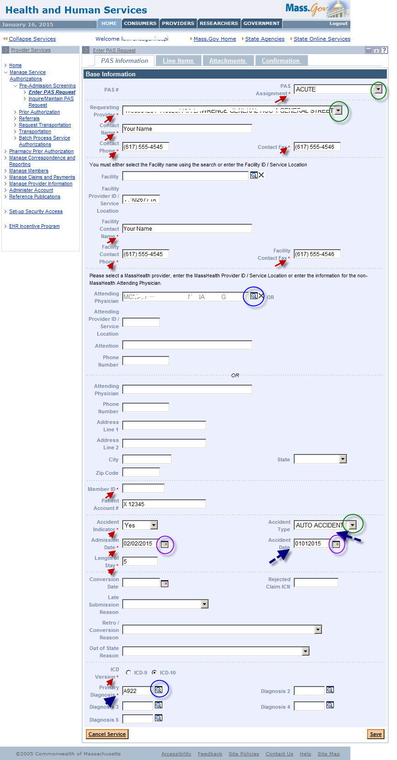

Required fields are flagged with an asterisk and data must be entered.

If the Accident Indicator is set to Yes, the Accident Type and Accident Date fields are required.

Include PID and SL when entering information in the Facility Provider ID and Attending Provider ID fields.

Some fields have dropdown lists to allow you to pick an option from a list of valid values.

Some fields have a pop-up search option that you can open by clicking on the magnifying glass. Selecting a value from the search result will populate this field for you.

Some fields have a calendar to assist you. Selecting a date from the calendar will populate the Panel field.

The required field called Primary Diagnosis must be an ICD code.

- After completing the data entry on the PAS Information panel, click on the Line Items tab to open up the Line Items page.

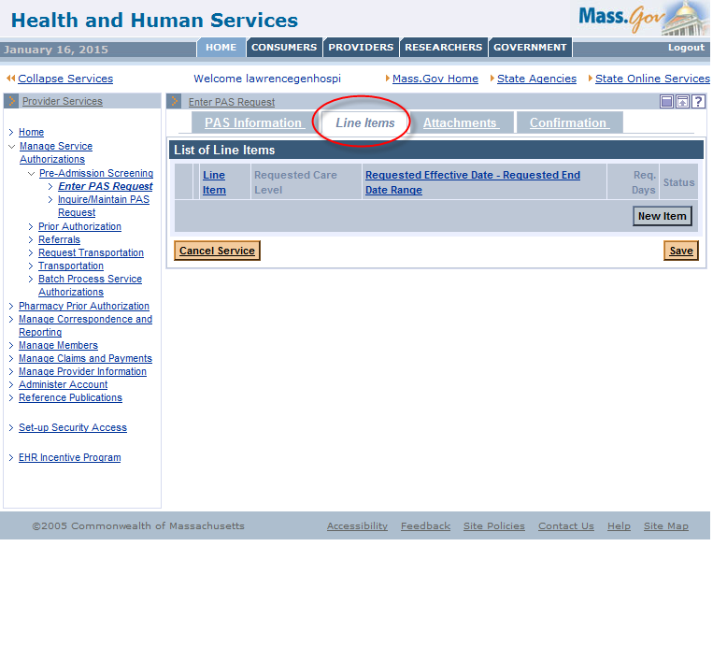
- Click on the New Item button on the List of Line Items panel to allow for entry of line item details.

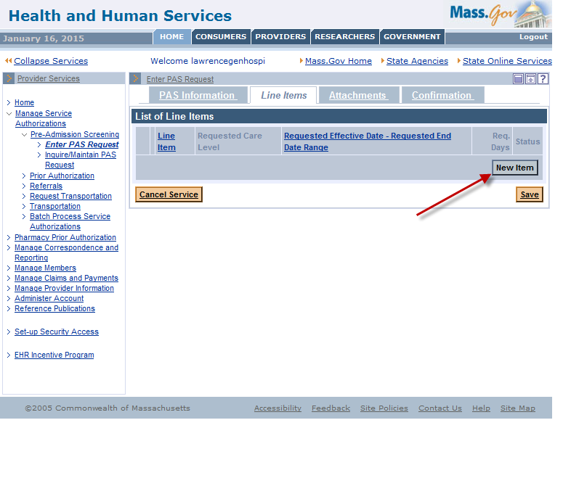

- Line Item A will open and allow for data entry of line item details.

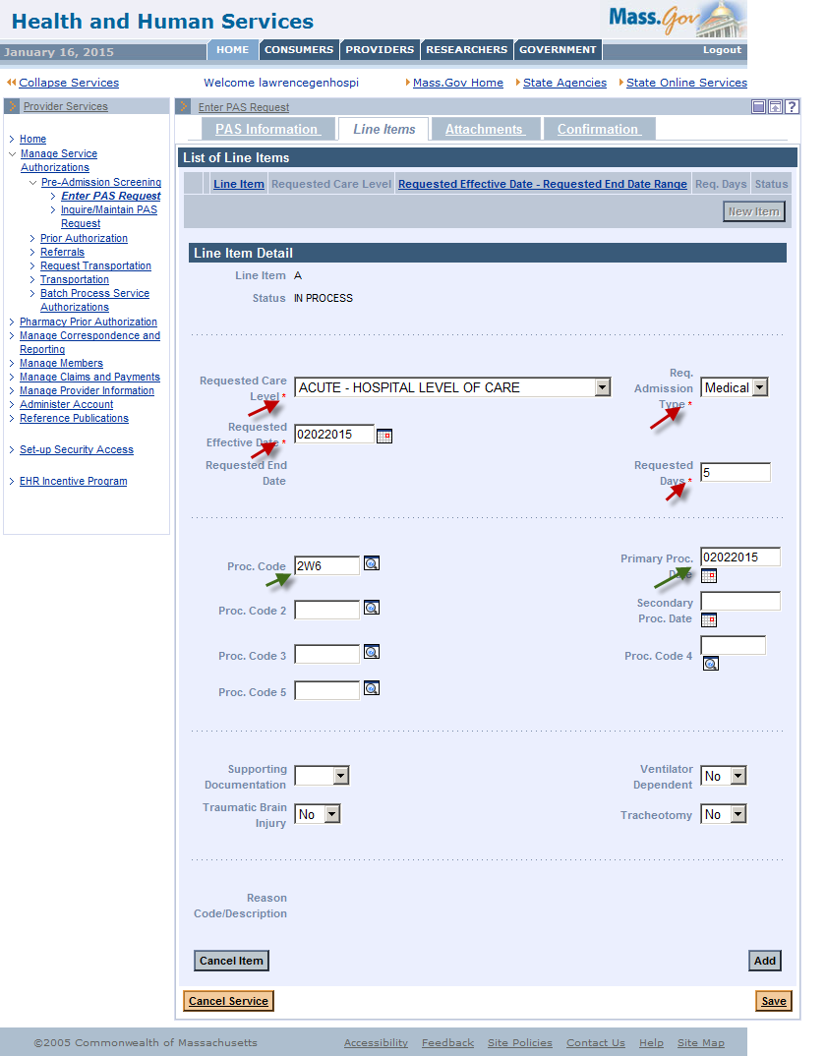

- After you have entered all necessary panel data, click on the Add button to add the line item data to the request.

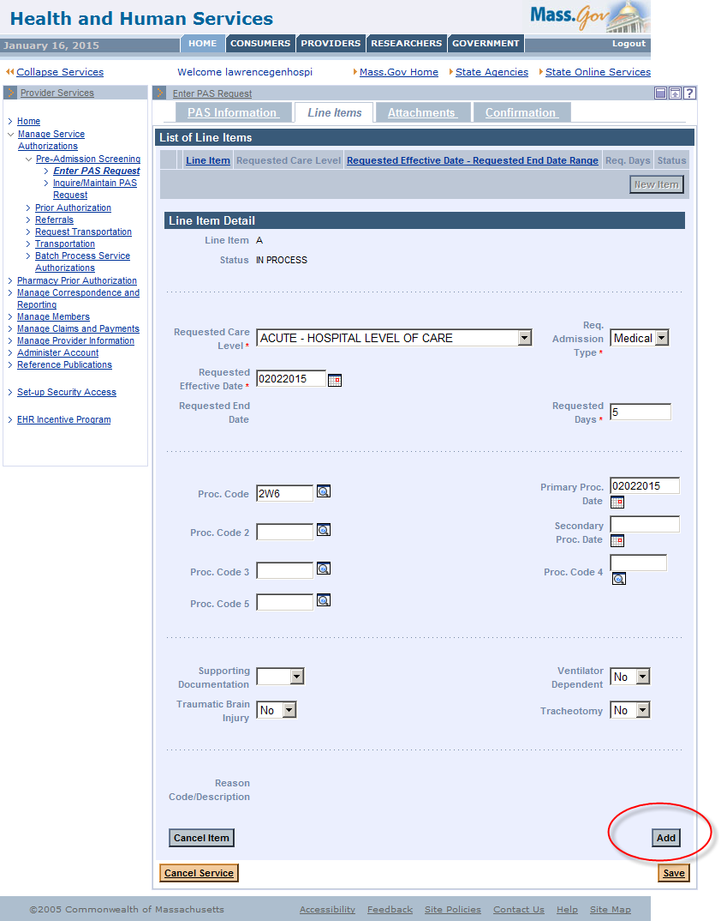
- Click on the Attachments tab to open the List of Attachments page.

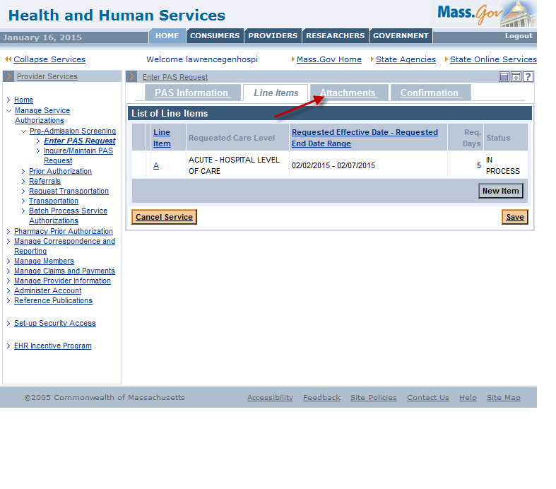

- Click on New Item to allow for an addition of an attachment to the PAS request.

Printed documentation may be scanned and then added or uploaded as an attachment. Another option is to make a copy of printed documentation on a current copier, e-mail the copied information to a secure e-mail, and attach the newly created electronic image as instructed above.

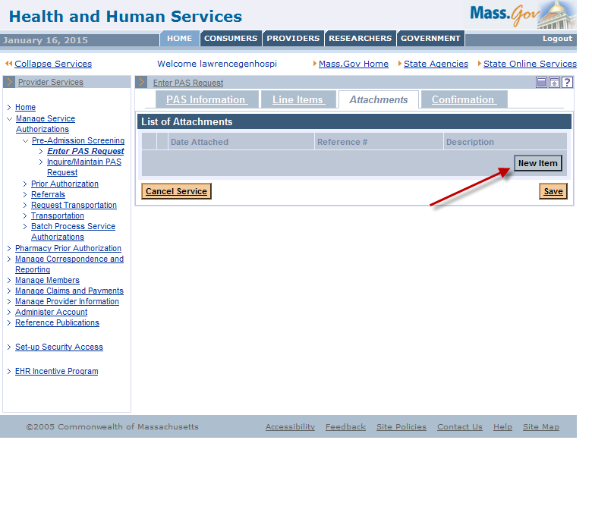

- On the Attachments Detail page, select the report type from the Report Type dropdown list.

- To open the dropdown list click on the arrow.

- Select Electronically Only from the Transmission Code dropdown list.

- In the Description box, enter a brief description of the document you are attaching.

- Click on the Browse button to open up a search for an electronic document on your computer.

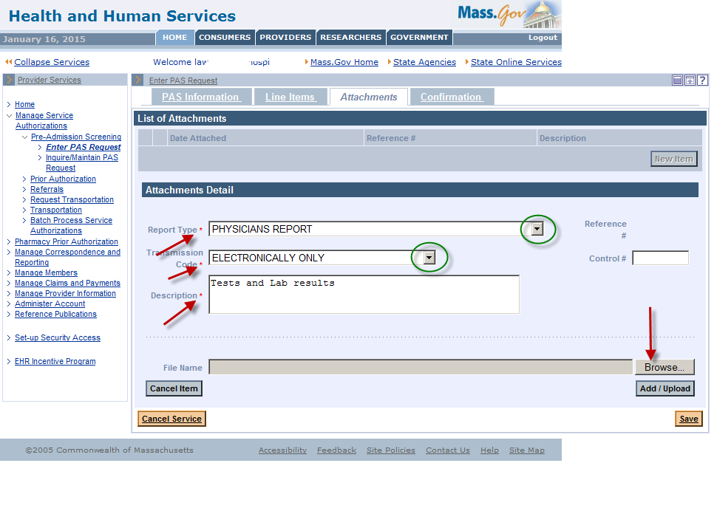

- Select a file on your computer and click Open. This will populate the file name on the panel.

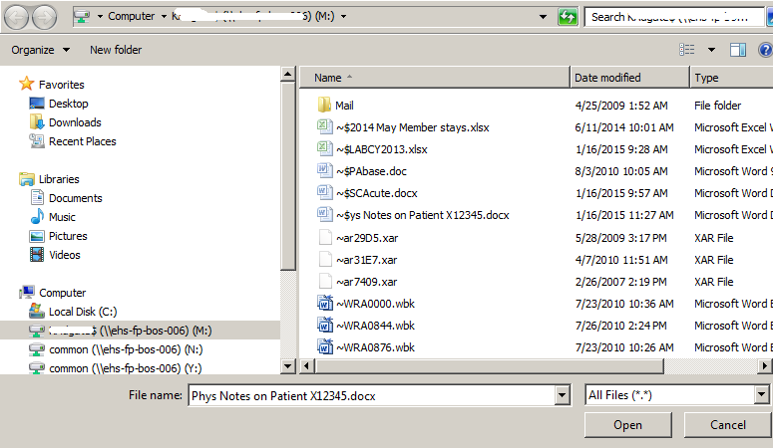

- Click Add/Upload to attach that file to the PAS request.

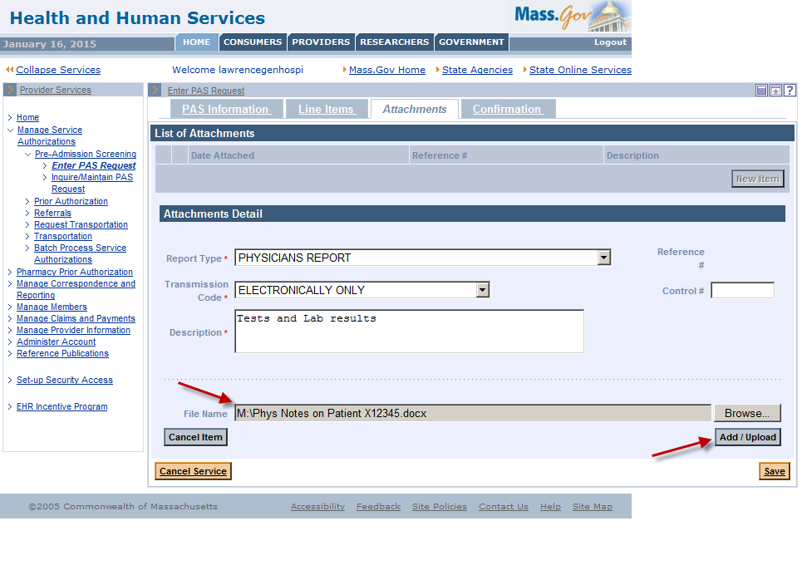

- Click on the Confirmation tab to open the Confirmation panel. This is where you will submit the new request for review.

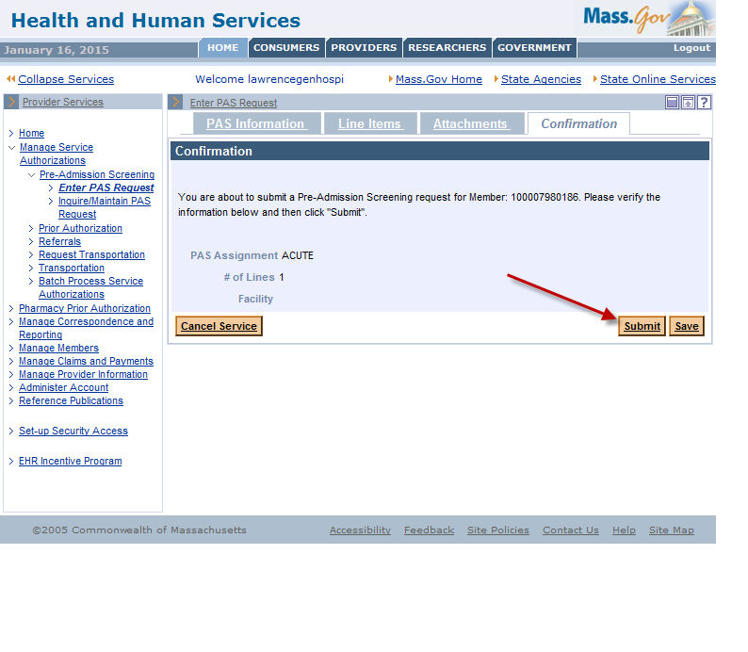
- Click Submit on the Confirmation panel to submit the request for review. If you click Save, the data you entered will be saved in the system for completion and submission at a later time. The status of the saved request will be “In Process.” After you submit the request, it will be “Ready for Review.” The PAS review team will not be able to see requests that are “In Process” until you have submitted them and they are “Ready for Review.”

- When you click Submit, the panel performs edits and validation on the data you entered. If you receive any errors from that validation, you must fix them before the request can be submitted.

- If you receive warnings, you must acknowledge them by adding a check to the checkbox.

- Open the tab where the field in error is found and correct the error or add missing required values.

- Click Submit again on the Confirmation tab to attempt to submit the request. After you have corrected the errors and acknowledged the warnings by checking the checkbox, you will see a new page called the Pre-Admission Screening Response page.

- The Pre-Admission Screening Response page will give you the PAS number and confirm successful submission of your PAS request.

