 

Employee: Enter Goals at Kickoff

The following steps guide an employee through the process of entering goals during Kickoff. Each expectation should have at least one associated goal to achieve that expectation. This step occurs *after* your manager has set expectations for you and conducted the Check-in meeting where you discuss how your goals align with your managers’ expectations. For detailed video instructions, please watch the 2-minute [video demonstration here.](https://youtu.be/ZROzp6T-MkI)

**Please note:** As the employee, it is not your responsibility to enter expectations. You are only entering the goals within each expectation your manager submitted.

**STEP 1.** Sign in to your **MyPath** account at [**mass.csod.com**.](https://mass.csod.com/client/mass/default.aspx) (Login is your employee ID)

**STEP 2.** On the homepage, locate the **My Performance Action Items** box on the right side of the screen   
 and click the **FYXX MassPerform Kickoff** **for [Your Name]** link.

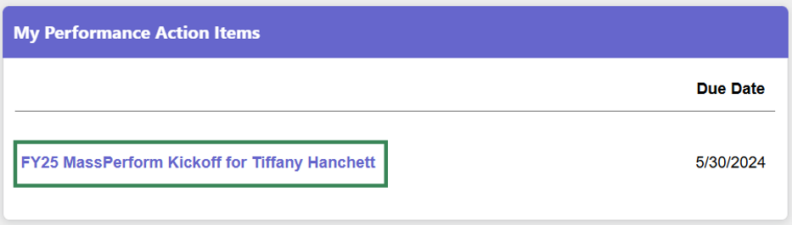

**STEP 3.** You’ll be brought to the **Overview** page. Review the on-screen instructions and then select the  
 **Next** buttonat the bottom of the screen to proceed to the **Expectations and Goals** page.

**Note:** You may also select the **Sections** button on the left-hand panel to navigate to the next section.

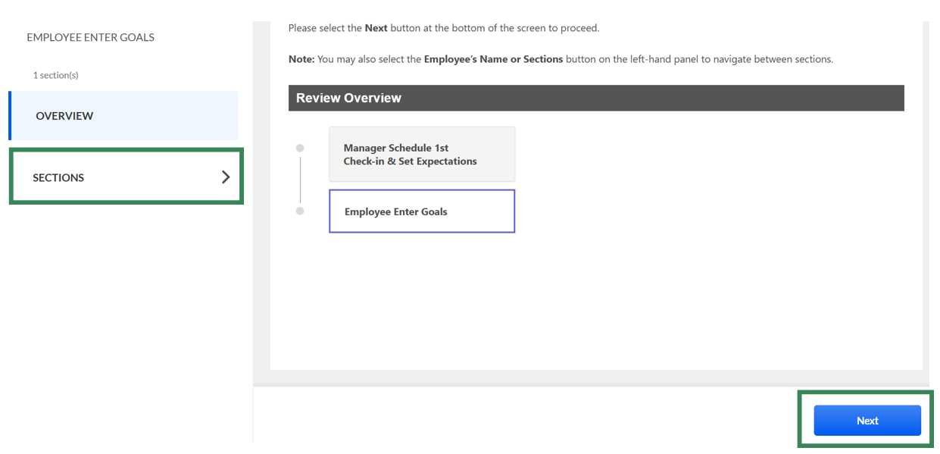

**Reminder:** Do not enter your goals yet if your manager has not conducted the Kickoff Check-in.  
 A check-in meeting is a time for your manager to discuss their expectations of you and you discuss   
 how your goals will meet their expectations.   
 **STEP 4.** On the **Expectations and Goals** page, review the on-screen instructions. Af*ter* you and your manager   
 have met and agreed on your goals,click the **More Options** menu button (down arrow) beside each   
 expectation and click the **Edit** button to enter your corresponding SMART goals.

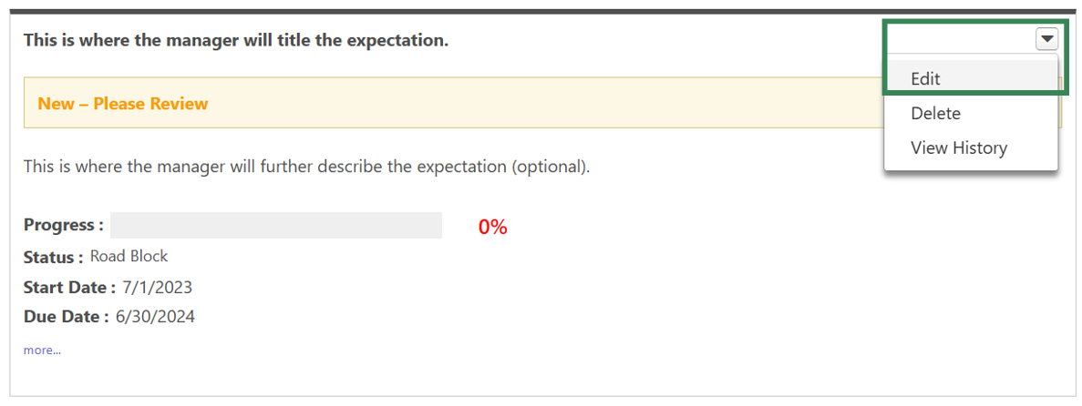

**STEP 5.** On the **Edit Expectation & Goals** screen, review the expectation details provided by your manager   
 and click the **Add Goals** button. **Do not enter your goal(s) within the manager’s expectation   
 Description field.**

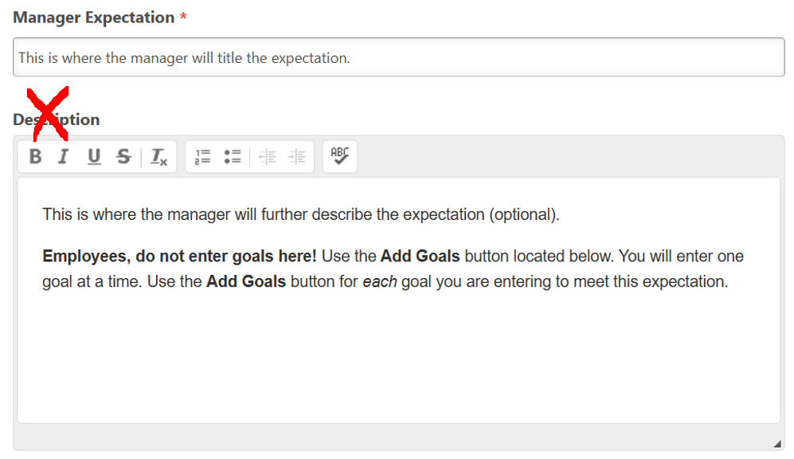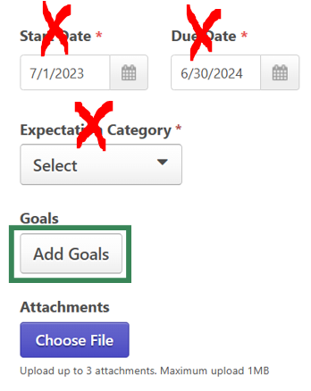

**STEP 6.** The **Add Goals** pop-up box will open. Complete the following:

1. In the **Description** field, describe the goal and how it meets this expectation set by your manager. *Do not**enter multiple goals in the description box. If you have multiple goals for one expectation, enter one at a time by repeating these steps.*
2. Enter a **Start Date** and **Due Date** for each goal. This automatically pre-populates the entire fiscal year.
3. Click the **Type** drop-down menu button and select a measurement type. For example, if your goal is to increase production by 20%, then the **Type** is **% (percent)**.
4. Enter the **Start Value** (where you are starting today) and **Target** (where you want to be by the expectation’s due date). For example, using the goal “increase production by 20%,” the **Start Value** would be 0% and the **Target** would be 20%.
5. Click the **Done** button.

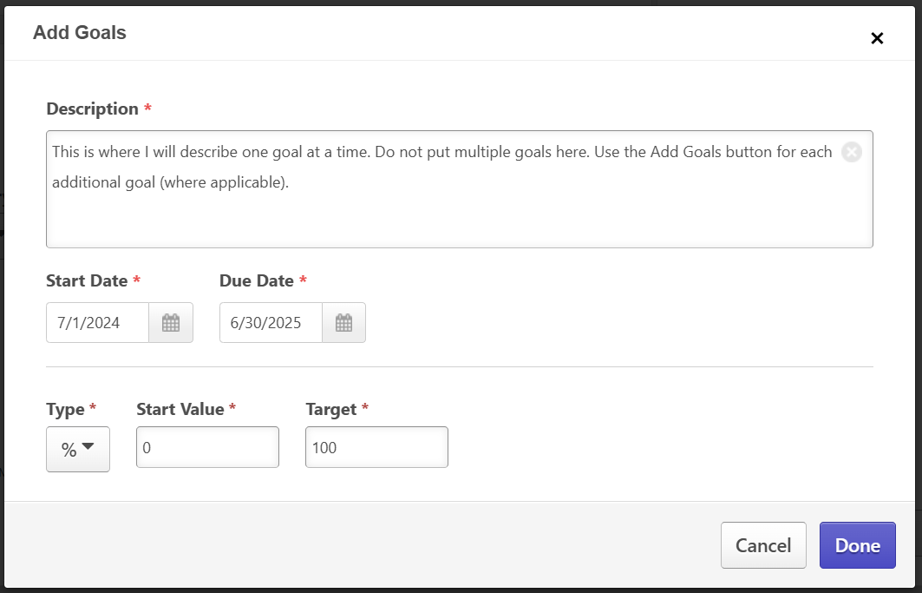

**STEP 7.** After entering a goal, you will be redirected back to the **Edit Expectation & Goals** screen. If you have   
 additional goals for this expectation, repeat steps 5 – 6. When finished, click the **Save** button on the   
 bottom of the screen to save your goals for that expectation.

**STEP 8.** You will be redirected to the **Expectations and Goals** screen. Click the **More…** button below the **Due   
 Date** within each expectation to view the goal(s) you entered and to confirm that the goal(s) you entered for   
 that expectation are properly showing.

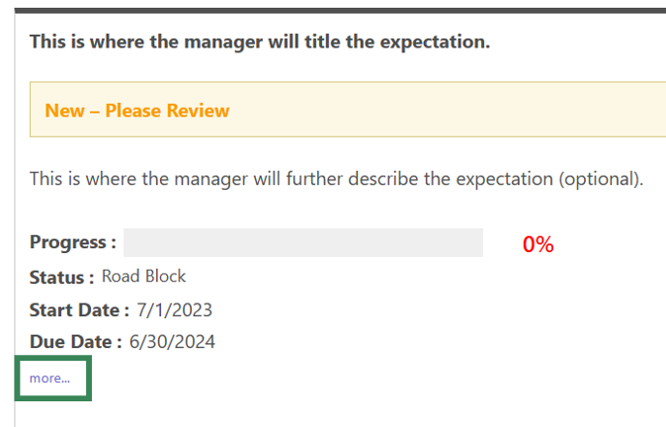

**STEP 9.** Continue adding goals for each expectation set by your manager by repeating steps 4 – 7.   
 Ensure every expectation has at least one corresponding goal.

**STEP 10.** When all your goals have been created for**each** expectation, click the **Submit** button at the bottom.

**STEP 11.** The **Submit Review** pop-up box will open. Click the **Submit Review** button *again* to complete Kickoff.

**Tip:** You will know you’ve successfully submitted your Kickoff action item when the **FYXX   
 MassPerform Kickoff** **for [Your Name]** link disappears from your **My Performance Action Items** boxon the homepage.