INDOOR AIR QUALITY ASSESSMENT

John A. Crisafulli Elementary School
13 Robinson Road
Westford, Massachusetts

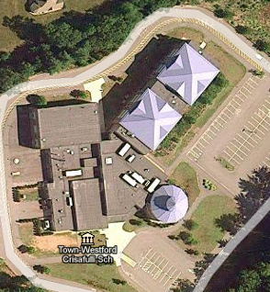

Prepared by:
Massachusetts Department of Public Health
Bureau of Environmental Health
Indoor Air Quality Program
October 2010

Background/Introduction
At the request of Everett V. Olsen Jr., Superintendant, Westford Public Schools, the Massachusetts Department of Public Health (MDPH), Bureau of Environmental Health (BEH) conducted an indoor air quality (IAQ) assessment at the John A. Crisafulli Elementary School (CES) located at 13 Robinson Road, Westford, Massachusetts. On May 28, 2010, Cory Holmes, Environmental Analyst/Regional Inspector within BEH’s IAQ Program, conducted an assessment of the building. The assessment was coordinated through the Westford Health Department.
The CES is a red brick building that was completed in 2002. The school contains general classrooms, science classrooms, a kitchen/cafeteria, music/band rooms, art room, library, gymnasium and office space. The library and portions of the classroom wing have peaked metal roofs; the remainder of the building has flat rubber membrane roofs. Windows are openable throughout the building.

Methods
Air tests for carbon monoxide, carbon dioxide, temperature and relative humidity were conducted with the TSI, Q-Trak, IAQ Monitor, Model 7565. Air tests for airborne particle matter with a diameter less than 2.5 micrometers were taken with the TSI, DUSTTRAK™ Aerosol Monitor Model 8520. BEH staff also performed visual inspection of building materials for water damage and/or microbial growth.

Results
The school houses approximately 433 students grades three through five with a staff of approximately 60. Tests were taken during normal operations and results appear in Table 1.

Discussion

Ventilation
It can be seen from Table 1 that carbon dioxide levels were above 800 parts per million (ppm) in four of forty-five areas surveyed indicating adequate air exchange throughout most of the building (Table 1). An elevated dioxide level of 1,027 was measured in the gymnasium, however the mechanical ventilation system had reportedly been deactivated at the request of staff, therefore no means to introduce outside air was available at the time of the assessment.
Mechanical ventilation for occupied areas is provided by air-handling units (AHUs) located in penthouse mechanical rooms (Pictures 1 and 2), or ceiling-mounted units in the case of the gymnasium. AHUs draw air in through fresh air intakes located on the exterior of the building (Picture 1). Air is filtered and heated by the AHU before it is distributed to occupied areas via ceiling-mounted air diffusers (Picture 3). Exhaust air is drawn into ceiling-mounted return vents and ducted back to the AHUs (Picture 4). Noise from the exhaust vent was heard in classroom 203, which may indicate a mechanical issue.
To maximize air exchange, the MDPH recommends that both supply and exhaust ventilation operate continuously during periods of occupancy. In order to have proper ventilation with a mechanical supply and exhaust system, the systems must be balanced to provide an adequate amount of fresh air to the interior of a room while removing stale air from the room. It is recommended that HVAC systems be re-balanced every five years to ensure adequate air systems function (SMACNA, 1994). The system was reportedly last balanced in 2002.
The Massachusetts Building Code requires that each room have a minimum ventilation rate of 15 cubic feet per minute (cfm) per occupant of fresh outside air or openable windows (SBBRS, 1997; BOCA, 1993). The ventilation must be on at all times that the room is occupied. Providing adequate fresh air ventilation with open windows and maintaining the temperature in the comfort range during the cold weather season is impractical. Mechanical ventilation is usually required to provide adequate fresh air ventilation.
Carbon dioxide is not a problem in and of itself. It is used as an indicator of the adequacy of the fresh air ventilation. As carbon dioxide levels rise, it indicates that the ventilating system is malfunctioning or the design occupancy of the room is being exceeded. When this happens, a buildup of common indoor air pollutants can occur, leading to discomfort or health complaints. The Occupational Safety and Health Administration (OSHA) standard for carbon dioxide is 5,000 parts per million parts of air (ppm). Workers may be exposed to this level for 40 hours/week, based on a time-weighted average (OSHA, 1997).
The MDPH uses a guideline of 800 ppm for publicly occupied buildings. A guideline of 600 ppm or less is preferred in schools due to the fact that the majority of occupants are young and considered to be a more sensitive population in the evaluation of environmental health status. Inadequate ventilation and/or elevated temperatures are major causes of complaints such as respiratory, eye, nose and throat irritation, lethargy and headaches. For more information concerning carbon dioxide, consult Appendix A.
Indoor temperature measurements ranged from 73º F to 82º F, which were above the MDPH recommended comfort range in several areas on the day of the assessment (Table 1), most likely due to solar gain. The MDPH recommends that indoor air temperatures be maintained in a range of 70º F to 78º F in order to provide for the comfort of building occupants. In many cases concerning indoor air quality, fluctuations of temperature in occupied spaces are typically experienced, even in a building with an adequate fresh air supply.
The relative humidity measured in the building ranged from 31 to 47 percent, which was below the MDPH recommended comfort range in the majority of areas surveyed (Table 1). The MDPH recommends a comfort range of 40 to 60 percent for indoor air relative humidity. Relative humidity levels in the building would be expected to drop during the winter months due to heating. The sensation of dryness and irritation is common in a low relative humidity environment. Low relative humidity is a very common problem during the heating season in the northeast part of the United States.

Microbial/Moisture Concerns
Several classrooms had water-damaged ceiling tiles which can indicate sources of water penetration from either the building envelope or plumbing system (Picture 5/Table 1). Water-damaged ceiling tiles can provide a source of moisture/microbial growth and should be replaced after a water leak is discovered and repaired. The building reportedly has issues with ice dams that result in ice accumulation on the roof to melt back into the building (Picture 6). In addition, open seams between metal roofing materials is also reported to be a source of water penetration damaging ceiling tiles (Pictures 7 and 8).
The US Environmental Protection Agency (US EPA) and the American Conference of Governmental Industrial Hygienists (ACGIH) recommend that porous materials be dried with fans and heating within 24 to 48 hours of becoming wet (US EPA, 2001; ACGIH, 1989). If not dried within this time frame, mold growth may occur. Once mold has colonized porous materials, they are difficult to clean and should be removed and discarded.
Plants were noted in several classrooms. Plants can be a source of pollen and mold which can be respiratory irritants to some individuals. Plants should be properly maintained and equipped with drip pans. They should also be located away from univents to prevent the aerosolization of dirt, pollen and mold.
Open seams between sink countertops and backsplashes were observed in some rooms (Picture 9/Table 1). If not watertight, moisture can penetrate through seams, causing damage. Improper drainage or sink overflow can lead to water penetration into countertops, cabinet interiors and areas behind cabinets. Water penetration and chronic exposure of porous and wood-based materials can cause these materials to swell and show signs of water damage. Repeated moistening of porous materials can result in mold growth.

Other IAQ Evaluations
Indoor air quality can be negatively influenced by the presence of respiratory irritants, such as products of combustion. The process of combustion produces a number of pollutants. Common combustion emissions include carbon monoxide, carbon dioxide, water vapor and smoke (fine airborne particle material). Of these materials, exposure to carbon monoxide and particulate matter with a diameter of 2.5 micrometers (μm) or less (PM2.5) can produce immediate, acute health effects upon exposure. To determine whether combustion products were present in the indoor environment, BEH staff obtained measurements for carbon monoxide and PM2.5.

Carbon Monoxide
Carbon monoxide is a by-product of incomplete combustion of organic matter (e.g., gasoline, wood and tobacco). Exposure to carbon monoxide can produce immediate and acute health effects. Several air quality standards have been established to address carbon monoxide and prevent symptoms from exposure to these substances. The MDPH established a corrective action level concerning carbon monoxide in ice skating rinks that use fossil-fueled ice resurfacing equipment. If an operator of an indoor ice rink measures a carbon monoxide level over 30 ppm, taken 20 minutes after resurfacing within a rink, that operator must take actions to reduce carbon monoxide levels (MDPH, 1997).
The American Society of Heating Refrigeration and Air-Conditioning Engineers (ASHRAE) has adopted the National Ambient Air Quality Standards (NAAQS) as one set of criteria for assessing indoor air quality and monitoring of fresh air introduced by HVAC systems (ASHRAE, 1989). The NAAQS are standards established by the US EPA to protect the public health from six criteria pollutants, including carbon monoxide and particulate matter (US EPA, 2006). As recommended by ASHRAE, pollutant levels of fresh air introduced to a building should not exceed the NAAQS levels (ASHRAE, 1989). The NAAQS were adopted by reference in the Building Officials & Code Administrators (BOCA) National Mechanical Code of 1993 (BOCA, 1993), which is now an HVAC standard included in the Massachusetts State Building Code (SBBRS, 1997). According to the NAAQS, carbon monoxide levels in outdoor air should not exceed 9 ppm in an eight-hour average (US EPA, 2006).
Carbon monoxide should not be present in a typical, indoor environment. If it is present, indoor carbon monoxide levels should be less than or equal to outdoor levels. On the day of the assessment, outdoor carbon monoxide concentrations were non-detect (ND) (Table 1). No measurable levels of carbon monoxide were detected inside the building (Table 1).

Particulate Matter
The US EPA has established NAAQS limits for exposure to particulate matter. Particulate matter is airborne solids that can be irritating to the eyes, nose and throat. The NAAQS originally established exposure limits to particulate matter with a diameter of 10 μm or less (PM10). According to the NAAQS, PM10 levels should not exceed 150 micrograms per cubic meter (μg/m³) in a 24-hour average (US EPA, 2006). These standards were adopted by both ASHRAE and BOCA. Since the issuance of the ASHRAE standard and BOCA Code, US EPA established a more protective standard for fine airborne particles. This more stringent PM2.5 standard requires outdoor air particle levels be maintained below 35 μg/m³ over a 24-hour average (US EPA, 2006). Although both the ASHRAE standard and BOCA Code adopted the PM10 standard for evaluating air quality, MDPH uses the more protective PM2.5 standard for evaluating airborne particulate matter concentrations in the indoor environment.
Outdoor PM2.5 concentrations were measured at 10 μg/m³ (Table 1). PM2.5 levels measured indoors ranged from 7 to 17 μg/m³ (Table 1), which were below the NAAQS PM2.5 level of 35 μg/m³. Frequently, indoor air levels of particulates (including PM2.5) can be at higher levels than those measured outdoors. A number of mechanical devices and/or activities that occur indoors can generate particulate during normal operations. Sources of indoor airborne particulates may include but are not limited to particles generated during the operation of fan belts in the HVAC system, use of stoves and/or microwave ovens in kitchen areas; use of photocopiers, fax machines and computer printing devices; operation of an ordinary vacuum cleaner and heavy foot traffic indoors.

Volatile Organic Compounds
Indoor air quality can also be negatively influenced by the presence of materials containing volatile organic compounds (VOCs). VOCs are carbon-containing substances that have the ability to evaporate at room temperature. Frequently, exposure to low levels of total VOCs (TVOCs) may produce eye, nose, throat and/or respiratory irritation in some sensitive individuals. For example, chemicals evaporating from a paint can stored at room temperature would most likely contain VOCs. In an effort to identify materials that can potentially increase indoor VOC concentrations, BEH staff examined classrooms and common areas for products containing these respiratory irritants.
The majority of classrooms contained dry erase boards and related materials. Materials such as dry erase markers and dry erase board cleaners may contain VOCs, such as methyl isobutyl ketone, n-butyl acetate and butyl-cellusolve (Sanford, 1999), which can be irritating to the eyes, nose and throat. Cleaning products were also observed in a number of classrooms (Table 1). Like dry erase materials, cleaning products contain VOCs and other chemicals. These chemicals can be irritating to the eyes, nose and throat and should be kept out of reach of students. A Material Safety Data Sheet (MSDS) should be available at a central location for each product in the event of an emergency as required by Massachusetts General Laws. Consideration should be given to providing teaching staff with school issued cleaning products and supplies to ensure that MSDS information is available for all products used at the school.
Tennis balls were observed sliced open and placed on the base of the legs likely in an effort to reduce noise from sliding desks/chairs (Table 1). Tennis balls are made of a number of materials that can serve as respiratory irritants. Constant wearing of tennis balls can produce fibers and cause VOCs to off-gas. Tennis balls are made with a natural rubber latex bladder, which becomes abraded when used as a chair leg pad. Use of tennis balls in this manner may introduce latex dust into the school environment. Some individuals are highly allergic to latex (e.g., spina bifida patients) (SBAA, 2001). It is recommended that the use of materials containing latex be limited in buildings to reduce the likelihood of symptoms in sensitive individuals (NIOSH, 1997).

Other Conditions
Other conditions that can affect indoor air quality were observed during the assessment. In several classrooms, items were observed on the floor, windowsills, tabletops, counters, bookcases and desks. The large number of items stored in classrooms provides a source for dusts to accumulate. These items (e.g., papers, folders, boxes) make it difficult for custodial staff to clean. Items should be relocated and/or be cleaned periodically to avoid excessive dust build up. In addition, these materials can accumulate on flat surfaces (e.g., desktops, shelving and carpets) in occupied areas and subsequently be re-aerosolized causing further irritation.
A number of air diffusers, exhaust/return vents and personal fans were observed to have accumulated dust. If exhaust vents are not functioning, backdrafting can occur, which can re-aerosolize accumulated dust particles. Re-activated univents and fans can also aerosolize dust accumulated on vents/fan blades.
BEH staff inspected the rooftop AHUs and penthouses. The AHUs draw in fresh outside air through a bank of pleated filters. Although filters are reportedly changed twice per year, filters in one of the penthouse units were found dated “8-26-09” and saturated with accumulated dust/debris (Picture 10). Also noted was a build-up of dirt, dust/debris inside the unit and on the floor of the penthouse (Pictures 11 and 12). Filters for air-handling equipment (e.g., AHUs) should be changed as per the manufacturers’ instructions or more frequently if needed. In addition, the interior of units should be cleaned/vacuumed on a regular basis (e.g., during filter changes) to prevent the accumulation/aerosolization of dirt, dust and particulate matter.
Finally, upholstered furniture, large pillows and cushions were seen on the floor in several classrooms (Table 1). Upholstered furniture, pillows and cushions are covered with fabric that comes in contact with human skin. This type of contact can leave oils, perspiration, hair and skin cells on such items. Dust mites feed upon human skin cells and excrete waste products that contain allergens. In addition, if relative humidity levels increase above 60 percent, dust mites tend to proliferate (US EPA, 1992). In order to remove dust mites and other pollutants, frequent vacuuming of upholstered furniture is recommended (Berry, M.A., 1994). It is also recommended that upholstered furniture (if present in schools), be professionally cleaned on an annual basis. If outdoor conditions or indoor activities (e.g., renovations) create an excessively dusty environment, cleaning frequency should be increased (every six months) (IICRC, 2000).

Conclusions/Recommendations
In view of the findings at the time of the visit, the following recommendations are provided:
- Operate all ventilation systems throughout the building (e.g., gym, cafeteria, classrooms) continuously during periods of occupancy to maximize air exchange.
- Examine exhaust vent for classroom 203, make repairs as needed.
- Ensure filters for air-handling equipment (e.g., AHUs) are changed as per the manufacturers’ instructions or more frequently if needed. The interior of units should be cleaned/vacuumed on a regular basis (e.g., during filter changes) prior to activation to prevent the aerosolization of dirt, dust and particulate matter.
- Clean/inspect the penthouse area on a regular basis to prevent the accumulation of dust, dirt/debris.
- Close classroom doors to facilitate air exchange.
- Examine if fresh air supply can be increased in areas that measured over 800 ppm carbon dioxide (i.e., classrooms 105, 106 and the music area).
- Use openable windows in conjunction with mechanical ventilation to facilitate air exchange. Care should be taken to ensure windows are properly closed at night and weekends to avoid the freezing of pipes and potential flooding.
- Consider adopting a balancing schedule of every 5 years for all mechanical ventilation systems, as recommended by ventilation industrial standards (SMACNA, 1994).
- For buildings in New England, periods of low relative humidity during the winter are often unavoidable. Therefore, scrupulous cleaning practices should be adopted to minimize common indoor contaminants whose irritant effects can be enhanced when the relative humidity is low. To control dusts, a high efficiency particulate arrestance (HEPA) filter equipped vacuum cleaner in conjunction with wet wiping of all surfaces is recommended. Avoid the use of feather dusters. Drinking water during the day can help ease some symptoms associated with a dry environment (throat and sinus irritations).
- Work with building occupants in indentifying classrooms that have excessive heat issues. In order to reduce temperatures and heat in problematic classrooms several actions should be taken and/or considered:
  - Ensure classroom ventilation is operating continuously during occupied hours to draw in cool outside air (by lowering thermostat).
  - Ensure exhaust ventilation is operating to remove excess heat.
  - Consider mounting portable fans to facilitate air circulation.
  - Consider applying solar (tinted) film to windows as needed to reduce solar gain/excess heat.
- Repair any existing water leaks and replace any remaining water-damaged ceiling tiles. Examine the area above these tiles for mold growth. Disinfect areas of water leaks with an appropriate antimicrobial, as needed.
- Work with building engineer and/or roofing contractor to examine best ways to prevent ice dams from occurring.
- Ensure plants are equipped with drip pans. Examine drip pans periodically for mold growth and disinfect with an appropriate antimicrobial, as needed. Move plants away from fresh air supply sources.
- Seal areas around sinks to prevent water damage to the interior of cabinets and adjacent wallboard.
- Store cleaning products properly and out of reach of students. All cleaning products used at the facility should be approved by the school department with MSDS’ available at a central location.
- Routinely clean particulate residue from dry erase boards and trays.
- Consider replacing tennis balls with latex-free tennis balls or glides.
- Relocate or consider reducing the amount of materials stored in classrooms to allow for more thorough cleaning of classrooms. Clean items regularly with a wet cloth or sponge to prevent excessive dust build-up.
- Clean accumulated dust and debris periodically from the surface of air diffusers, exhaust vents and blades of personal and ceiling fans.
- Clean upholstered furniture, floor cushions and pillows on a regular basis. If not possible/practical, consider removing from classrooms.
- Consider adopting the US EPA (2000) document, “Tools for Schools”, as an instrument for maintaining a good indoor air quality environment in the building. This document is available at: http://www.epa.gov/iaq/schools/index.html.
- Refer to resource manual and other related indoor air quality documents located on the MDPH’s website for further building-wide evaluations and advice on maintaining public buildings. These documents are available at: http://mass.gov/dph/iaq.

References
ACGIH. 1989. Guidelines for the Assessment of Bioaerosols in the Indoor Environment. American Conference of Governmental Industrial Hygienists, Cincinnati, OH.
ASHRAE. 1989. Ventilation for Acceptable Indoor Air Quality. American Society of Heating, Refrigeration and Air Conditioning Engineers. ANSI/ASHRAE 62-1989.
Berry, M.A. 1994. Protecting the Built Environment: Cleaning for Health, Michael A. Berry, Chapel Hill, NC.
BOCA. 1993. The BOCA National Mechanical Code/1993. 8th ed. Building Officials and Code Administrators International, Inc., Country Club Hill, IL.
IICRC. 2000. IICRC S001 Reference Guideline for Professional On-Location Cleaning of Textile Floor Covering Materials Institute of Inspection, Cleaning and Restoration Certification. Institute of Inspection Cleaning and Restoration, Vancouver, WA.
MDPH. 1997. Requirements to Maintain Air Quality in Indoor Skating Rinks (State Sanitary Code, Chapter XI). 105 CMR 675.000. Massachusetts Department of Public Health, Boston, MA.
NIOSH. 1997. NIOSH Alert: Preventing Allergic Reactions to Natural Rubber Latex in the Workplace. National Institute for Occupational Safety and Health, Atlanta, GA.
OSHA. 1997. Limits for Air Contaminants. Occupational Safety and Health Administration. Code of Federal Regulations. 29 C.F.R 1910.1000 Table Z-1-A.
Sanford. 1999. Material Safety Data Sheet (MSDS No: 198-17). Expo® Dry Erase Markers Bullet, Chisel, and Ultra Fine Tip. Sanford Corporation. Bellwood, IL.
SBAA. 2001. Latex In the Home And Community Updated Spring 2001. Spina Bifida Association of America, Washington, DC.
SBBRS. 1997. Mechanical Ventilation. State Board of Building Regulations and Standards. Code of Massachusetts Regulations. 780 CMR 1209.0
SMACNA. 1994. HVAC Systems Commissioning Manual. 1st ed. Sheet Metal and Air Conditioning Contractors’ National Association, Inc., Chantilly, VA.
US EPA. 1992. Indoor Biological Pollutants. US Environmental Protection Agency, Environmental Criteria and Assessment Office, Office of Health and Environmental Assessment, research Triangle Park, NC. EPA 600/8-91/202 January 1992.
US EPA. 2000. Tools for Schools. Office of Air and Radiation, Office of Radiation and Indoor Air, Indoor Environments Division (6609J). EPA 402-K-95-001, Second Edition. http://www.epa.gov/iaq/schools/tools4s2.html.
US EPA. 2001. “Mold Remediation in Schools and Commercial Buildings”. Office of Air and Radiation, Indoor Environments Division, Washington, DC. EPA 402-K-01-001. March 2001. Available at: http://www.epa.gov/iaq/molds/mold_remediation.html.
US EPA. 2006. National Ambient Air Quality Standards (NAAQS). US Environmental Protection Agency, Office of Air Quality Planning and Standards, Washington, DC. http://www.epa.gov/air/criteria.html.
Picture 1

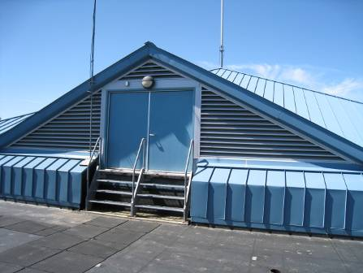

Penthouse for Mechanical Ventilation Components, Note Louvered Intake Vents

Picture 2

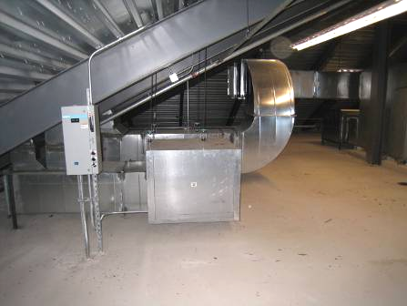

Air Handling Unit (AHU) in Penthouse

Picture 3

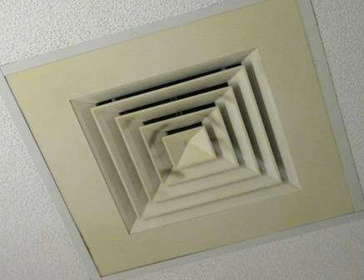

Ceiling-Mounted Supply Diffuser

Picture 4

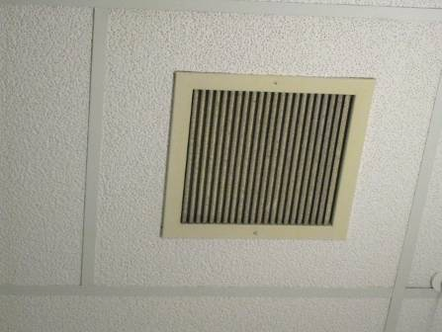

Ceiling-Mounted Return Vent

Picture 5

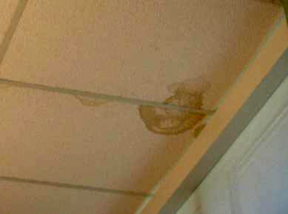

Water Damaged Ceiling Tiles in Third Floor Classroom

Picture 6

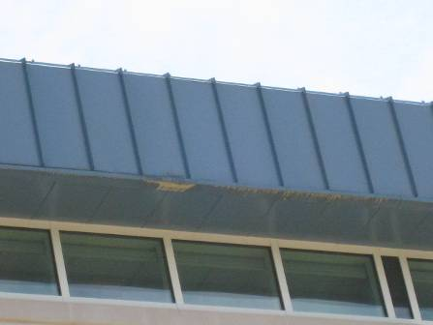

Overhang Roof Where Ice Dams Reportedly Occur

Picture 7

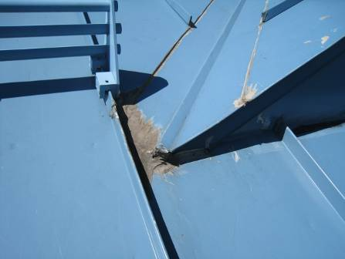

Sealant Applied between Seams of Metal Roofing Material

Picture 8

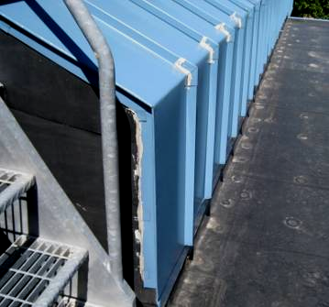

Sealant Applied between Seams of Metal Roofing Material

Picture 9

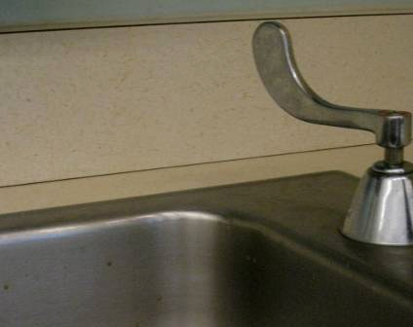

Open Seam between Sink Countertop and Backsplash

Picture 10

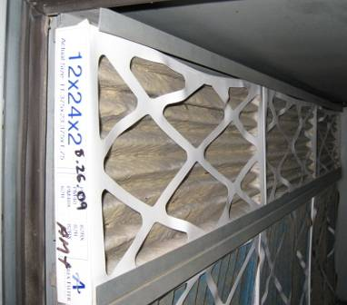

Bank of Pleated Air Filters in Penthouse AHU Accumulated with Dust/Debris, Note Date Written on Side of Filter “8-26-09”

Picture 11

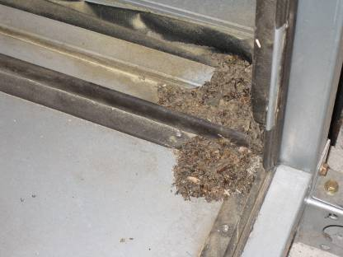

Dirt/Dust/Debris Buildup inside Penthouse AHU

Picture 12

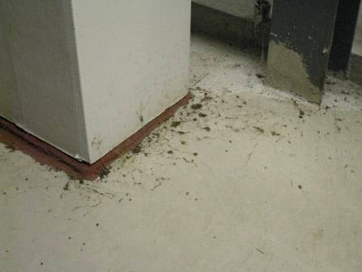

Dirt/Dust/Debris Buildup inside Penthouse
Location/ Room | Occupants  in Room | Temp  (°F) | Relative  Humidity  (%) | Carbon  Dioxide  (ppm) | Carbon Monoxide  (ppm) | PM2.5  (µg/m³) | Windows  Openable | Ventilation |  | Remarks
 |  |  |  |  |  |  |  | Supply | Exhaust | Remarks
background |  | 70 | 40 | 360 | ND | 10 |  |  |  | Sunny, scattered clouds
R1 | 4 | 77 | 36 | 508 | ND | 9 | Y | Y | Y | Window open
R2 | 0 | 77 | 31 | 408 | ND | 7 | Y | Y | Y
R3 | 2 | 81 | 34 | 419 | ND | 11 | Y | Y | Y | Window open, 3 WD CTs
Library | 0 | 76 | 37 | 371 | ND | 8 | N | Y | Y
School Psychologist Office | 2 | 77 | 39 | 497 | ND | 9 | N | Y | Y | 1 WD CT, UF
TP1 | 0 | 77 | 35 | 443 | ND | 8 | Y | Y | Y
TP2 | 3 | 78 | 31 | 408 | ND | 8 | Y | Y | Y | Window open, DO
TP3 | 0 | 81 | 34 | 481 | ND | 10 | Y | Y | Y | 7 WD CTs, PC
Cafeteria | ~100 | 76 | 36 | 524 | ND | 9 | Y | Y | Y
Teacher’s Lunchroom | 0 | 76 | 38 | 419 | ND | 9 | Y | Y | Y
Gym | 21 | 76 | 47 | 1027 | ND | 13 | N | Y | Y | Mech ventilation-off at request of gym staff
101 | 0 | 77 | 35 | 428 | ND | 9 | Y | Y | Y | DO, window open, CP, PF, spaces around sink-caulking
102 | 2 | 76 | 37 | 421 | ND | 9 | Y | Y | Y
103 | 21 | 77 | 37 | 511 | ND | 9 | Y | Y | Y | Window open, PF, spaces around sink-caulking
104 | 22 | 76 | 37 | 459 | ND | 8 | Y | Y | Y | DO, CP, dust/debris accumulation on vents, spaces around sink-caulking
105 | 22 | 78 | 40 | 854 | ND | 10 | Y | Y | Y | Spaces around sink-caulking
106 | 18 | 77 | 41 | 830 | ND | 10 | Y | Y | Y | DO
107 | 18 | 79 | 40 | 706 | ND | 12 | Y | Y | Y | PF, plants, dust/debris accumulation on vents, spaces around sink-caulking
108 | 0 | 77 | 36 | 452 | ND | 10 | Y | Y | Y | Occupants at computer room, PF, DO
113 Band | 0 | 76 | 37 | 531 | ND | 8 | Y | Y | Y | DO, Return vent missing cover
114 Nurse | 2 | 73 | 38 | 441 | ND | 7 | N | Y | Y
115 Music | 0 | 76 | 37 | 496 | ND | 8 | Y | Y | Y | Plants, spaces around sink-caulking
117 Art | 22 | 74 | 39 | 625 | ND | 11 | Y | Y | Y | Kiln-vented, DO, TB, spaces around sink-caulking
119 Music | 0 | 74 | 45 | 1075 | ND | 13 | Y | Y | Y | AC unit
201 | 20 | 79 | 36 | 745 | ND | 9 | Y | Y | Y | TB, CP, spaces around sink-caulking
202 | 15 | 78 | 34 | 648 | ND | 9 | Y | Y | Y | Window open, DO, TB, spaces around sink-caulking
203 | 14 | 77 | 32 | 433 | ND | 8 | Y | Y | Y | DO, window open, spaces around sink-caulking, dust/debris accumulation on vents, TB, PF, noise from exhaust vent
204 | 20 | 77 | 35 | 601 | ND | 8 | Y | Y | Y | Window open, PF, spaces around sink-caulking
205 | 20 | 78 | 35 | 607 | ND | 9 | Y | Y | Y | Spaces around sink-caulking, DO
206 | 19 | 77 | 34 | 498 | ND | 8 | Y | Y | Y | Window open, spaces around sink-caulking, dust/debris accumulation on vents
207 | 7 | 77 | 34 | 428 | ND | 7 | Y | Y | Y | Spaces around sink-caulking, window open
208 | 0 | 76 | 32 | 364 | ND | 8 | Y | Y | Y | DO
211 Copy Room | 0 | 76 | 33 | 487 | ND | 8 | Y | Y | Y | 3 WD CTs, 3 PCs, 1 lamination machine, DO
212 Computer Room | 23 | 75 | 35 | 476 | ND | 9 | N | Y | Y
213 | 1 | 76 | 33 | 488 | ND | 9 | Y | Y | Y | 3 WD CT, DO
214 Computer Room | 18 | 75 | 39 | 445 | ND | 8 | Y | Y | Y | Spaces around sink-caulking
215 | 0 | 77 | 38 | 499 | ND | 14 | Y | Y | Y | Spaces around sink-caulking
217 Library Office | 0 | 74 | 37 | 367 | ND | 8 | Y | Y | Y | DO
301 | 23 | 81 | 37 | 681 | ND | 17 | Y | Y | Y | Dust/debris accumulation on vents, pillows/cushions, spaces around sink-caulking
302 | 2 | 79 | 36 | 401 | ND | 9 | Y | Y | Y | Spaces around sink-caulking, 4 WD CTs
303 | 22 | 82 | 34 | 419 | ND | 11 | Y | Y | Y | Window open, PF-on, pillows/cushions
304 | 22 | 79 | 38 | 539 | ND | 10 | Y | Y | Y | Dust/debris accumulation on vents, PF, accumulated items, 2 WD CTs
305 | 0 | 81 | 35 | 477 | ND | 10 | Y | Y | Y | Window open, pillows/cushions, PF, TB
306 | 1 | 81 | 37 | 674 | ND | 13 | Y | Y | Y | Dust/debris accumulation on vents, 1 WD CT, 21 occupants gone ~ 13 mins
307 | 24 | 81 | 36 | 701 | ND | 11 | Y | Y | Y | Window open, TB, 3 WD CTs, PF, dust/debris accumulation on vents, spaces around sink-caulking

