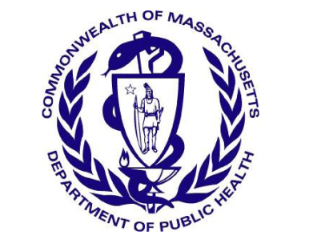
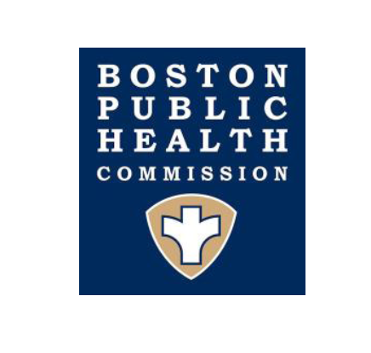
Massachusetts Department of Public Health
Boston Public Health Commission

TO: Boston Healthcare Providers
FROM: Catherine M. Brown, DVM, MSc, MPH, State Epidemiologist, MDPH
Jenifer Leaf Jaeger, MD, MPH, Director, Infectious Disease Bureau, BPHC
DATE: January 25, 2019
RE: Increase in newly diagnosed HIV infections among persons who inject drugs in Boston

The Massachusetts Department of Public Health (MDPH) and the Boston Public Health Commission (BPHC) are responding to 6 newly diagnosed HIV infections since November 1, 2018 in people who inject drugs (PWID) in the City of Boston, thus raising the risk for more cases. Outbreaks among persons who inject drugs have been identified in both urban and rural areas in the United States and more recently in the Cities of Lowell and Lawrence.
MDPH is asking clinical care providers to increase vigilance for HIV infection in patients reporting current or recent injection drug use (IDU).
Recommendations:
- Remain alert to the potential for HIV infection in PWID:
    - Elicit behavioral risk history including IDU, transactional sex, methamphetamine use, unstable housing/homelessness.
    - Encourage HIV and HCV testing for at-risk individuals, and follow current national recommendations for routine screening (see https://www.cdc.gov/mmwr/preview/mmwrhtml/rr5514a1.htm and https://www.cdc.gov/hepatitis/hcv/guidelinesc.htm) even among persons recently tested.
- Link all HIV+ persons to care for full evaluation, follow-up, and prompt initiation of antiretroviral therapy as soon as possible. Focused efforts should be made to optimize treatment adherence and retain patients in care. Early treatment of acute HIV infection is essential to rapidly reduce viral load to reduce forward transmission and improve patient outcomes.
- Be prepared to refer patients who use injectable substances to harm reduction services in your community (e.g., syringe service programs, see below).
- Report all new cases of HIV infection to the MDPH promptly, with as much risk history, clinical, and demographic data as you can obtain. To report a new case of HIV infection to MDPH, call the HIV Surveillance Program at 617-983-6560.
- Field epidemiologists from MDPH are being deployed to assist in HIV partner notification and linkage to support services and insurance. To request field epidemiologist services for HIV partner notification and linkage to support services and insurance, call the Division of STD Prevention and HIV/AIDS Surveillance at 617-983-6940.

For current listing of substance use disorder treatment programs:
http://www.mass.gov/eohhs/gov/departments/dph/programs/substance-abuse/providers/substance-abuse-services.html
For a current listing of syringe service programs:
http://www.mass.gov/eohhs/gov/departments/dph/programs/id/hiv-aids/

