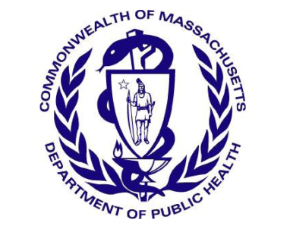
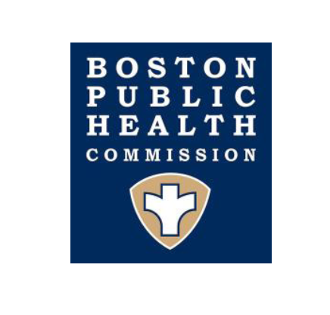
Massachusetts Department of Public Health
Boston Public Health Commission

TO: Boston Area Healthcare Providers
FROM: Larry Madoff, MD, Medical Director, Bureau of Infectious Disease and Laboratory Sciences, MDPH
Catherine M. Brown, DVM, MSc, MPH, State Epidemiologist, MDPH
Jennifer José Lo, MD, Medical Director, BPHC
DATE: January 8, 2020
RE: Increase in newly diagnosed HIV infections among persons who inject drugs in Boston

The Massachusetts Department of Public Health (MDPH) and the Boston Public Health Commission (BPHC) have investigated a cluster of 7 newly diagnosed HIV infections in the City of Boston in people who inject drugs (PWID) who are experiencing or have experienced recent homelessness. These recently detected HIV infections follow a cluster first detected in the City in early 2019, renewing concerns about ongoing transmission in PWID in Massachusetts.
Between 2000 and 2014, the number of reported HIV infections in Massachusetts declined by 47% overall and by 91% among PWID. However, starting in 2015 this trend reversed presumably as a result of the opioid epidemic and the widespread introduction of fentanyl into the illicit drug supply. Between 2016 and 2018, a large outbreak of HIV infection occurred in Lawrence and Lowell; the majority of these cases were among PWID who were also experiencing homelessness. Active drug use, homelessness, and for some, periods of incarceration create significant challenges to screening for HIV infection and continuous treatment of HIV infection. It is important that diagnosis of infection is made early and treatment initiated early, both for the health of the individual and to prevent onward transmission of HIV infection.
MDPH and BPHC ask healthcare providers to enhance vigilance for HIV risk, increase testing for HIV infection (both routine and risk-based), and to rapidly report any new HIV infections to MDPH, particularly in PWID and/or individuals experiencing homelessness. Prompt identification of HIV infection and linkage to treatment improves clinical outcomes and is critical to reducing HIV transmission and containing outbreaks. Report any diagnoses of HIV infection in a person who injects drugs immediately to MDPH, by calling the HIV/STD Reporting and Partner Services Line at 617-983-6999.
Recommendations:
- Remain alert to the potential for HIV infection in PWID:
    - Elicit behavioral risk history including IDU, transactional sex, methamphetamine use, unstable housing/homelessness.
    - Encourage HIV, HCV, and syphilis testing for at-risk individuals, especially those seeking care in emergency departments, and follow current national recommendations for screening even among persons recently tested (see https://www.cdc.gov/mmwr/preview/mmwrhtml/rr5514a1.htm and https://www.cdc.gov/hepatitis/hcv/guidelinesc.htm).
- Link all HIV+ persons to care for full evaluation, follow-up, and prompt initiation of antiretroviral therapy as soon as possible. Focused efforts should be made to optimize treatment adherence and retain patients in care. Early treatment of acute HIV infection is essential to rapidly reduce viral load to reduce forward transmission and improve patient outcomes.
- Be prepared to refer patients who use injectable substances to syringe service programs (see below), providers that offer PrEP and PEP, and other harm reduction services in your community ).
- Field epidemiologists from MDPH are routinely deployed to assist in HIV cluster investigations, provide anonymous and confidential partner notification for newly diagnosed individuals, and make referrals to support services. To speak with a Field Epidemiologist or Field Operations Manager, call the Division of STD and HIV/AIDS Surveillance reporting and Partner Services Line at 617-983-6999.

For current listing of substance use disorder treatment programs:
http://www.mass.gov/eohhs/gov/departments/dph/programs/substance-abuse/providers/substance-abuse-services.html
For a current listing of syringe service programs:
https://www.mass.gov/syringe-service-programs

For substance use disorder treatment programs and services in the City of Boston:
https://www.boston.gov/departments/recovery-services

