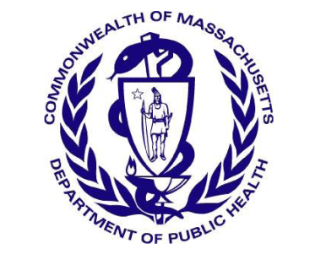
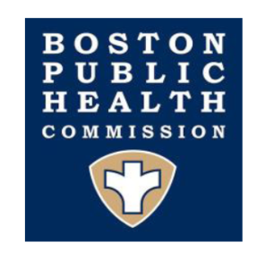
Massachusetts Department of Public Health
Boston Public Health Commission

TO: Boston Area Healthcare Providers
FROM: Larry Madoff, MD, Medical Director, Bureau of Infectious Disease and Laboratory Sciences, DPH
Catherine M. Brown, DVM, MSc, MPH, State Epidemiologist, DPH
Jennifer José Lo, MD, Medical Director, BPHC
Sarimer Sánchez, MD, Director, Infectious Disease Bureau, BPHC
DATE: March 15, 2021
RE: Increase in newly diagnosed HIV infections among persons who inject drugs in Boston

The Department of Public Health (DPH) and the Boston Public Health Commission (BPHC) are investigating an ongoing cluster of HIV infections in the City of Boston in persons who inject drugs (PWID) who are experiencing or have experienced recent homelessness, with 13 newly identified cases between January 1, 2021 and February 28, 2021. These recently identified HIV infections appear to be part of a cluster first detected in the city in early 2019, renewing concerns about ongoing transmission. A total of 113 cases have been investigated and identified as part of the cluster. Many cases have evidence of recent infection as determined by previous negative HIV tests. Emerging trends among those newly diagnosed also include an increase in polysubstance and methamphetamine use.
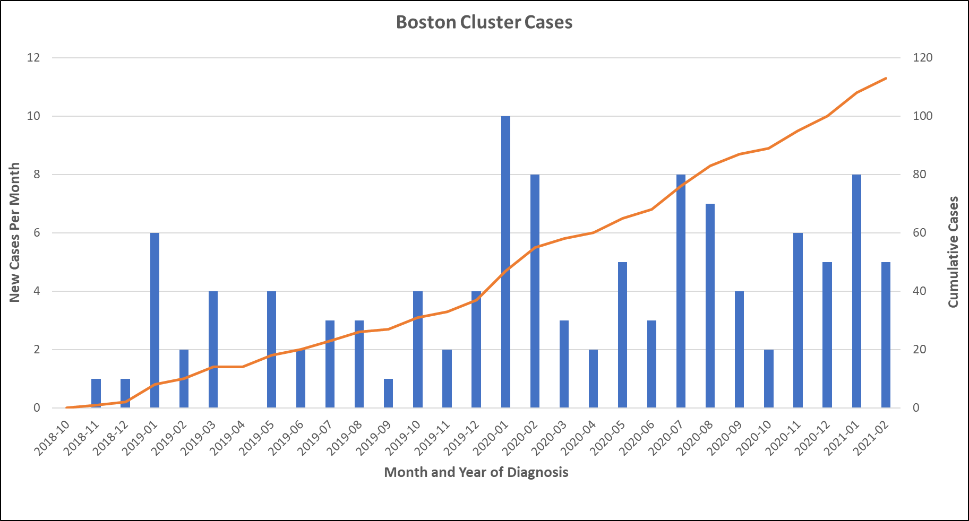
Data current as of March 1, 2021 and subject to change.
Between 2000 and 2014, the number of reported HIV infections in Massachusetts declined by 47% overall and by 91% among PWID. However, starting in 2015 the downward trend among PWID reversed as a result of the opioid epidemic and the widespread introduction of fentanyl into the drug supply. Between 2016 and 2018, a large outbreak of HIV infection occurred in Lawrence and Lowell; the majority of these cases were among PWID who were also experiencing homelessness. Active drug use, homelessness and mental illness may create barriers to consistent access to HIV testing, and/or to adherence to biomedical HIV prevention (PrEP) and HIV treatment. Intermittent periods of incarceration may interrupt care and treatment. It is important that HIV infection is diagnosed early and HIV treatment initiated promptly, both for the health of the individual and to prevent onward transmission of HIV infection.
The SARS-CoV-2 pandemic has introduced added barriers to HIV testing, prevention and care; especially among vulnerable populations. As an example, specimen submissions to the State Public Health Laboratory (SPHL) by DPH-supported providers who specifically serve vulnerable populations have experienced disruption. The figure below shows data on HIV testing done at the SPHL during 2020, with a sharp decline during the stay-at-home advisory. Service levels are gradually increasing but have not yet returned to pre-pandemic levels.
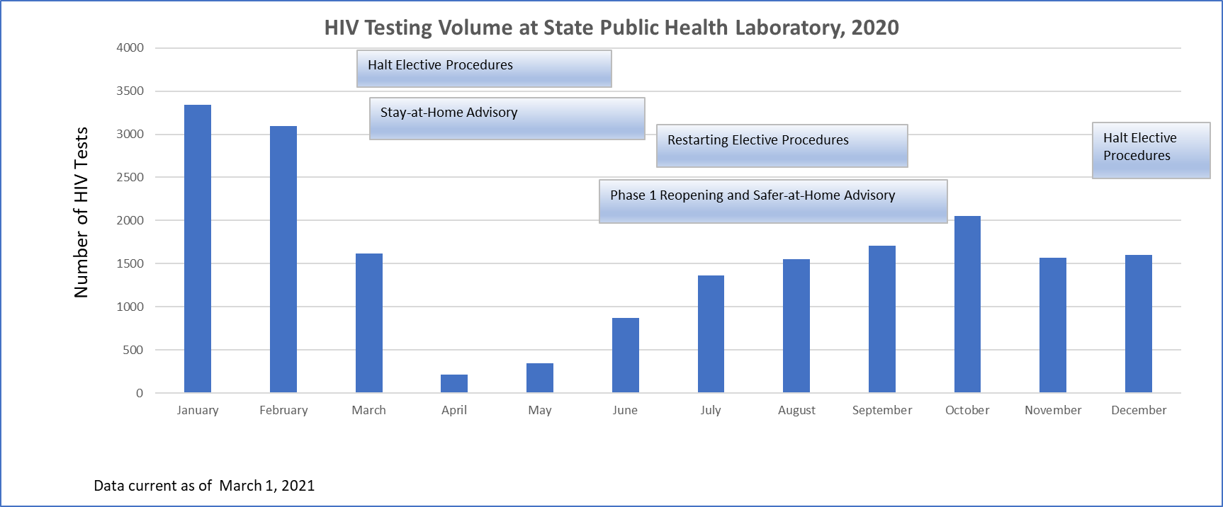
DPH and BPHC ask healthcare providers to increase testing for HIV infection (both routine and risk-based), to include screening for co-occurring conditions such as HCV, and to report any new HIV infections to DPH immediately, particularly those in PWID, patients who report stimulant use, and/or individuals experiencing homelessness. Prompt identification of HIV infection and linkage to treatment improves clinical outcomes and is critical to reduce HIV transmission and contain outbreaks.
Recommendations:
- Remain alert to the potential for HIV infection:
    - Ascertain behavioral risk history, including injection drug use (IDU), transactional sex, methamphetamine use, unstable housing/homelessness.
    - Encourage frequent HIV, HCV, and syphilis screening for at-risk individuals, especially patients seeking care in emergency departments, even among those who were recently tested.
    - For all other individuals, follow current national recommendations for screening (see https://www.cdc.gov/mmwr/preview/mmwrhtml/rr5514a1.htm and https://www.cdc.gov/hepatitis/hcv/guidelinesc.htm).
    - Assess for probable serious mental illness and link patients to mental health and substance use disorder treatment programs.
    - Provide patients with condoms to reduce risk of HIV and STD transmission through sexual encounters.
- Link all HIV+ persons to care for full evaluation, follow-up, and prompt initiation of antiretroviral therapy, as soon as possible. Focused efforts should be made to optimize treatment adherence and retain patients in care. Early treatment of acute HIV infection is essential to rapidly reduce viral load to reduce forward transmission and improve patient outcomes, therefore blood-based, antigen/antibody (4th gen) testing is highly recommended to identify acute infection.
- Be prepared to refer patients who use injectable substances to syringe service programs (see below), providers that offer PrEP and PEP, and other harm reduction services in your community.
- Report any diagnoses of HIV infection in a person who injects drugs immediately to DPH, by calling the HIV/STD Reporting and Partner Services Line. Field epidemiologists from DPH are routinely deployed to assist in HIV cluster investigations, provide anonymous and confidential partner notification for newly diagnosed individuals, and make referrals to support services. To speak with a Field Operations Manager, call the Division of STD Prevention and HIV/AIDS Surveillance Reporting and Partner Services Line at 617-983-6999.

For current listing of substance use disorder treatment programs:
http://www.mass.gov/eohhs/gov/departments/dph/programs/substance-abuse/providers/substance-abuse-services.html
For a current listing of syringe service programs:
https://www.mass.gov/syringe-service-programs

For substance use disorder treatment programs and services in the City of Boston:
https://www.boston.gov/departments/recovery-services

For a list of locations offering PrEP / PEP:
https://www.mass.gov/hiv-pre-exposure-prophylaxis-prep

