INDOOR AIR QUALITY ASSESSMENT

Jordan/Jackson Elementary School
255 East Street
Mansfield, MA 02048



Prepared by:
Massachusetts Department of Public Health
Bureau of Environmental Health
Indoor Air Quality Program
April 2008

Background/Introduction
At the request of Walter Parker, Director of Buildings and Grounds, Mansfield Public Schools, the Massachusetts Department of Public Health (MDPH), Bureau of Environmental Health (BEH) provided assistance and consultation regarding indoor air quality concerns at Jordan/Jackson Elementary School (JJES), 255 East Street, Mansfield, Massachusetts. The request was prompted by occupant complaints of respiratory symptoms.
On February 15, 2008, an initial visit to conduct an assessment was made to the JJES by Mike Feeney, Director, and Cory Holmes and James Tobin, Environmental Analysts in BEH’s Indoor Air Quality (IAQ) Program. BEH staff were accompanied by Mr. Parker during the assessment. Mr. Holmes and Mr. Tobin returned to JJES on February 26, 2008 to complete the assessment. It was reported that over February vacation, intensive cleaning of classrooms was conducted, particularly the surfaces and interiors of classroom unit ventilators.
The school is a two-story brick building that was built in 1991. The building contains general classrooms, small rooms for specialized instruction, a library, a kitchen, a cafeteria, a gymnasium, an auditorium, office space, music/band rooms, art rooms and multipurpose rooms. Windows are openable throughout the building. The school has initiated a carpet removal project that was reportedly about 85 percent complete at the time of the assessment. This project involves removing wall to wall carpet and installing a non-porous flooring material (e.g., tile).

Methods
Air tests for carbon monoxide, carbon dioxide, temperature and relative humidity were conducted with the TSI, Q-Trak, IAQ Monitor, Model 8551. Air tests for airborne particle matter with a diameter less than 2.5 micrometers were taken with the TSI, DUSTTRAK™ Aerosol Monitor Model 8520. MDPH staff also performed visual inspection of building materials for water damage and/or microbial growth.

Results
The school houses approximately 1,200 elementary students in grades 3 to 5 with approximately 125 staff members. Tests were taken during normal operations at the school and results appear in Tables 1 and 2.

Discussion
Ventilation
It can be seen from Tables 1 and 2 that carbon dioxide levels were above 800 parts per million (ppm) in 17 of 49 areas on February 15, and in 27 of 48 on February 26, 2008. These levels of carbon dioxide indicate a poor air exchange in a number of areas. Elevated levels of carbon dioxide are largely the result of deactivated mechanical ventilation equipment. It is also important to note that several classrooms had open windows and/or were empty/sparsely populated, which can greatly reduce carbon dioxide levels. Carbon dioxide levels would be expected to increase with full occupancy and windows closed.
Fresh air is supplied to classrooms by unit ventilator (univent) systems (Picture 1). A univent draws air from the outdoors through a fresh air intake located on the exterior wall of the building (Picture 2) and returns air through an air intake located at the base of the unit (Figure 1). Fresh and return air are mixed, filtered, heated and provided to classrooms through an air diffuser located in the top of the unit. Univents were found obstructed by furniture, books and other stored materials (Picture 3). Further, a heavy buildup of dust and debris was observed in the air diffusers of several univents. In one particular room, BEH staff opened the univent to find a buildup of dirt, dust and debris as well as disintegrating fiberglass insulation (Pictures 4 and 5/Table 1). In order for univents to provide fresh air as designed, air diffusers, intakes and returns must remain free of obstructions. Importantly, these units must remain “on” and be allowed to operate while rooms are occupied.
Exhaust ventilation in classrooms is provided by ceiling and wall-mounted vents (Picture 6) ducted to rooftop motors. Exhaust ventilation was deactivated in a number of areas during the assessment (Table 1). As with univents, in order to function properly, exhaust vents must be activated and allowed to operate while rooms are occupied. Without adequate supply and exhaust ventilation, excess heat and environmental pollutants can build up leading to indoor air/comfort complaints. Also of note was a breach in the ductwork in classroom A-214 (Picture 7), which can reduce the efficiency of the exhaust system.
Ventilation for common areas (e.g., gym, cafeteria) is provided by rooftop or ceiling-mounted air-handling units (AHUs). Fresh air is distributed via wall/ceiling-mounted air diffusers and ducted back to AHUs via ceiling or wall-mounted return vents. As with univents, AHUs should be activated and allowed to operate continuously during occupied periods.
To maximize air exchange, the MDPH recommends that both supply and exhaust ventilation operate continuously during periods of school occupancy. In order to have proper ventilation with a mechanical supply and exhaust system, the systems must be balanced to provide an adequate amount of fresh air to the interior of a room while removing stale air from the room. It is recommended that HVAC systems be re-balanced every five years to ensure adequate air systems function (SMACNA, 1994). The systems at JJES were reportedly balanced upon installation in 1991 and most recently in 2002.
The Massachusetts Building Code requires a minimum ventilation rate of 15 cubic feet per minute (cfm) per occupant of fresh outside air or have openable windows in each room (SBBRS, 1997; BOCA, 1993). The ventilation must be on at all times that the room is occupied. Providing adequate fresh air ventilation with open windows and maintaining the temperature in the comfort range during the cold weather season is impractical. Mechanical ventilation is usually required to provide adequate fresh air ventilation.
Carbon dioxide is not a problem in and of itself. It is used as an indicator of the adequacy of the fresh air ventilation. As carbon dioxide levels rise, it indicates that the ventilating system is malfunctioning or the design occupancy of the room is being exceeded. When this happens, a buildup of common indoor air pollutants can occur, leading to discomfort or health complaints. The Occupational Safety and Health Administration (OSHA) standard for carbon dioxide is 5,000 parts per million parts of air (ppm). Workers may be exposed to this level for 40 hours/week, based on a time-weighted average (OSHA, 1997).
The MDPH uses a guideline of 800 ppm for publicly occupied buildings. A guideline of 600 ppm or less is preferred in schools due to the fact that the majority of occupants are young and considered to be a more sensitive population in the evaluation of environmental health status. Inadequate ventilation and/or elevated temperatures are major causes of complaints such as respiratory, eye, nose and throat irritation, lethargy and headaches. For more information concerning carbon dioxide, consult Appendix A.
Temperature measurements ranged from 70 º F to 76 º F on February 15 and from 67 º F to 74 º F on February 26, 2008 (Tables 1 and 2). These measurements were within or close to the lower end of the MDPH recommended comfort range on both days of the assessment. The MDPH recommends that indoor air temperatures be maintained in a range of 70º F to 78º F in order to provide for the comfort of building occupants. In many cases concerning indoor air quality, fluctuations of temperature in occupied spaces are typically experienced, even in a building with an adequate fresh air supply. In addition, it is often difficult to control temperature and maintain comfort without operating the ventilation equipment as designed (e.g., univents/exhaust vents deactivated/obstructed).
The relative humidity measured in the building ranged from 18 to 30 percent on February 15, and from 16 to 25 percent on February 26, 2008 (Tables 1 and 2). Relative humidity measurements were below the MDPH recommended comfort range in all areas surveyed on both days of the assessment. The MDPH recommends a comfort range of 40 to 60 percent for indoor air relative humidity. Relative humidity levels in the building would be expected to drop during the winter months due to heating. The sensation of dryness and irritation is common in a low relative humidity environment. Low relative humidity is a very common problem during the heating season in the northeast part of the United States.

Microbial/Moisture Concerns
Several classrooms had water-damaged ceiling tiles which can indicate sources of water penetration (Tables 1 and 2). Water-damaged ceiling tiles can provide a source of mold and should be replaced after a water leak is discovered and repaired.
Open seams between sink countertops and walls were observed in several rooms (Picture 8). If not watertight, moisture can penetrate through the seam, causing water damage. Improper drainage or sink overflow can lead to water penetration into the countertop, cabinet interior and areas behind cabinets. Water penetration and chronic exposure of porous and wood-based materials can cause these materials to swell and show signs of water damage.
The US Environmental Protection Agency (US EPA) and the American Conference of Governmental Industrial Hygienists (ACGIH) recommend that porous materials be dried with fans and heating within 24 to 48 hours of becoming wet (US EPA, 2001; ACGIH, 1989). If not dried within this time frame, mold growth may occur. Once mold has colonized porous materials, they are difficult to clean and should be removed/discarded.
Some classrooms were equipped with exterior doors. Several of these doors had damaged weather stripping, and light could be seen penetrating through the spaces underneath the door from the outdoors (Picture 9). Spaces beneath exterior doors can serve as a source of water entry into the building, causing water damage and potentially leading to mold growth. In addition, these spaces can serve as pathways for insects, rodents and other pests into the building.
Several classrooms had a number of plants (Picture 10). Moistened plant soil and drip pans can be a source of mold growth. Plants should be equipped with drip pans; the lack of drip pans can lead to water pooling and mold growth on windowsills. Plants are also a source of pollen. Terrariums were observed in some classrooms in close proximity to classroom univents (Picture 10). Terrariums should be properly maintained to ensure soil does not become a source for mold growth. Plants and terrariums should also be located away from univents to prevent the aerosolization of dirt, mold, pollen, odors or particulate matter throughout the classroom.
BEH staff examined the building exterior to identify breaches in the building envelope that could provide a source of water penetration. Several potential sources were identified:
- Missing/damaged sealant between expansion joints (Pictures 11 and 12);
- Gutters/downspouts were damaged and emptying against the exterior of the building, allowing rainwater to pool on the ground at the base of the building (Picture 13);
- Open utility holes (Picture 14); and
- Plants/debris in/near univent fresh air intakes (Picture 15).
The conditions listed above can undermine the integrity of the building envelope and create/provide a means of water entry by capillary action into the building through exterior walls, foundation concrete and masonry (Lstiburek & Brennan, 2001). The freezing and thawing action of water during the winter months can create cracks and fissures in the foundation. In addition, they can serve as pathways for insects, rodents and other pests into the building.

Other IAQ Evaluations
Indoor air quality can be negatively influenced by the presence of respiratory irritants, such as products of combustion. The process of combustion produces a number of pollutants. Common combustion emissions include carbon monoxide, carbon dioxide, water vapor and smoke (fine airborne particle material). Of these materials, exposure to carbon monoxide and particulate matter with a diameter of 2.5 micrometers (μm) or less (PM2.5) can produce immediate, acute health effects upon exposure. To determine whether combustion products were present in the school environment, BEH staff obtained measurements for carbon monoxide and PM2.5.
Carbon monoxide is a by-product of incomplete combustion of organic matter (e.g., gasoline, wood and tobacco). Exposure to carbon monoxide can produce immediate and acute health affects. Several air quality standards have been established to address carbon monoxide and prevent symptoms from exposure to these substances. The MDPH established a corrective action level concerning carbon monoxide in ice skating rinks that use fossil-fueled ice resurfacing equipment. If an operator of an indoor ice rink measures a carbon monoxide level over 30 ppm, taken 20 minutes after resurfacing within a rink, that operator must take actions to reduce carbon monoxide levels (MDPH, 1997).
The American Society of Heating Refrigeration and Air-Conditioning Engineers (ASHRAE) has adopted the National Ambient Air Quality Standards (NAAQS) as one set of criteria for assessing indoor air quality and monitoring of fresh air introduced by HVAC systems (ASHRAE, 1989). The NAAQS are standards established by the US EPA to protect the public health from six criteria pollutants, including carbon monoxide and particulate matter (US EPA, 2006). As recommended by ASHRAE, pollutant levels of fresh air introduced to a building should not exceed the NAAQS levels (ASHRAE, 1989). The NAAQS were adopted by reference in the Building Officials & Code Administrators (BOCA) National Mechanical Code of 1993 (BOCA, 1993), which is now an HVAC standard included in the Massachusetts State Building Code (SBBRS, 1997). According to the NAAQS, carbon monoxide levels in outdoor air should not exceed 9 ppm in an eight-hour average (US EPA, 2006).
Carbon monoxide should not be present in a typical, indoor environment. If it is present, indoor carbon monoxide levels should be less than or equal to outdoor levels. Outdoor carbon monoxide concentrations were non-detect (ND) on both days of the assessment (Tables 1 and 2). Carbon monoxide levels measured in the building were also ND on both days of the assessment (Tables 1 and 2).
The US EPA has established NAAQS limits for exposure to particulate matter. Particulate matter is airborne solids that can be irritating to the eyes, nose and throat. The NAAQS originally established exposure limits to particulate matter with a diameter of 10 μm or less (PM10). According to the NAAQS, PM10 levels should not exceed 150 microgram per cubic meter (μg/m³) in a 24-hour average (US EPA, 2006). These standards were adopted by both ASHRAE and BOCA. Since the issuance of the ASHRAE standard and BOCA Code, US EPA established a more protective standard for fine airborne particles. This more stringent PM2.5 standard requires outdoor air particle levels be maintained below 35 μg/m³ over a 24-hour average (US EPA, 2006). Although both the ASHRAE standard and BOCA Code adopted the PM10 standard for evaluating air quality, MDPH uses the more protective PM2.5 standard for evaluating airborne particulate matter concentrations in the indoor environment.
Outdoor PM2.5 concentrations on February 15, 2008, were measured at 21 μg/m³. (Table 1). PM2.5 levels measured in the school ranged from 12 to 27 μg/m³, which were below the NAAQS PM2.5 level of 35 μg/m³ (Table 1). Outdoor PM2.5 concentrations on February 26, 2008, were measured at 59 μg/m³, which were above the NAAQS PM2.5 level of 35 μg/m³ (Table 2). PM2.5 levels measured in the school ranged between 18 and 48 on February 26, 2008. These PM2.5 levels were above the NAAQS of 35 μg/m³ in the majority of areas (Table 2), which were reflective of elevated outdoor levels.
At the time of the February 26, 2008 assessment, BEH staff did not observe any outdoor activities that would have contributed to increased outdoor PM2.5 level of 59 μg/m³. However, outdoor PM2.5 levels for the February 26, 2008 assessment were predicted to be between 50-100 μg/m³ (AIRNow, 2008). The U.S. Environmental Protection Agency, National Oceanic and Atmospheric Agency, National Park Services, tribal, state, and local agencies developed the AIRNow Web site to provide the public with easy access to national air quality information. Predicted levels are calculated using a method that averages particulate levels measured over a 12-hour period average and an adjusted 4-hour average (AirNow, 2008).
In addition, indoor air levels of particulates (including PM2.5) can frequently be at higher levels than those measured outdoors. A number of mechanical devices and/or activities that occur in schools can generate particulate during normal operations. Sources of indoor airborne particulates may include but are not limited to particles generated during the operation of fan belts in the HVAC system, cooking in the cafeteria stoves and microwave ovens; use of photocopiers, fax machines and computer printing devices; operation of an ordinary vacuum cleaner and heavy foot traffic indoors.
Indoor air concentrations of volatile organic compounds (VOCs) can be greatly impacted by the use of products containing VOCs . VOCs are carbon-containing substances that have the ability to evaporate at room temperature. Frequently, exposure to low levels of total VOCs (TVOCs) may produce eye, nose, throat and/or respiratory irritation in some sensitive individuals. For example, chemicals evaporating from a paint can stored at room temperature would most likely contain VOCs. In an effort to identify materials that can potentially increase indoor VOC concentrations, BEH staff examined classrooms for products containing these respiratory irritants.
Several work rooms throughout the building contain photocopiers and laminators (Picture 16). Lamination machines give off odors. VOCs and ozone can be produced by photocopiers, particularly if the equipment is older and in frequent use. Ozone is a respiratory irritant (Schmidt Etkin, 1992). It is important that local exhaust ventilation in these areas is functioning to help reduce excess heat and odors.
The majority of classrooms contained dry erase boards and related materials. Materials such as dry erase markers and dry erase board cleaners may contain VOCs, such as methyl isobutyl ketone, n-butyl acetate and butyl-cellusolve (Sanford, 1999), which can be irritating to the eyes, nose and throat.
Cleaning products, spray paint and plastic primer spray were found on countertops and in unlocked cabinets beneath sinks in a number of classrooms (Pictures 17 and 18). These products contain VOCs and petroleum distillates, which can be irritating to the eyes, nose and throat. Further, the plastic primer is an extremely flammable liquid and vapor. It is important that cleaning products, spray paint and plastic primer spray be kept out of reach of children. Unlabeled/poorly labeled spray bottles were also observed in some classrooms. Products should be kept in their original containers, or should be clearly labeled as to their contents, for identification purposes in the event of an emergency. Further, material safety data sheets (MSDS) for all cleaning products must be available at a central location.
In one classroom, bottles of sodium borate, an industrial cleaner, were observed on the countertop next to the sink (Picture 19). Sodium Borate is slightly toxic by inhalation, ingestion and skin absorption. It is irritating to the eyes, skin and respiratory tract; avoid contact with body tissue (NIOSH, 2008). Therefore, it is important that sodium borate be kept out of reach of children.
In an effort to reduce noise from sliding tables/chairs, tennis balls had been sliced open and placed on the base of the legs (Picture 20). Tennis balls are made of a number of materials that are a source of respiratory irritants. Constant wearing of tennis balls can produce fibers and cause VOCs to off-gas. Tennis balls are made with a natural rubber latex bladder, which becomes abraded when used as a chair leg pad. Use of tennis balls in this manner may introduce latex dust into the school environment. Some individuals are highly allergic to latex (e.g., spina bifida patients) (SBAA, 2001). It is recommended that the use of materials containing latex be limited in buildings to reduce the likelihood of symptoms in sensitive individuals (NIOSH, 1997).
Other conditions that can affect indoor air quality were observed during the assessment. In several classrooms, items were observed on the floor, windowsills, tabletops, counters, bookcases and desks (Picture 21). The large number of items stored in classrooms provides a source for dusts to accumulate. These items (e.g., papers, folders, boxes) make it difficult for custodial staff to clean. Items should be relocated and/or be cleaned periodically to avoid excessive dust build up. In addition, these materials can accumulate on flat surfaces (e.g., desktops, shelving and carpets) in occupied areas and subsequently be re-aerosolized causing further irritation.
A high efficiency particulate air (HEPA) purifier was observed on the floor of a classroom (Picture 22). Air purifiers should be placed within the breathing zone rather than at floor level. In addition, this equipment is normally equipped with filters that should be cleaned or changed as per manufacturer’s instructions to prevent build up and re-aerosolization of dirt, dust and particulate matter.
A number of exhaust/return vents, univent air diffusers and personal fans (Pictures 23 and 24) were observed to have accumulated dirt, dust and debris. If exhaust vents are not functioning, backdrafting can occur, which can re-aerosolize accumulated dirt and dust particles. Re-activated univents and fans can also aerosolize dirt and dust accumulated on vents/fan blades.
An accumulation of chalk dust, pencil shavings and dry erase particulate was observed in some classrooms. When windows are opened or univents are operating, these materials can become airborne. Once aerosolized, they can act as irritants to the eyes and respiratory system.
A number of classrooms contained upholstered furniture and pillows/cushions (Picture 25). These items are covered with fabric that comes in contact with human skin, which can leave oils, perspiration, hair and skin cells. Dust mites feed upon human skin cells and excrete waste products that contain allergens. Furthermore, increased relative humidity levels above 60 percent can also perpetuate dust mite proliferation (US EPA, 1992). In order to remove dust mites and other pollutants, frequent vacuuming of upholstered furniture is recommended (Berry, 1994). It is also recommended that if upholstered furniture is present in schools, it should be professionally cleaned on an annual basis or every six months if dusty conditions exist (IICRC, 2000).
Food containers being reused in several classrooms were observed. Exposed food products and reused food containers can attract a variety of pests. The presence of pests inside a building can produce conditions that can degrade indoor air quality. For example, rodent infestation can result in indoor air quality related symptoms due to materials in their wastes. Mouse urine is known to contain a protein that is a known sensitizer (US EPA, 1992). A sensitizer is a material that can produce symptoms in exposed individuals, including nose irritations and skin rashes. Pest attractants should be reduced/eliminated. Proper food storage is an integral component in maintaining indoor air quality. Food should be properly stored and clearly labeled. Reuse of food containers (e.g., for art projects) is not recommended since food residue adhering to the container surface may serve to attract pests.
Finally, in a number of classrooms, exposed fiberglass insulation was observed in the top corners of the room. Fiberglass insulation can provide a source of skin, eye and respiratory irritation (Picture 26).

Conclusions/Recommendations
Several issues regarding general building conditions, design and routine maintenance that can affect indoor air quality were observed. The majority of issues listed in the report have been observed in other elementary school environments (clutter, dust control, building maintenance) and should be addressed. These factors can be associated with a range of IAQ related health and comfort complaints (e.g., eye, nose, and respiratory irritations).
In view of the findings at the time of the assessment, the following recommendations are made:
- Operate all ventilation systems throughout the building (e.g., gym, cafeteria, classrooms) continuously during periods of school occupancy and independent of thermostat control. To increase airflow in classrooms, set univent controls to “high”.
- Inspect exhaust motors and belts for proper function. Repair and replace as necessary.
- Remove all blockages from univents and exhaust vents to ensure adequate airflow.
- Close classroom doors to maximize air exchange.
- Use openable windows in conjunction with classroom univents and exhaust vents to increase air exchange. Care should be taken to ensure windows are properly closed at night and weekends to avoid the freezing of pipes and potential flooding.
- Consider adopting a balancing schedule of every 5 years for all mechanical ventilation systems, as recommended by ventilation industrial standards (SMACNA, 1994).
- For buildings in New England, periods of low relative humidity during the winter are often unavoidable. Therefore, scrupulous cleaning practices should be adopted to minimize common indoor air contaminants whose irritant effects can be enhanced when the relative humidity is low. To control for dusts, a high efficiency particulate arrestance (HEPA) filter equipped vacuum cleaner in conjunction with wet wiping of all surfaces is recommended. Avoid the use of feather dusters. Drinking water during the day can help ease some symptoms associated with a dry environment (throat and sinus irritations).
- Install weather stripping around exterior doors to prevent drafts, water penetration and pest entry.
- Seal areas around sinks to prevent water damage to the interior of cabinets and adjacent wallboard. Inspect wallboard for water damage and mold growth, repair/replace as necessary. Disinfect areas with an appropriate antimicrobial, as needed.
- Move plants away from univents in classrooms. Avoid over-watering and examine drip pans periodically for mold growth. Disinfect with an appropriate antimicrobial where necessary.
- Examine all expansion joint seals on the exterior wall system. Reseal all expansion joints with damaged, missing or eroded sealant.
- Seal spaces around exterior utility holes.
- Make repairs to missing/damaged gutter/downspout system.
- Clear plants/debris away from the exterior of univent fresh air intakes.
- Clean and maintain aquariums and terrariums to prevent mold growth and associated odors.
- Store cleaning products properly and out of reach of students. Ensure spray bottles are properly labeled. All cleaning products used at the facility should be approved by the school department with MSDS’ available at a central location.
- Relocate or consider reducing the amount of materials stored in classrooms to allow for more thorough cleaning of classrooms. Clean items regularly with a wet cloth or sponge to prevent excessive dust build-up.
- Clean personal fans, univent air diffusers, return vents and exhaust vents periodically of accumulated dust.
- Clean chalk and dry erase trays to prevent accumulation of materials.
- Replace latex-based tennis balls with latex-free tennis balls or alternative “glides”.
- Clean upholstered furniture/cushions/pillows on the schedule recommended in this report. If not possible/practical consider removal.
- Ensure local exhaust ventilation is operating in teacher work rooms during use.
- Clean/change filters for HEPA air purifier as per the manufacture’s instructions.
- Encapsulate exposed fiberglass insulation in classrooms (Picture 26).
- School staff are encouraged to report any building and/or health related issues via the established written protocol as provided by the Mansfield Buildings & Grounds Office.
- Consider adopting the US EPA document, “Tools for Schools” to maintain a good indoor air quality environment on the building (US EPA, 2000). This document can be downloaded from the Internet at: http://www.epa.gov/iaq/schools/index.html.
- Refer to resource manuals and other related indoor air quality documents for further building-wide evaluations and advice on maintaining public buildings. These materials are located on the MDPH’s website: http://mass.gov/dph/indoor_air.

References
ACGIH. 1989. Guidelines for the Assessment of Bioaerosols in the Indoor Environment. American Conference of Governmental Industrial Hygienists, Cincinnati, OH.
AirNow. 2008. http://airnow.gov/index.cfm?action=airnow.displaymaps#map
ASHRAE. 1989. Ventilation for Acceptable Indoor Air Quality. American Society of Heating, Refrigeration and Air Conditioning Engineers. ANSI/ASHRAE 62-1989
Berry, M.A. 1994. Protecting the Built Environment: Cleaning for Health, Michael A. Berry, Chapel Hill, NC.
BOCA. 1993. The BOCA National Mechanical Code/1993. 8th ed. Building Officials and Code Administrators International, Inc., Country Club Hill, IL.

IICRC. 2000. IICRC S001 Reference Guideline for Professional On-Location Cleaning of Textile Floor Covering Materials Institute of Inspection, Cleaning and Restoration Certification. Institute of Inspection Cleaning and Restoration, Vancouver, WA.
Lstiburek, J. & Brennan, T. 2001. Read This Before You Design, Build or Renovate. Building Science Corporation, Westford, MA. U.S. Department of Housing and Urban Development, Region I, Boston, MA
MDPH. 1997. Requirements to Maintain Air Quality in Indoor Skating Rinks (State Sanitary Code, Chapter XI). 105 CMR 675.000. Massachusetts Department of Public Health, Boston, MA.
NIOSH. 1997. NIOSH Alert Preventing Allergic Reactions to Natural Rubber latex in the Workplace. National Institute for Occupational Safety and Health, Atlanta, GA.
NIOSH. 2008. International Chemical Safety Card: Sodium Borate. National Institute for Occupational Safety and Health, Atlanta, GA. http://0-www.cdc.gov.pugwash.lib.warwick.ac.uk/niosh/ipcsneng/neng0567.html
OSHA. 1997. Limits for Air Contaminants. Occupational Safety and Health Administration. Code of Federal Regulations. 29 C.F.R 1910.1000 Table Z-1-A.
Sanford. 1999. Material Safety Data Sheet (MSDS No: 198-17). Expo® Dry Erase Markers Bullet, Chisel, and Ultra Fine Tip. Sanford Corporation. Bellwood, IL.
SBAA. 2001. Latex In the Home And Community Updated Spring 2001. Spina Bifida Association of America, Washington, DC.
SBBRS. 1997. Mechanical Ventilation. State Board of Building Regulations and Standards. Code of Massachusetts Regulations. 780 CMR 1209.0
SMACNA. 1994. HVAC Systems Commissioning Manual. 1st ed. Sheet Metal and Air Conditioning Contractors’ National Association, Inc., Chantilly, VA.

US EPA. 1992. Indoor Biological Pollutants. US Environmental Protection Agency, Environmental Criteria and Assessment Office, Office of Health and Environmental Assessment, research Triangle Park, NC. EPA 600/8-91/202 January 1992.
US EPA. 2001. Mold Remediation in Schools and Commercial Buildings. US Environmental Protection Agency, Office of Air and Radiation, Indoor Environments Division, Washington, D.C. EPA 402-K-01-001. March 2001.
US EPA. 2006. National Ambient Air Quality Standards (NAAQS). US Environmental Protection Agency, Office of Air Quality Planning and Standards, Washington, DC. http://www.epa.gov/air/criteria.html.
Picture 1

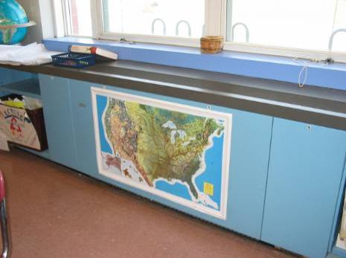

Classroom Univent

Picture 2

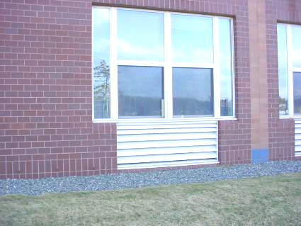

Fresh Air Intake

Picture 3

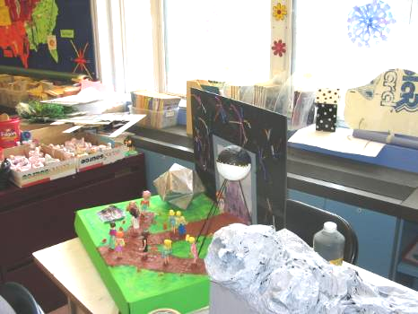

Univent Blocked by Furniture and Store Materials

Picture 4

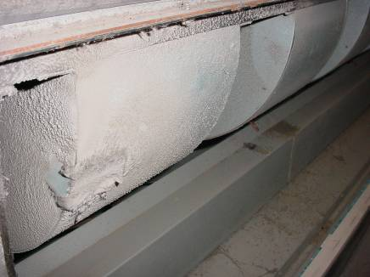

Dirt, Dust, Debris Buildup in Univent

Picture 5

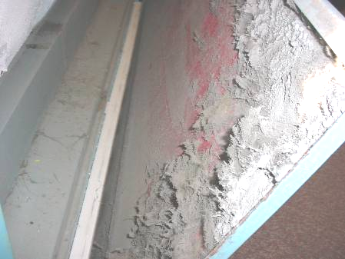

Disintegrating Fiberglass Insulation in Univent

Picture 6

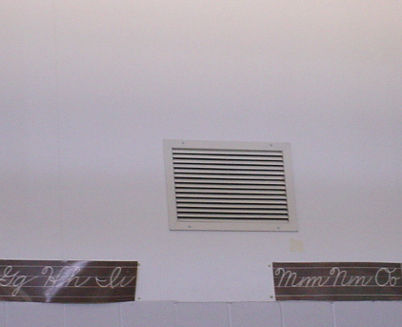

Wall-Mounted Exhaust Vent
Picture 7

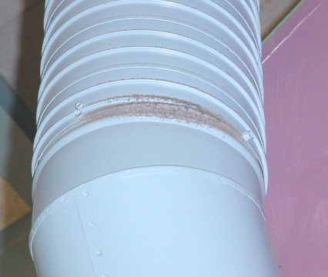

Breach in Exhaust Duct, Note Dust/Debris Accumulation

Picture 8

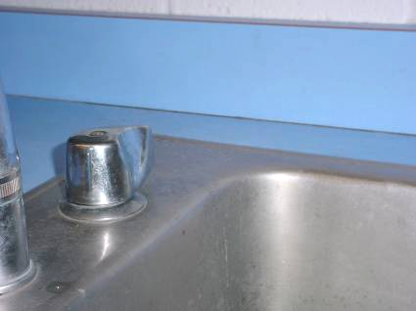

Open Seam between Sink Countertop and Backsplash

Picture 9

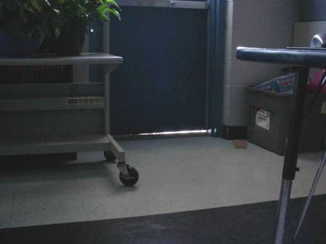
Space underneath Exterior Door

Picture 10

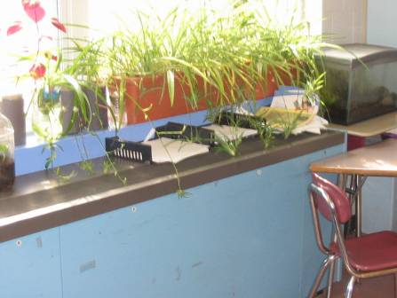

Plants and Terrarium near Univent

Picture 11



Sealed Expansion Joint

Picture 12

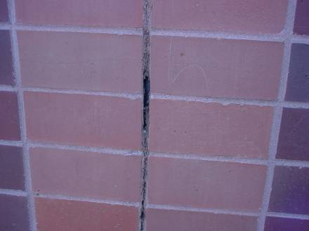

Expansion Joint with Missing/Damaged Sealant

Picture 13

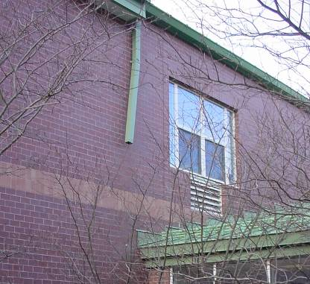

Missing/Damaged Downspout

Picture 14

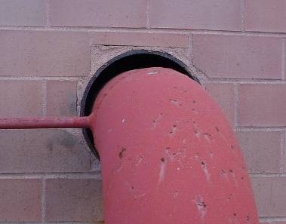

Spaces around Utility Hole

Picture 15

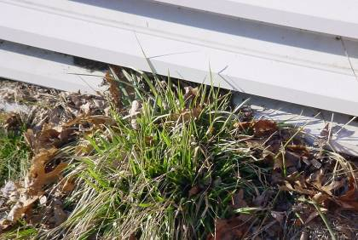

Plants/Leaves/Debris in/near Univent Air Intake

Picture 16

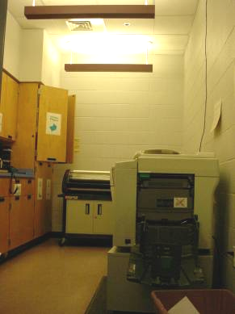

Work Room with Photocopier and Laminator

Picture 17

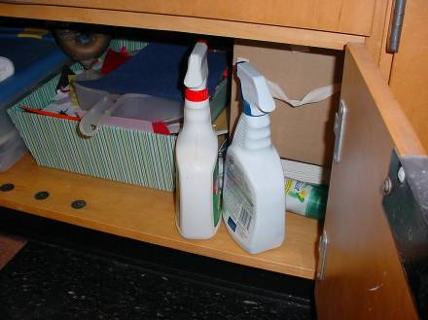

Cleaners under Sink

Picture 18

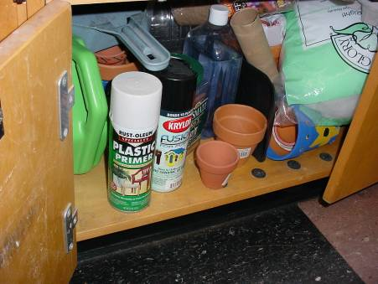

Spray Paint and Plastic Primer under Sink

Picture 19

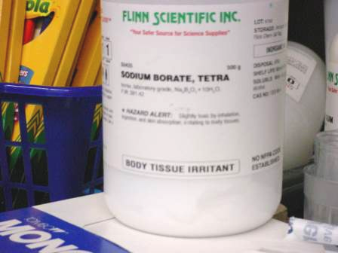

Sodium Borate on Countertop in Classroom

Picture 20

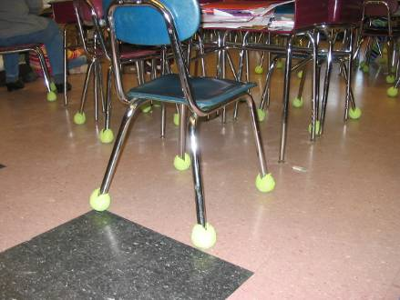

Tennis Balls on Chair Legs

Picture 21

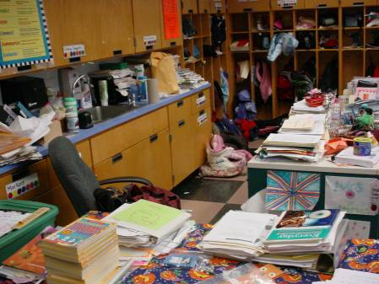

Accumulated Items in Classroom

Picture 22

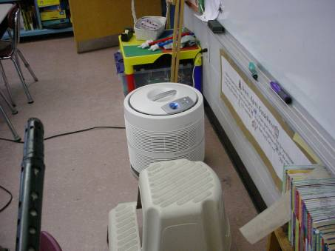

Air Purifier on Floor

Picture 23

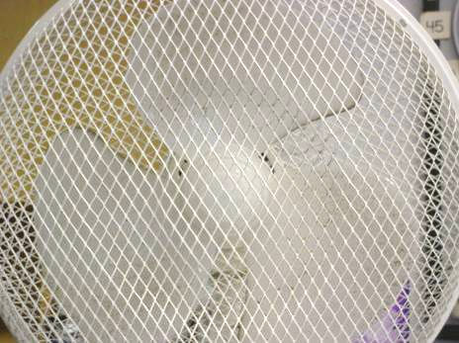

Dirt and Dust on Personal Fan

Picture 24

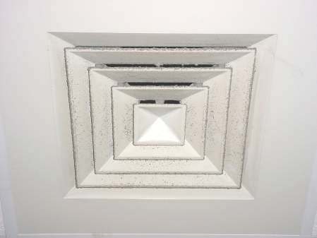

Exhaust Vent with Dirt and Dust
Picture 25

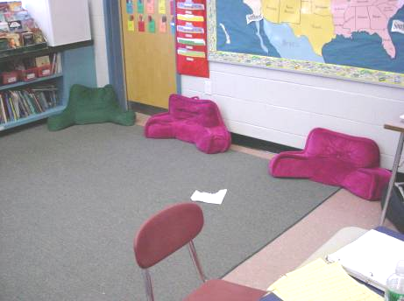

Upholstered Furniture/Cushions
Picture 26

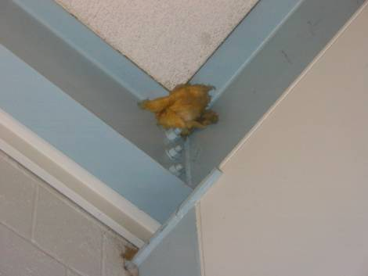

Exposed Fiberglass Insulation
Location/ Room | Occupants  in Room | Temp  (°F) | Relative  Humidity  (%) | Carbon  Dioxide  (ppm) | Carbon Monoxide  (ppm) | PM2.5  (µg/m³) | Windows  Openable | Ventilation |  | Remarks
 |  |  |  |  |  |  |  | Supply | Exhaust | Remarks
background |  | 49 | 40 | 349 | ND | 21 |  |  |  | Mostly Sunny; Scattered Clouds; Winds
A202 | 14 | 73 | 18 | 564 | ND |  | Y | Y | Y | Candy
A207 | 0 | 75 | 24 | 979 | ND | 27 | Y | Y | Y | Univent-blocked by desk; Exhaust-off; Cleaners; Plants; DEM
A208 | 22 | 74 | 20 | 759 | ND | 23 | Y | Y | Y | Exhaust-off; Clutter; CD; CF; DO; TB
A210 | 21 | 73 | 22 | 620 | ND | 15 | Y | Y | Y | Exhaust off; Spray cleaners
A211 | 0 | 70 | 18 | 540 | ND | 21 | Y | Y | Y | Univent-blocked by desk; Cleaners under sink; Space betw. sink/wall; CD; CF; DEM; DO; FC; PS; Fiber glass insulation in top corner of room
A211 | 17 | 73 | 23 | 682 | ND | 19 | Y | Y | Y | Univent blocked by desk; Space betw. sink/wall
A212 | 21 | 72 | 22 | 741 | ND | 23 | Y | Y | Y | Univent blocked by desk; Exhaust above door; Space betw. sink/wall; CF; DEM
A213 | 17 | 74 | 23 | 665 | ND | 18 | Y | Y | Y | Exhaust dusty; 1 Window open; Pillow on floor
A214 | 0 | 73 | 21 | 460 | ND | 15 | Y | Y | Y
A214 | 10 | 73 | 25 | 864 | ND | 15 | Y | Y | Y | Breach in ductwork; DO
A215 | 1 | 73 | 20 | 710 | ND | 25 | N | Y | Y | Supply off; CD; AD
A218 | 9 | 74 | 25 | 845 | ND | 14 | Y | Y | Y | TB
A218 (Small Room) | 0 | 74 | 21 | 892 | ND | 20 | N | Y | Y
A226 | 2 | 72 | 19 | 659 | ND |  | Y | Y | Y | DEM; CF; PC
A227 | 24 | 73 | 22 | 741 | ND |  | Y | Y | Y | Clutter; DO
B107 | 19 | 71 | 23 | 888 | ND | 22 | Y | Y | Y | Plants on univent; Exhaust-off, above door; Terra; Unlabeled spray bottle; DEM; DO; PF
B108 | 14 | 73 | 25 | 718 | ND | 15 | Y | Y | Y | Occupant concerns of dust/debris in return under univent; Cleaners on sink; Items hanging from CTs; Dust/debris on flat surfaces; HEPA air purifier on floor; DO
B112 | 75 | 74 | 30 | 1215 | ND | 15 | Y | Y | Y | Triple occupancy for movie; Plants on univent; Space under exterior door; Previous leak never replaced; Dislodged CTs
B113 | 21 | 72 | 22 | 651 | ND | 21 | Y | Y | Y | Univent-books on top, heavy dust build-up inside univent, damaged fiberglass insulation, dirt, debris and paper in air diffuser; Outside door-weather stripping damaged, light seen underneath; WD-CT along window
B116 | 0 | 71 | 26 | 632 | ND | 13 | Y | Y | Y | Exhaust-off, above door; Space betw. sink/wall; Cleaners under sink
B117 | 23 | 73 | 28 | 1196 | ND | 14 | Y | Y | Y | 4 CT WD along window; Space betw sink/wall; DO
B118 | 21 | 70 | 29 | 864 | ND | 20 | Y | Y | Y | Univent-blocked by furniture; Exhaust-off, above door; TB; Clutter
B119 | 22 | 73 | 27 | 868 | ND | 16 | Y | Y | Y
B120 | 22 | 74 | 25 | 1224 | ND | 22 | Y | Y | Y | Exhaust-off, above door; Cleaners under sink; Plants; Pillows; CD; PS
B123 | 0 | 71 | 19 | 455 | ND | 22 | Y | Y | Y | Cleaners; DEM; PF; PS
B124 | 0 | 73 | 25 | 626 | ND | 12 | Y | Y | Y | Exhaust off; Space betw sink/wall; DO; PF-dusty; MT
B128 | 13 | 71 | 21 | 675 | ND | 21 | Y | Y | Y | Univent-blocked by furniture; terra and plants on univent; Exhaust off, above door, dusty vent; Cleaners; Food containers; Bottles of Sodium Borate (body tissue irritant) near sink; Clutter; DEM; DO; TB
B201 | 10 | 71 | 23 | 467 | ND |  | Y | Y | Y | DEM; CF-off
B206 |  |  |  |  |  |  |  |  |  | Egg Crates
B207 | 19 | 76 | 24 | 802 | ND | 16 | Y | Y | Y | TB; Space betw sink/wall
B208 | 24 | 76 | 21 | 810 | ND | 24 | Y | Y | Y | Exhaust-off; Space betw. sink/wall; Clutter; CD; PF; Microwave
B209 | 13 | 76 | 2 | 1024 | ND | 23 | Y | Y | Y | Exhaust-off; Cleaners under sink; Space betw. sink/wall; CD; CF; DEM; DO; Microwave
B210 | 27 | 76 | 24 | 1374 | ND | 23 | Y | Y | Y | Exhaust-off; Cleaners; DEM
B215 | 12 | 73 | 21 | 659 | ND | 22 | Y | Y | Y | Exhaust-off; Cleaners; Plants; CD; DEM; DO; UF
B216 | 18 | 75 | 25 | 792 | ND | 18 | Y | Y | Y | Exhaust off; Space betw sink/wall; CF; DO; TB
B217 | 10 | 74 | 19 | 652 | ND | 21 | Y | Y | Y | Exhaust vent dusty; Space betw. sink/wall; CD; CF
B218 | 20 | 73 | 22 | 659 | ND | 19 | Y | Y | Y | Exhaust off; PF; UF
B220 | 19 | 75 | 25 | 959 | ND | 13 | Y | Y | Y | Exhaust off; Space betw sink/wall; DO
B221 | 24 | 75 | 25 | 591 | ND | 15 | Y | Y | Y | Exhaust off; Exposed insulation in top corner; DO
B223 | 22 | 75 | 24 | 726 | ND | 14 | Y | Y | Y | Exhaust off; Univent return blocked by items against it; Cleaners on sink; DO
B224 | 19 | 75 | 22 | 612 | ND | 15 | Y | Y | Y | Exposed insulation in corner; Cleaners on sink; Space betw sink/wall; DO
B225 | 6 | 70 | 25 | 655 | ND |  | Y | Y | Y | TB; DEM; DO; CF-on
B226 | 29 | 72 | 25 | 811 | ND |  | Y | Y | Y | TB
C208 | 0 | 73 | 20 | 538 | ND |  | N | Y |  | Clutter; DO
C214 | 0 | 74 | 21 | 712 | ND |  | N | Y | Y | DO
C215 | 0 | 71 | 24 | 722 | ND |  | N | Y | Y | Spray paint; Kiln with exhaust
Conference Room | 0 | 73 | 19 | 454 | ND |  | Y | Y | Y | Scented markers
Copy Room (B120) | 0 | 74 | 26 | 901 | ND | 13 | Y | Y | Y | Vent off; Laminator; PC
Copy Room (B207) | 0 | 75 | 23 | 677 | ND | 16 | N | Y | Y | PC; Laminator; Vent off
Library | 0 | 73 | 20 | 592 | ND |  | Y | Y | Y | Univent off; Exhaust off

Location/ Room | Occupants  in Room | Temp  (°F) | Relative  Humidity  (%) | Carbon  Dioxide  (ppm) | Carbon Monoxide  (ppm) | PM2.5  (µg/m³) | Windows  Openable | Ventilation |  | Remarks
 |  |  |  |  |  |  |  | Supply | Exhaust | Remarks
background |  | 42 | 33 | 392 | ND | 59 |  |  |  | Cold; Overcast
A102 Music | 3 | 72 | 19 | 692 | ND | 37 | Y | Y | Y | Exhaust off; DO
A107 | 0 | 71 | 16 | 456 | ND | 39 | Y | Y | Y | Univent blocked by furniture, plants on univent; Cleaners; DO
A108 | 15 | 71 | 19 | 859 | ND | 40 | Y | Y | Y | DEM; DO; PF
A109 | 0 | 71 | 19 | 837 | ND | 37 | N | N | Y | Exhaust dusty; Light cover missing; DO
A112 | 23 | 72 | 18 | 774 | ND | 38 | Y | Y | Y | Space underneath outside door; Cleaners; DEM
A113 | 20 | 73 | 22 | 1385 | ND | 33 | Y | Y | Y | Univent off, books on univent; DEM
A114 | 0 | 72 | 19 | 802 | ND | 34 | N | Y | Y | Supply off; 2 PCs; Laminator
A116 | 1 | 71 | 17 | 557 | ND | 39 | Y | Y | Y | Plants on univents; Exhaust vent dusty; Cleaners; Clutter; Space betw sink/wall; CD; 22 occupants gone 35 minutes
A117 | 4 | 71 | 17 | 626 | ND | 37 | Y | Y | Y | 20 occupants gone 20 minutes; Space betw sink/wall; Cleaners; DO; TB
A118 | 1 | 70 | 19 | 896 | ND | 31 | Y | Y | Y | Exhaust above door; 21 occupants gone 20 minutes; DO
A119 | 0 | 71 | 19 | 754 | ND | 34 | Y | Y | Y | Univent blocked by furniture; Clutter; TB
A120 | 22 | 72 | 22 | 1025 | ND | 36 | Y | Y | Y | Cleaners; Space betw sink/wall
A123 | 19 | 72 | 19 | 907 | ND | 36 | Y | Y | Y | Univent blocked by books and furniture, cleaners above univent; DEM; 2 WD CT
A124 | 22 | 73 | 20 | 971 | ND | 33 | Y | Y | Y | Exhaust off; Space betw sink/wall; DEM; DO; PF; PS; UF
A127 | 2 | 72 | 18 | 706 | ND | 36 | Y | Y | Y | Univent blocked by furniture; Space betw sink/wall; Plants; 22 occupants gone 20 minutes; DEM; DO; UF
A128 | 1 | 70 | 18 | 613 | ND | 37 | Y | Y | Y | Univent blocked by furniture; Exhaust vent dusty; 19 occupants gone 25 minutes; DO; TB
A201 Conference | 0 | 71 | 16 | 486 | ND | 32 | Y | Y | Y | Exhaust off; Cleaners; PF
A202 | 13 | 71 | 19 | 1019 | ND | 33 | Y | Y | Y | Exhaust off; Space betw sink/wall; Plants; Pillows; UF
A204 | 18 | 73 | 19 | 910 | ND | 38 | Y | Y | Y | Exhaust off, above door; Space betw. sink/wall; CF; DO; TB
A205 | 23 | 73 | 25 | 1413 | ND | 33 | Y | Y | Y | Univent off; Exhaust off, above door; Cleaners; CD; PS; TB
A220 | 14 | 71 | 24 | 985 | ND | 27 | Y | Y | Y | Space betw. sink/wall; CF; DEM; DO; TB
A221 | 22 | 73 | 20 | 1018 | ND | 36 | Y | Y | Y | Exhaust off, above door; Space betw. sink/wall; Spray cleaners; Clutter; CD; CF; DEM; DO
A222 | 0 | 73 | 20 | 920 | ND | 38 | N | N | Y | Exhaust above door; 2 PCs; Laminator; Printer; DO
A226 | 14 | 67 | 18 | 725 | ND | 37 | Y | Y | N | Cleaners; Pillows; DEM; DO; PF; UF
A227 Art | 21 | 72 | 20 | 928 | ND | 48 | Y | Y | Y | Plants; DO; PF
B102 | 18 | 73 | 17 | 612 | ND | 40 | Y | Y | Y | Exhaust off; Plumbing leak along windows (from above room); 8 WD CT; MT; CD
B201 | 1 | 72 | 16 | 490 | ND | 39 | Y | Y | Y | Exhaust off; CD; DEM
B201 | 13 | 73 | 17 | 555 | ND |  | Y | Y | Y | Exhaust off; CD; DEM
B225 | 5 | 72 | 19 | 782 | ND | 29 | Y | Y | Y | Exhaust off; Space betw sink/wall; Plants; PF; TB
B226 Art | 24 | 72 | 20 | 868 | ND | 26 | N | Y | Y
Band | 1 | 72 | 19 | 673 | ND | 27 | Y | Y | Y | 4 occupants gone 5 minutes; 2 WD CT; DEM
C101 | 4 | 72 | 21 | 865 | ND | 30 | N | Y | Y
C124 | 0 | 73 | 16 | 441 | ND | 28 | Y | Y | Y | Exhaust vent dirty
C128 | 0 | 73 | 21 | 848 | ND | 23 | N | Y | Y | Exhaust vent dirty
C202 | 1 | 72 | 18 | 780 | ND | 31 | Y | Y | Y | Supply off; Exhaust off
C203 | 1 | 73 | 18 | 838 | ND | 33 | Y | Y | Y | Supply off; Exhaust off, dusty vent; DEM
C204 | 1 | 73 | 18 | 830 | ND | 33 | Y | Y | Y | Supply off; Exhaust off; DEM; DO
C205 | 0 | 73 | 17 | 820 | ND | 34 | Y | Y | Y | Supply off; Exhaust off; Spray cleaners
C208 | 19 | 74 | 17 | 797 | ND | 38 | Y | Y | N | DO; PF; Clutter
C214 | 1 | 73 | 17 | 753 | ND | 34 | N | Y | Y | Supply off; Exhaust off; PC; 2 WD CT; 2 computers; DO
C215 Kiln Room | 0 | 71 | 20 | 819 | ND | 24 | N | Y | Y | Door opened with bricks to main hallway while kiln in operation
Cafeteria | 132 | 72 | 19 | 796 | ND | 32 | N | Y | Y
East Asst. Principal’s Office | 0 | 72 | 20 | 893 | ND | 20 | Y | Y | Y | Plants
East Office | 3 | 72 | 21 | 921 | ND | 20 | N | Y | Y | PCs
East Principal’s Office | 1 | 72 | 20 | 863 | ND | 19 | Y | Y | Y | Plants
East Principal’s Office | 0 | 73 | 20 | 854 | ND | 18 | Y | Y | Y | Plumbing/Heat leak being addressed; Moisture extractor
Library | 25 | 73 | 17 | 773 | ND | 24 | Y | Y | Y | 27 computers; DEM
West Office | 2 | 74 | 19 | 803 | ND | 19 | N | Y | Y | Aqua; Plants

