INDOOR AIR QUALITY ASSESSMENT

Joseph H. Downey Community School
55 Electric Avenue
Brockton, Massachusetts 02302



Prepared by:
Massachusetts Department of Public Health
Bureau of Environmental Health
Indoor Air Quality Program
September 2008

Background/Introduction
At the request of a parent, the Massachusetts Department of Public Health (MDPH), Bureau of Environmental Health (BEH) provided assistance and consultation regarding indoor air quality concerns at the Joseph H. Downey Community School (DCS) located at 55 Electric Avenue, Brockton, Massachusetts. The request was prompted due to occupant complaints of water damage, mold growth, and other air quality and sanitary conditions in the building.
On April 1, 2008, Cory Holmes and James Tobin, Inspectors within BEH’s Indoor Air Quality (IAQ) Program, conducted an indoor air quality assessment of the DCS. BEH staff were accompanied by Doreen Quaglia, Sanitary Inspector, Brockton Health Department (BHD) and Michael Towne, Supervisor of Buildings and Grounds, Brockton Public Schools, during the assessment.
The DCS is a two-story concrete and brick building constructed in the early 1970s. The building consists of large, open areas separated into “pods” by flexible barriers. Each pod is quartered into four classrooms. The building also has common areas such as computer rooms, a gymnasium, kitchen, cafeteria, auditorium, library, music/art rooms and office space. Windows throughout the building are openable. Attached to the building are two wood-framed modular classrooms.

Methods
Air tests for carbon dioxide, carbon monoxide, temperature and relative humidity were conducted with the TSI, Q-TRAK™ IAQ Monitor, Model 8551. Air tests for airborne particle matter with a diameter less than 2.5 micrometers were taken with the TSI, DUSTTRAK™ Aerosol Monitor Model 8520. BEH staff also performed a visual inspection of building materials for water damage and/or microbial growth. Moisture content of porous building materials was measured with a Delmhorst, BD-2000 Model, Moisture Detector equipped with a Delmhorst Standard Probe.

Results
The school houses approximately 575 students in grades K through 6 with approximately 125 staff members. Tests were taken during normal operations at the school and results appear in Table 1.

Discussion
Ventilation
It can be seen from Table 1 that carbon dioxide levels were above 800 parts per million (ppm) in 15 of 43 areas at the time of the assessment, indicating adequate air exchange in the majority of areas surveyed. Elevated carbon dioxide levels were the result of deactivated mechanical ventilation equipment. It is important to note that at the time of the assessment several areas had open windows and/or were empty/sparsely populated, which can greatly reduce carbon dioxide levels. Carbon dioxide levels would be expected to be higher with increased occupancy and windows closed.
Fresh air is supplied to pod classrooms by unit ventilator (univent) systems (Picture 1). A univent draws air from the outdoors through a fresh air intake located on the exterior wall of the building (Picture 2) and returns air through an air intake located at the base of the unit (Figure 1). Fresh and return air are mixed, filtered, heated and provided to classrooms through an air diffuser located in the top of the unit. Univents were found obstructed by furniture, books and other materials in some areas. In order for univents to provide fresh air as designed, air diffusers, intakes and return vents must remain free of obstructions. Importantly, these units must remain “on” and be allowed to operate while rooms are occupied.
Exhaust ventilation is provided by wall-mounted vents located in/near the ceiling of storage closets (Pictures 3 through 5); the majority were not operating or were found deactivated at the time of the assessment. In addition, due to their location these vents are prone to blockage by storage of items in closets (Pictures 4 and 6). Without adequate supply and exhaust ventilation, excess heat and environmental pollutants can build up and lead to indoor air/comfort complaints.
Ventilation for modular classrooms is provided by rooftop AHUs (Picture 7). Fresh air is drawn in through an air intake on the side of the AHU and distributed to classrooms via ceiling-mounted air diffusers (Picture 8) and drawn back to the AHUs through ceiling-mounted return grills (Picture 9). Thermostats control each AHU. Thermostats for both AHUs were set to the fan “auto” setting (Picture 10), which deactivates the HVAC system at a preset temperature. Therefore, no mechanical ventilation is provided until the thermostat re-activates the system.
To maximize air exchange, the MDPH recommends that both supply and exhaust ventilation operate continuously during periods of school occupancy. In order to have proper ventilation with a mechanical supply and exhaust system, the systems must be balanced to provide an adequate amount of fresh air to the interior of a room while removing stale air from the room. It is recommended that HVAC systems be re-balanced every five years to ensure adequate air systems function (SMACNA, 1994). The date of the last balancing of these systems was not available at the time of the assessment.
The Massachusetts Building Code requires that each room have a minimum ventilation rate of 15 cubic feet per minute (cfm) per occupant of fresh outside air or openable windows (SBBRS, 1997; BOCA, 1993). The ventilation must be on at all times that the room is occupied. Providing adequate fresh air ventilation with open windows and maintaining the temperature in the comfort range during the cold weather season is impractical. Mechanical ventilation is usually required to provide adequate fresh air ventilation.
Carbon dioxide is not a problem in and of itself. It is used as an indicator of the adequacy of the fresh air ventilation. As carbon dioxide levels rise, it indicates that the ventilating system is malfunctioning or the design occupancy of the room is being exceeded. When this happens, a buildup of common indoor air pollutants can occur, leading to discomfort or health complaints. The Occupational Safety and Health Administration (OSHA) standard for carbon dioxide is 5,000 parts per million parts of air (ppm). Workers may be exposed to this level for 40 hours/week, based on a time-weighted average (OSHA, 1997).
The MDPH uses a guideline of 800 ppm for publicly occupied buildings. A guideline of 600 ppm or less is preferred in schools due to the fact that the majority of occupants are young and considered to be a more sensitive population in the evaluation of environmental health status. Inadequate ventilation and/or elevated temperatures are major causes of complaints such as respiratory, eye, nose and throat irritation, lethargy and headaches. For more information concerning carbon dioxide, consult Appendix A.
Temperature measurements ranged from 69º F to 76º F, which were within or slightly below the lower end of the MDPH recommended comfort range during the assessment. The MDPH recommends that indoor air temperatures be maintained in a range of 70º F to 78º F in order to provide for the comfort of building occupants. In many cases concerning indoor air quality, fluctuations of temperature in occupied spaces are typically experienced, even in a building with an adequate fresh air supply.
The relative humidity in the building on the day of the assessment ranged from 31 to 42 percent, which was below the MDPH recommended comfort range in the majority of areas. The MDPH recommends a comfort range of 40 to 60 percent for indoor air relative humidity. Relative humidity levels in the building would be expected to drop during the winter months due to heating. The sensation of dryness and irritation is common in a low relative humidity environment. Low relative humidity is a very common problem during the heating season in the northeast part of the United States.
Microbial/Moisture Concerns
Several areas showed signs of water damage, as evidenced by stained ceiling tiles, concrete ceilings and wall, peeling paint and efflorescence. Such damage can indicate leaks from the roof, building exterior or plumbing system (Pictures 11-14/Table 1). Efflorescence is a characteristic sign of water damage to brick and mortar, but it is not mold growth. As moisture penetrates and works its way through mortar, brick or concrete, water-soluble compounds dissolve, creating a solution. As the solution moves to the surface of the material, the water evaporates, leaving behind white, powdery mineral deposits. The water damage observed in the original building appears to be historic; no current/active leaks were reported in those areas. Active roof leaks were reported in modular classroom 2; the leak is most likely associated with the rooftop AHU (Picture 15).
Open seams between sink countertops and walls were observed in several rooms (Picture 16). Improper drainage or sink overflow can lead to water penetration into the countertop, cabinet interior and areas behind cabinets. If not watertight, moisture can penetrate through the seam, causing water damage and potential mold growth.
Exterior doors in the library and modular classroom wing had damaged/missing weather stripping, and light could be seen penetrating through the spaces around/underneath doors (Picture 17 and 18). Missing/damaged strip caulking was observed around windows in several areas (Pictures 19 and 20). Missing/damaged caulking and spaces around exterior doors and windows can serve as sources of drafts and/or water penetration into the building, causing water damage and potentially leading to mold growth. In addition, these spaces can serve as pathways for insects, rodents and other pests into the building.
The US Environmental Protection Agency (US EPA) and the American Conference of Governmental Industrial Hygienists (ACGIH) recommend that porous materials be dried with fans and heating within 24 to 48 hours of becoming wet (US EPA, 2001; ACGIH, 1989). If not dried within this time frame, mold growth may occur. Once mold has colonized porous materials, they are difficult to clean and should be removed/discarded.
BEH staff examined the exterior of the building to identify any breaches in the building envelope that could provide a source of water penetration. Several potential sources were identified:
- Shrubbery/trees growing in close proximity to the building (Pictures 21 and 22), which holds moisture against exterior brick and prevents drying;
- Missing/damaged mortar and exterior brick (Pictures 23 and 24);
- Missing/damaged joint compound (Picture 25); and
- Missing/damaged elbows/downspouts on modular classroom wing (Pictures 26).
The aforementioned conditions represent potential water penetration sources. Over time, these conditions can undermine the integrity of the building envelope and provide a means of water entry into the building via capillary action through foundation concrete and masonry (Lstiburek & Brennan, 2001). In addition, these breaches may provide a means for pests/rodents to enter the building.
Also noted on the exterior of the building was stagnant water in a concrete-lined pit at the rear of the building (Picture 27 and 28); this is the result of inadequate drainage. The freezing and thawing of water during winter months can lead to damage to exterior walls and subsequent water penetration into the building. Pooling water can also become stagnant, which can lead to mold/bacterial growth and associated odors and serve as a breeding ground for mosquitoes.

Other IAQ Evaluations
Indoor air quality can be negatively influenced by the presence of respiratory irritants, such as products of combustion. The process of combustion produces a number of pollutants. Common combustion emissions include carbon monoxide, carbon dioxide, water vapor and smoke (fine airborne particle material). Of these materials, exposure to carbon monoxide and particulate matter with a diameter of 2.5 micrometers (μm) or less (PM2.5) can produce immediate, acute health effects upon exposure. To determine whether combustion products were present in the school environment, BEH staff obtained measurements for carbon monoxide and PM2.5.

Carbon Monoxide
Carbon monoxide is a by-product of incomplete combustion of organic matter (e.g., gasoline, wood and tobacco). Exposure to carbon monoxide can produce immediate and acute health affects. Several air quality standards have been established to address carbon monoxide and prevent symptoms from exposure to these substances. The MDPH established a corrective action level concerning carbon monoxide in ice skating rinks that use fossil-fueled ice resurfacing equipment. If an operator of an indoor ice rink measures a carbon monoxide level over 30 ppm, taken 20 minutes after resurfacing within a rink, that operator must take actions to reduce carbon monoxide levels (MDPH, 1997).
The American Society of Heating Refrigeration and Air-Conditioning Engineers (ASHRAE) has adopted the National Ambient Air Quality Standards (NAAQS) as one set of criteria for assessing indoor air quality and monitoring of fresh air introduced by HVAC systems (ASHRAE, 1989). The NAAQS are standards established by the US EPA to protect the public health from six criteria pollutants, including carbon monoxide and particulate matter (US EPA, 2006). As recommended by ASHRAE, pollutant levels of fresh air introduced to a building should not exceed the NAAQS levels (ASHRAE, 1989). The NAAQS were adopted by reference in the Building Officials & Code Administrators (BOCA) National Mechanical Code of 1993 (BOCA, 1993), which is now an HVAC standard included in the Massachusetts State Building Code (SBBRS, 1997). According to the NAAQS, carbon monoxide levels in outdoor air should not exceed 9 ppm in an eight-hour average (US EPA, 2006).
Carbon monoxide should not be present in a typical, indoor environment. If it is present, indoor carbon monoxide levels should be less than or equal to outdoor levels. On the day of assessment, outdoor carbon monoxide concentrations were non-detect (ND) (Table 1). Carbon monoxide levels measured in the school were also ND.

Particulate Matter (PM2.5)
The US EPA has established NAAQS limits for exposure to particulate matter. Particulate matter is airborne solids that can be irritating to the eyes, nose and throat. The NAAQS originally established exposure limits to particulate matter with a diameter of 10 μm or less (PM10). According to the NAAQS, PM10 levels should not exceed 150 microgram per cubic meter (μg/m³) in a 24-hour average (US EPA, 2006). These standards were adopted by both ASHRAE and BOCA. Since the issuance of the ASHRAE standard and BOCA Code, US EPA established a more protective standard for fine airborne particles. This more stringent PM2.5 standard requires outdoor air particle levels be maintained below 35 μg/m³ over a 24-hour average (US EPA, 2006). Although both the ASHRAE standard and BOCA Code adopted the PM10 standard for evaluating air quality, MDPH uses the more protective PM2.5 standard for evaluating airborne particulate matter concentrations in the indoor environment.
Outdoor PM2.5 concentrations were measured at 6 μg/m³ (Table 1). PM2.5 levels measured in the school were between 2 to 27 μg/m³ (Table 1), below the NAAQS PM2.5 level of 35 μg/m³. Frequently, indoor air levels of particulates (including PM2.5) can be at higher levels than those measured outdoors. A number of mechanical devices and/or activities that occur in schools can generate particulate during normal operations. Sources of indoor airborne particulates may include but are not limited to particles generated during the operation of fan belts in the HVAC system, cooking in the cafeteria stoves and microwave ovens; use of photocopiers, fax machines and computer printing devices; operation of an ordinary vacuum cleaner and heavy foot traffic indoors.

Volatile Organic Compounds
Indoor air concentrations can be greatly impacted by the use of products containing volatile organic compounds (VOCs). VOCs are carbon-containing substances that have the ability to evaporate at room temperature. Frequently, exposure to low levels of total VOCs (TVOCs) may produce eye, nose, throat and/or respiratory irritation in some sensitive individuals. For example, chemicals evaporating from a paint can stored at room temperature would most likely contain VOCs. In an effort to identify materials that can potentially increase indoor VOC concentrations, BEH staff examined classrooms for products containing these respiratory irritants.
Several classrooms contained dry erase boards and dry erase board markers. Materials such as dry erase markers and dry erase board cleaners may contain VOCs, such as methyl isobutyl ketone, n-butyl acetate and butyl-cellusolve (Sanford, 1999), which can be irritating to the eyes, nose and throat. Cleaning products were also found on countertops and in unlocked cabinets beneath sinks in some classrooms. Like dry erase materials, cleaning products contain VOCs and other chemicals that can be irritating to the eyes, nose and throat of sensitive individuals.

Other Conditions
Other conditions that can affect indoor air quality were observed during the assessment. In several classrooms, items were observed on windowsills, tabletops, counters, bookcases and desks. The large number of items stored in classrooms provides a source for dusts to accumulate. These items (e.g., papers, folders, boxes) make it difficult for custodial staff to clean. Items should be relocated and/or be cleaned periodically to avoid excessive dust build up. In addition, these materials can accumulate on flat surfaces (e.g., desktops, shelving and carpets) in occupied areas and subsequently be re-aerosolized causing further irritation.
A number of supply and exhaust/return vents as well as personal fans were observed to have accumulated dust/debris (Pictures 5 and 8). If exhaust vents are not functioning, backdrafting can occur, which can re-aerosolize accumulated dust particles. Re-activated supply vents and fans can also aerosolize dust accumulated on vents/fan blades.
Accumulated chalk dust and pencil shavings were observed in several classrooms (Table 1). When windows are opened and/or univents are operating, these materials can become airborne. Once aerosolized, they can act as irritants to the eyes and respiratory system.
Upholstered furniture was located in several areas (Table 1). Upholstered furniture is covered with fabric that comes in contact with human skin, which can leave oils, perspiration, hair and skin cells. Dust mites feed upon human skin cells and excrete waste products that contain allergens. If relative humidity levels increase above 60 percent, dust mites tend to proliferate (US EPA, 1992). In order to remove dust mites and other pollutants, frequent vacuuming of upholstered furniture is recommended (Berry, 1994). It is also recommended that upholstered furniture (if present in schools), be professionally cleaned on an annual basis or every six months if dusty conditions exist outdoors (IICRC, 2000).
Finally, exposed fiberglass insulation was observed in modular classroom 2 due to ceiling damage from roof leaks (Picture 15). Fiberglass insulation can provide a source of skin, eye and respiratory irritation.

Conclusions/Recommendations
In view of the findings at the time of the assessment, the following recommendations are made:
- Operate all ventilation systems throughout the building (e.g., gym, cafeteria, classrooms) continuously during periods of school occupancy and independent of thermostat control. Set thermostat controls in modular classrooms to fan “on” during occupied hours.
- Inspect exhaust motors and belts periodically for proper function. Repair and replace as necessary.
- Remove all blockages from exhaust vents to ensure adequate airflow.
- Use openable windows in conjunction with mechanical ventilation to increase air exchange. Care should be taken to ensure windows are properly closed at night and weekends to avoid the freezing of pipes and potential flooding; as well as during air conditioning season to prevent condensation on building materials, which can lead to mold growth.
- Consider adopting a balancing schedule of every 5 years for all mechanical ventilation systems, as recommended by ventilation industrial standards (SMACNA, 1994).
- For buildings in New England, periods of low relative humidity during the winter are often unavoidable. Therefore, scrupulous cleaning practices should be adopted to minimize common indoor air contaminants whose irritant effects can be enhanced when the relative humidity is low. To control for dusts, a high efficiency particulate arrestance (HEPA) filter equipped vacuum cleaner in conjunction with wet wiping of all surfaces is recommended. Avoid the use of feather dusters. Drinking water during the day can help ease some symptoms associated with a dry environment (throat and sinus irritations).
- Ensure leaks are repaired, primarily in modular classroom 2. Remove/replace any water damaged ceiling tiles and insulation. Examine beneath carpet in this area and make repairs or replace building materials if moldy.
- Encourage staff to monitor their classrooms for active leaks/water damage and report to school maintenance staff for prompt remediation.
- Clean, prepare, and re-paint ceiling/walls in water damaged areas once leaks are repaired.
- Replace water-damaged pipe insulation (Picture 13).
- Install weather stripping around exterior doors (e.g., modular classroom wing, library) to prevent drafts, water penetration and pest entry.
- Examine all strip caulking around windows and make repairs as needed to prevent drafts, water penetration and pest entry.
- Seal areas around sinks to prevent water damage to the interior of cabinets and adjacent wallboard. Inspect wallboard for water damage and mold growth, repair/replace as necessary. Disinfect areas with an appropriate antimicrobial, as needed.
- Make repairs to missing/damaged gutter/downspout system on modular classroom wing.
- Re-point missing/damaged mortar around exterior brick to prevent further damage and water intrusion.
- Avoid over-watering plants and examine drip pans periodically for mold growth. Disinfect with an appropriate antimicrobial where necessary.
- Trim shrubbery/trees back approximately 5-feet to prevent water impingement on exterior brick.
- Examine the feasibility of installing drainage in the concrete-lined pit at rear of building. If not feasible use portable pump (as needed) to prevent the stagnation of standing water.
- Store cleaning products properly and out of reach of students. Ensure spray bottles are properly labeled. All cleaning products used at the facility should be approved by the school department with MSDS’ available at a central location.
- Relocate or consider reducing the amount of materials stored in classrooms to allow for more thorough cleaning of classrooms. Clean items regularly with a wet cloth or sponge to prevent excessive dust build-up.
- Clean personal fans, univent air diffusers, return vents and exhaust vents periodically of accumulated dust.
- Clean chalk trays and areas around pencil sharpeners to prevent accumulation of materials.
- Clean upholstered furniture on the schedule recommended in this report. If not possible/practical, remove upholstered furniture from classrooms.
- Consider adopting the US EPA (2000) document, “Tools for Schools”, as an instrument for maintaining a good indoor air quality environment in the building. This document is available at: http://www.epa.gov/iaq/schools/index.html.
- Refer to resource manual and other related indoor air quality documents located on the MDPH’s website for further building-wide evaluations and advice on maintaining public buildings. These documents are available at: http://mass.gov/dph/indoor_air.

References
ACGIH. 1989. Guidelines for the Assessment of Bioaerosols in the Indoor Environment. American Conference of Governmental Industrial Hygienists, Cincinnati, OH.
ASHRAE. 1989. Ventilation for Acceptable Indoor Air Quality. American Society of Heating, Refrigeration and Air Conditioning Engineers. ANSI/ASHRAE 62-1989.
Berry, M.A. 1994. Protecting the Built Environment: Cleaning for Health, Michael A. Berry, Chapel Hill, NC.
BOCA. 1993. The BOCA National Mechanical Code/1993. 8th ed. Building Officials & Code Administrators International, Inc., Country Club Hills, IL.
IICRC. 2000. IICRC S001 Reference Guideline for Professional On-Location Cleaning of Textile Floor Covering Materials Institute of Inspection, Cleaning and Restoration Certification. Institute of Inspection Cleaning and Restoration, Vancouver, WA.
Lstiburek, J. & Brennan, T. 2001. Read This Before You Design, Build or Renovate. Building Science Corporation, Westford, MA. U.S. Department of Housing and Urban Development, Region I, Boston, MA
MDPH. 1997. Requirements to Maintain Air Quality in Indoor Skating Rinks (State Sanitary Code, Chapter XI). 105 CMR 675.000. Massachusetts Department of Public Health, Boston, MA.
OSHA. 1997. Limits for Air Contaminants. Occupational Safety and Health Administration. Code of Federal Regulations. 29 C.F.R 1910.1000 Table Z-1-A.
Sanford. 1999. Material Safety Data Sheet (MSDS No: 198-17). Expo® Dry Erase Markers Bullet, Chisel, and Ultra Fine Tip. Sanford Corporation. Bellwood, IL.
SBBRS. 1997. Mechanical Ventilation. State Board of Building Regulations and Standards. Code of Massachusetts Regulations. 780 CMR 1209.0
SMACNA. 1994. HVAC Systems Commissioning Manual. 1st ed. Sheet Metal and Air Conditioning Contractors’ National Association, Inc., Chantilly, VA.
US EPA. 1992. Indoor Biological Pollutants. US Environmental Protection Agency, Environmental Criteria and Assessment Office, Office of Health and Environmental Assessment, research Triangle Park, NC. EPA 600/8-91/202 January 1992.
US EPA. 2000. Tools for Schools. Office of Air and Radiation, Office of Radiation and Indoor Air, Indoor Environments Division (6609J). EPA 402-K-95-001, Second Edition. http://www.epa.gov/iaq/schools/tools4s2.html
US EPA. 2001. “Mold Remediation in Schools and Commercial Buildings”. Office of Air and Radiation, Indoor Environments Division, Washington, DC. EPA 402-K-01-001. March 2001. Available at: http://www.epa.gov/iaq/molds/mold_remediation.html
US EPA. 2006. National Ambient Air Quality Standards (NAAQS). US Environmental Protection Agency, Office of Air Quality Planning and Standards, Washington, DC. http://www.epa.gov/air/criteria.html.

Picture 1

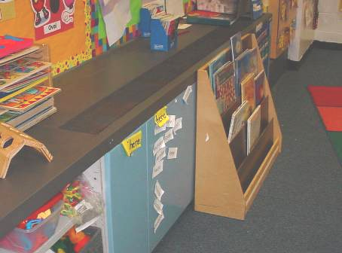

Classroom Univent

Picture 2

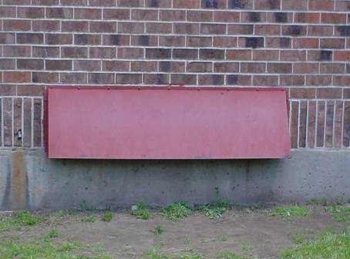

Univent Fresh Air Intake, Note Sheet-Metal Protective Hood

Picture 3



Front Wall of Classroom, Note Open Storage Area below White Board
Used to Draw Exhaust from Classroom

Picture 4

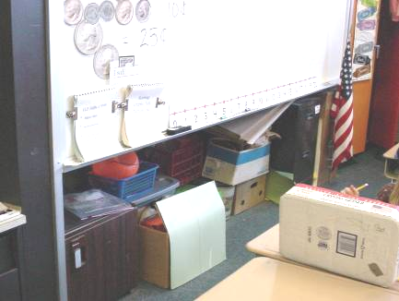

Close-Up of Open Storage Area at Front of Classroom
Used to Draw Exhaust from Classroom
Picture 5

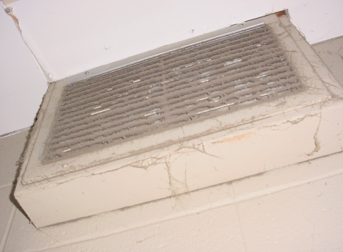

Exhaust Vent Located in/near the Ceiling of Storage Closets, Note Heavy Dust/Debris Accumulation

Picture 6



Storage Area at Front of Classroom Obstructed with Sheets, Limiting Airflow
Picture 7

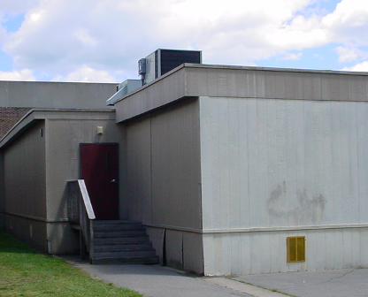

Rooftop AHU for Modular Classroom

Picture 8

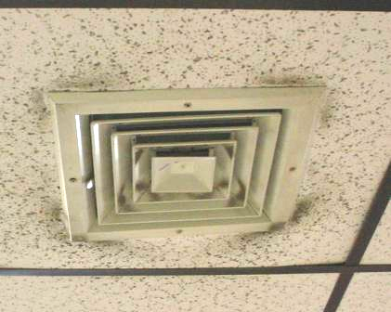

Ceiling-Mounted Air Diffusers in Modular Classroom, Note Dust/Debris Accumulation on/around Vent/Ceiling Tiles

Picture 9

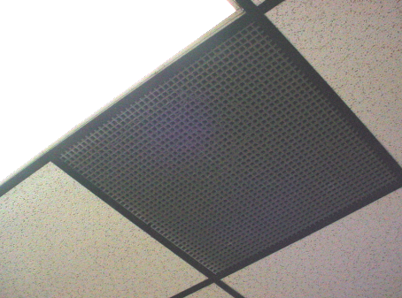

Ceiling-Mounted Return Vent in Modular Classroom

Picture 10

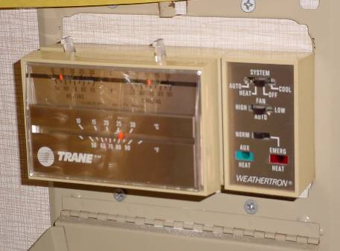

Thermostat for Modular Classroom, Note Fan Switch in “Auto” Position
Picture 11

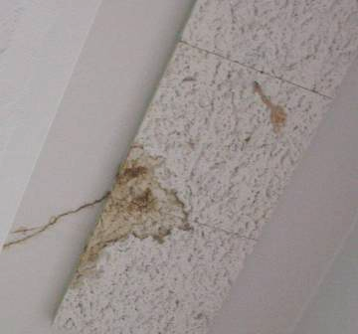

Water Stained Ceiling Tiles and (Discolored) Crack in Concrete Ceiling,
Indicating Water Penetration

Picture 12

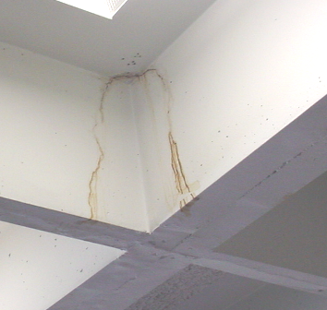

Water Stained Concrete Ceiling, Indicating Water Penetration from Crack

Picture 13

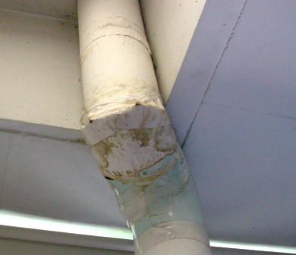

Water Damaged Pipe Insulation

Picture 14

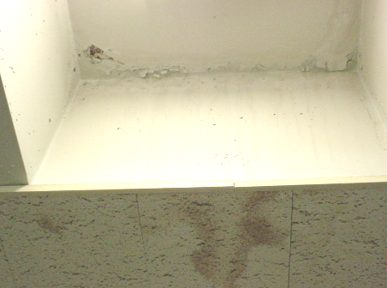

Water Stained Concrete/Ceiling Tiles and Peeling Paint
Picture 15

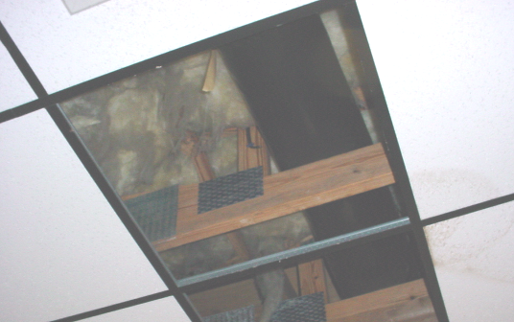

Missing Damaged Ceiling Tiles Due to Roof Leaks in Modular Classroom 2,
Note Exposed Fiberglass Insulation

Picture 16

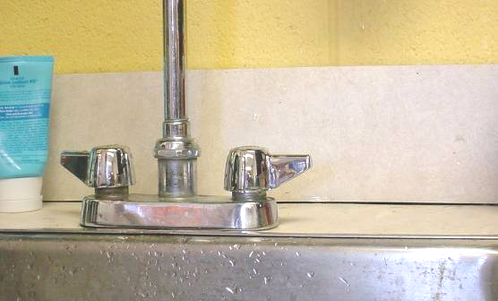

Spaces between Sink Countertop and Backsplash
Picture 17

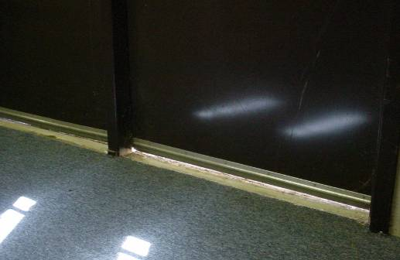

Light Penetrating from beneath Modular Classroom Exterior Doors

Picture 18

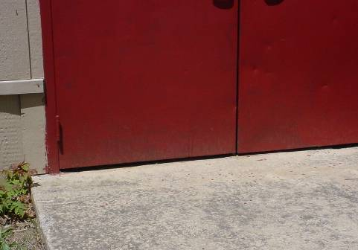

Spaces beneath Modular Classroom Exterior Doors

Picture 19

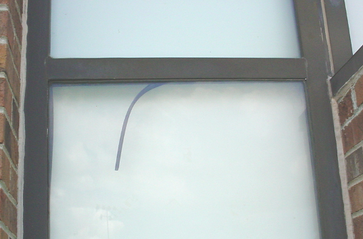

Loose Strip Caulking in Window

Picture 20

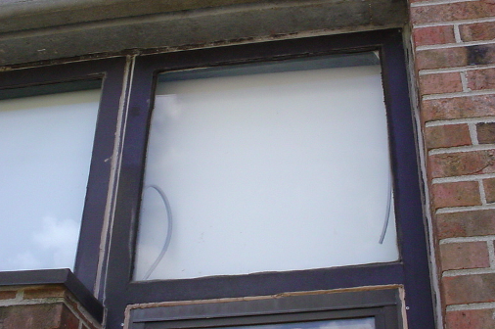

Loose Strip Caulking in Window

Picture 21

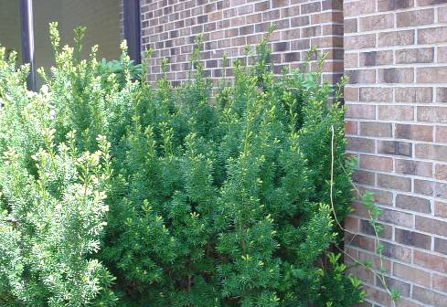

Shrubbery in Contact with Exterior Brick

Picture 22

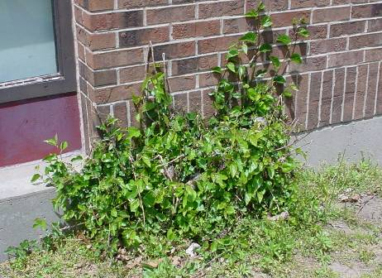

Shrubbery/Roots in Contact with Exterior Brick/Foundation

Picture 23

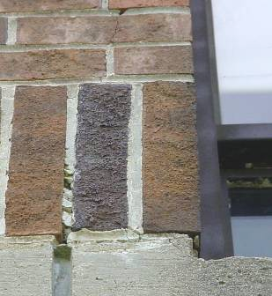

Missing/Damaged Mortar around Exterior Brick

Picture 24

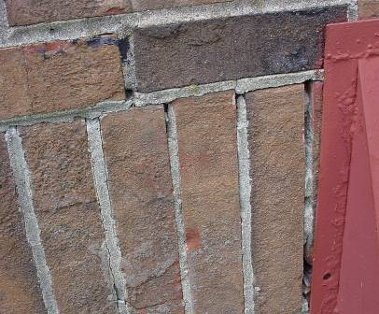

Missing/Damaged Mortar around Exterior Brick

Picture 25

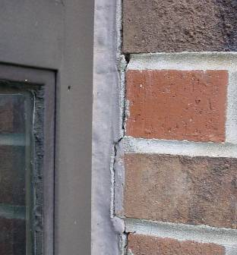

Missing/Damaged Joint Compound/Sealant

Picture 26

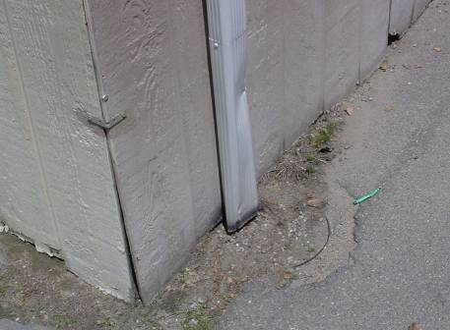

Downspout on Modular Classroom Missing Elbow Extension

Picture 27

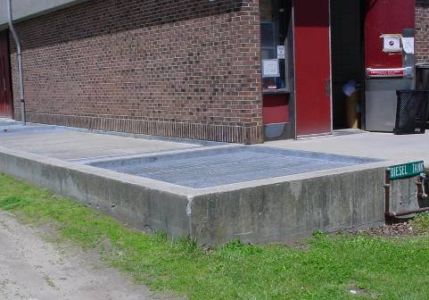

Cement-Lined/Grated Pit at Rear of the Building

Picture 28

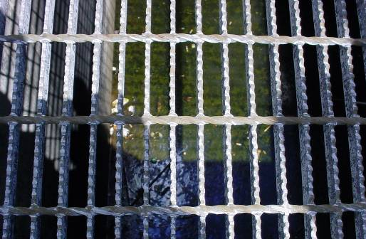

Standing Water at Bottom of Cement-Lined/Grated Pit
Location/ Room | Occupants  in Room | Temp  (°F) | Relative  Humidity  (%) | Carbon  Dioxide  (ppm) | Carbon Monoxide  (ppm) | PM2.5  (µg/m³) | Windows  Openable | Ventilation |  | Remarks
 |  |  |  |  |  |  |  | Supply | Exhaust | Remarks
background |  | 67 | 49 | 353 | ND | 6 |  |  |  | Mostly Sunny; winds NE 5-10 mph
Art | 0 | 74 | 39 | 1372 | ND | 16 | N | Y  off | Y  off | PS; CD
B-16 | 0 | 74 | 35 | 445 | ND | 2 | Y | Y | Y | DEM
B-21 | 11 | 72 | 38 | 1051 | ND | 6 | N | Y | Y  weak | CD; UF
B-31 | 1 | 74 | 36 | 948 | ND | 9 | N | Y | Y  off
B-32 | 0 | 74 | 36 | 946 | ND | 10 | N | Y |  | MT
B-5 basement work room | 0 | 72 | 37 | 677 | ND | 5 | Y | Y
B-5 work room | 0 | 73 | 37 | 424 | ND | 3 | Y | Y  blocked
C-05 | 0 | 73 | 42 | 463 | ND | 3 | Y | Y |  | DEM
C-07 | 0 | 73 | 31 | 1248 | ND | 10 | Y | Y  debris |  | Carpet rippled; CD; DEM
C-08 | 5 | 73 | 38 | 1278 | ND | 20 | Y | Y  off
Café | 200 | 73 | 38 | 600 | ND | 7 | N | Y | Y
Curriculum office | 1 | 73 | 37 | 804 | ND | 7 | N | Y  off | Y  off | Wall-to-wall carpet
D-15 | 14 | 73 | 37 | 774 | ND | 10 | N | Y | Y
D-25 | 17 | 70 | 42 | 637 | ND | 8 | N | Y | Y  off, dusty | WD pipe insulation
D-31 | 16 | 71 | 42 | 750 | ND | 7 | N | Y | Y  off, dusty | Stained concrete-leak, historic damage
D-34 Reading | 0 | 74 | 36 | 767 | ND | 7 | N | Y  off | Y  off, dust | Clutter; wal1-to-wall carpet
Gym | 30 | 76 | 38 | 847 | ND | 27 | N | Y | Y | Vent off
Library | 14 | 73 | 34 | 558 | ND | 4 | N | Y | off | Space around exterior door
Library 2nd floor |  |  |  |  |  |  |  | Y  off | Y | Coving removed
Modular classroom 1 | 16 | 74 | 39 | 1242 | ND | 5 | Y | Y | Y | Thermostat fan set to “on”; dust/debris on vents; 1 WD CT
Modular classroom 2 | 17 | 73 | 38 | 1565 | ND | 15 | Y | Y | Y | Thermostat fan set to “auto”; 2 MTs, active leak, exposed fiber insulation; dust/debris on vents; WD CT
Music | 15 | 74 | 37 | 969 | ND | 17 | N | Y | Y
Nurse | 4 | 73 | 41 | 1004 | ND | 5 | Y | Y | Y  dirty
Pod 1 “F” | 18 | 73 | 38 | 835 | ND | 9 | N | Y | Y | Peeling paint, efflorescence, stained CT
Pod 1 “J” | 21 | 69 | 38 | 750 | ND | 7 | N | Y | Y
Pod 1 “M” | 16 | 73 | 37 | 904 | ND | 9 | N | Y  off | Y
Pod 1 “MC” | 19 | 73 | 39 | 699 | ND | 9 | N | Y | Y  blocked
Pod 2 “A” | 18 | 74 | 36 | 619 | ND | 5 | N | Y | Y
Pod 2 “AL” | 1 | 74 | 37 | 738 | ND | 6 | Y | Y | Y
Pod 2 “K” | 17 | 74 | 37 | 671 | ND | 6 | N | Y | Y
Pod 2 “L” | 20 | 74 | 37 | 760 | ND | 5 | Y | Y | Y
Pod 2 “M” | 1 | 72 | 39 | 637 | ND | 6 | N | Y | Y | 1 MT
Pod 2 “P” | 0 | 74 | 36 | 684 | ND | 8 | N | Y | Y
Pod 3 | 7 | 73 | 34 | 561 | ND | 5 | Y | Y  blocked | Y | DEM; space between sink and backsplash; spray cleaners; humidifier
Pod 3 rear classroom | 0 | 73 | 34 | 568 | ND | 5 | Y | Y | Y | DEM
Pod 4 East door | 49 | 76 | 35 | 710 | ND | 4 | Y | Y | Y | 25 computers
Pod 4 rear classroom | 13 | 76 | 35 | 670 | ND | 2 | Y | Y | Y | Peeling paint; UF; DEM; plants
Pod 4 West door | 49 | 76 | 36 | 685 | ND | 7 | Y | Y | Y  dusty | Peeling paint, DEM, space between sink and backsplash; PS
Pod 5 “Bu” | 2 | 74 | 38 | 667 | ND | 10 | Y | Y | Y | 20 occupants gone 1 min., WD paper on wall
Pod 5 “K” | 0 | 75 | 36 | 713 | ND | 6 | Y | Y | Y | UF; DEM
Pod 5 “N” | 2 | 74 | 38 | 717 | ND | 8 | Y | Y | Y
Pod 5 rear classroom | 0 | 75 | 36 | 631 | ND | 6 | Y | Y | Y | DEM; humidifier
Pod 6 | 60 | 72 | 40 | 815 | ND | 8 | Y | Y | Y | DEM; cleaners
Pod 6 rear classroom | 0 | 71 | 36 | 720 | ND | 5 | Y | Y | Y | PF; DEM; cleaners

