INDOOR AIR QUALITY ASSESSMENT

Joshua Hyde Public Library
306 Main St
Sturbridge, MA

Prepared by:
Massachusetts Department of Public Health
Bureau of Environmental Health
Indoor Air Quality Program
November 2018

Background
Building: | Joshua Hyde Public Library (JHPL)
Address: | 306 Main St, Sturbridge
Assessment Requested by: | Tricia Valiton, Health Inspector, Town of Sturbridge
Reason for Request: | General indoor air quality (IAQ) concerns
Date of Assessment: | October 26, 2018
Massachusetts Department of Public Health/Bureau of Environmental Health (MDPH/BEH) Staff Conducting Assessment: | Ruth Alfasso, Environmental Engineer/Inspector, IAQ Program
Building Description: | The JHPL was originally built in the 1800s. Additions and renovations occurred in 1989. The JHPL is a yellow brick building with a large central skylight. The interior includes a main floor, balcony, lower level children’s library, and basement event space. Since the building is located on a hill, lower level areas also exit to ground level.
Building Population: | Approximately 5 staff work in the building. Members of the public visit daily.
Windows: | Openable

Methods
Please refer to the IAQ Manual for methods, sampling procedures, and interpretation of results (MDPH, 2015).

IAQ Testing Results
The following is a summary of indoor air testing results (Table 1).
- Carbon dioxide levels were below the MDPH guideline of 800 parts per million (ppm) in all areas assessed.
- Temperature was within the recommended range of 70°F to 78°F in the ground floor area, but mostly below on the lower levels.
- Relative humidity was below the recommended range of 40 to 60% in all areas assessed.
- Carbon monoxide levels were non-detectable (ND) in all areas assessed.
- Fine particulate matter (PM2.5) concentrations measured were below the National Ambient Air Quality Standard (NAAQS) level of 35 μg/m³ in all areas assessed.

Ventilation
A heating, ventilating, and air conditioning (HVAC) system has several functions. First it provides heating and, if equipped, cooling. Second, it is a source of fresh air. Finally, an HVAC system will dilute and remove normally-occurring indoor environmental pollutants by not only introducing fresh air, but by filtering the airstream and removing stale air to the outdoors via exhaust ventilation. Even if an HVAC system is operating as designed, point sources of respiratory irritants may be present and produce symptoms in sensitive individuals. The following analysis examines and identifies components of the HVAC system and likely sources of respiratory irritant/allergen exposure due to water damage, aerosolized dust, and/or chemicals found in the indoor environment.
The JHPL main floor is served by an HVAC system located on the roof. This system heats or cools fresh air and supplies it through ducts to vents located in the ceiling (Pictures 1 through 3). Return vents are present on the walls of the main room (Picture 4). This HVAC system was installed in the 1980s. Floor-mounted vents exist in the front part of the main floor (Picture 5). To maximize air exchange, the MDPH recommends that both supply and exhaust ventilation operate continuously during periods of occupancy. In order to have proper ventilation with a mechanical supply and exhaust system, the systems must be balanced to provide an adequate amount of fresh air to the interior of a room while removing stale air from the room. It is recommended that HVAC systems be re-balanced every five years to ensure adequate air systems function (SMACNA, 1994). This HVAC system was most recently balanced in early 2018.
On the lower level, unit ventilators supply tempered air from vents in the side of the building (Pictures 6 and 7). Note that one of the fresh air intake vents is obstructed by plants.
Direct-vented exhaust vents were present in the bathroom on the main floor and the boys’ and girls’ bathrooms in the children’s library. Direct ventilation is recommended wherever pollutants, odors and water vapor are generated, particularly in bathrooms and areas which may produce moisture and odors.

Microbial/Moisture Concerns
It is important to note that the Boston area experienced an unprecedented period of extended hot, humid weather. According to the Washington Post, “[d]ata…show[s]…cities in the Northeast have witnessed such humidity levels for record-challenging duration...[i]ncluding Albany, Boston, Burlington Portland and Providence” during the summer of 2018 (WP, 2018). “Boston and nearby locations… [saw]…historic numbers of those warm nights with low temperatures at or above 70 degrees…Providence and Blue Hill Observatory have already broken their annual records” (WP, 2018). If a building does not have either adequate exhaust ventilation and/or air chilling capacity to remove/reduce relative humidity from outside air, then hot, moist air can be introduced into a building and linger to increase occupant discomfort as well as possibly moisten materials that may lead to mold growth.
There were several concerns expressed by staff relating to water damage and odors in the building. Water-damaged ceiling tiles were observed in many areas (Pictures 8 and 9; Table 1), although the style of acoustic ceiling tile used in much of the building does not easily show water damage. A portion of the ceiling tile system on the main floor was removed and covered with plastic (Picture 10) reportedly due to chronic leaks from the roof and/or HVAC system. This portion of the ceiling was removed in August of 2018 along with other remediation efforts by a water damage remediation contractor (ServPro). According to documentation provided by ServPro, the area was contained using plastic sheeting, several bags of moistened ceiling tiles and insulation were removed, and the area was cleaned prior to removal of the containment barrier. It is not known when the ceiling tiles will be replaced.
It was also reported that some ceiling tiles had been removed and replaced in the stairwell from the main area down to the children’s library shortly prior to the IAQ program visit (area shown in Picture 1). Water-damaged tiles should be replaced as soon as the leaks are repaired as they can be a source of mold and odors. In addition, replacing water-damaged tiles can make detecting new leaks easier. It was reported by building occupants that attempts have been made to repair the roof and HVAC system, but leaks still occur.
Building staff reported musty odors in the stairwell and Children’s Library main area. A slight musty odor was apparent in the stairwell. Several areas were investigated, and no odor was detected from the hatchway to the roof (Picture 11). Exposed insulation in the area shown was dry. An odor was present in the janitor’s closet (Picture 12) which opens onto this stairwell which has a janitorial sink as well as mops and mop buckets. Stagnant water from mops, a dry drain trap or debris-filled drain, and moistened walls from spills can all lead to musty/moldy odors. Note that the janitor’s closet did not have an exhaust vent which would help in removing odors.
There were reports of several other water-related issues in the building including the recent failure of a water heater which moistened carpeting in the lower level. The carpeting was reportedly dried at the time using heating and fans. At the time of the visit, the carpeting was dry. However, the BEH IAQ program does not recommend carpeting in areas that are below grade as they are likely to be moistened by condensation.
An odor like sewage was detected in the girls’ bathroom in the children’s library. No odor was detected in the boys’ bathroom directly next to this room. The odor was not coming from the floor drain or sinks at the time of the assessment. It is possible that the wax seal on the toilet is damaged or that there is a break in sewer vent lines from the room.
In the lowest level, there is a small kitchen with a sink, which had items, including porous items underneath it (Picture 13). There are also two storage rooms, one of which had a large sink in it which is currently not used (Picture 14). If this drain is not periodically filled with water, the trap will become dry and allow sewer odors and gas into the room.
There is also an unfinished basement area right off the stairwell that has a concrete floor with brick and stone walls. The water heater and controls for the HVAC system are located in this area (Picture 15). This location has at least periodic humidity/moisture issues as shown by mold spots on wallboard used on the ceiling near the door to the stairwell (Picture 16). The wallboard should be replaced with a non-porous material. As shown in Picture 15, a dehumidifier is present but was not operating at the time of the assessment. Dehumidifiers can prevent moisture-related issues in basement areas, but they need to be maintained regularly, including emptying receptacles and cleaning, to prevent mold growth and odors.
This area is used for storage and has items and surfaces with dust and debris on them, but no musty odors were detected. It is important that the door to this area from the hallway/stairwell be made as air-tight as possible to avoid moisture, odors, dust/debris and pests from migrating to occupied areas. Also note that within this basement area is a second door which leads to an unfinished basement area with a dirt floor and low ceiling (Pictures 17 and 18). While some ductwork and electrical service runs through this area, this space should generally not be used for storage or other activities unless needed for maintenance. The door between the two basement areas is not air-tight, gaps exist between the door frame and wall (Picture 19), and electric wires run along the top of the door preventing it from closing completely (Picture 20). This door should also be rendered as air-tight as possible.
The exterior of the building was examined for additional sources of moisture/water infiltration and the following were noted:
- Building gutter downspouts were found disconnected (Picture 21).
- Plants were found up against the foundation in several areas (Pictures 7 and 22). Plants hold moisture against the side of the building and roots can damage the foundation and lead to water infiltration. In addition, plants can be a source of pollen, mold and odors into the indoor air when they are close to intake vents as shown in Picture 7.

Other Conditions
Upholstered furniture and plush toys are present in several areas (Picture 23; Table 1). Upholstered furniture, pillows and cushions are covered with fabric that comes in contact with human skin. This type of contact can leave oils, perspiration, hair and skin cells. Dust mites feed upon human skin cells and excrete waste products that contain allergens. In addition, if relative humidity levels increase above 60 percent, dust mites tend to proliferate (US EPA, 1992). In order to remove dust mites and other pollutants, frequent vacuuming of upholstered furniture is recommended (Berry, M.A., 1994). It is also recommended that upholstered furniture be professionally cleaned on an annual basis. If outdoor conditions or indoor activities (e.g., renovations) create an excessively dusty environment, cleaning frequency should be increased (every six months) (IICRC, 2000).
In some areas, there were items on the floor, against walls and on flat surfaces, which makes it difficult to clean (Picture 24). Items should be stored neatly and moved periodically for cleaning. Cloth curtains were in use for some of the tall windows, and the upper portions of these in particular appeared dusty. Curtains should be cleaned periodically to remove dust.
Some portions of the building are carpeted. Carpeting should also be cleaned several times a year in accordance with IICRC recommendations (IICRC, 2012). Carpeting in areas that may be subject to chronic moistening (e.g., entrance areas) should be removed and replaced with non-porous flooring.

CONCLUSIONS/RECOMMENDATIONS
Based on the observations made during the visit, the following recommendations are made:
- Operate the HVAC system when the building is occupied.
- Continue with regular maintenance of the HVAC system including filter changes.
- Develop a plan for addressing roof/HVAC leaks and replace ceiling tiles when leaks are addressed.
- Ensure that drains, mops and mop buckets, and other materials in the janitor’s closet are dry and odor-free. Clean or replace as needed.
- Check the seal on the toilet in the girls’ bathroom in the children’s library for gaps leading to sewer odor. If this does not resolve the odor, consider contracting with a plumber to investigate if there are gaps in pipes or vents.
- Remove any carpeting that in the past had been wet and not properly dried. Check under carpeting and coving/wallboard for any signs of microbial growth and remediate as needed.
- Consider removing carpeting in basement areas and near entrances and installing non-porous flooring materials (e.g., tile).
- Ensure the janitorial sink on the lowest level is periodically filled with water. If this sink is no longer needed, consider having it properly removed and the plumbing cut and capped.
- Avoid placing porous items under the sink in the lower level.
- Ensure that doors between conditioned and unconditioned areas (outdoors, basement, attic) are well-fitted, weather-tight and kept closed.
- Remove the mold-colonized wallboard from the ceiling in the basement (Picture 16).
- If the dehumidifier in the basement is to be used, ensure it is properly maintained, including cleaning and drainage.
- Do not store any porous items in direct contact with the basement floor.
- Remove any stored items from the less finished basement and render the door between the two basement areas weather tight, including filling gaps between the door frame and wall with an appropriate sealant.
- Ensure the gutter/downspout system is intact and directing water away from the building.
- Remove plants away from the foundation, and particularly away from fresh air supply vents.
- Keep stored items off the floor and contained in an organized manner (e.g., shelves, cabinets or totes) to make them easier to clean. Non-porous stored items should be cleaned periodically using a high efficiency particulate arrestance (HEPA) filter-equipped vacuum cleaner followed by wet wiping to prevent the buildup of dusts that can become re-aerosolized or dampened and mold-colonized.
- Clean personal fans, supply and exhaust vents regularly to prevent aerosolization of debris.
- Clean carpeting, upholstered items, and curtains regularly in accordance with IICRC recommendations (IICRC, 2012).
- Refer to resource manual and other related IAQ documents located on the MDPH’s website for further building-wide evaluations and advice on maintaining public buildings. These documents are available at: http://mass.gov/dph/iaq.

References
Berry, M.A. 1994. Protecting the Built Environment: Cleaning for Health. Michael A. Berry, Chapel Hill, NC.
IICRC. 2000. IICRC S001. Reference Guideline for Professional On-Location Cleaning of Textile Floor Covering Materials. Institute of Inspection, Cleaning and Restoration Certification. Institute of Inspection Cleaning and Restoration, Vancouver, WA.
IICRC. 2012. Institute of Inspection, Cleaning and Restoration Certification. Carpet Cleaning: FAQ.
MDPH. 2015. Massachusetts Department of Public Health. Indoor Air Quality Manual: Chapters I-III. Available at: http://www.mass.gov/eohhs/gov/departments/dph/programs/environmental-health/exposure-topics/iaq/iaq-manual/.
SMACNA. 1994. HVAC Systems Commissioning Manual. 1st ed. Sheet Metal and Air Conditioning Contractors’ National Association, Inc., Chantilly, VA.
US EPA. 1992. Indoor Biological Pollutants. US Environmental Protection Agency, Environmental Criteria and Assessment Office, Office of Health and Environmental Assessment, research Triangle Park, NC. EPA 600/8-91/202. January 1992.
WP. 2018. ‘It’s been relentless’: Smothering summer humidity in the Northeast has crushed records. Washington Post, Washington, DC. https://www.washingtonpost.com/news/capital-weather-gang/wp/2018/08/30/its-been-relentless-smothering-summer-humidity-in-the-northeast-has-crushed-records/

Picture 1
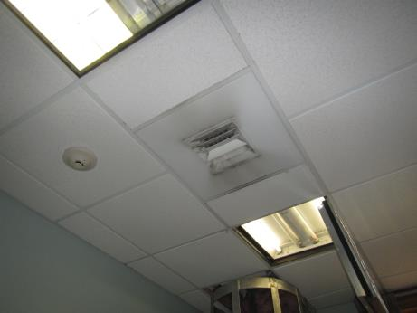
Supply vent in stairwell
Picture 2
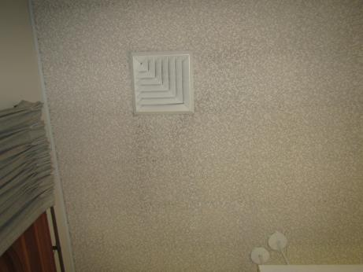
Supply vent in non-fiction section
Picture 3
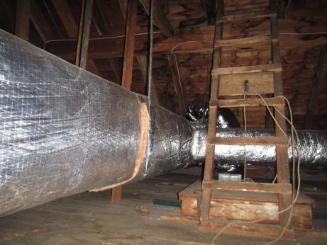
Ducts in attic above main floor
Picture 4
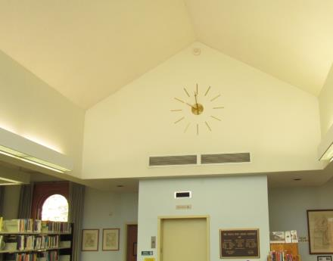
Return vents
Picture 5
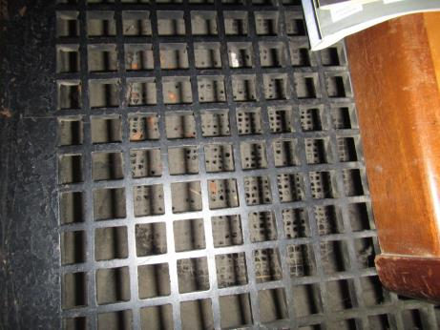
Dust in floor vent in Mystery section
Picture 6
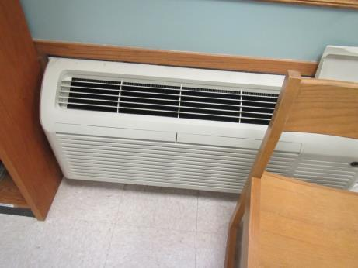
Unit ventilator in lower level
Picture 7
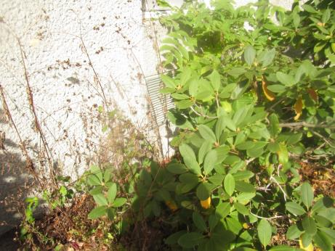
Supply vent for lower level unit ventilator, obstructed by plants
Picture 8
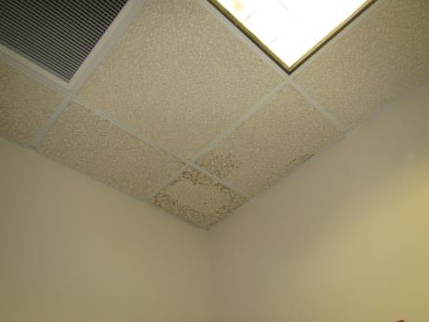
Water-damaged ceiling tile
Picture 9
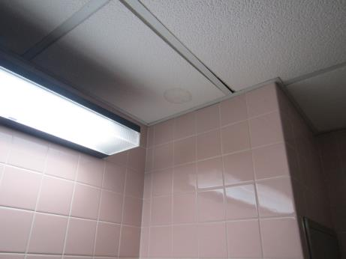
Water-damaged ceiling tile in the girls’ bathroom on the lower level
Picture 10
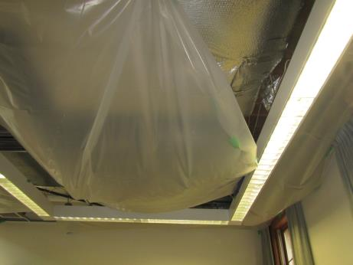
Removed ceiling tiles and plastic covering over part of the main floor
Picture 11
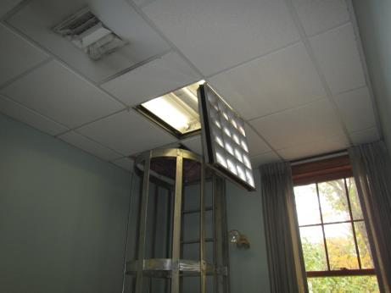
Ladder for roof access in stairwell, note exposed insulation, curtains, and open light cover
Picture 12
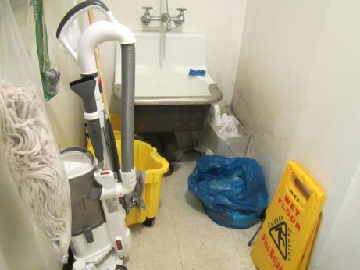
Janitorial closet with slop sink and mops
Picture 13
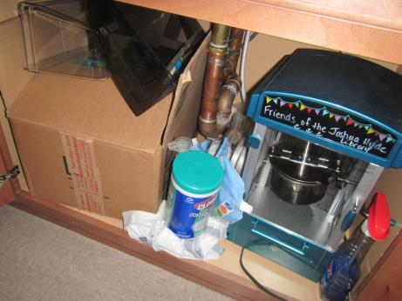
Box and other porous items under the sink in the lower level
Picture 14
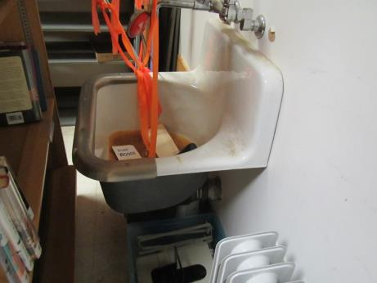
Disused large sink in lower level storage room
Picture 15
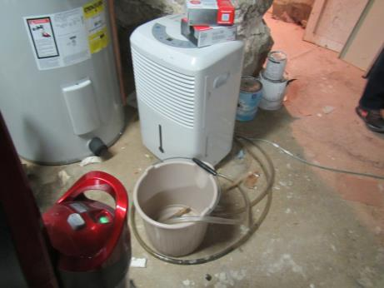
Dehumidifier (not currently plugged in) and water heater in concrete-floored basement
Picture 16
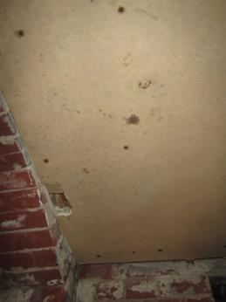
Mold-colonized wallboard on the ceiling of the basement
Picture 17
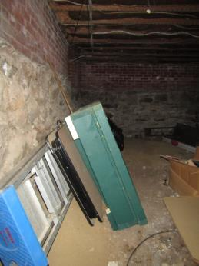
Unfinished basement
Picture 18
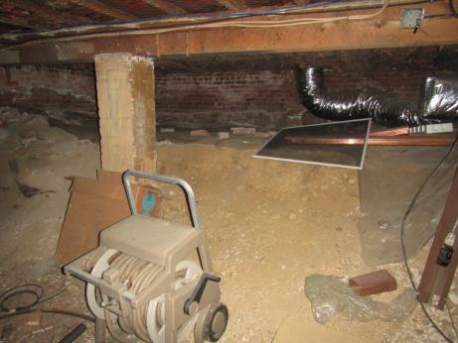
Items, ductwork, dirt floor in unfinished basement
Picture 19
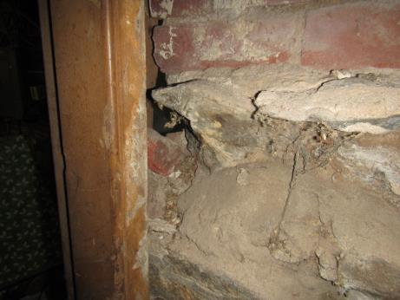
Gap between door frame and wall on door between basement areas
Picture 20
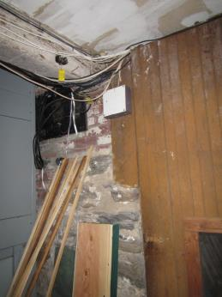
Wires preventing door from closing completely
Picture 21
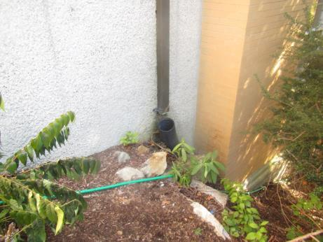
Disconnected downspout
Picture 22
Plants against the side of the building
Picture 23
Plush toys
Picture 24
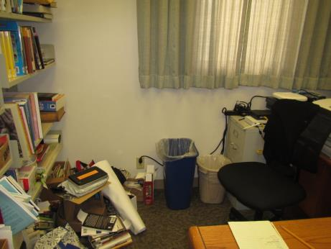
Items on the floor
Location | Carbon  Dioxide  (ppm) | Carbon Monoxide  (ppm) | Temp  (°F) | Relative  Humidity  (%) | PM2.5  (µg/m³) | Occupants  in Room | Windows  Openable | Ventilation |  | Remarks
 |  |  |  |  |  |  |  | Supply | Exhaust
Background | 396 | ND | 45 | 24 | 2
Basement
Events area | 533 | ND | 66 | 26 | ND | 1 | Y | Y |  | Unit ventilator, NC with area rug, elevator room
Kitchen | 516 | ND | 66 | 27 | ND | 1 | Y | Y |  | Dishwasher, fridge, microwave, items under sink, book donation storage
Storage 1 | 566 | ND | 64 | 35 | ND | 0 | N | N | N | Stored books and other items (mostly not on floor)
Storage 2 |  |  |  |  | ND | 0 | N | N | N | Old slop sink, not used (dry trap?), books and other items (not on floor)
Lower Level
Children’s Library | 520 | ND | 71 | 29 | ND | 1 |  | Y | Y | Carpeting
CL girls RR | 592 | ND | 65 | 37 | ND | 0 | N | Y | Y | Exhaust is on, odor like sewer (not from floor drain), WD CT
CL boys RR | 583 | ND | 66 | 34 | ND | 0 | N | Y | Y | No odor
CL behind desk | 561 | ND | 67 | 35 | ND | 1 | Y | Y | Y | Plush toys, art supplies in cabinets
Main floor
Mystery book area | 642 | ND | 75 | 24 | 1 | 1 | Y | Y | Y | Floor vent dusty
Main open area | 785 | ND | 73 | 26 | 2 | 0 | Y | Y | Y | Part of ceiling tile system missing due to leaks, upholstered furniture
Non-fiction | 587 | ND | 73 | 26 | 1 | 2-3 | Y | Y | Y | Window screen ripped
Librarian office | 606 | ND | 72 | 25 | 2 | 0 | N | Y | Y | Items on floor
Librarian lounge | 626 | ND | 74 | 24 | 2 | 0 | Y | Y | Y | Carpeted, fridge and microwave, 2 WD CT
Work room | 677 | ND | 73 | 24 | 4 | 0-1 | Y | Y | Y | 1 WD CT
Main area, front | 626 | ND | 72 | 24 | 1 | 3 | Y | Y | Y
Front area restroom |  |  |  |  |  |  | N | N | Y | Restroom exhaust is on a switch
Upper level balcony area | 777 | ND | 76 | 26 | ND | 0 | N | Y |  | Ceiling fan not currently on. Access to attic through this area

