
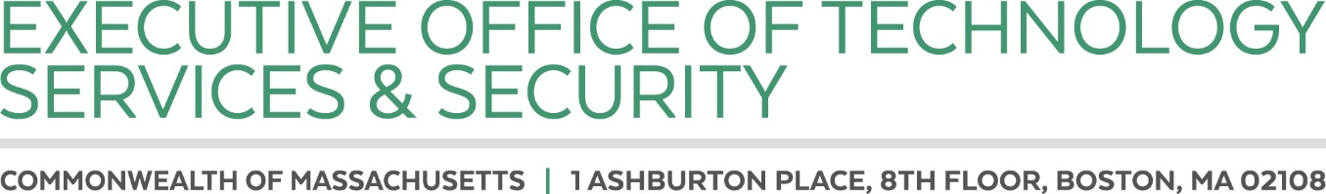

CHARLES D. BAKER
Governor

KARYN E. POLITO
Lieutenant Governor

CURTIS M. WOOD
Secretary

Posted: July 7, 2022

NOTICE OF OPEN MEETING

Pursuant to the provisions of G.L. c. 30A, M.G.L. c. 7D, § 11, 940 CMR 29.00 et seq., and Section 20 of Chapter 20 of the Acts of 2021, the Justice Reinvestment Policy Oversight Board will meet remotely on Tuesday, July 12, at 11:00am via Zoom. Board members and members of the public may join via a browser or by dialing in. Zoom information is included on the following page.

Meeting Agenda:

- Roll call.
- Review and approve meeting minutes from June 13th, 2022.
- Update on cross-tracking initiative.
- Board member comments.
- Public comments.
- Matters not reasonably anticipated by Chair.

If any member of the public wishing to attend this meeting seeks special accommodations in accordance with the Americans with Disabilities Act, please contact Shannon Sullivan, EOTSS General Counsel, at shannon.c.sullivan@mass.gov.

Join Zoom Meeting
https://zoom.us/j/94111406634?pwd=WGNnRzJ3ckRsa0xlRWp4TW5NL2ZBZz09

Meeting ID: 941 1140 6634
Passcode: 088488
One tap mobile
+13017158592,,94111406634#,,,,*088488# US (Washington DC)
+13126266799,,94111406634#,,,,*088488# US (Chicago)

Dial by your location
+1 301 715 8592 US (Washington DC)
+1 312 626 6799 US (Chicago)
+1 929 205 6099 US (New York)
+1 253 215 8782 US (Tacoma)
+1 346 248 7799 US (Houston)
+1 669 900 6833 US (San Jose)
Meeting ID: 941 1140 6634
Passcode: 088488
Find your local number: https://zoom.us/u/arWS08Gpp

