
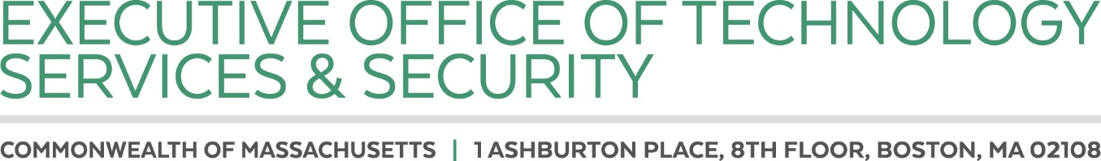

CHARLES D. BAKER
Governor

KARYN E. POLITO
Lieutenant Governor

CURTIS M. WOOD
Secretary

Posted: September 22, 2022

NOTICE OF OPEN MEETING

Pursuant to the provisions of G.L. c. 30A, M.G.L. c. 7D, § 11, 940 CMR 29.00 et seq., and Section 20 of Chapter 20 of the Acts of 2021, the Justice Reinvestment Policy Oversight Board will meet remotely on Thursday September 29, at 10:00am via Zoom. Board members and members of the public may join via a browser or by dialing in. Zoom information is included on the following page.

Meeting Agenda:

- Roll call.
- Review and approve meeting minutes from June 13th, 2022.
- Update on cross-tracking initiative.
  - EOPSS will present cross-tracking roadmap
4. Plan for scheduling remainder of FY23 Meetings
5. Board member comments.
6. Public comments.
7. Matters not reasonably anticipated by Chair.

If any member of the public wishing to attend this meeting seeks special accommodations in accordance with the Americans with Disabilities Act, please contact EOTSS Acting General Counsel, Tom Myers at thomas.b.myers2@mass.gov.

Join Zoom Meeting
https://zoom.us/j/96034152926?pwd=NGlrK3c1SkxJeVRuUUpCMU1aZEY0dz09

Meeting ID: 960 3415 2926
Passcode: 672224
One tap mobile
+19292056099,,96034152926#,,,,*672224# US (New York)
+13017158592,,96034152926#,,,,*672224# US (Washington DC)

Dial by your location
+1 929 205 6099 US (New York)
+1 301 715 8592 US (Washington DC)
+1 309 205 3325 US
+1 312 626 6799 US (Chicago)
+1 646 931 3860 US
+1 386 347 5053 US
+1 564 217 2000 US
+1 669 444 9171 US
+1 669 900 6833 US (San Jose)
+1 719 359 4580 US
+1 253 215 8782 US (Tacoma)
+1 346 248 7799 US (Houston)
Meeting ID: 960 3415 2926
Passcode: 672224
Find your local number: https://zoom.us/u/adYJF6kteR

