INDOOR AIR QUALITY ASSESSMENT
INCIDENT RESPONSE

J.S. Sullivan Elementary School
151 Kemp Avenue
North Adams, Massachusetts 01247

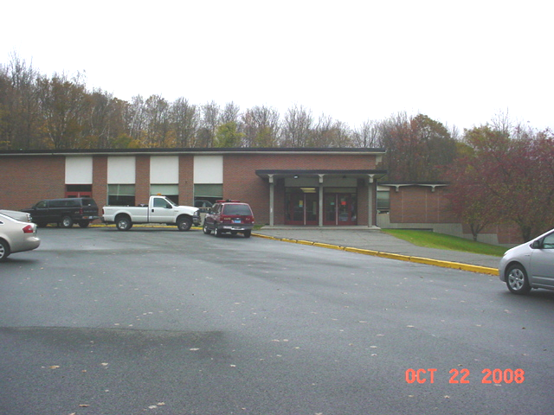

Prepared by:
Massachusetts Department of Public Health
Bureau of Environmental Health
Indoor Air Quality and Environmental Toxicology Programs
October 2008

Background/Introduction
On the evening of Tuesday, October 21, 2008, the Massachusetts Department of Public Health (MDPH), Bureau of Environmental Health (BEH) was contacted to provide consultation and assistance regarding an incident involving a broken mercury thermometer at the J.S. Sullivan Elementary School (SES), 151 Kemp Avenue, North Adams, Massachusetts. As a result of the incident, indoor air quality and exposure concerns were raised.
On October 21, 2008, school staff found the remains of a broken mercury thermometer in a hallway outside a locker in the lower wing of the building (Picture 1). Shortly after this discovery was made, the North Adams Board of Health, North Adams Fire Department, Massachusetts Department of Environmental Protection (MDEP) and State Hazardous Materials (HazMat) Team were contacted and the building was closed. The State HazMat Team conducted mercury air sampling, and evaluated/remediated contaminated materials. The HazMat team removed the lockers to clean up the spill in and around the locker. Mercury beads were removed and broken glass was picked up. The area was then cleaned with soap and water. The hallway was ventilated overnight to remove mercury vapors.
Later in the evening of October 21, 2008, Beverly Anderson, Director of BEH’s Coordinated Environmental Response, contacted Michael Feeney, Director of the BEH’s Indoor Air Quality Program. Mr. Feeney subsequently contacted Martha Steele, Deputy Director of BEH, and various North Adams city officials involved in the response to the incident. Ms. Anderson also contacted Mary Clark, Director of the MDPH’s Bureau of Emergency Preparedness and the MDPH Communications Office to report the incident. On Wednesday, October 22, 2008, Mike Feeney visited the SES to assist in evaluation and remediation efforts related to the mercury release.

Methods
BEH staff performed a visual inspection of the building’s heating, ventilation and air conditioning (HVAC) system for pathways of mercury migration. At the request of North Adams city officials, the MDEP conducted mercury testing using a LUMEX Zeeman mercury analyzer RA-915 (Lumex).

Discussion
As mentioned, the HazMat team screened for mercury vapors using a Jerome mercury vapor analyzer (Jerome meter). The Jerome meter has a detection limit of 3 µg/m³ (AI, 2005). All samples taken by the HazMat team were reportedly below the detection limit, with the exception of the samples taken directly over the mercury beads and broken glass on the floor and in the locker. These results indicated that mercury contamination was contained to the floor and locker where the thermometer had broken, and were not spread to other areas of the school. For these reasons, it was concluded that human exposure to mercury, at levels approaching health concern, were extremely unlikely.
While it is helpful to determine if acute hazards exist, the Jerome meter does not have the capacity to measure levels less than 1 µg/m³ (1,000 ng/m³), the Agency for Toxic Substances and Disease Registry (ATSDR) Suggested Action Level (SAL) for mercury clean up air (ATSDR, 2001). In order to determine if mercury concentrations in the NACH were below the ATSDR SAL, North Adams city staff requested the MDEP conduct air sampling using a LUMEX (Picture 2). The LUMEX has a detection limit of 0.002 µg/m³ (2 ng/m³) for measuring mercury vapor (LUMEX, 2008). All samples measured on the floor and locker using the LUMEX were below the ATSDR SAL for mercury (Table 1).

Conclusions/Recommendations
In view of findings at the time of assessment, no further recommendations were made concerning mercury contamination clean up nor in relation to concerns over human exposure.

References
AI. 2005. Jerome 431-X Mercury Vapor Analyzer Operation Manual. Arizona Instruments LLC, Tempe, AZ www.azic.com/pdf/manual_700-0046.pdf

ATSDR, 2001. Health Consultation Residential Mercury Spills from Gas Regulators in Illinois (a/k/a NICOR) Mt. Prospect, Lake County, Illinois. Agency for Toxic Substances and Disease Registry, Atlanta, GA. http://www.atsdr.cdc.gov/HAC/PHA/resmerc/nic_p1.html

LUMEX. 2008. Zeeman mercury analyzer RA-915+. LUMEX, Inc., St. Petersburg, Russia. http://www.lumex.biz/product/ra915.shtml

Picture 1

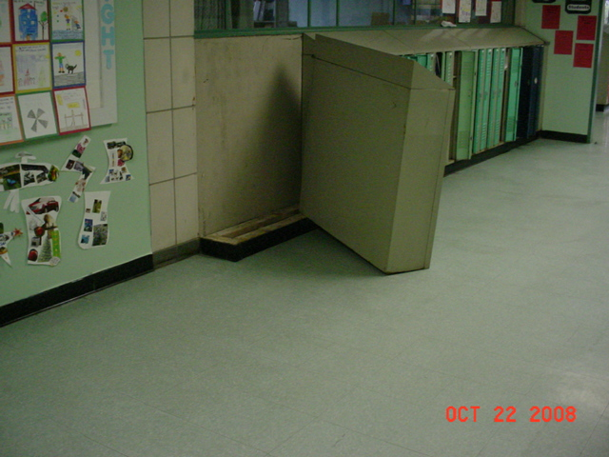

Moved Locker Section Where Mercury Beads Were Discovered
(Circle Indicates Reported Local of Thermometer Break on Floor)

Picture 2

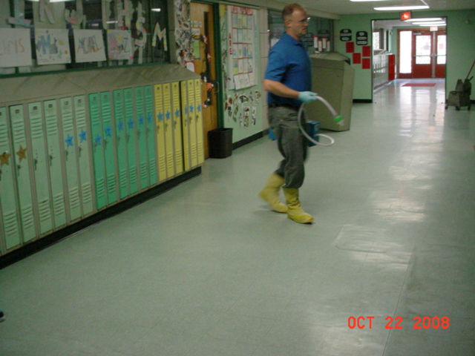

DEP Staff Conducting Air Sampling With LUMEX Mercury Vapor Analyzer
Location | Instantaneous Reading  ng/m³
Front Lobby | 14
Floor outside locker | 19
Baseboard of wall near locker | 42
Tile crack near locker | 21
Tile crack near locker | 111
Tile crack near locker | 161
Tile crack near locker | 88
Under locker | 22-30
Tile crack near locker | 30
Tile crack near locker | 34
Tile crack near locker | 40
Tile crack near locker | 26
Locker 186 | 75
Tile crack near locker | 30
Tile crack near locker | 27
Tile crack near locker | 39
Above floor breath zone | 25
Outdoors | 6

