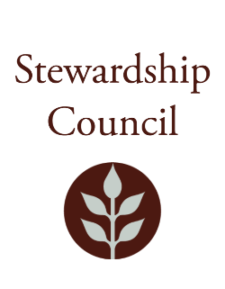

Stewardship Council Meeting
Thursday, July 11, 2024 | 9:00 to 11:00 AM
Conducted via Videoconference

Agenda

TOPIC | SEGMENT
Welcome and Chair’s Update – Jack Buckley, Chair | 9:00 – 9:10 AM
DCR Report – Brian Arrigo, Commissioner | 9:10 – 9:25 AM
Regular Business I  - Presentation from Western Mass Backcountry Alliance, Andy Mathey and Dave O’Neil  - Approve Minutes: June 13, 2024  - Public Comment | 9:25-10:00 AM
Regular Business II  - Discussion of FY26 Budget Recommendation  - Committee Updates  - Councilor Comments | 10:00 – 11:00 AM
Adjourn | 11:00 AM

July Meeting of the DCR Stewardship Council

Matthew Perry is inviting you to a scheduled Zoom meeting.

Join Zoom Meeting
https://zoom.us/j/92851384248?pwd=UFhrWEhuRHRBN1EyVlhZbStqanRrQT09

Meeting ID: 928 5138 4248
Passcode: 882888

One tap mobile
+13017158592,,92851384248#,,,,*882888# US (Washington DC)
+13052241968,,92851384248#,,,,*882888# US

Please contact Matt Perry at matthew.s.perry1@mass.gov for accessibility information.
7/3/2024 8:50 AM

