The Commonwealth of Massachusetts

Executive Office of Public Safety and Security

MASSACHUSETTS Parole Board

12 Mercer Road
Natick, Massachusetts 01760
Telephone: (508) 650-4500
Facsimile: (508) 650-4598
Maura T. Healey
Governor
Kimberley Driscoll
Lieutenant Governor

Gina K. Kwon
Secretary

Angelo Gomez, Jr.
Chair

Lian Hogan
Executive Director

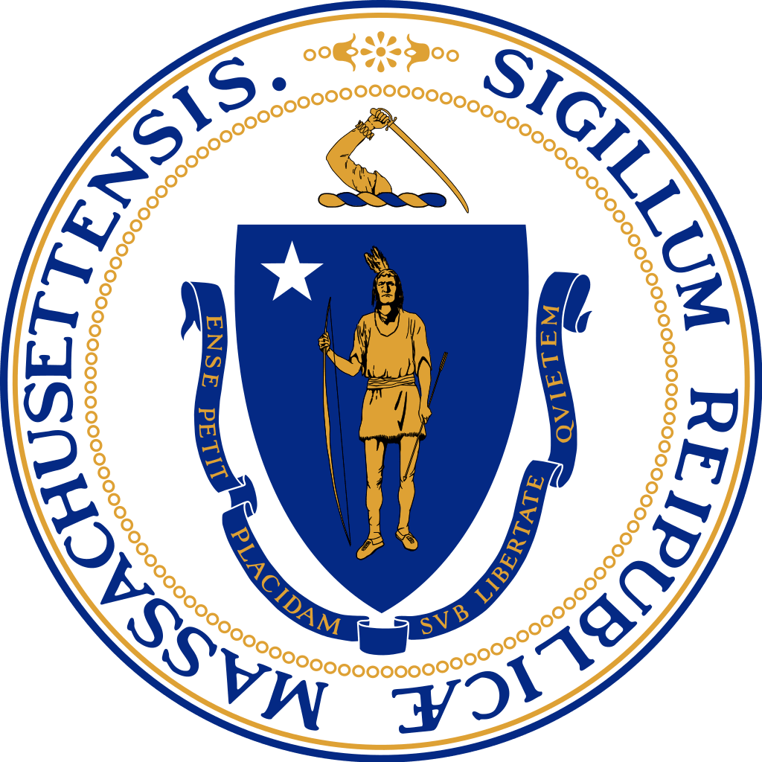

JULY 2026
Life Sentence Unit Hearing Calendar – June 2, 2026

Thursday July 2, 2026
Hearing Time | Commitment Name | Hearing Type
10:00 AM | James Kenyon | Initial

Thursday, July 9, 2026
Hearing Time | Commitment Name | Hearing Type
10:00 AM | Timothy Brown | Initial
1:00 PM | Carl Ruth | Review

Thursday, July 16, 2026
Hearing Time | Commitment Name | Hearing Type
10:00 AM | Santos Portillo | Initial
1:00 PM | Clyde Smith | Review

Thursday, 21, 2026
Hearing Time | Commitment Name | Hearing Type
10:00 AM | Rafael Rivera | Initial
1:00 PM | William Santos | Review

Thursday, July 23, 2026
Hearing Time | Commitment Name | Hearing Type
10:00 AM | Delaneau Jamal Pierre | Initial
1:00 PM | Albert Jackson | Review

Tuesday, July 28, 2026
Hearing Time | Commitment Name | Hearing Type
10:00 AM | Joshua Whitaker (M) | Initial
1:00 PM | Willliam F. McDermott | Review

Tuesday, July 30, 2026
Hearing Time | Commitment Name | Hearing Type
10:00 AM | Kyron Gorham (M) | Initial
1:00 PM | Rafael Davila | Initial

(M) Mattis

