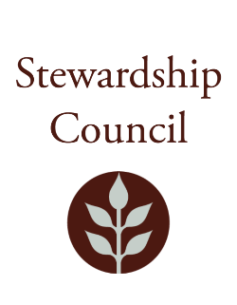

Stewardship Council Meeting
Thursday, July 24, 2025 | 9:00 to 11:00 AM
Conducted via Videoconference

Agenda

TOPIC | SEGMENT
Welcome and Chair’s Update – Dicken Crane, Chair | 9:00 – 9:10 AM
DCR Report – Nicole LaChapelle, Commissioner  Kendra Amaral, Deputy Commissioner | 9:10 – 9:30 AM
Regular Business I  - DCR Trails Master Plan Presentation – Ale Echandi, Senior Trails and Greenways Planner and Megan Shave, Senior Inland Ecologist  - Approve Minutes: June 26, 2025  - Public Comment | 9:30-10:15 AM
Regular Business II  - Letter of Support for the Mass Ready Act  - Review of Stewardship Council Committees  - Nominating Committee Appointment  - Committee Updates  - Councilor Comments | 10:15 – 11:00 AM
Adjourn | 11:00 AM

July Meeting of the DCR Stewardship Council

Join Zoom Meeting
https://zoom.us/j/5296343609?pwd=dVI3NHdJUjlTeWlSVmtDTGRTUGU5Zz09&omn=93176112835

Meeting ID: 529 634 3609
Passcode: 818194

One tap mobile
+13052241968,,5296343609#,,,,*818194# US
+13092053325,,5296343609#,,,,*818194# US

Please contact Matt Perry at matthew.s.perry1@mass.gov for accessibility information.
7/17/2025 12:43 PM

