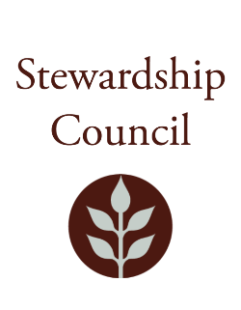

Stewardship Council Meeting
Thursday, June 13, 2024 | 9:00 to 11:00 AM
Conducted via Videoconference

Agenda

TOPIC | SEGMENT
Welcome and Chair’s Update – Jack Buckley, Chair | 9:00 – 9:10 AM
DCR Report – Brian Arrigo, Commissioner | 9:10 – 9:25 AM
Regular Business I  - Presentation on Biodiversity Executive Order, MassWildlife staff  - Approve Minutes: May 9, 2024  - Public Comment | 9:25-10:00 AM
Regular Business II  - Committee Updates  - Councilor Comments | 10:00 – 11:00 AM
Adjourn | 11:00 AM

June Meeting of the DCR Stewardship Council

Join Zoom Meeting
https://zoom.us/j/92258777206

Please contact Dan Cushing at Daniel.cushing@mass.gov for accessibility information.

