Occupational Lung Disease Bulletin

Massachusetts Department of Public Health

Occupational Health Surveillance Program, 250 Washington Street, Boston, MA 02108

Tel: (617) 624-5632  Fax: (617) 624-5696  www.mass.gov/dph/bhsre/ohsp/ohsp.htm

SENSOR
June 2005

Dear Health Care Provider,

This Occupational Lung Disease Bulletin provides a brief summary of the use of spirometry in the diagnosis of asthma and other obstructive and restrictive lung diseases. It was written by Dr. Britt Hatfield, a fellow in occupational and environmental medicine at Harvard School of Public Health, on rotation at the Occupational Health Surveillance Program.

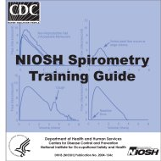 | The summary is based on the 257-page NIOSH Spirometry Training Guide, NIOSH Publication No. 2004-154C, available on line at http://www.cdc.gov/niosh/docs/2004-154c/ . The Guide was written as an adjunct to a NIOSH approved course on spirometry.
Remember to report suspected and confirmed cases of work-related asthma to OHSP by phone, fax or mail. To receive your Bulletin by e-mail, send a message, with the word “Bulletin” in the subject line to Occupational.Asthma@state.ma.us.
Sincerely,
Elise Pechter, M.P.H., C.I.H.

Spirometry
Britt H. Hatfield, M.D., M.P.H.
Although lung diseases are not the most common occupational diseases, they are significant due to their severity and impact. The human and economic toll from occupational asthma, the pneumoconioses (asbestosis, black lung disease, silicosis, etc.), and occupational lung cancer is notable. These diseases are significant causes of morbidity, disability, early retirement, and death. Moreover, they are preventable once their causes are recognized. Spirometry plays an important role in a respiratory surveillance program.

Spirometric testing is utilized both for screening and as an aid to diagnosis of lung diseases. Spirometry is used to detect lung abnormalities that show obstructive or restrictive patterns, or a combination of the two. Certain diseases or conditions affect the rate at which air can move through the lungs (obstructive diseases) and/or the ability of the lungs to expand (restrictive diseases). Obstructive diseases or abnormalities interfere with air flow. The underlying disease process frequently alters the diameter or integrity of the airways, with increased airflow resistance from bronchospasm, mucosal edema, and increased production of secretions. Asthma, COPD and emphysema are forms of obstructive disease. When individuals with obstructive disease exhale (especially if they exhale forcefully), the airways narrow further or collapse. Restrictive diseases, such as asbestosis and silicosis, are caused by fibrotic tissue changes that reduce the ability of the lungs to expand (i.e., they have low compliance) but do not necessarily affect air flow. Disorders that affect the neuromuscular functioning of the chest wall may also produce a restrictive pattern. Other lung diseases, such as pneumonia, may show both obstructive and restrictive patterns. Since spirometric testing reveals both the rate of air flow and the volume of air moved, the testing identifies individuals who have these diseases or conditions.

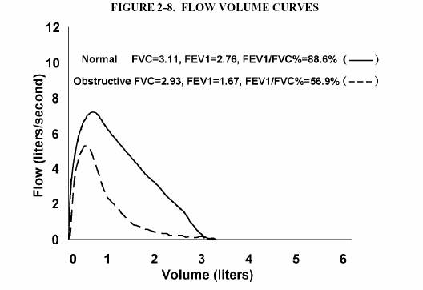

Three measurements obtained through spirometry are particularly useful: forced vital capacity (FVC), forced expiratory volume at one second (FEV₁), and the ratio of the FEV₁ to the FVC. Computerized spirometers frequently print out six or more measures of flow or volume. However, for most purposes, the FVC and FEV₁ suffice. The FVC is the total volume of air exhaled after a Forced Expiratory Maneuver (the act of exhaling as hard and fast as possible after maximal inspiration). FVC should not be confused with vital capacity, which is defined as the maximum amount of air that the subject can breathe out after the deepest inspiration, whether or not the air was exhaled forcefully. In subjects without airways obstruction, the FVC is usually equal to the VC. The FEV₁ is the amount of air that a person breathes out during the first second of a forced expiratory maneuver. The ratio of the FEV₁ to the FVC is obtained by dividing the FEV₁ by the FVC. A person with a low FVC may have a restrictive disease while a low FEV₁/FVC ratio may indicate an obstructive disease. For example, on average, 70-80% of the FVC is exhaled in the first second from a person who is healthy, while a person with airways obstruction may only be able to exhale 60% or less of the FVC in the first second, even though the FVC may be normal. A person with a low FVC typically will also have a low FEV₁, indicating a possible restrictive pattern. Some individuals may also show evidence of a combination of both airways obstruction and a low FVC. It should be noted that some clinicians may consider these curves to show an obstructive pattern instead of a mixed pattern. In many cases, the low FVC of a mixed impairment pattern is secondary to the air-trapping and incomplete expiration of moderate or severe airways obstruction.

The Lung Diseases and Spirometry Results Table below shows the possible relationships between spirometry results and lung diseases.
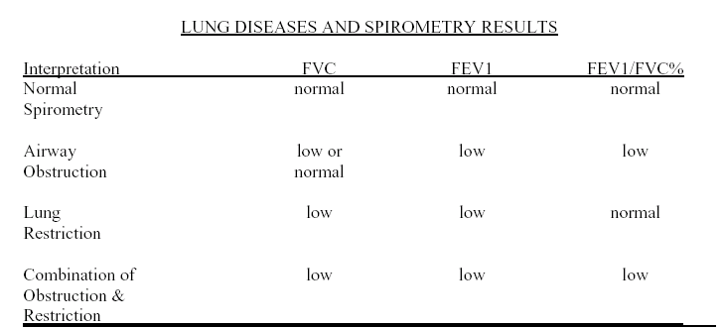

As a screening tool, spirometry is performed periodically on workers at risk for occupational lung disease due to exposure to specific respiratory hazards. Spirometric testing is generally used in two ways for respiratory surveillance programs: (1) To compare pre- and post-shift values for acute changes (example: FEV₁ in cotton dust exposure); (2) To compare longitudinal test results (example: those taken over an extended period of time, such as annually) for signs of chronic disease (example: FVC in asbestos exposure). In either case, the expected annual decline (simply due to normal aging) in spirometry values must be taken into account. The numbers below are "averages" derived from cross-sectional studies; considerable variation may occur among individuals. For males, FEV₁ decreases 30 ml/year and FVC decreases 25 ml/year. For females, FEV₁ decreases 25 ml/year and FVC decreases 25 ml/year. As a diagnostic tool, spirometry is used when a patient has a specific medical complaint or finding, such as shortness of breath, wheezing, etc. It can also measure the effects of treatment regimens, such as use of bronchodilators or steroids. Test sessions in which the highest minus second highest FEV₁s (or FVCs) don’t match within 0.20 liters indicate poor reproducibility (repeatability or degree of match) and should be interpreted with caution. Poor reproducibility of the FEV₁ or FVC within a test session is an indication that effort was submaximal. This also reduces confidence in the interpretation of subsequently measured changes in lung function (changes across the work shift or year-to-year).

Lung function in healthy persons increases rapidly with growth during childhood and adolescence, reaches a peak sometime between the ages of 18 and 25, and then begins to slowly decline. Persons who grow relatively tall also have relatively large lungs when compared to those who are shorter in stature. Women on average, have lungs that are about 20% smaller than men of the same height and age. For a given standing height, African-American men, on the average, have longer legs than Caucasian men, and a correspondingly shorter trunk size; and therefore slightly smaller lungs explaining most of the differences between predicted values for Caucasian and African-American men. All of the above factors mean that to interpret spirometry results (observed values), you must first know the employee’s age, height, gender, and race or ethnicity.

Further investigation is usually recommended when:

a. There is a decline in FEV₁ or FVC that is greater than 15% over time. However, if the period of follow-up is long (greater than 5 years), it may be necessary to adjust for the expected decline due to aging.
b. The FVC, FEV₁, or FEV₁/FVC% is less than the lower limit of normal at any time. The lower limit of the normal range (LLN) is the threshold below which a value is considered abnormal - usually the value is set so that 95% of a “normal” population will have values above the LLN.
c. There is a 10% or greater decline in the FEV₁ between pre- and post-shift screening, when a single exam is conducted or a 5% or greater decline (more than 150 ml for FEV₁s less than 3 liters) if a follow-up exam confirms this decline (Cotton Dust recommendation).

Work-Related Asthma Cases Reported to
Massachusetts SENSOR

March  2005 | April 2005 | May 2005 | Total  (3/92 – 5/05)
6 | 8 | 2** | 1020*
* Correction: December 2004 (9), January 2005 (0), February 2005 (2) for a total of 1004, not 1008.
**Cases reported to 5/25/05.

