

The Commonwealth of Massachusetts
Executive Office of Health and Human Services

Office of Medicaid, Health Safety Net

100 Hancock Street, 6th Floor.

Quincy, Massachusetts 02171

MIKE LEVINE
Assistant Secretary for MassHealth

www.mass.gov/eohhs

MAURA HEALEY
Governor

KIM DRISCOLL
Lieutenant Governor

KATE WALSH
Secretary

June 2024 Billing Update HSN-ALL BU-9

Cybersecurity Attack

As you are aware, in February 2024, HSN sent out a notice regarding the cybersecurity attack. As a best business practice, HSN would like to remind facilities that any facility utilizing a billing company or billing intermediary to submit 837 files to MH/HSN, your facility may want to consider submitting electronic 837 files/claims directly as an alternative method when issues arise. This alternative, direct submission of electronic 837 files/claims during a crisis will alleviate an increase in your Accounts Receivable as well as submitting a request for an HSN billing waiver.

If your facility would like to implement direct claims submissions as an alternative method, please fill out the necessary document - HSN User Agreement and forward to the hsnhelpdesk@massmail.state.ma.us.

In addition, your facility will need to reach out to MH EDI at edi@mahealth.net to update/add your facility claims submission status.

Pharmacy Remits

HSN has identified an internal issue where some POPS payments were not included within the HSN remits.

While HSN is working on rectifying the issue, the expectation is that the August remits will include such payments. For facilities who utilize Billing Intermediaries, please notify your BI that the HSN POPS remit for August may be larger than normal.

Rate Updates

The 2024 HSN covered code list for CHCs has been updated and are effective for
dates of service beginning 1/1/2024. As well as PPS rates have been updated for 2024.
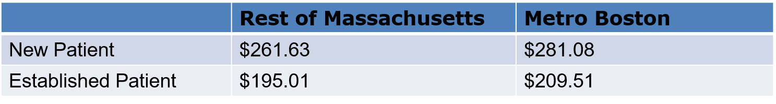
For any questions about this billing update, please contact the HSN Customer Service line at 800-609-7232 or by email at HSNHelpdesk@state.ma.us.

