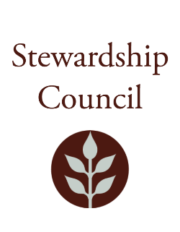

# Stewardship Council Meeting

**Thursday, June 26, 2025 |** 11:00 AM to 1:00 PM

Peddocks Island Visitor Center

Boston Harbor Islands

## Agenda

|  |  |
| --- | --- |
| TOPIC | SEGMENT |
| **Welcome and Chair’s Update** – Dicken Crane, Chair | 11:00 – 11:10 AM |
| **DCR Report** – Brian Arrigo, Commissioner | 11:10 – 11:30 AM |
| **Regular Business I**   * Boston Harbor Now Presentation – Kathy Abbott, President and CEO of Boston Harbor Now * Approve Minutes: May 8, 2025 * Public Comment | 11:30AM – 12:15 PM |
| **Regular Business II**   * Committee Updates * Councilor Comments | 12:15 – 1:00 PM |
| **Adjourn** | 1:00 PM |

## Zoom Meeting Information

**Meeting of the DCR Stewardship Council Observation Link**

Join Zoom Meeting

<https://zoom.us/j/5296343609?pwd=dVI3NHdJUjlTeWlSVmtDTGRTUGU5Zz09&omn=93176112835>

Meeting ID: 529 634 3609

Passcode: 818194

One tap mobile

+13052241968,,5296343609#,,,,*818194# US

+13092053325,,5296343609#,,,,*818194# US

Please contact Matt Perry at [matthew.s.perry1@mass.gov](mailto:matthew.s.perry1@mass.gov%20) for accessibility information.

6/18/2025 10:21 AM