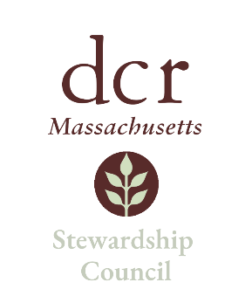

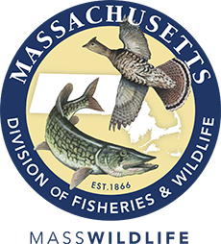
Joint Stewardship Council and Massachusetts Fisheries and Wildlife Board Meeting
Thursday, June 8, 2023 | 4:00pm to 4:50pm
MassWildlife Field Headquarters
1 Rabbit Hill Road, Westborough, MA 01581

Agenda

TOPIC | SEGMENT
Joint Welcome – Jack Buckley, Chair Stewardship Council, & Steve Sears, Chair Fisheries and Wildlife Board | 4:00pm – 4:10pm
Introduction of Members | 4:10pm – 4:25pm
General Discussion | 4:25pm – 4:50pm
Adjourn | 4:50pm

