INDOOR AIR QUALITY ASSESSMENT

J.W. Martin Elementary School
37 Landry Avenue
North Attleborough, Massachusetts

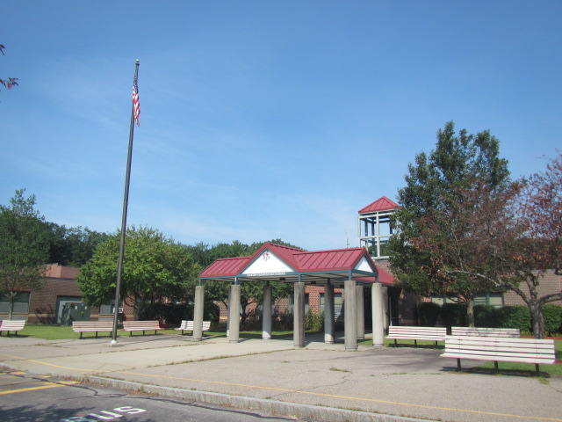

Prepared by:
Massachusetts Department of Public Health
Bureau of Environmental Health
Indoor Air Quality Program
October 2021

BACKGROUND
Building: | Martin Elementary School (MES)
Address: | 37 Landry Avenue, North Attleborough, MA
Assessment Requested by: | North Attleborough Public Schools (NAPS)
Reason for Request: | Collaborative effort to perform general indoor air quality (IAQ) assessments throughout the NAPS
Date of Assessment: | August 12, 2021
Massachusetts Department of Public Health/Bureau of Environmental Health (MDPH/BEH) Staff Conducting Assessment: | Cory Holmes, Assistant Director, IAQ Program
Building Description: | The MES is a one-story red brick building that was constructed in 1967. An addition was built in 1995. The majority of building materials in the 1967 portion of the building appear to be original (e.g., floor tiles, heating and ventilation components, window systems).
Windows: | Openable

Although the majority of building components are original to the building, 1960’s and 1990’s respectively, some building improvements have been made, including roof repairs and a building-wide insulation project. At the time of assessment the building was undergoing a thorough summer break cleaning.

METHODS
MDPH IAQ staff conducted a series of visual assessments, temperature and relative humidity measurements to identify likely areas that could be prone to condensation in hot, humid weather. Please refer to the IAQ Manual for methods, sampling procedures, and interpretation of results (MDPH, 2015).

RESULTS and DISCUSSION
The following is a summary of testing results (Table 1):
- Temperature was within or close to the upper end of the MDPH recommended range of 70°F to 78°F in areas tested. It is important to note that the MES is not an air-conditioned building and the assessment occurred during the 2nd day of a heatwave.
- Relative Humidity was above the MDPH recommended range of 40 to 60% in all but four areas tested, which was similar to outside/background conditions.

Ventilation
A heating, ventilating and air conditioning (HVAC) system has several functions. First it provides heating and, if equipped, cooling. Second, it is a source of fresh air. Finally, an HVAC system will dilute and remove normally-occurring indoor environmental pollutants by not only introducing fresh air, but by filtering the airstream and ejecting stale air to the outdoors via exhaust ventilation. Even if an HVAC system is operating as designed, point sources of respiratory irritation may exist and cause symptoms in sensitive individuals.
Fresh air in the majority of classrooms is supplied by 1960’s vintage unit ventilators (univents, Picture 1). A wing built in the 1990’s contains univents from that era (Picture 2), which are now over 26 years old. Univents draw air from the outdoors through a fresh air intake located on the exterior wall of the building (Picture 3) and return air through an air intake located at the base of the unit. Fresh and return air are mixed, filtered, heated or cooled and provided to rooms through an air diffuser located in the top of the unit (Figure 1). Obstructions to airflow, such as papers and books stored on univents and bookcases, carts and desks in front of univent returns, were seen in a few classrooms (Table 1, Pictures 4 and 5). In order for univents to provide fresh air as designed, units must remain free of obstructions. At the time of assessment univents in classrooms 1 and 3 were making “rattling” noises, which may indicate a mechanical issue.
Mechanical exhaust ventilation in classrooms is provided by unit exhaust ventilators (Picture 6), also 1960’s vintage. A unit exhaust ventilator appears similar to a univent, but removes air from the classroom and exhausts it out of the building (Picture 3). As with the univents, unit exhaust ventilators need to be unobstructed. Without sufficient supply and exhaust ventilation, normally occurring environmental pollutants can build-up and lead to indoor air quality/comfort complaints.
Mechanical ventilation for common areas like the gym, cafeteria and interior rooms is provided by rooftop or ceiling-mounted air handling units (AHUs). Fresh air is distributed via ductwork connected to ceiling-mounted air diffusers (Picture 7). Return vents draw air back to the AHUs through wall or ceiling-mounted grilles (Picture 8).
It is also important to note that despite ongoing maintenance and replacement of parts/components by NAPS facilities staff, many of the HVAC units are at the end of their life cycle. Efficient function of equipment of this age is difficult to maintain, since compatible replacement parts are often unavailable. According to the American Society of Heating, Refrigeration, and Air-Conditioning Engineering (ASHRAE), the service life of this type of unit is 15-20 years, assuming routine maintenance of the equipment (ASHRAE, 1991). It was reported that currently two univents could not be repaired and were on a list for replacement.
To maximize air exchange, the IAQ program recommends that both supply and exhaust ventilation operate continuously during periods of occupancy. To have proper ventilation with a mechanical ventilation system, the systems must be balanced after installation to provide an adequate amount of fresh air to the interior of a room while removing stale air from the room. It is recommended that HVAC systems be re-balanced every five years to ensure adequate air systems function (SMACNA, 1994).

Microbial/Moisture Concerns
As previously mentioned, this visit included a visual inspection for signs of water damage and microbial growth. Water-damaged ceilings/tiles were observed in some classrooms, hallways and common areas (Table 1, Pictures 8 and 9), which can indicate current/historic roof/plumbing leaks or other water infiltration. Water-damaged ceiling tiles can provide a source of mold and should be replaced after a water leak is discovered and repaired. In a few areas (Table 1), ceiling tiles appeared “bowed” (Picture 10), which is likely the result of moisture exposure over the years, primarily from elevated relative humidity conditions.
In some rooms, the sink backsplashes had a gap (Table 1, Picture 11), which can allow water into the porous material underneath (Table 1). This can lead to water damage and mold growth.
A perimeter inspection of the building was conducted to identify any breaches/potential pathways for water intrusion; a number of issues were found including:
- Caulking/sealant around windows was observed missing/damaged (Picture 12);
- Plants in close contact with exterior walls (Picture 13);
- Shrubbery in front of univent air intakes (Picture 14); and
- Missing/damaged mortar around exterior brickwork (Picture 15).
Over time, these conditions can undermine the integrity of the building envelope and provide a means of water entry into the building via capillary action through foundation concrete and masonry (Lstiburek & Brennan, 2001). The freezing and thawing action of water during the winter months can create cracks and fissures in the foundation. These breaches may provide a means for moisture and pests to enter the building.

Building Materials Prone to Condensation
The key to managing condensation in hot, humid weather indoors is understanding dew point. When warm, moist air passes over a cooler surface, condensation can form. Condensation is the collection of moisture on a surface at or below the dew point. The dew point is the temperature that air must reach for saturation to occur. If a building material/component has a temperature below the dew point, condensation will accumulate on that material. Over time, condensation can collect and form water droplets.
A method to locate areas in a building prone to condensation is to measure air and building material temperatures using a laser thermometer (Table 1). If a wide temperature range exists between measurements (>5°F), the building materials at the colder end of the range may be prone to becoming moistened with condensation if exposed to hot, humid weather (70% relative humidity) for extended periods of time. According to the test results in Table 1, a number of areas of the building would appear to be prone to condensation if exposed to hot, humid weather for extended periods of time.
According to American Society of Heating, Refrigerating and Air-Conditioning Engineers (ASHRAE), if relative humidity exceeds 70%, mold growth may occur due to wetting of building materials (ASHRAE, 1989). It is recommended that porous material be dried with fans and heating within 24 to 48 hours of becoming wet (US EPA, 2008, ACGIH, 1989). If porous materials are not dried within this time frame, mold growth may occur. Water-damaged porous materials cannot be adequately cleaned to remove mold growth.
Vinyl mats were observed on carpeting in the OT/PT room. These mats should be lifted off carpeting periodically/when not in use to avoid trapping moisture, which can create mold growth conditions beneath them.

Other Issues
Several areas were carpeted. Carpets should be cleaned annually (or semi-annually in soiled/high traffic areas) in accordance with Institute of Inspection, Cleaning and Restoration Certification (IICRC) recommendations, (IICRC, 2012). The service life of carpeting is approximately 10-11 years (IICRC, 2002). Regular cleaning with a high efficiency particulate air (HEPA) filtered vacuum in combination with an annual cleaning will help to reduce accumulation and potential aerosolization of materials from carpeting. Several rooms had area rugs, which should also be vacuumed/cleaned on a regular basis. In addition, area rugs should not be placed on top of other carpeting because it can trap moisture beneath and create mold conditions.
It was reported that to supplement mechanical ventilation and filtration, every classroom is provided with a HEPA-filtered air purifier (Picture 16). It is important to note that filters should be changed and these units be maintained in accordance with the manufacturers’ recommendations.
Many classrooms had personal or pedestal fans to provide circulation. Some of these had dusty blades/housing (Picture 17, Table 1). Some supply and exhaust vent louvers were also observed to be dusty (Picture 7). This dust can be reaerosolized when the equipment is activated.
In a number of areas, tennis balls had been sliced open and placed on chair footings to reduce noise (Table 1, Picture 18). Tennis balls are made of a number of materials that are a source of respiratory irritants. Constant wearing of tennis balls can produce fibers and lead to off-gassing of volatile organic compounds (VOCs). Tennis balls are made with a natural rubber latex bladder, which becomes abraded when used as a chair leg pad. Use of tennis balls in this manner may introduce latex dust into the school environment. Some individuals are highly allergic to latex (e.g., spina bifida patients) (SBAA, 2001). It is recommended that the use of materials containing latex be limited in buildings to reduce the likelihood of symptoms in sensitive individuals (NIOSH, 1997; NIOSH, 1998).
The MDPH recommends that HVAC equipment be outfitted with filters of a Minimum Efficiency Reporting Value (MERV) of 8 or higher, which are adequate in filtering out pollen and mold spores (ASHRAE, 2012). In addition, filters should be changed 2-4 times a year or in accordance with the manufacturers’ recommendations. The AHUs at MES are fitted with a MERV 9 filter media, univents with MERV 8, and both are reportedly changed 3-4 times per year. Many classrooms also had window-mounted air conditioners (Table 1). Window ACs have filters which need to be cleaned regularly.
The Environmental Protection Agency (EPA) conducted a National School Radon Survey in which it discovered nearly one in five schools had “…at least one frequently occupied ground contact room with short-term radon levels above 4 [picocuries per liter] pCi/L” (US EPA, 1993). The BEH/IAQ Program therefore recommends that every school be tested for radon, and that this testing be conducted during the heating season while school is in session in a manner consistent with USEPA radon testing guidelines. Radon measurement specialists and other information can be found at www.nrsb.org and http://aarst-nrpp.com/wp, with additional information at: http://www.mass.gov/eohhs/gov/departments/dph/programs/environmental-health/exposure-topics/iaq/radon.

CONCLUSIONS AND RECOMMENDATIONS
In view of the findings at the time of the visit, the following recommendations are made:

Ventilation recommendations
- As previously discussed, the age (>50 years old), physical deterioration and availability of parts for mechanical ventilation system components and controls should be fully evaluated by an HVAC engineering firm to determine the operational lifespan of existing equipment and/or examining the feasibility of repair vs. replacement.
- The U.S. Department of Education has released new guidance encouraging the use of American Rescue Plan (ARP) funds to improve ventilation systems and make other indoor air quality improvements in schools. More information can be found at this link https://www.ed.gov/coronavirus/improving-ventilation?utm_content=&utm_medium=email&utm_name=&utm_source=govdelivery&utm_term=
- Operate all supply and exhaust ventilation equipment continuously during occupied periods. Remove all obstructions from the front and top of the univents and unit exhausts.
- Examine univents in classrooms 1 and 3 for mechanical issues/excessive noise, make adjustments/repairs as necessary.
- Continue with plans to replace univents that are currently inoperable.
- Check exhaust vents for draw periodically and repair any non-operating vents.
- Consider adopting a balancing schedule of every 5 years for all mechanical ventilation systems, as recommended by ventilation industrial standards (SMACNA, 1994).
- Continue to change filters for HVAC equipment 2-4 times a year. Use filters of Minimum Efficiency Reporting Value (MERV) 8, which are adequate in filtering out pollen and mold spores (ASHRAE, 2012) or the highest MERV rating a building’s ventilation system can accommodate to improve air filtration as much as possible without significantly reducing airflow.
- Use openable windows to supplement fresh air during temperate weather. Ensure all windows are tightly closed at the end of the day.

Water Damage Recommendations
- Ensure roof and plumbing leaks are repaired and replace water-damaged ceiling tiles.
- Repair/seal holes and breaches in exterior walls/building envelope to eliminate drafts, moisture and pest entry.
- Remove plants and trees/branches a minimum of 5 feet away from the building.
- Replace any damaged window gaskets and repair gaps around exterior window frames to prevent water infiltration.
- Consider long-term plans/capital repair project to replace windows where needed.
- Repoint exterior brickwork where missing/damaged mortar is noted.
- Closely monitor parameters such as temperature, relative humidity and dew point over summer months to prevent condensation on floors/surfaces. Refrain from storing porous items, such as cardboard and paper on floor in these areas. If carpeting is present, consider removing from areas that are prone to condensation.
- Do not place area rugs on carpeting.
- Vinyl mats in the OT/PT room should be lifted off carpeting periodically/when not in use to avoid trapping moisture, which can create mold growth conditions.
- Repair sink backsplashes to seal gaps or replace with a one-piece unit. Avoid storage of porous materials and large amounts of materials under sinks.
- Consider using the methods described in the document “Preventing Mold Growth in Massachusetts Schools During Hot, Humid Weather” to help reduce impact of conditions during hot, humid weather. This guideline can be found online at: https://www.mass.gov/service-details/preventing-mold-growth-in-massachusetts-schools-during-hot-humid-weather

Other Recommendations
- Change filters and maintain HEPA units as per manufacturers’ recommendations.
- Regularly clean/vacuum supply/return vents and personal fans to avoid aerosolizing accumulated particulate matter.
- Clean AC filters prior to the start of the cooling season and on a regular basis while in use.
- Ensure ceiling tiles are flush with the ceiling grid to prevent pathways for dust/debris to migrate into occupied areas.
- Reduce use of products and equipment that create VOCs and only use in well-ventilated areas. Minimize the use of air fresheners, deodorizers and scented products.
- Keep spray bottles/cleaning products out of the reach of children. Ensure that products are compatible with one another. It is suggested that only school-supplied products be used to avoid product interactions.
- Clean carpeting annually (or semi-annually in soiled high traffic areas) as per the recommendations of the Institute of Inspection, Cleaning and Restoration Certification (IICRC, 2012).
- Consider replacing any carpeting that is beyond its service life (i.e., > 11yrs.).
- Regularly clean/vacuum supply/return vents and personal fans to avoid aerosolizing accumulated particulate matter.
- For buildings in New England, periods of low relative humidity during the winter are often unavoidable. Therefore, scrupulous cleaning practices should be adopted to minimize common indoor air contaminants whose irritant effects can be enhanced when the relative humidity is low. To control dusts, a high efficiency particulate arrestance (HEPA) filter equipped vacuum cleaner in conjunction with wet wiping of all surfaces is recommended. Avoid the use of feather dusters. Drinking water during the day can help ease some symptoms associated with a dry environment (throat and sinus irritations).
- The school should be tested for radon by a certified radon measurement specialist during the heating season when school is in session. Radon measurement specialists and other information can be found at: www.nrsb.org, and http://aarst-nrpp.com/wp.
- To learn more about radon, review the MDPH’s Radon in Schools and Child Care Programs factsheet, with additional information at: http://www.mass.gov/eohhs/gov/departments/dph/programs/environmental-health/exposure-topics/iaq/radon.
- Consider forming an IAQ committee in each school building district-wide. Committees should have an IAQ liaison/teacher representative, a member of maintenance/facilities and administration that conduct regular walk-throughs to identify on-going and/or potential environmental issues.
- Consider adopting the US EPA (2000) document, “Tools for Schools”, as an instrument for maintaining a good IAQ environment in the building available at: https://www.epa.gov/iaq-schools/indoor-air-quality-tools-schools-action-kit
- Refer to resource manual and other related IAQ documents located on the MDPH’s website for further building-wide evaluations and advice on maintaining public buildings. These documents are available at: http://mass.gov/dph/iaq.

REFERENCES
ACGIH. 1989. Guidelines for the Assessment of Bioaerosols in the Indoor Environment. American Conference of Governmental Industrial Hygienists, Cincinnati, OH.
ASHRAE. 1989. Ventilation for Acceptable Indoor Air Quality. American Society of Heating, Refrigeration and Air Conditioning Engineers. ANSI/ASHRAE 62-1989
ASHRAE. 1991. ASHRAE Applications Handbook, Chapter 33 “Owning and Operating Costs”. American Society of Heating, Refrigeration and Air Conditioning Engineers, Atlanta, GA.
ASHRAE. 2012. American Society of Heating, Refrigeration and Air Conditioning Engineers (ASHRAE) Standard 52.2-2012 -- Method of Testing General Ventilation Air-Cleaning Devices for Removal Efficiency by Particle Size (ANSI Approved).
IICRC. 2002. Institute of Inspection, Cleaning and Restoration Certification. A Life-Cycle Cost Analysis for Floor Coverings in School Facilities.
IICRC. 2012. Institute of Inspection, Cleaning and Restoration Certification. Carpet Cleaning: FAQ.
Lstiburek, J. & Brennan, T. 2001. Read This Before You Design, Build or Renovate. Building Science Corporation, Westford, MA. U.S. Department of Housing and Urban Development, Region I, Boston, MA
MDPH. 2015. Massachusetts Department of Public Health. “Indoor Air Quality Manual: Chapters I-III”. Available at: https://www.mass.gov/lists/indoor-air-quality-manual-and-appendices#indoor-air-quality-manual-
NIOSH. 1997. National Institute for Occupational Safety and Health. Alert Preventing Allergic Reactions to Natural Rubber latex in the Workplace. National Institute for Occupational Safety and Health, Atlanta, GA.
NIOSH. 1998. National Institute for Occupational Safety and Health. Latex Allergy A Prevention. National Institute for Occupational Safety and Health, Atlanta, GA.
SBAA. 2001. Latex In the Home And Community Updated Spring 2001. Spina Bifida Association of America, Washington, DC.
SMACNA. 1994. HVAC Systems Commissioning Manual. 1st ed. Sheet Metal and Air Conditioning Contractors’ National Association, Inc., Chantilly, VA.
US EPA. 1993. Radon Measurement in Schools, Revised Edition. Office of Air and Radiation, Office of Radiation and Indoor Air, Indoor Environments Division (6609J). EPA 402-R-92-014.
US EPA. 2000. Tools for Schools. Office of Air and Radiation, Office of Radiation and Indoor Air, Indoor Environments Division (6609J). EPA 402-K-95-001, Second Edition. http://www.epa.gov/iaq/schools/index.html.
US EPA. 2008. “Mold Remediation in Schools and Commercial Buildings”. Office of Air and Radiation, Indoor Environments Division, Washington, DC. EPA 402-K-01-001. September 2008. Available at: http://www.epa.gov/mold/mold-remediation-schools-and-commercial-buildings-guide.

Figure 1

Unit Ventilator (Univent)

Mixed Air

Air Diffuser

Outdoors Indoors

Fan

Heating/Cooling Coil

Air Mixing Plenum

Filter

Outdoor Return
Air Air

Air
Flow
Control
Louvers

Air Flow

= Fresh Air/Return Air

= Mixed Air

Picture 1

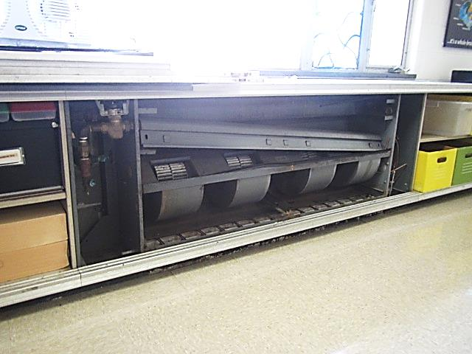
1960’s vintage univent currently on repair list in Art Room 29
Picture 2
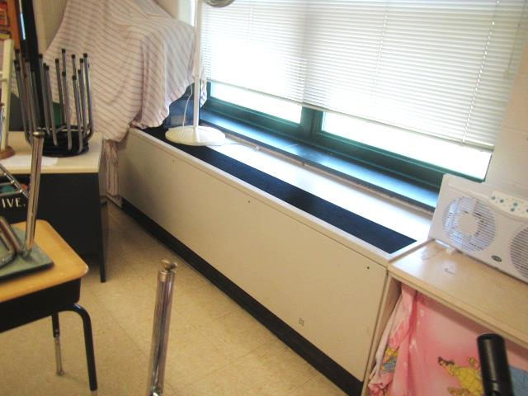
Early 1990s vintage univent
Picture 3
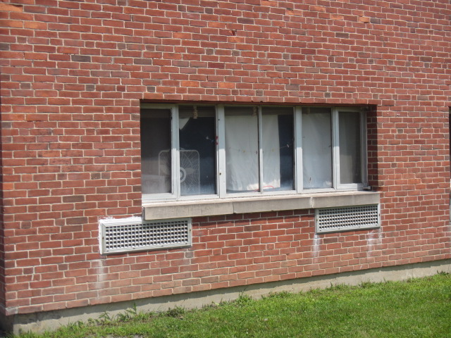
Univent air intake and unit exhaust vent (arrows)
Picture 4
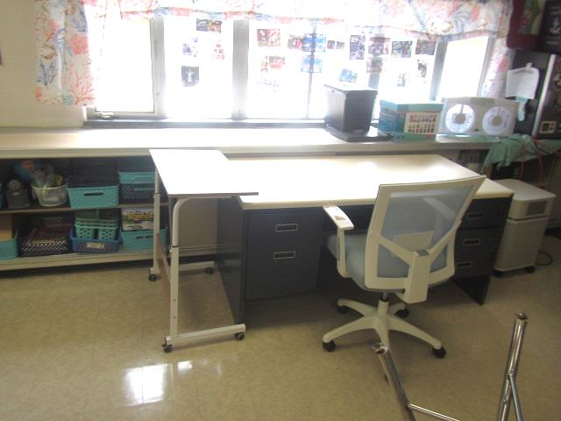
Desk in front of univent return vent (bottom front of unit)
Picture 5
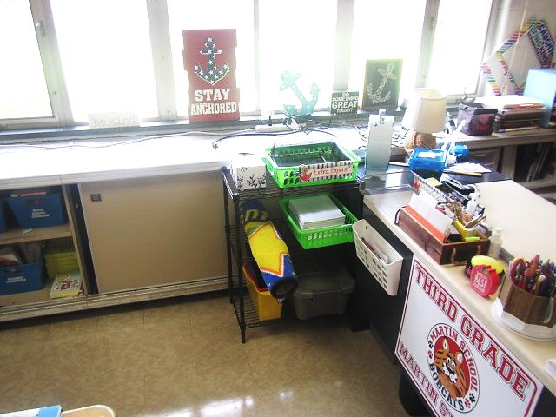
Desk/classroom items in front of univent return vent (bottom front of unit)
Picture 6
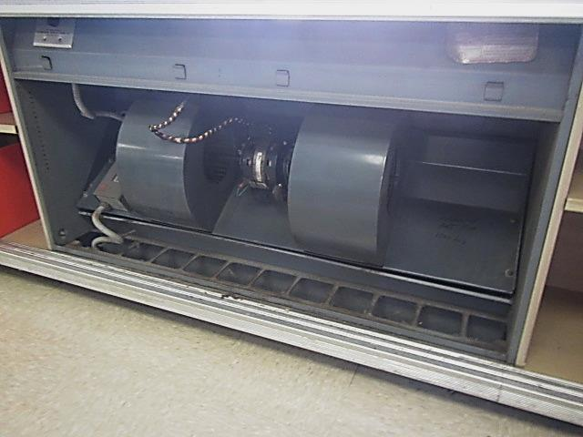
1960's vintage unit exhaust ventilator
Picture 7
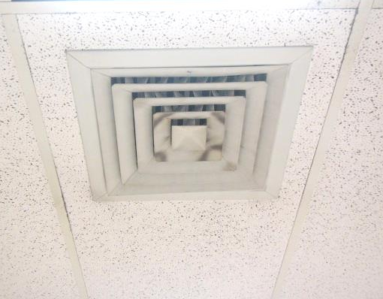
Ceiling-mounted supply diffuser, note dust/debris build up on louvers
Picture 8
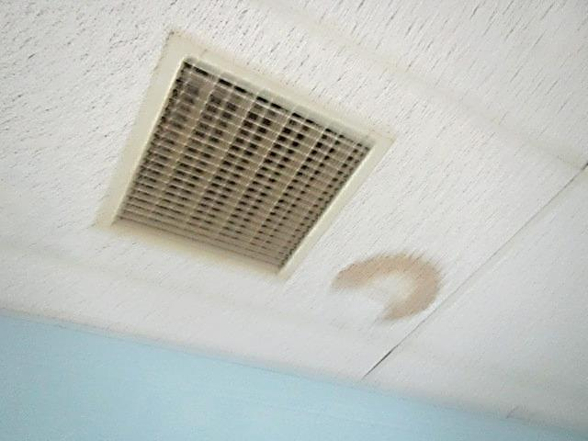
Ceiling-mounted return grille, note water-damaged ceiling tile
Picture 9
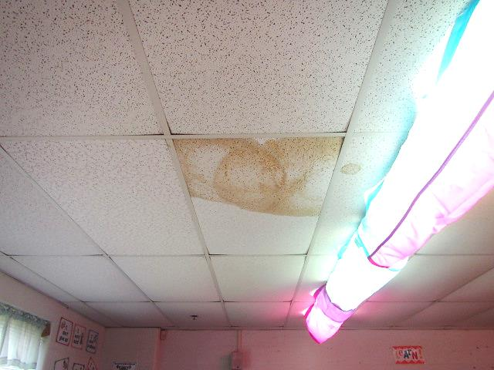
Water-damaged ceiling tiles
Picture 10
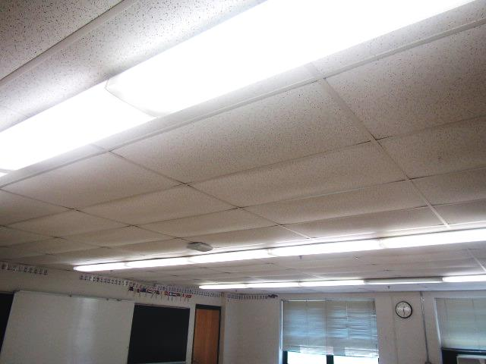
Bowed ceiling tiles in classroom
Picture 11
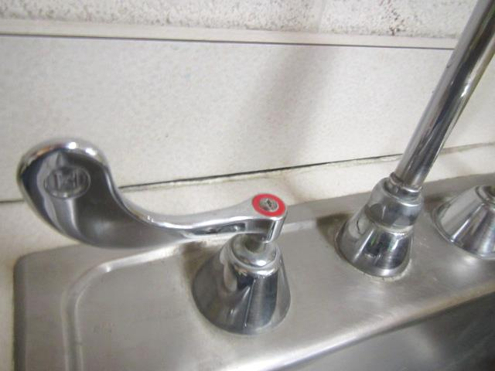
Space between sink countertop and backsplash
Picture 12
Missing/damaged caulking around window frames
Picture 13
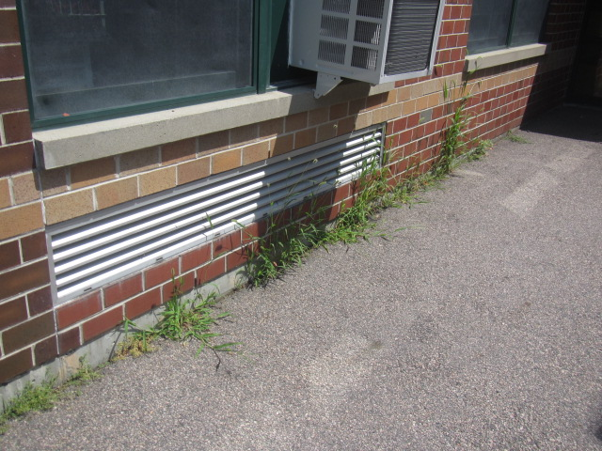
Plant growth against the building
Picture 14
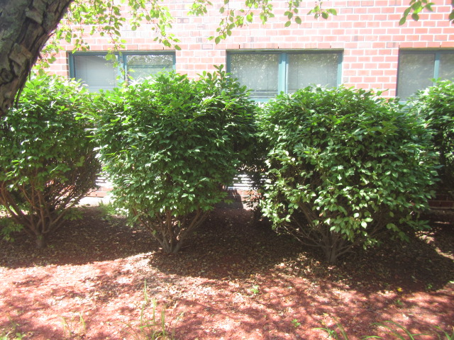
Shrubbery in front of fresh air intakes
Picture 15
Missing/damaged mortar around exterior brick
Picture 16
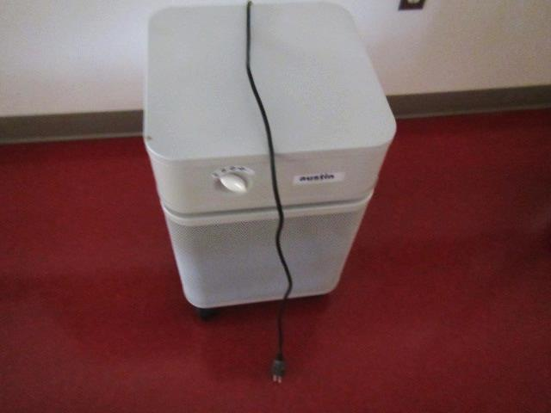
HEPA air purifiers in classrooms
Picture 17
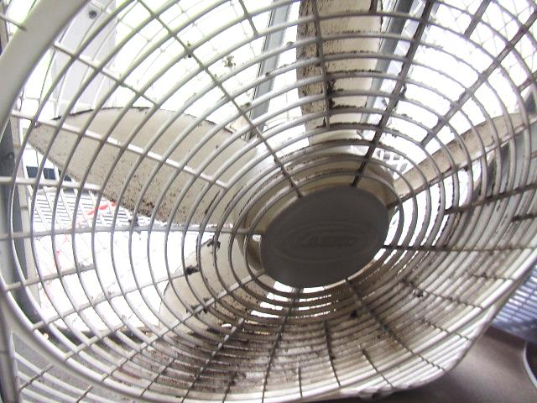
Dust/debris accumulation on classroom fan
Picture 18
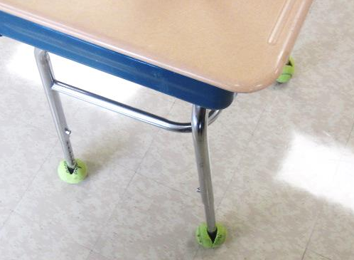
Tennis balls on desk legs

Location | Air Temp  (ºF) | Relative Humidity  (%) | Dew Point  (ºF) | Floor Temp  (ºF) | Temp at Floor/ Exterior Wall Junction  (ºF) | Water-Damaged Ceiling Tiles-stained  (#) | Water-Damaged  Bowed Ceiling Tile  (#) | Ventilation |  |  | Floor to Air Temp  Difference  (ºF) | Comments
 |  |  |  |  |  |  |  | Windows openable | Supply | Exhaust
Background (outdoors) | 85 | 70 | 74 |  |  |  |  |  |  |  |  | Hazy, warm, humid, 2nd day of heatwave
1 | 80 | 76 | 72 | 73 | 74 |  |  | Y | Y | Y | -7 | UV obstructed by desk, UV “rattling” noise, AP, PF
2 | 79 | 76 | 71 | 73 | 74 |  | Y | Y | Y | Y | -6 | PF, AP, TB
3 | 80 | 76 | 72 | 73 | 74 |  |  | Y | Y | Y | -7 | TB, AP, PF, UV-noisy
4 | 79 | 76 | 72 | 73 | 73 | 6 |  | Y | Y | Y | -6 | PF, AP
5 | 80 | 77 | 72 | 73 | 73 | 6 |  | Y | Y | Y | -7 | AP, items on UV
S-3 | 79 | 77 | 72 | 73 | 74 | 1 |  | N | Y | Y | -6 | Carpet
6 Music | 79 | 78 | 71 | 71 | 73 |  |  | Y | Y | Y | -8 | AP, PF, items on UV
7 | 79 | 78 | 73 | 74 | 75 | 2 | Y | Y | Y | Y | -5 | PF, AP
8 | 78 | 81 | 71 | 73 | 73 | 2 |  | Y | Y | Y | -5 | AP, TB
9 | 78 | 79 | 72 | 72 | 73 |  |  | Y | Y | Y | -6 | TB, PF, AP
10 | 78 | 78 | 71 | 73 | 74 |  |  | Y | Y | Y | -5 | TB, PF, AP, furniture obstructing UV
11 | 78 | 79 | 72 | 74 | 75 |  |  | Y | Y | Y | -4 | Furniture obstructing exhaust vent
12 | 79 | 80 | 72 | 74 | 74 |  |  | Y | Y | Y | -5 | PF, AP
13 A&B | 79 | 80 | 72 | 74 | 74 |  |  | Y | Y | Y | -5 | AP, PF
14 A&B | 79 | 77 | 72 | 76 | 76 |  |  | Y | Y | Y | -3 | AP, PF-dusty, AP
15 | 79 | 79 | 72 | 73 | 74 | 3 | Y | Y | Y | Y | -6 | AP, PF, stained caulking around sink
16 | 79 | 74 | 69 | 69 | 70 |  | Y | Y | Y | Y | -10 | AC, PF, TB
17 | 79 | 79 | 72 | 73 | 71 | 2 | Y | Y | Y | Y | -6 | PF, AP, TB
18 | 80 | 77 | 72 | 70 | 70 | 3 | Y | Y | Y | Y | -10 | AP, PF, TB
19 | 79 | 79 | 72 | 70 | 71 | 2 | Y | Y | Y | Y | -9 | TB, AP, PF
20 | 79 | 76 | 71 | 69 | 69 | 2 | Y | Y | Y | Y | -10 | TB, AP, PF
21 | 79 | 73 | 69 | 68 | 68 | 4 | Y | Y | Y | Y | -11 | TB, AC, AP
22 | 79 | 79 | 72 | 70 | 71 | 2 | Y | Y | Y | Y | -9 | TB, AP, PF
23 | 79 | 75 | 70 | 69 | 69 | 4 | Y | Y | Y | Y | -10 | TB, AP, PF
24 | 78 | 73 | 68 | 65 | 67 | 1 | Y | Y | Y | Y | -13 | Glue/mastic around floor tiles, missing/damaged caulking sink
25 | 79 | 76 | 72 | 69 | 69 | 4 | Y | Y | Y | Y | -10 | TB, AP, PF
0.4 Office | 79 | 76 | 72 | 76 | 76 | 4 |  | N | Y | Y | -3 | AP, dusty vents
29 Art | 79 | 79 | 73 | 74 | 75 |  |  | Y | Y | Y | -5 | UV-not operable (steam leak) on repair/replacement list, PF, AP
30 | 80 | 77 | 72 | 76 | 76 | 5 |  | Y | Y | Y | -4 | TB, AP, PF
32 | 79 | 75 | 71 | 74 | 76 | 2 | Y | N | Y | Y | -5 | Dusty vents, AP
Staff Work Room | 77 | 68 | 66 | 74 | 74 | 1 |  | N | Y | Y | -3 | Dusty vents, PC, laminator
Main Office | 74 | 54 | 57 | 66 | 66 | 3 |  | Y | Y | Y | -8 | Carpet
Assistant Principal | 72 | 60 | 57 | 65 | 65 | 1 |  | N | Y | Y | -7 | WD CT around vent, AP, carpet
Principal | 70 | 57 | 54 | 63 | 64 | 2 |  | Y | Y | Y | -7 | WD CT around vent, AP, carpet
Team Chairperson | 79 | 75 | 70 | 73 | 73 |  | Y | N | Y | Y | -6 | AP
Library | 75 | 71 | 65 | 69 | 69 |  | Y | Y | Y | Y | -6 | Carpet (area carpet on carpet), AC
PT | 79 | 83 | 73 | 76 | 78 |  | Y | N | Y | Y | -3 | Vinyl mats on carpet squares, AP
Gym | 79 | 79 | 72 | 75 | 74 |  |  | N | Y | Y | -4
0-6 Guidance | 79 | 77 | 72 | 71 | 72 | 2 | y | N | y | y | -8 | AP
R-1 | 77 | 83 | 72 | 70 | 71 | 4 | Y | N | Y | Y | -7 | TB, AP, PF
R-2 | 79 | 77 | 72 | 71 | 72 | 2 | y | N | y | y | -8 | PF, AP, dusty vents
R-3 | 77 | 80 | 70 | 69 | 70 | 2 | Y | Y | Y | Y | -8 | TB, PF, AC
K-1 | 76 | 74 | 67 | 70 | 69 | 4 | Y | Y | Y | Y | -6 | TB, AP, AC, PF
K-3 | 77 | 79 | 70 | 68 | 68 | 3 | Y | Y | Y | Y | -9 | AC, AP
K-4 | 77 | 77 | 69 | 68 | 68 | 2 | Y | Y | Y | Y | -9 | AC, PF, AP
K-5 | 76 | 71 | 66 | 67 | 68 | 6 | Y | Y | Y | Y | -9 | PF, AP, AC
Reading Room | 78 | 82 | 72 | 71 | 72 |  | Y | N | Y | Y | -7 | Empty
159A | 76 | 56 | 59 | 65 | 65 | 1 |  | N | Y | Y | -11 | Stained vents

The service life is the median time during which a particular system or component of …[an HVAC]… system remains in its original service application and then is replaced. Replacement may occur for any reason, including, but not limited to, failure, general obsolescence, reduced reliability, excessive maintenance cost, and changed system requirements due to such influences as building characteristics or energy prices (ASHRAE, 1991).

