Keeping Kids Safe In and Around Water

Swimming is a fun activity and a great way to keep cool during the hot summer months, but it’s important to know how to keep your kids safe in and around water.
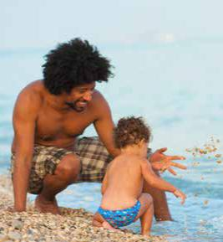
Drowning is swift and silent—there may be little splashing or cries for help. It can take as few as 20 seconds to sink below the water and only minutes to drown, but you can help keep your kids safe by following these tips.

- Make sure you and your child know how to swim. For a list of places offering swim lessons, go to www.mass.gov/dph/swimsafety.

- Even if your child knows how to swim, always watch closely when they are in or near water—whether a pond, lake, river, ocean, or pool.

- For children who cannot swim, use a U.S. Coast Guard-guard approved life jacket. Do not use air-filled or foam toys, such as “water wings,” “noodles,” or inner-tubes, in place of life jackets. These toys are not designed to keep swimmers safe.

- Teach kids that it is dangerous to play rough or climb on each other in the water.

- Children should be supervised in and around water at all times.
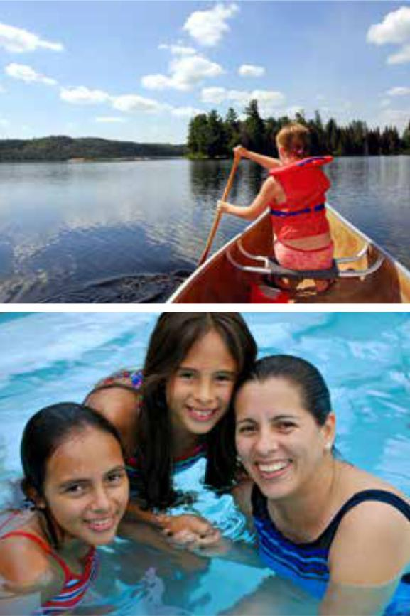
»»Do not drink alcohol while supervising children.

»»Select swimming sites that have lifeguards whenever possible. A lifeguard is there to enforce rules, scan the area, and provide rescue intervention. They cannot watch each child.
»»Designate an adult “water watcher.” Being a water watcher means avoiding any kind of distracting activity such as talking on the phone, even for a moment. Take turns watching with other adults.
»»Whenever infants and toddlers are in or around water an adult should be within an arm’s length at all times providing “touch supervision.”


The Massachusetts Injury Prevention & Control Program

Visit our website www.mass.gov/dph/swimsafety for more information, or call us at 617-624-6060.

PG 1 of 2 AUG 2016

Keeping Kids Safe In and Around Water

NATURAL BODIES OF WATER (OCEANS, PONDS, LAKES, RIVERS)
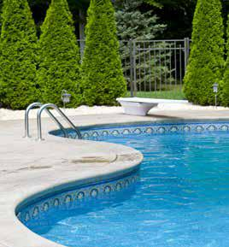
- Don’t let your child swim in an area with strong moving currents in the water.

- When in a boat, you and your child should wear a US Coast Guard approved life jacket.

POOL SAFETY

- If you have a pool, install a four-sided pool fence that completely separates the house and play area of the yard from the pool area. Consider additional barriers such as automatic door locks or alarms to prevent access or notify you if someone enters the pool area.

- When children are done swimming, remove floats, balls and other toys from the pool so that children are not tempted to reach for them. Secure the pool so they cannot get back in.

- Keep rescue equipment (such as a shepherd’s hook or life preserver) and a telephone by the pool.


Learn CPR!

Find a class near you:

The Red Cross offers a wide selection of trainings on CPR/ AED, first aid, lifeguarding, swimming and water safety, caregiving, disaster response and emergency preparedness. For information on classes, visit redcross.org/ux/take-a-class.

The Massachusetts Injury Prevention & Control Program

Visit our website www.mass.gov/dph/swimsafety for more information, or call us at 617-624-6060.

PG 2 of 2 AUG 2016

