INDOOR AIR QUALITY ASSESSMENT INCIDENT RESPONSE
Keith Middle School
225 Hathaway Boulevard
New Bedford, Massachusetts



Prepared by:
Massachusetts Department of Public Health
Bureau of Environmental Health
Indoor Air Quality Program
June 2011

Background/Introduction
On Monday, November 1, 2010, the New Bedford Fire Department and the state Regional Hazardous Materials (HAZMAT) Team responded to a Tier II HAZMAT call at the Keith Middle School (KMS) located at 225 Hathaway Boulevard, New Bedford, Massachusetts. The incident was reportedly the result of a fire that occurred in a chemical storage locker in a first floor science prep-room (Pictures 1 through 3). The incident occurred during a professional day, therefore the building was unoccupied. The building remained closed to occupants for several days following the incident to allow for remediation.
On the morning of November 2, 2010, Michael Feeney, Director of the Massachusetts Department of Public Health (MDPH), Bureau of Environmental Health (BEH), Indoor Air Quality (IAQ) Program conducted an IAQ assessment at the KMS. Mr. Feeney was accompanied by Cory Holmes, Environmental Analysts/Regional Inspector within BEH’s IAQ Program. The assessment was coordinated through the New Bedford Health and School departments. BEH/IAQ Program staff returned to the KMS the evening of November 3, 2010; and the morning of November 5, 2010, prior to school reoccupancy, to conduct follow-up air testing.

Methods/Results
Screening for volatile organic compounds (products of combustion of wood) was conducted using a Thermo Environmental Instruments Inc., Model 580 Series Photo Ionization Detector (PID). Tests for carbon monoxide were conducted with the TSI, Q-Trak, IAQ Monitor, Model 7565. Air tests for airborne particle matter with a diameter less than 2.5 micrometers (μm) were taken with the TSI, DUSTTRAK™ Aerosol Monitor Model 8520. MDPH testing results by date appear in Tables 1-3. A listing of materials stored in the science prep area provided by the New Bedford School Department is included as Table 4.

Discussion
The fire originated in a metal cabinet that had a variety of salts and weak acids (Table 4), none of which would be expected to be an airborne contaminant after a fire is extinguished. It appears that a material ignited on the metal shelves and spread to an adjacent wooden storage cabinet. Upon entering the building on November 2, a wood smoke odor could be detected in the hallway. The burning of wood products produces a number of pollutants, including carbon monoxide, water vapor, carbon dioxide, ash, particulate matter, and volatile organic compounds (VOCs) (NFPA, 1997). Of these materials, exposure to carbon monoxide and PM2.5 can produce immediate, acute health effects upon exposure. In order to assess whether fire residue in the building was cleaned/aired out sufficiently for re-occupancy, BEH staff conducted air sampling for carbon monoxide, particulate matter with a diameter of 2.5 μm or less (PM2.5) and VOCs.

Carbon Monoxide
Carbon monoxide is a by-product of incomplete combustion of organic matter (e.g., gasoline, wood and tobacco). Exposure to carbon monoxide can produce immediate and acute health effects. Several air quality standards have been established to address carbon monoxide and prevent symptoms from exposure to these substances. The MDPH established a corrective action level concerning carbon monoxide in ice skating rinks that use fossil-fueled ice resurfacing equipment. If an operator of an indoor ice rink measures a carbon monoxide level over 30 ppm, taken 20 minutes after resurfacing within a rink, that operator must take actions to reduce carbon monoxide levels (MDPH, 1997).
The American Society of Heating Refrigeration and Air-Conditioning Engineers (ASHRAE) has adopted the National Ambient Air Quality Standards (NAAQS) as one set of criteria for assessing indoor air quality and monitoring of fresh air introduced by HVAC systems (ASHRAE, 1989). The NAAQS are standards established by the US EPA to protect the public health from six criteria pollutants, including carbon monoxide and particulate matter (US EPA, 2006). As recommended by ASHRAE, pollutant levels of fresh air introduced to a building should not exceed the NAAQS levels (ASHRAE, 1989). The NAAQS were adopted by reference in the Building Officials & Code Administrators (BOCA) National Mechanical Code of 1993 (BOCA, 1993), which is now an HVAC standard included in the Massachusetts State Building Code (SBBRS, 1997). According to the NAAQS, carbon monoxide levels in outdoor air should not exceed 9 ppm in an eight-hour average (US EPA, 2006).
Carbon monoxide should not be present in a typical, indoor environment. If it is present, indoor carbon monoxide levels should be less than or equal to outdoor levels. Results of BEH testing at the KMS for carbon monoxide were as follows:
- November 2, 2010: Outdoors – ND: Indoor carbon monoxide concentrations were also ND (Table 1).
- November 3, 2010: Outdoors – ND: Indoor carbon monoxide concentrations were also ND (Table 2).
- November 5, 2010: Outdoors – ND: Indoor carbon monoxide concentrations were also ND (Table 3).

Particulate Matter
Particulate matter is airborne solids that can be irritating to the eyes, nose and throat. The NAAQS originally established exposure limits to particulate matter with a diameter of 10 μm or less (PM10). According to the NAAQS, PM10 levels should not exceed 150 microgram per cubic meter (μg/m³) in a 24-hour average (US EPA, 2006). These standards were adopted by both ASHRAE and BOCA. Since the issuance of the ASHRAE standard and BOCA Code, US EPA established a more protective standard for fine airborne particles. This more stringent PM2.5 standard requires outdoor air particle levels be maintained below 35 μg/m³ over a 24-hour average (US EPA, 2006). Although both the ASHRAE standard and BOCA Code adopted the PM10 standard for evaluating air quality, MDPH uses the more protective PM2.5 standard for evaluating airborne particulate matter concentrations in the indoor environment.
Frequently, indoor air levels of particulates (including PM2.5) can be at higher levels than those measured outdoors. A number of activities that occur indoors and/or mechanical devices can generate particulates during normal operations. Sources of indoor airborne particulates may include but are not limited to particles generated during the operation of fan belts in the HVAC system, cooking in the cafeteria stoves and microwave ovens; use of photocopiers, fax machines and computer printing devices; operation of an ordinary vacuum cleaner; and heavy foot traffic indoors.
Results of the BEH indoor air testing at the KMS for PM2.5 were as follows:
- November 2, 2010: Outdoor PM2.5 concentration was measured at 3-5 μg/m³. PM2.5 levels measured indoors ranged from 4 to 13 μg/m³ (Table 1).
- November 3, 2010: Outdoor PM2.5 concentration was measured at 6 μg/m³. PM2.5 levels measured indoors ranged from 3 to 6 μg/m³ (Table 2).
- November 5, 2010: Outdoor PM2.5 concentration was measured at 7 μg/m³. PM2.5 levels measured indoors ranged from 1 to 4 μg/m³ (Table 3).
All PM2.5 measurements over the course of the three days of testing were below the NAAQS PM2.5 level of 35 μg/m3. In addition, the fact that PM2.5 concentrations indoors were lower than outdoors on November 3 and 5, after remediation, indicates that cleaning activities likely, contributed to removing residual airborne particulates resulting from the fire.

Volatile Organic Compounds (VOCs)
Indoor air concentrations can be greatly impacted by the use of products containing volatile organic compounds (VOCs). VOCs are carbon-containing substances that have the ability to evaporate at room temperature. Frequently, exposure to low levels of total VOCs (TVOCs) may produce eye, nose, throat and/or respiratory irritation in some sensitive individuals. As discussed, the incident occurred in a chemical storage locker in a science prep-room. BEH staff contacted the New Bedford Fire Department, Massachusetts Division of Fire Safety (DFS) HAZMAT Response, and the Massachusetts Department of Environmental Protection (MassDEP) to obtain any air testing results that were conducted as part of the response to the KMS fire. However, the incident report prepared by the New Bedford Fire Department, contained no air testing results, and neither DFS HAZMAT Response nor MassDEP had any date tables or reports on air testing results related to the KMS fire available for review.
In an effort to determine whether lingering VOCs were present in the building on the days following the fire, BEH staff conducted VOC screening. Outdoor air samples were also taken for comparison. Results of the BEH indoor air testing at the KMS for TVOCs were as follows:
- November 2, 2010: Outdoors – non-detect (ND): Indoor TVOC concentrations were also ND (Table 1).
- November 3, 2010: Outdoors – ND: Indoor TVOC concentrations were also ND (Table 2).
- November 5, 2010: Outdoors – ND: Indoor TVOC concentrations were also ND (Table 3).

It is important to note that the chemical storage locker was equipped with local exhaust ventilation designed to draw odors/vapors directly from the locker and exhaust them outside of the building via a stack on the roof (Pictures 1 and 4), which likely resulted in minimal smoke/fire damage and airborne VOCs/products of combustion in the building.

Conclusions/Recommendations
The air testing results indicated that carbon monoxide and TVOCs were non-detectable within all areas of the KMS surveyed on all three testing dates. In addition all PM2.5 levels measured were below the NAAQS PM2.5 level of 35 μg/m³ and were lower indoors than outdoors on the later testing dates, indicating the effectiveness of remediation/ventilation on reducing residual airborne particulate levels. It is important to note that at the time of the first assessment lingering smoke odors were detected in first floor classrooms adjacent to the prep room where the fire occurred. These rooms were to remain unoccupied for further cleaning and ventilating prior to their reoccupancy. It was recommended by MDPH staff at the time of the first assessment that classroom univents be cleaned out using compressed air to loosen/remove any residual smoke particulates that may be causing odors. MDPH has also prepared guidance on “Proper Use and Storage of Chemicals in Schools” (Appendix A) in order to prevent/reduce occupant exposure to chemicals in schools. In view of the findings at the time of these visits, the following recommendations are made.
- As previously mentioned, the interior of univents should be thoroughly cleaned using compressed air. If odors persist, clean with mild detergent and air dry.
- It is highly recommended that a thorough inventory of chemicals in the science department be done on a regular basis (e.g., weekly) to assess chemical storage and disposal in an appropriate manner consistent with Massachusetts hazardous waste laws.
- Consider partnering with a college or university in the local area to establish a mentoring program regarding chemical storage and safety.
- Properly store flammable materials in a manner consistent with local fire codes. Ensure caps/covers are tightened to prevent off-gassing/mixing of chemicals. Discard hazardous materials or empty containers of hazardous materials in a manner consistent with environmental statutes and regulations.
- Label each container with the chemical name of the material stored within (not chemical formula solely). Chemical names must be consistent with M.G.L. c. 111F (Hazardous Substances Disclosure by Employers, also known as the Massachusetts Right-To-Know Law) in order to facilitate the identification of the chemical(s) in case of a spill.
- Obtain and maintain Material Safety Data Sheets (MSDS) for chemicals from manufacturers or suppliers. Maintain these MSDS’ and train individuals in the proper use, storage and protective measures for each material in a manner consistent with the Massachusetts Right-To-Know Law, M.G.L. c. 111F (MGL, 1983).
- Inspect/maintain chemical storeroom exhaust vents on a regular basis (e.g., annually) by appropriately trained individuals to ensure proper function.
- Storage Cabinets
  - Flammable materials
      - All cabinets for storage of flammable materials must be in compliance with Massachusetts statutes, regulations and local ordinances promulgated pursuant to M.G.L. c. 148, § 13. In addition, all flameproof cabinets must meet the design and installation criteria set forth in the National Fire Prevention Association’s (NFPA) latest version of NFPA 30: Flammable and Combustible Liquids Code.
    - Acids
      - Acids must be stored in a cabinet that is constructed from corrosion-resistant materials. Each acid cabinet should be vented to reduce acid vapor build up.
- Chemical Spill Response Plan: Schools should have a chemical inventory and emergency response plan to ensure the safety of building occupants and emergency responders. The elements of an emergency response plan should include the following topics:
- Procedures for evacuation of the building in the case of a spill that may to result in exposure to building occupants.
- Contact number (911) for emergency response to a chemical spill.
- Emergency procedures to contain the material in the location of the spill.
- Closing of doors.
- Deactivation of the ventilation system.
- Routing of evacuation away from the spill location.
- Contact information for remediation services.
- Procedures for proper disposal of hazardous material in compliance with Massachusetts hazardous waste disposal laws.

References
ASHRAE. 1989. Ventilation for Acceptable Indoor Air Quality. American Society of Heating, Refrigeration and Air Conditioning Engineers. ANSI/ASHRAE 62-1989.
ATSDR. 2002. Toxicological Profile for Wood Creosote, Coal Tar Creosote, Coal Tar, Coal Tar Pitch, And Coal Tar Pitch Volatiles. Agency for Toxic Substances and Disease Registry, Atlanta, GA. September 2002.
BOCA. 1993. The BOCA National Mechanical Code/1993. 8th ed. Building Officials and Code Administrators International, Inc., Country Club Hill, IL.
MDPH. 1997. Requirements to Maintain Air Quality in Indoor Skating Rinks (State Sanitary Code, Chapter XI). 105 CMR 675.000. Massachusetts Department of Public Health, Boston, MA.
MGL. 1983. Hazardous Substances Disclosure by Employers. Massachusetts General Laws. M.G.L. c. 111F.
NFPA. 1996. Flammable and Combustible Liquids Code. 1996 ed. National Fire Prevention Association, Quincy, MA. NFPA 30.
NFPA. 1997. Fire Protection Handbook. 18th ed. Cote, A.E., ed. National Fire Protection Association, Quincy, MA.
SBBRS. 1997. Mechanical Ventilation. State Board of Building Regulations and Standards. Code of Massachusetts Regulations. 780 CMR 1209.0.
US EPA. 2006. National Ambient Air Quality Standards (NAAQS). US Environmental Protection Agency, Office of Air Quality Planning and Standards, Washington, DC. http://www.epa.gov/air/criteria.html
.
Picture 1
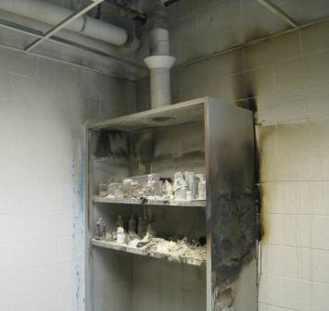
Fire Damage to Chemical Storage Locker in Prep Room 126, Note Ducted Local Exhaust Vent at top
Picture 2
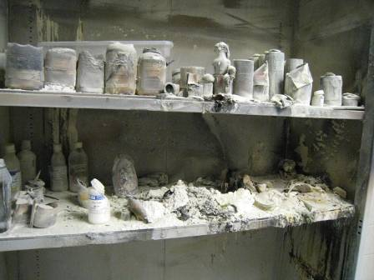
Fire Damaged Chemicals in Storage Locker Prep Room 126

Picture 3
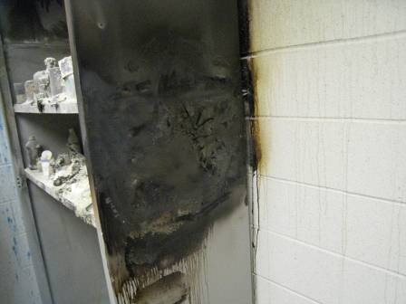
Fire Damage to Chemical Storage Locker in Prep Room 126
Picture 4
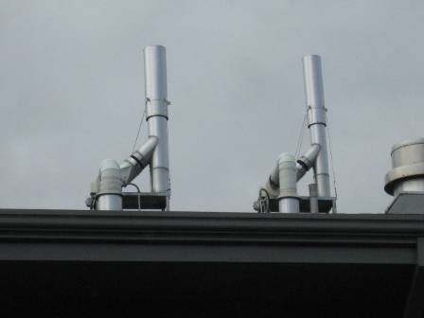
Rooftop Vent Stacks for Chemical Storage Lockers/Science Prep Rooms
Location | Carbon  Monoxide  (*ppm) | TVOCs  (*ppm) | PM2.5  (**µg/m3) |  | Windows  Openable | Ventilation |  | Remarks
 |  |  |  |  |  | Supply | Exhaust | Remarks
Outside (Background) | ND | ND |  | 3-5 |  |  |  | Cool, mostly cloudy, winds NNW 2-9 mph
Main Lobby | ND | ND |  | 7 |  |  |  | Smoke odors
Hallway (127) | ND | ND |  | 5 | Y | Y  Off | Y  Off
125 | ND | ND |  | 4 | Y | Y  Off | Y  Off
126 Prep Room | ND | ND |  | 13 | Y | Y  Off | Y  Off | Chem cabinet-fire, will be removed, local exhaust ventilation
127 | ND | ND |  | 10 | Y | Y  Off | Y  Off
2nd Floor
(above fire)
211 | ND | ND |  | 11 | Y open | Y  Off | Y  Off
216 | ND | ND |  | 5 | Y | Y  Off | Y  Off | Water damaged ceiling tiles near window, smoke odors (no odors in adjacent room)
222 Prep Room | ND | ND |  | 4 | Y | Y  Off | Y  Off | No odors
223 | ND | ND |  | 4 | Y | Y  Off | Y  Off | No odors
Hallway | ND | ND |  | 6 | Y
3rd Floor
(above fire)
322 Prep Room | ND | ND |  | 8 | Y open | Y  Off | Y  Off | Smoke odors
323 | ND | ND |  | 10 | Y open | Y  Off | Y  Off | Smoke odors

Location | Carbon  Monoxide  (*ppm) | TVOCs  (*ppm) | PM2.5  (**µg/m3) |  | Windows  Openable | Ventilation |  | Remarks
 |  |  |  |  |  | Supply | Exhaust | Remarks
Outside (Background) | ND | ND |  | 6 |  |  |  | Cool, partly cloudy, winds SW 1-10, gusts up to 18
125 | ND | ND |  | 4 | Y  Open | Y  On | Y  On | Lingering smoke odors-ceiling tiles may have to be removed
126 Prep Room | ND | ND |  | 3 | Y  Open | Y  On | Y  On | HEPA air scrubber in use, ceiling tiles removed
1st Floor Hallway |  |  |  |  |  | Y  On | Y  On | Exterior doors open, industrial fans-exhausting
Main Lobby | ND | ND |  | 5 |  |  |  | No odors
2nd Floor  (above fire) |  |  |  |  | Y  Open
216 | ND | ND |  | 5 | Y  Open | Y  On | Y  On
222 Prep Room | ND | ND |  | 6 | Y  Open | Y  On | Y  On
223 | ND | ND |  | 5 | Y  Open | Y  On | Y  On
2nd floor Hallway | ND | ND |  | 6 | Y  Open
3rd Floor  (above fire) |  |  |  |  | Y  Open
321 | ND | ND |  | 6 | Y  Open | Y  On | Y  On
322 Prep Room | ND | ND |  | 6 | Y  Open | Y  On | Y  On | Slight smoke odors
323 | ND | ND |  | 5 | Y  Open | Y  On | Y  On

Location | Carbon  Monoxide  (*ppm) | TVOCs  (*ppm) | PM2.5  (**µg/m3) |  | Windows  Openable | Ventilation |  | Remarks
 |  |  |  |  |  | Supply | Exhaust | Remarks
Outside (Background) | ND | ND |  | 7 |  |  |  | Warm, moderate to heavy rains, winds 10-22 mph, gusts up to 29 mph
125 | ND | ND |  | 4 | Y  Open | Y  On | Y  On | Lingering smoke odors-ceiling tiles replaced
126 Prep Room | ND | ND |  | 4 | Y | Y  On | Y  On | Ceiling tiles removed, Lingering smoke odors
1st Floor Hallway |  |  |  | 3 |  | Y  On | Y  On
Main Lobby | ND | ND |  | 2
2nd Floor
2nd floor Hallway | ND | ND |  | 2 | Y  Open
216 | ND | ND |  | 1 | Y  Open | Y  On | Y  On
217 | ND | ND |  | 2 | Y  Open | Y  On | Y  On
221 | ND | ND |  | 1 | Y | Y  On | Y  On
222 Prep Room | ND | ND |  | 1 | Y | Y  On | Y  On | Lingering smoke odors
223 | ND | ND |  | 2 | Y | Y  On | Y  On
224 | ND | ND |  | 1 | Y | Y  On | Y  On
3rd Floor
321 | ND | ND |  | 3 | Y | Y  On | Y  On
322 Prep Room | ND | ND |  | 3 | Y | Y  On | Y  On
323 | ND | ND |  | 2 | Y | Y  On | Y  On
3rd Floor Hallway | ND | ND |  | 3 | Y

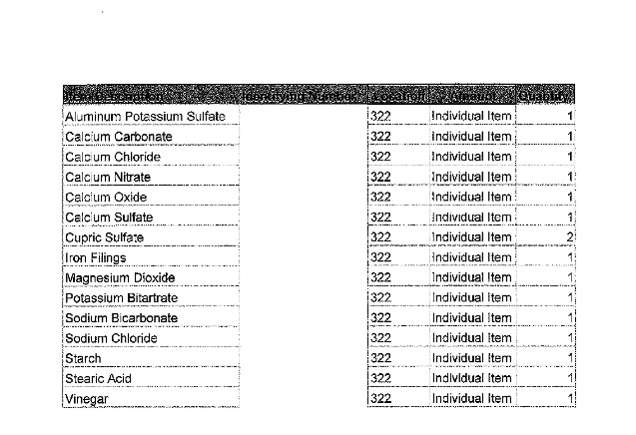

VOCs that result from the combustion of wood include creosol and other alcohols (ATSDR, 2002).

