 **Beyond Bubbles and Blocks**  

Tips for EI Home Visitors

**Did you Know?**

The Department of Public Health has created a documented to support the field with the Massachusetts Early Intervention Mission and Key Principles. The document is called Massachusetts Early Intervention: 7 Key Principles Looks Like/Doesn’t Look Like. There is now a Mission and Key Principles Module on Training on Demand that outlines all 7 Key Principles and what it Looks Like/Doesn’t Look Like.

# **Tips and Techniques**

# It is often explained what Early Intervention looks like, but we don’t always share what it doesn’t look like. This is the Massachusetts 7th Key Principles of Early Intervention with a description of what it looks like and a description of what it “doesn’t look like” because too often those practices are still being used.

**Key Principle #7**

IFSP outcomes must be functional and based on the child and family’s needs, family identified priorities, and input from all members of the child’s IFSP team. This looks like: Learning about the family’s life before early intervention, their *community*, commitments, recreational activities, and the pressures in their family’s life. Realizing that families exist in the context of a larger *community* and fostering communities as resources to support IFSP outcomes and services. (*Community* - a MA EI Core Value). It also looks like: Writing outcomes that support active participation in *community* and family life and what is important to the family.

It does not look like: Assuming that eligible children receiving early intervention services should be the sole focus of the child and family’s life. It does not look like: Writing outcomes based on what the provider thinks is important or writing outcomes with jargon or professional speak.

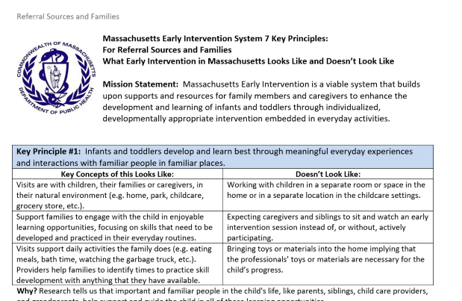**Why?** High quality IFSP outcomes build on the child’s motivations to learn and strengthen what is important and already happening in their daily life. The goal of IFSP outcomes is practical improvements in the child and family’s life.

The Looks Like Doesn’t Look Like document was created in two versions. One version is for the Provider/EI Specialists. The other version is for  referral sources.

**Family Engagement Tip**

Building a respectful, trusting, and reciprocal relationship is a shared responsibility of families, practitioners, organizations, and systems. This positive relationship has the individual family’s strengths and assets at its center.

Guiding Principle #3 from *Strengthening Partnerships: A Framework for Prenatal through Young Adulthood on Family Engagement in Massachusetts.*

For more information visit:[doe.mass.edu/sfs/family-engagement-framework.pdf](http://www.doe.mass.edu/sfs/family-engagement-framework.pdf)