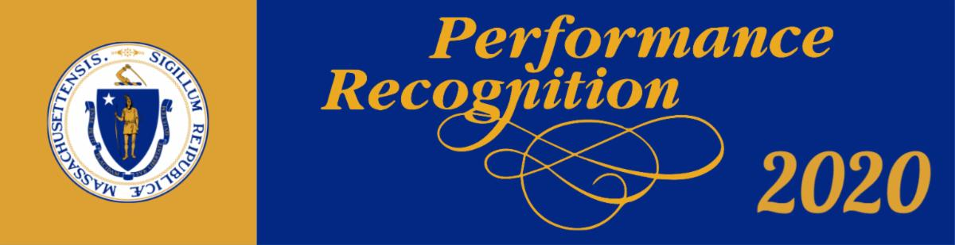

TEMPLATE FOR AGENCY HEAD TO SHARE WITH AGENCY STAFF
FOLLOWING HRD ANNOUNCEMENT

Hello Staff,

The Human Resources Division along with (Agency Name) is excited to kick off the 2020 Performance Recognition Program. The Commonwealth's Performance Recognition Program has been an important means to publicly acknowledge and encourage outstanding performance over the past 35 plus years.

We have seen outstanding examples of our workforce going the extra mile, showing the highest commitment to service, and motivating and influencing fellow employees. Our employee’s daily contributions play a major role in the Commonwealth’s successful delivery of quality services to its citizens.

This is an excellent opportunity to recognize your colleagues for their contributions by nominating an employee or group of employees that have gone above and beyond ordinary expectations.

This year, we have doubled the number of citations that (Agency Name) can distribute to employees, due to the many heroic efforts we have witnessed throughout state government in the recent months.

Please visit the updated PRP website to learn about the various performance awards and nominate your colleagues.

- Commonwealth Citation for Outstanding Performance
- Manuel Carballo Governor’s Award for Excellence in Public Service
- Eugene H. Rooney, Jr. Public Service Award
- Governor Paul Cellucci Award for Leadership and Mentoring in State Government
- Commonwealth Equity in Governance Award

We are excited to open the nomination cycle which will run through August 31. If you have any questions please contact: (insert Coordinator’s name and email address).

Thank you,
Agency Head Name

