
Hello, John Smith! My Site Training Center Resources Signout
KINDERGARTEN IMMUNIZATION SURVEY

PATIENTS SCHOOL VACCINES REPORTS MANAGEMENT

2025 / 2026 Immunization Survey

SCHOOL

Elementary School - 00000

Elementary School - 00000, Kindergarten
Public Schools - 00000

QUICK VIEW Public Schools - 00000

School Type: Public School District

Save

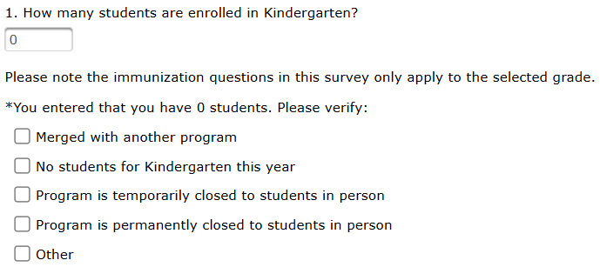
TOOLTIP: Zero Students in the Grade
When completing a survey for a grade with zero students attending, please enter “0” for “Total number of Students.” The following supplemental questions appear.
Close

Phone Number: (123) 456-7890

School Contacts
Primary Contact: John Smith Email: jsmith@school.org
Secondary Contact: Email:

Principal: Email:

Street Address: 123 School St. Address Line 2:
City: State: MA Zip Code:
Question 1) This is a count of the total number of students CURRENTLY ATTENDING this grade.

If there are “0” students in this grade, please enter that in Q.1, and complete the supplemental questions shown in the tooltip above.

- Total number of Students:
100

- How many students have nothing on file about their immunizations or exemptions? *
Question 2) This is a count of students with no records.

Only count students here if they DO NOT have any immunizations or exemptions on file.

They essentially have nothing on file for their immunization status.
5
Do not count students who have an exemption or a required immunization on file.
DTaP (Diphtheria Tetanus Pertussis) Less
DTaP Requirements:
- 5 doses of DTaP vaccine
- 4 doses of DTaP vaccine if the 4th dose was administered on or after the student's 4th birthday

Do not count students who received DT vaccine. Count each student in one category only.

How many of the 95 students have the following:
- Required doses of DTaP vaccine?
Questions 3-5) These questions assess the DTaP vaccination or exemption status of students in this grade.
92

- A medical exemption to DTaP vaccine?
0

- A religious exemption to DTaP vaccine?
3
Polio Less
Polio Requirements:
- 4 doses of Polio vaccine with 4th dose administered on or after the student's 4th birthday and at least 6 months from the previous dose
- 3 doses of Polio vaccine if the 3rd dose was administered on or after the student's 4th birthday and at least 6 months after the previous dose
Count each student in one category only.

How many of the 95 students have the following:
- Required doses of Polio vaccine?
Questions 6-8) These questions assess the polio vaccination or exemption status of students in this grade.
92

- A medical exemption to Polio vaccine?
0

- A religious exemption to Polio vaccine?
3
MMR (Measles Mumps Rubella) Less
MMR Requirements:
- 2 or more doses of MMR vaccine, administered on or after the student's 1st birthday and separated by at least 28 days
- Laboratory evidence of immunity to measles, mumps, and rubella
- If a student has 2 doses of vaccine and laboratory evidence of immunity, count as vaccinated
Count each student in one category only.

How many of the 95 students have the following:
- Required doses of MMR vaccine?
92
Questions 9-12) These questions assess the MMR vaccination or exemption status of students in this grade.
- Laboratory evidence of immunity to measles, mumps, and rubella? (Do not count students who have 2 doses of MMR vaccine.)
0
- A medical exemption to MMR vaccine?
0

- A religious exemption to MMR vaccine?
3
Hepatitis B Less
Hepatitis B Requirements:
- 3 or more doses of Hepatitis B vaccine
- Laboratory evidence of immunity to Hepatitis B
- If a student has 3 doses of vaccine and laboratory evidence of immunity, count as vaccinated
Count each student in one category only.

How many of the 95 students have the following:
- Required doses of Hepatitis B vaccine?
92

- Laboratory evidence of immunity to Hepatitis B? 0
Questions 13-16) These questions assess the hepatitis B vaccination or exemption status of students in this grade.
(Do not count students who have 3 doses of Hepatitis B vaccine.)
- A medical exemption to Hepatitis B vaccine?
0

- A religious exemption to Hepatitis B vaccine?
3
Varicella Less
Varicella Requirements:
- 2 doses of Varicella vaccine, administered on or after the student's 1st birthday and separated by at least 28 days
- Reliable history of chickenpox disease (a diagnosis of chickenpox or interpretation of parent/guardian description of chickenpox by a physician, nurse practitioner, physician assistant or designee)
- Laboratory evidence of immunity to Varicella
- If a student has history of disease and 2 doses of vaccine, count as vaccinated
- If a student has history of disease and 1 dose of vaccine, count as disease
- If a student has laboratory evidence of immunity and 2 doses of vaccine, count as vaccinated
- If a student has laboratory evidence of immunity and 1 dose of vaccine, count as laboratory evidence
- If a student has history of disease and laboratory evidence of immunity, count as disease
Count each student in one category only.
Varicella Requirements:
- 2 doses of Varicella vaccine, administered on or after the student's 1st birthday and separated by at least 28 days
- Reliable history of chickenpox disease (a diagnosis of chickenpox or interpretation of parent/guardian description of chickenpox by a physician, nurse practitioner, physician assistant or designee)
- Laboratory evidence of immunity to Varicella
- If a student has history of disease and 2 doses of vaccine, count as vaccinated
- If a student has history of disease and 1 dose of vaccine, count as disease
- If a student has laboratory evidence of immunity and 2 doses of vaccine, count as vaccinated
- If a student has laboratory evidence of immunity and 1 dose of vaccine, count as laboratory evidence
- If a student has history of disease and laboratory evidence of immunity, count as disease
Count each student in one category only.

How many of the 95 students have the following:
- Required doses of Varicella vaccine?
92

- A physician-certified history of chickenpox disease?
Questions 17-21) These questions assess the varicella vaccination or exemption status of students in this grade.
0
(Do not count students who have 2 doses of Varicella vaccine.)
- Laboratory evidence of immunity to Varicella?
0
(Do not count students who have 2 doses of Varicella vaccine or history of chickenpox disease.)
- A medical exemption to Varicella vaccine?
0

- A religious exemption to Varicella vaccine?
3

Series Less
Questions 22) This is a count of the number of students who meet all requirements for DTaP, polio, MMR, hepatitis B, and varicella.

Students may meet requirements for all required vaccines by having the required number of doses; for MMR, hepatitis B, and varicella students may have laboratory evidence of immunity or disease; for varicella students may also have a physicians-certified history.

DO NOT count partially immunized students on catch-up schedules or those with exemptions.
Series Requirements:
Student has all required doses of vaccine (or laboratory evidence/disease):
- 5 doses of DTaP vaccine or 4 doses of DTaP vaccine if the 4th dose was administered on or after the student's 4th birthday

- 4 doses of Polio vaccine with 4th dose administered on or after the students 4th birthday and at least 6 months fromthe previous dose or 3 doses of Polio vaccine if the 3rd dose was administered on or after the student's 4th birthday and at least 6 months after the previous dose

- 2 MMR
- 3 Hep B
- 2 Varicella

- How many of the 95 students have had all the required vaccines for school entry?
92

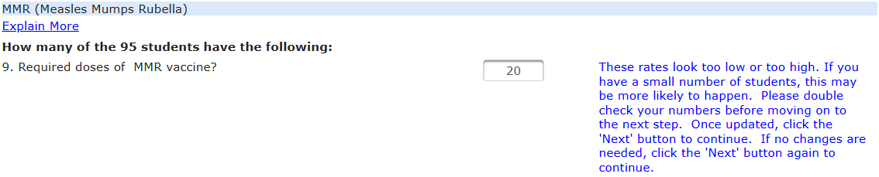
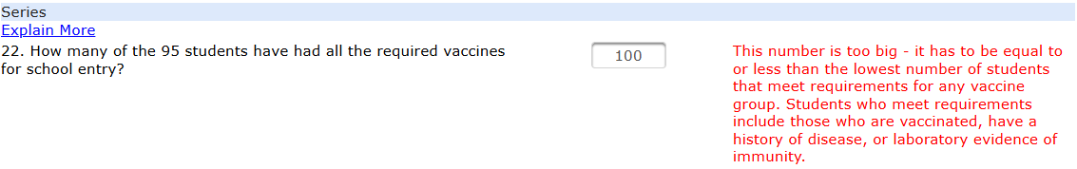

Questions 26-27) These questions assess the number of students with exemptions from ‘Questions 23-24’ who DO NOT MEET ANY REQUIREMENTS ABOVE.

“No vaccines at all?” = “Does not meet any requirements for this grade.
For this survey, Q.22 was changed to “100.” This value is mathematically impossible.

100 students CANNOT meet all requirements when only 92 meet varicella, hepatitis B, etc.
For this survey, Q.9 was changed to “20.” This value is possible, but very low.

When moving to advance a survey, low values or values that seem “off” will be marked for review.
RED (HARD) ERRORS
BLUE (SOFT) ERRORS
Questions 23-24) These questions assess the number of students with either a medical or religious exemption.

This is a count of the number of students with an exemption, NOT THE NUMBER OF EXEMPTIONS. A student with a medical exemption to both varicella and DTaP should only be counted as “1” here.
0
3
0
3
Exemptions
How many of the 95 students have the following:
- A medical exemption to one or more required vaccines included in this survey?
- A religious exemption to one or more required vaccines included in this survey?
25. Does your school ask for an annual renewal of religious exemptions? (This is an MDPH Recommendation)
Yes
Unimmunized
- How many of the 0 student(s) with a medical exemption have no vaccines at all?
- How many of the 3 student(s) with a religious exemption have no vaccines at all?
Save

Close
Back to Top

For assistance contact:
Assessment Unit
Tel: 617-983-4330
Email: immassessmentunit@mass.gov
For technical assistance contact:
MIIS Helpdesk
Tel: Fax:
Email:
617-983-4335
857-323-8321
miishelpdesk@mass.gov
© 2019 Commonwealth of Massachusetts | Immunization Division

