INDOOR AIR QUALITY ASSESSMENT
INCIDENT RESPONSE

Kindred Nursing & Rehabilitation Walden Branch
785 Main Street
Concord, Massachusetts

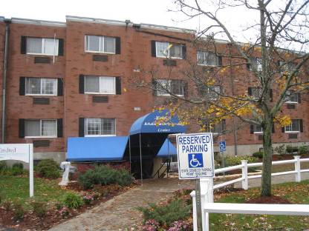

Prepared by:
Massachusetts Department of Public Health
Bureau of Environmental Health
Indoor Air Quality Program
November 2012

Background/Introduction
In response to a referral from the MDPH Emergency Preparedness Bureau concerning a sewage backup, the Massachusetts Department of Public Health (MDPH), Bureau of Environmental Health’s (BEH) Indoor Air Quality (IAQ) Program conducted an IAQ assessment at the Walden branch of Kindred Nursing & Rehabilitation located at 785 Main Street, Concord, Massachusetts.
On October 30, 2012, Cory Holmes, Environmental Analyst/Regional Inspector for BEH’s IAQ Program visited the building to conduct the assessment. Mr. Holmes was accompanied by Mr. Kevin Sheehan, Regional Facilities Manager of Kindred Healthcare, Susan Rask, Director of the Concord Board of Health, and members of the Concord Fire Department (CFD) during the assessment. The assessment was focused on the basement level of the building where flooding occurred.
It was reported to BEH/IAQ staff that on the morning of October 30, 2012, a clog in the plumbing system caused a sewage backup, contaminating basement areas with one to two inches of sewage. CFD was contacted; they cleared the area and conducted decontamination of 12-13 workers. Areas affected in the basement included office space, a rehab unit, lobby areas, hallways, the kitchen, and general and food storage space. At the time of the BEH/IAQ assessment, food service had been suspended, the blockage had been cleared, and ServiceMaster, a flooding/restoration firm, had started conducting remedial actions including drying and disinfection/removal of water-damaged/contaminated materials.

Methods
BEH/IAQ staff performed visual inspection of building materials for water damage, sewage contamination and other environmental concerns.

Discussion
According to the Institute of Inspection, Cleaning and Restoration Certification (IICRC), who provide guidance concerning professional restoration of water-damaged materials, any porous materials damaged by category 3 water (also known as “black” water) should be removed. Category 3 water is defined as grossly unsanitary water containing pathogenic agents arising from sewage or similar contaminated water sources (IICRC, 1999). At the time of assessment, ServiceMaster was planning to remove all contaminated carpeting, gypsum wallboard and all porous stored materials (cardboard, paper, etc.) (Pictures 1 through 4). In addition, all non-porous materials were to be cleaned, dried and disinfected. Remediation areas were isolated with plastic polyethylene sheeting and placed under negative pressure using high-efficiency particulate arrestance (HEPA) filtered air scrubbers (Pictures 5 through 7).
BEH/IAQ staff returned the following day, October 31, 2012, along with Ms. Rask and Ms. Gerry Marcus of the MDPH Bureau of Healthcare Safety and Quality’s Division of Health Care Quality (BHCSQ/DHCQ) to examine the progress of remediation efforts, particulary in kitchen areas. The BHCSQ/DHCQ provides regulatory oversight for long term care facilities in Massachusetts. At the time of the follow-up visit, the east wing had been remediated (Pictures 8 through 10) and final efforts were being conducted to sanitize the kitchen and kitchen equipment in preparation for the day’s dinner service. The west wing areas were separated from the east and were undergoing remediation efforts (Pictures 11 through 13). Later that evening BEH/IAQ staff were informed by Ms. Ladan Azarm, Executive Director, Kindred Nursing & Rehabilitation-Walden, that all surfaces and equipment in the kitchen were sanitized and confirmed by the Concord Board of Health to resume food preparation operations.

Conclusions/Recommendations
In view of the findings at the time of the visit, the following recommendations were made verbally at the time of the visit, and are reiterated below:
- Continue to remove wet/contaminated gypsum wallboard and wooden wall coverings from 1-3 feet above floor level, as well as any wet carpeting and insulation in wall cavities.
- Discard porous items (e.g., books, papers, boxes) that are water-damaged/mold-colonized.
- Continue to seal off/contain remediation areas and place under negative pressure to draw particulates/odors away from occupied areas.
- Continue with plans to clean, dry and sanitize all non-porous surfaces once remediation efforts are complete.
- For more information on mold consult “Mold Remediation in Schools and Commercial Buildings” published by the US Environmental Protection Agency (US EPA, 2001). This document can be downloaded from the US EPA website at: http://www.epa.gov/iaq/molds/mold_remediation.html.

References
IICRC. 1999. IICRC S500. Standard and Reference Guide for Professional Water Damage Restoration, 2nd Edition. Institute of Inspection Cleaning and Restoration, Vancouver, WA.
US EPA. 2001. “Mold Remediation in Schools and Commercial Buildings”. Office of Air and Radiation, Indoor Environments Division, Washington, DC. EPA 402-K-01-001. March 2001. Available at: http://www.epa.gov/iaq/molds/mold_remediation.html
Picture 1

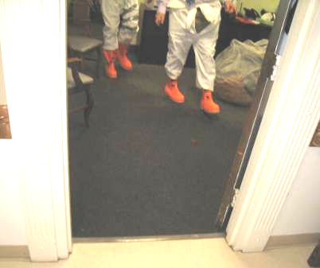

Water-damaged/contaminated carpeting

Picture 2

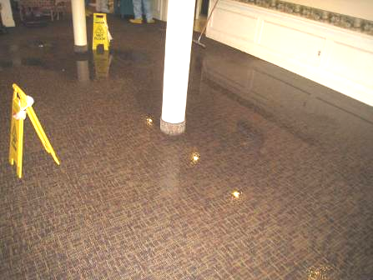

Water-damaged/contaminated carpeting

Picture 3

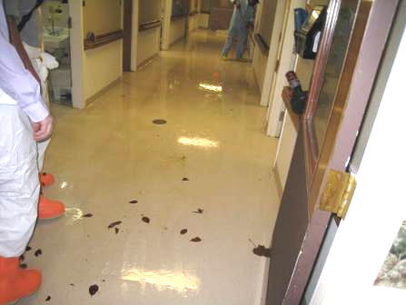

Water-damaged/contaminated gypsum wallboard in hallway

Picture 4

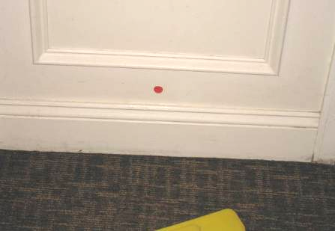

Water-damaged/contaminated carpeting and wood, dot/sticker placed by ServiceMaster indicating moisture testing

Picture 5

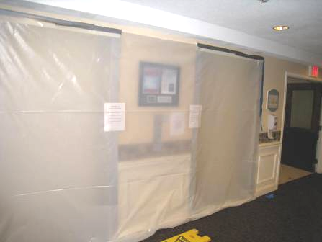

Affected areas isolated by plastic poly sheeting and tape

Picture 6

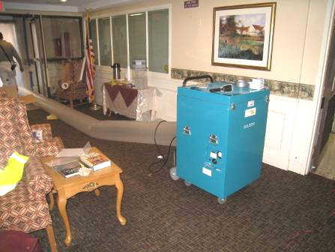

HEPA-filtered air scrubber ducted to outside

Picture 7

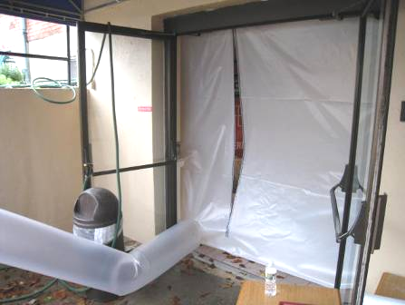

HEPA-filtered air scrubber ducted to outside

Picture 8

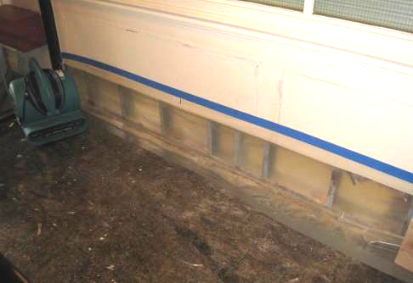

Water-damaged/contaminated gypsum drywall and carpeting removed, floor sanitized

Picture 9

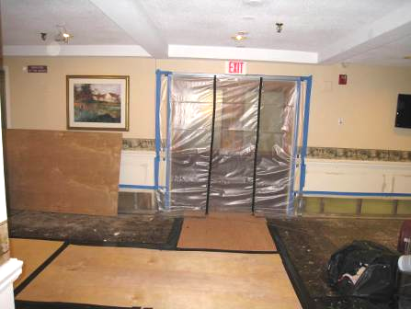

Water-damaged/contaminated gypsum drywall and carpeting removed, floor sanitized

Picture 10

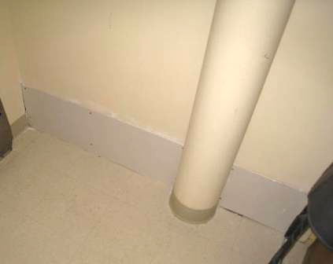

Water-damaged/contaminated gypsum drywall removed/replaced

Picture 11

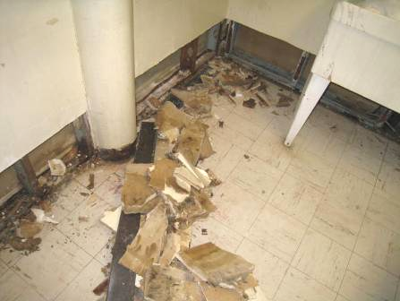

Area of west wing under remediation

Picture 12

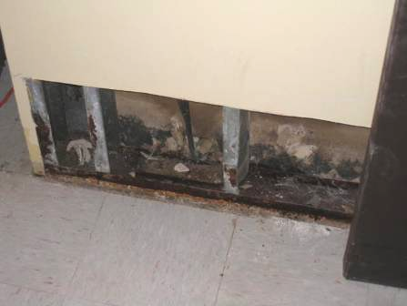

Contaminated gypsum drywall in west wing under remediation

Picture 13

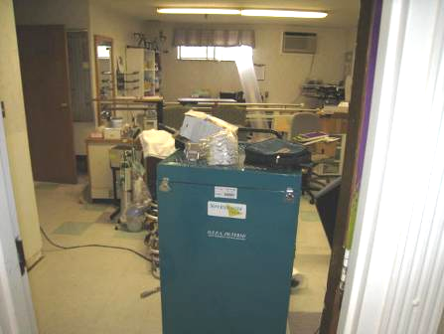

Area of west wing under remediation, note HEPA-filtered air scrubber ducted to outside

