Indicator: L38 - Physicians’ orders and treatment protocols are followed. (When agreement for treatment has been reached by the individual/ guardian/ team).

Date: 9/19

The following set of Interpretations replaces some previous interpretations which have now been deleted from this section.

WHEN IS A MEDICAL TREATMENT PROTOCOL
(HEALTH CARE MANAGEMENT PLAN) NEEDED?

If a person has a medical condition that requires staff to perform specific actions steps to manage/treat and/or prevent a more serious health issue, the need for a protocol/management plan should be discussed with the Health Care Practitioner (HCP)*. Part of this discussion with the HCP should include when the HCP or 911, need to be contacted if specific symptoms are observed.

- If the HCP did not write a treatment protocol initially, when a known significant medical condition exists, it is important for the staff/provider to follow-up with the HCP, and inquire about whether a written treatment protocol/management plan should be put into place to specify actions for staff to follow.

There is no exact list of “significant medical conditions” that automatically warrant a medical treatment protocol/ home health management plan. In large part, the determination of the need for a health care management plan is based on whether staff intervention to monitor, prevent, treat, and/or seek medical assistance for the condition is needed.

Examples of significant medical conditions may include but are not limited to:
Dysphagia | Diabetes | Epilepsy/Seizure Disorder | Severe Allergies/Asthma | Sleep Apnea

Health Care Practitioner (HCP) means an individual who is licensed or otherwise authorized by a state to provide health care services. (45 CFR § 60.3)

WHAT SHOULD BE IN PLACE?

**Verification can consist of using an original health care practitioner encounter form if it gives instructions regarding action steps and when to access a healthcare practitioner and/or 911.

The frequency of review of should be determined by the monitoring HCP

The Protocol/Health management plan can vary in complexity based on the person’s support needs. It is important that health care management plans be written in a manner that direct support staff can easily understand and are able to follow the guidance/ instructions necessary to address the significant health condition.
***The following examples are for illustration only, not meant for reproduction ***

Dysphagia - A Medical Treatment Protocol/ health management plan that outlines action steps for staff to implement in order to assist the person with managing dysphagia and prevent choking and/or aspiration. It must include information about how to recognize choking and/or aspiration and when to access medical assistance.
Name: John Jones
Action Steps:
- Diet: Encourage small bites and sips
- Honey consistency liquids
- Pureed foods
- John should sit up at a 90 degree angle for 30 minutes after eating
- John’s bed should be elevated 45 degrees when sleeping.
Aspiration is defined as when something enters the airway or lungs by accident.

*** If any of these symptoms are note, contact the HCP.
Aspiration from dysphagia can cause signs and symptoms such as:
- Feeling that food is sticking in your throat or coming back into your mouth.
- Pain when swallowing.
- Coughing or wheezing after eating.
- Coughing while drinking liquids or eating solids.
- Chest discomfort or heartburn.
- Elevated temperature/Fever minutes to an hour after eating
What are symptoms of aspiration pneumonia?
- chest pain.
- shortness of breath.
- wheezing.
- fatigue.
- blue discoloration of the skin.
- cough, possibly with green sputum, blood, or a foul odor.
- difficulty swallowing.
****If the person is having difficulty breathing call 911.***

Joan Happy SLP 3/11/19
Valid until reevaluated which is recommended every 3 years or if instances of choking/ aspiration or pneumonia continue.

Congestive Heart Failure (CHF) - A Medical Treatment Protocol/ health management plan that outlines action steps for staff implement to assist the person with managing CHF how to recognize when to access medical assistance.
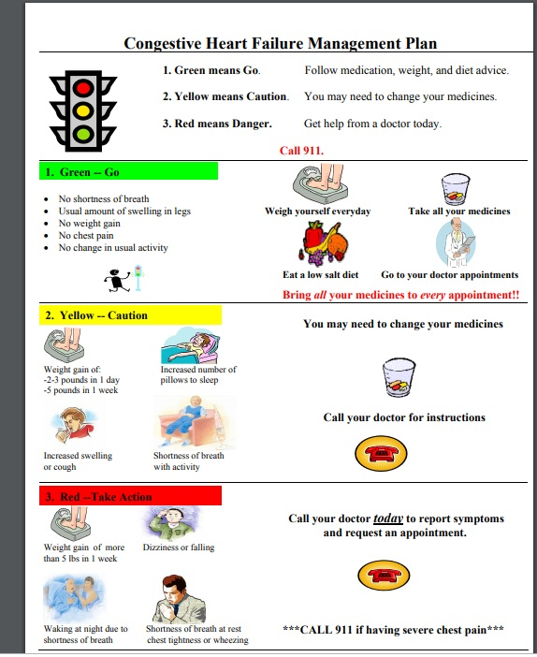

Severe Asthma - A Medical Treatment Protocol/ health management plan that outline action steps for staff implement to assist the person with managing Asthma and how to recognize when to access medical assistance.
Verification that the CHF protocol/home management plan is recommended to be followed per practictioner.

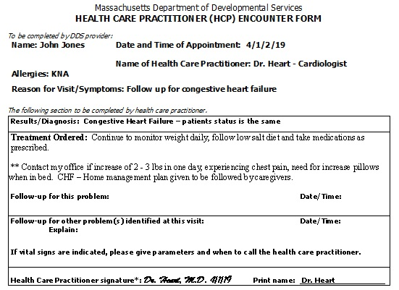

Name: Tim Strong DOB: 10/15/1980
Action Steps
- Tim is highly allergic to dust, mold and tree pollen – These can trigger a severe allergic attack.
- Staff have to dust daily at a time the John is not present in the area.
- During the months of Sept. Oct. Nov (Fall) the pollen counts are high
  - Windows should remain closed Hepa Air filter kept on at all time.

- Tim also has exercise induced asthma attacks. It is important for him to warm up slowly and adequately prior to rigorous exercise.

- Tim is prescribed daily medications to treat his asthma.
- He is also prescribed Pro- Air a quick-acting (rescue inhaler) to be used when he is having a flare up.

Medication | Dosage | Directions for Use
Pro Air Inhaler | 90 mcg | 2 puffs by mouth for asthma flare up symptoms  - Wheezing  - Coughing  - Difficulty breathing  Diff | Repeat in 20 minutes if no improvement.  Repeat up to 3 times

Call 911 any of these symptoms are observed.
- Severe wheezing when breathing both in and out
- Coughing that won't stop
- Very rapid breathing
- Chest tightness or pressure
- Difficulty talking
- Feelings of anxiety or panic
- Pale, sweaty face
- Blue lips or fingernails
- No improvement after using a quick-acting (rescue) inhale

John Smith John Smith MD – 3/14/19

HOW IS THIS INDICATOR EVALUATED?

Surveyors must assess that treatment protocols/ health management plans are implemented consistently. In summary the following items must be in place to render a rating of met:

- Written protocol
- Staff are knowledgeable (Based on interview and training documentation)
- Correct implementation of protocol/health management plan

Staff must be trained, knowledgeable, and consistently following the medical treatment protocols to rate this indicator met. Thus, evidence is needed that all staff have been trained in this protocol, and that this protocol is being consistently implemented. If treatment protocols have not been implemented consistently, the standard is not met, regardless of the presence of training documentation.

Person has Significant Medical condition

There are no action steps for staff
or
Individual
self -manages

Staff need to monitor and implement actions steps

Not Rated
(L 38)

Yes
Yes
Yes
Yes
Yes
Met

Yes
Yes
Staff implement accurately

No
Not Met

Staff demonstrate knowledge of action steps
(interview and training)

No
Not Met

Written Protocol
(2 elements listed in flow chart above)

No
Not Met

WHAT IS THE THRESHOLD FOR STAFF KNOWLEDGE AS DETERMINED THROUGH INTERVIEW?

Staff must be both trained and knowledgeable. Surveyors will review training documentation and interview direct support staff about whether the sampled individual(s) has a health care protocol, and ask them to describe the protocol and what actions steps they take.

To be rated met, staff must be aware that a protocol is in place, and staff must be knowledgeable in the specific actions they are expected to implement.

There may be circumstances when staff are required to be familiar with every action step in the protocol; there may be other circumstances when staff need to be knowledgeable in when to seek medical assistance but could reference to the protocol for guidance regarding specific action steps. For example:
Allergy to Bee Stings – Staff must know exactly all the actions steps to respond immediately including the administration of medication and contacting emergency personnel.
Dysphagia – Staff need to know that a person has a protocol in place, but could reference the protocol for specificity around diet texture, the angle the person needs to sit at when eating. Staff however, have to be knowledgeable of how to immediately respond to signs of choking or aspiration.

** All staff must be knowledgeable concerning when to call 911.**
CAN A MEDICAL CONDITION EXIST WITHOUT A HEALTH MANAGEMENT PLAN, AND WHEN WOULD A PROTOCOL BE INDICATED?

Yes. A health care protocol is not necessary for an individual with a medical condition who receives on-going monitoring from a healthcare practitioner (HCP) who does not recommend any staff actions other than the administration of medication sand there is no requirement for contacting medical professionals and/or emergency medical services if specific symptoms occur between appointments.
Over time, this may change and the health care practitioner encounter forms should be reviewed for instructions regarding action steps and when to access a healthcare practitioner and/or 911. When HCP notes reflect needed staff actions to treat/manage the condition and instructions to contact medical professionals and/or emergency medical services if specific symptoms occur, then a protocol would be necessary.
HOW DOES AGREEMENT WITH A HEALTH MANAGEMENT PLAN WORK?

During the appointment with the HCP, the individual will learn about their significant medical condition and of the recommendations for staff actions. Once developed and verified with the HCP, the proposed treatment / health management plan needs to be discussed with the person and/or their guardian to ensure that he/she is willing to accept/participate in the proposed action steps. Health care management plans are required to be incorporated into the ISP.

QUESTIONS:
Date: replaced with 5/19 version
Question 5: When someone has a significant medical condition resulting in the need for a special diet, does the person also need a medical treatment protocol/health management plan?
Answer:
No, a medical treatment protocol is not always required. A Medical Treatment Protocol should be developed and implemented only when the significant medical condition requires staff intervention to monitor, prevent, treat, and seek medical assistance for the condition. For example, the HCP may recommend that someone with blood pressure concerns go on a low salt diet, with ongoing monitoring during regular follow-up appointments with no other health care management strategies. Special diets such as low salt diets, diabetic diets, gluten free diets, and should be evaluated within indicator L-39.

Also special diets may be in place for reasons other than a significant medical condition. These would be evaluated in L39. For example someone who is on a ground diet because they are edentulous does not meet the threshold for having a significant medical condition, and would therefore not automatically need a corresponding Medical Treatment Protocol.

DATE: 2/15; revised 9/19
Question 6: Day Supports
How is this indicator reviewed in a day service?
Answer:
The considerations are essentially the same across service types. It is essential that staff supporting the person, including day service support staff, be aware of significant medical conditions affecting a person’s health. Further, staff should be knowledgeable of their role and action(s) to take in supporting the person should the condition become active during the day service.

As a day service provider does not typically coordinate an individual’s health care, obtaining timely and accurate information can present a challenge. The surveyor begins with reviewing what information is documented about an individual; Emergency Fact Sheet, Health Care Record (if available), and the Individual Support Plan as examples. Along with the information present in the individual’s record, a surveyor would want to know how the provider ascertains health information and what the mechanism is for seeking this information from the person’s service coordinator, residential service provider, and/or family.

Once the surveyor has a sense of what the person’s medical conditions are, the surveyor can research the situation to determine as noted above whether there is a necessity for a medical treatment protocol. The criteria are basically the same:
- There is a diagnosed significant medical condition affecting the person’s health;
- The condition is active and/or being actively treated;
- This condition is present and staff are providing ongoing support and /or actions /emergency response is potentially needed during the day service hours.

When the above is true, the day service provider must obtain or develop a protocol / health management plan guiding its staff. If a person is supported residentially, the residential home may have obtained/developed a specific treatment protocol/ health care plan, a copy of which should be made available to the day service. In situations where the individual does not receive another service, the day service must rely on its own mechanisms for obtaining relevant health information. In any event, if a person has a significant medical condition, , it is essential that there be a consistent approach to treatment, and a written protocol/ health care management plan is required as noted above. Depending on the severity of the condition and the information available to the day service, this can be a generalized protocol outlining staff actions, for example in the event of seizures, staff contact 911. However, when the significant medical condition has specific action steps for implementation these should be clearly outlined in addition to noting when to contact medical professional and/or call 911 if necessary when medical emergency. .

Based on the need for a protocol that would need to be present during the day service, the rating of the indicator will be focused on the following:

- There is a mechanism for ascertaining what awareness/support might be needed during the day service;
- There is a protocol outlining the condition that is sufficiently specificity* to the person and the steps staff should be prepared to take if needed;
- Staff are knowledgeable of the condition and the steps they should take;
- There is evidence of the protocol being implemented correctly when /if it has been needed.

* “Sufficiently specificity” means commensurate with the severity of the condition and the level of intervention needed by staff. For example, a person with epilepsy that is infrequent may have a more generalized health care protocol with contains only generalized actions and emergency contact steps. But a more severe, active form of epilepsy may require a more individualized health care management plan with defined steps based on identified criteria. As mentioned above, both components need to be addressed within a medical treatment protocol:
A series of actions that staff/providers need to implement to treat/manage or prevent a more serious condition | How to recognize issues related to the condition to determine when to contact medical professional and/or call 911 if necessary.

In assessing the above, the surveyor conducts the following activities:

Offsite
- The surveyor reviews ISPs, HCRs, and Site information via the Meditech and/or HCSIS systems to learn about the individual’s needs and the setting where he or she is supported. This helps the surveyor understand what services and supports they should be expected to see and hear about when they visit.

Onsite
- The surveyor reviews the individual’s record, such as the Emergency Fact Sheet, progress notes, or communication logs. When a protocol should be present, the surveyor will also review documentation to identify if there were any instances of the protocol needing to be implemented. The surveyor reviews any documentation related to the protocol, including training documentation.
- The surveyor interviews staff about the individual’s supports to verify that staff are knowledgeable of the protocol.
- The surveyor will ask if the protocol has been implemented and request evidence of that, whether in an incident report, progress note, or communication log.

The following examples are intended to help illustrate this applicability and rating process.

Medical condition: Seizure Disorder/Epilepsy – Day Services

Scenario 1
- Emergency Fact Sheet documents “history of seizures.” (e.g., family reported there had been a seizure when person was a child);
- The person is not prescribed a neuroleptic;
- There is not an actual diagnosis documented;
- There has been no known seizure activity;
- The agency has evidence of its request for medical information from the residential services provider and/or family and there were no instructions related to this condition.

Protocol Needed: No
Rated: No
Provider asked to seek verification/correction to this notation on the EFS.
Scenario 2
- Emergency Fact Sheet documents “Epilepsy”;
- The person is prescribed a neuroleptic;
- There has been no seizure activity in last 5 years;
- There is no physician ordered instructions or recommendations available at the day service;
- The agency has evidence of its request for medical information from the residential services provider and/or family and there were no instructions related to this condition.

Protocol Needed: Yes – can be general in accordance with DDS Seizure guidelines; and
Staff knowledgeable of protocol: If Yes, Rating: Met
If No Rating: Not Met; and
If Protocol has been implemented, was protocol followed: If Yes, Met
If No, Not Met
Scenario 3
- Emergency Fact Sheet documents “Epilepsy”;
- The person is prescribed a neuroleptic, including PRN Diastat for seizure lasting greater than 1 minute;
- There has been seizure activity in last 5 years;
- There is no physician ordered instructions/ recommendations available at the day service; or There are physician ordered instructions or the provider has requested medical information from residential services provider and/or family and there were specific instructions related to this condition.
- The agency has evidence of its request for medical information from the residential services provider and/or family and there were no instructions related to this condition.

Protocol Needed: Yes and must be individual specific for rating of Met; the day service protocol should agree with / correspond with the physician instructions and the residential services provider plan
Staff Knowledgeable of protocol: If Yes, – Met
If No – Not Met; and
If Protocol has been implemented, was protocol followed: If Yes, Met
If No, Not Met
Medical Condition: Diabetes Scenario 1
- Emergency Fact Sheet documents “Diabetes”
- Dietary recommendations include low calorie and avoiding sugary foods
- The person is not prescribed a medication related to this condition
- There are no “triggers” as to when to contact medical professionals
- The agency has evidence of its request for medical information from the residential services provider and/or family and there were no instructions related to this condition.
Protocol Needed: No
Staff knowledgeable of person’s condition: Yes but not rated in L38.
Scenario 2
- Emergency Fact Sheet documents “Diabetes”
- The person is on a strict diet for this condition
- Medical professionals need to be contact when the person’s condition reaches a certain point
- The person has a treatment order to test blood sugar during day program hours.
- The person can independently test blood sugar level but needs support to interpret and respond appropriately to those results.
- The provider holds a supply of glucose tabs to be administered if needed.
- The provider has requested medical information from residential services provider and/or family and there were special instructions related to this condition.
Protocol Needed: Yes - must include parameters for glucose tabs and agree with special instructions from
HCP.
Staff Knowledgeable of protocol: Yes – Met
No – Not Met; and
If Protocol has been implemented, was protocol followed: If Yes, Met
If No, Not Met

Date: 9/17; revised 5/19
Question 7: Placement Services
What is the role of the Provider and the home care provider in meeting this indicator?
Answer:
It is the responsibility of the Provider in collaboration with and under the direction of the health care provider, to ensure that there is a health care management plan when indicated. The Provider supports the home care provider to implement the medical treatment protocols/ health care management plans. The home care provider is also responsible for tracking health related data per recommendation of the HCP, and for keeping the health care provider and the Provider up to date on the individual’s current status.

The surveyors will start with the Provider and inquire as to which individuals have a significant medical condition which warrants the need for a treatment protocol/ health management plan. While the treatment protocol may be available at the corporate site and/or at the home, it is important that the home care provider is accurately implementing all action steps outlined. The Provider needs to ensure that the home care provider is trained, knowledgeable and familiar with the treatment protocol/ health management plan. When the surveyor meets with the home care provider, the surveyor will review the treatment protocol, and interview the care provider about the protocol and about what is occurring and how these actions are being documented and shared with the doctor.

