Commonwealth of Massachusetts
Executive Office of Health and Human Services

Office of Medicaid
www.mass.gov/masshealth

MassHealth
Transmittal Letter LAB-47
May 2018

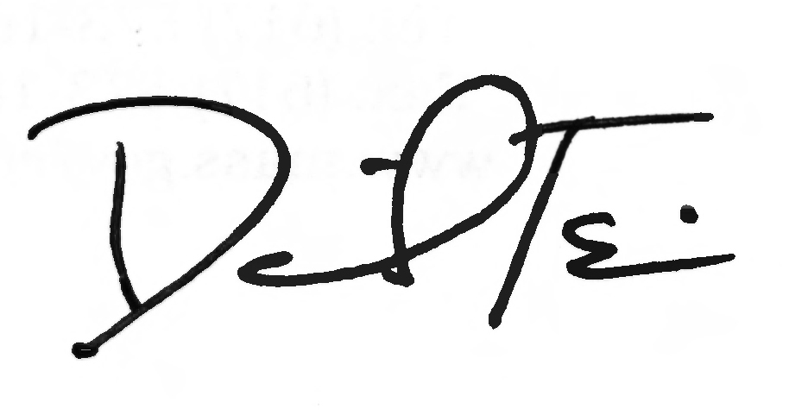
TO: Independent Clinical Laboratories Participating in MassHealth

FROM: Daniel Tsai, Assistant Secretary for MassHealth

RE: Independent Clinical Lab Manual (2018 Service Code Update)

This letter transmits revisions to the service codes in the Independent Clinical Laboratory Manual. The Centers for Medicare & Medicaid Services (CMS) has revised the Healthcare Common Procedures Coding System (HCPCS) for 2018. MassHealth has updated Subchapter 6 to include new service codes effective for dates of service on or after January 1, 2018.

MassHealth providers must refer to the American Medical Association’s Current Procedural
Terminology (CPT) codebook or the Healthcare Common Procedure Coding System (HCPCS) Level II codebook to obtain service descriptions of the codes listed in Subchapter 6 of the Independent Clinical Laboratory Manual.

To obtain a fee schedule at no cost, download the Executive Office of Health and Human Services regulations at https://www.mass.gov/regulations/101-CMR-32000-clinical-laboratory-services. The regulation title for Clinical Laboratory Services is 101 CMR 320.00; for Medicine Services, it is 101 CMR 317.00; and for Surgery Services, the regulation title is 101 CMR 316.00.

MassHealth Website

This transmittal letter and attached pages are available on the MassHealth website at www.mass.gov/masshealth.

To sign up to receive email alerts when MassHealth issues new transmittal letters and provider bulletins, send a blank email to join-masshealth-provider-pubs@listserv.state.ma.us. No text in the body or subject line is needed.

Questions

If you have any questions about the information in this transmittal letter, please contact the
MassHealth Customer Service Center at 1-800-841-2900, email your inquiry to providersupport@mahealth.net, or fax your inquiry to 617-988-8974.

(continued on the next page)
NEW MATERIAL
(The pages listed here contain new or revised language.)

Independent Clinical Laboratory Manual

Pages 6-1 through 6-6

OBSOLETE MATERIAL
(The pages listed here are no longer in effect.)

Independent Clinical Laboratory Manual

Pages 6-1 through 6-6 — transmitted by Transmittal Letter LAB-46

601 Introduction
MassHealth providers should refer to the American Medical Association’s Current Procedural Terminology (CPT) codebook or the Healthcare Common Procedure Coding System (HCPCS) Level II codebook for the service codes and service descriptions when billing for services provided to MassHealth members. MassHealth pays for the services represented by the codes listed in Subchapter 6 in effect at the time of service, subject to all conditions and limitations in MassHealth regulations at 130 CMR 401.000 and 450.000. An independent clinical laboratory may request prior authorization for any medically necessary service reimbursable under the federal Medicaid Act, in accordance with 130 CMR 450.144, 42 U.S.C. 1396d(a) and 42 U.S.C. 1396d(r)(5), for a MassHealth Standard or CommonHealth member younger than 21 years of age, even if it is not designated as covered or payable in Subchapter 6 of the Independent Clinical Laboratory Manual.

The following abbreviations are used in Subchapter 6.

(A) IC: Claim requires individual consideration. See 130 CMR 401.419 and 450.271 for more information.

(B) PA: Service requires prior authorization. See 130 CMR 450.303 for more information.

602 Payable Laboratory Services
This section lists CPT codes and HCPCS Level II codes that are payable under MassHealth.

80047
80048
80050
80051
80053
80055
80061
80069
80074
80076
80081
80150
80155
80156
80157
80158
80159
80162
80163
80164
80165
80168
80169
80170
80171
80173
80175
80176
80177
80178
80180
80183
80184
80185
80186
80188
80190
80192
80194
80195
80197
80198
80199
80200
80201
80202
80203
80299
80305
80306
80307
80400
80402
80406
80408
80410
80412
80414
80415
80416
80417
80418
80420
80422
80424
80426
80428
80430
80432
80434
80435
80436
80438
80439
81000
81001
81002
81003
81005
81007
81015
81020
81025
81050
81099 (IC)
81162 (PA)
81170
81211 (PA)
81211-59 (PA)
81212 (PA)
81215 (PA)
81217 (PA)
81218
81219
81228 (PA)(IC)
81229 (PA)(IC)
81272
81273
81276
81311
81314
81420 (PA)(IC)
81479 (IC)
81507 (PA)(IC)
81519 (PA)(IC)
82009
82010
82013
82016
82017
82024
82030
82040
82042
82043
82044
82045
82085
82088
82103
82104
82105
82106
82107
82108
82120
82127
82128
82131
82135
82136
82139
82140
82143
82150

82154
82157
82160
82163
82164
82172
82175
82180
82190
82232
82239
82240
82247
82248
82252
82261
82270
82271
82272
82274
82286
82300
82306
82308
82310
82330
82331
82340
82355
82360
82365
82370
82373
82374
82375
82376
82378
82379
82380
82382
82383
82384
82387
82390
82397
82415
82435
82436
82438
82441
82465
82480
82482
82485
82495
82507
82523
82525
82528
82530
82533
82540
82542
82550
82552
82553
82554
82565
82570
82575
82585
82595
82600
82607
82608
82610
82615
82626
82627
82633
82634
82638
82652
82656
82657
82658
82664
82668
82670
82671
82672
82677
82679
82693
82696
82705
82710
82715
82725
82726
82728
82731
82735
82746
82747
82757
82759
82760
82775
82776
82777
82784
82785
82787
82800
82803
82805
82810
82820
82930
82938
82941
82943
82945
82946
82947
82948
82950
82951
82952
82955
82960
82963
82965
82977
82978
82979
82985
83001
83002
83003
83006
83009
83010
83012
83013
83014
83015
83018
83020
83021
83026
83030
83033
83036
83037
83045
83050
83051
83060
83065
83068
83069
83070
83080
83088
83090
83150
83491
83497
83498
83500
83505
83516
83518
83519
83520
83525
83527
83528
83540
83550
83570
83582
83586
83593
83605
83615
83625
83630
83631
83632
83633
83655
83661
83662
83663
83664
83670
83690
83695
83698
83700
83701
83704
83718
83719
83721
83727
83735
83775
83785
83789
83825
83835
83857
83861
83864
83872
83873
83874
83876
83880
83883
83885
83915
83916
83918
83919
83921
83930
83935
83937
83945
83950
83951
83970
83986
83992
83993
84030
84035
84060
84066
84075
84078
84080
84081
84085
84087
84100
84105
84106
84110
84112
84119
84120
84126
84132
84133
84134
84135
84138
84140
84143
84144
84146
84150
84152
84153
84154
84155
84156
84157
84160
84163
84165
84166
84181
84182
84202
84203
84206
84207
84210
84220
84228
84233
84234
84235
84238
84244
84252
84255
84260
84270
84275
84285
84295
84300
84302
84305
84307
84311
84315
84375
84376
84377
84378
84379
84392
84402
84403
84425
84430
84432
84436
84437
84439
84442
84443
84445
84446
84449
84450
84460
84466
84478
84479
84480
84481
84482
84484
84485
84488
84490
84510
84512
84520
84525
84540
84545
84550
84560
84577
84578
84580
84583
84585
84586
84588
84590
84591
84597
84620
84630
84681
84702
84703
84704
84999 (IC)
85002
85004
85007
85008
85009
85013
85014
85018
85025
85027
85032
85041
85044
85045
85046
85048
85049
85055
85060
85097
85130
85170
85175
85210
85220
85230
85240
85244
85245
85246
85247
85250
85260
85270
85280
85290
85291
85292
85293
85300
85301
85302
85303
85305
85306
85307
85335
85337
85345
85347
85348
85360
85362
85366
85370
85378
85379
85380
85384
85385
85390
85396
85397
85400
85410
85415
85420
85421
85441
85445
85460
85461
85475
85520
85525
85530
85536
85540
85547
85549
85555
85557
85576
85597
85598
85610
85611
85612
85613
85635
85651
85652
85660
85670
85675
85705
85730
85732
85810
85999 (IC)
86000
86001
86003
86005
86008
86021
86022
86023
86038
86039
86060
86063
86140
86141
86146
86147
86148
86152
86153
86155
86156
86157
86160
86161
86162
86171
86200
86215
86225
86226
86235
86255
86256
86277
86280
86294
86300
86301
86304
86308
86309
86310
86316
86317
86318
86320
86325
86327
86329
86331
86332
86334
86335
86336
86337
86340
86341
86343
86344
86352
86353
86355
86356
86357
86359
86360
86361
86367
86376
86382
86384
86386
86403
86406
86430
86431
86480
86481
86485
86486
86490
86510
86590
86592
86593
86602
86603
86606
86609
86611
86612
86615
86617
86618
86619
86622
86625
86628
86631
86632
86635
86638
86641
86644
86645
86648
86651
86652
86653
86654
86658
86663
86664
86665
86666
86668
86671
86674
86677
86682
86684
86687
86688
86689
86692
86694
86695
86696
86698
86701
86702
86703
86704
86705
86706
86707
86708
86709
86710
86711
86713
86717
86720
86723
86727
86732
86735
86738
86741
86744
86747
86750
86753
86756
86757
86759
86762
86765
86768
86771
86774
86777
86778
86780
86784
86787
86788
86789
86790
86793
86794
86800
86803
86804
86805
86806
86807
86808
86812
86813
86816
86817
86821
86825
86826
86828
86829
86830
86831
86832
86833
86834
86835
86849 (IC)
86850
86860
86870
86880
86885
86886
86900
86901
86902
86904
86905
86906
86920
86921
86922
86923
86940
86941
86970
86971
86972
86975
86976
86977
86978
86999 (IC)
87003
87015
87040
87045
87046
87070
87071
87073
87075
87076
87077
87081
87084
87086
87088
87101
87102
87103
87106
87107
87109
87110
87116
87118
87140
87143
87147
87149
87152
87158
87164
87166
87168
87169
87172
87176
87177
87181
87184
87185
87186
87187
87188
87190
87197
87205
87206
87207
87209
87210
87220
87230
87250
87252
87253
87254
87255
87260
87265
87267
87269
87270
87271
87272
87273
87274
87275
87276
87278
87279
87280
87281
87283
87285
87290
87299
87300
87301
87305
87320
87324
87327
87328
87329
87332
87335
87336
87337
87338
87339
87340
87341
87350
87380
87385
87389
87390
87391
87400
87420
87425
87427
87430
87449
87450
87451
87471
87472
87475
87476
87480
87481
87482
87483
87485
87486
87487
87490
87491
87492
87495
87496
87497
87498
87500
87501
87502
87503
87505
87506
87507
87510
87511
87512
87516
87517
87520
87521
87522
87525
87526
87527
87528
87529
87530
87531
87532
87533
87534
87535
87536
87537
87538
87539
87540
87541
87542
87550
87551
87552
87555
87556
87557
87560
87561
87562
87580
87581
87582
87590
87591
87592
87623
87624
87625
87631
87632
87633
87634
87640
87641
87650
87651
87652
87653
87660
87661
87662
87797
87798
87799
87800
87801
87802
87803
87804
87806
87807
87808
87809
87810
87850
87880
87899
87900
87901
87902
87903
87904
87905
87906
87910
87912
87999 (PA)(IC)
88104
88106
88108
88112
88120
88121
88130
88140
88141
88142
88143
88147
88148
88150
88152
88153
88155
88160
88161
88162
88164
88165
88166
88167
88172
88173
88174
88175
88177
88182
88184
88185
88187
88188
88189
88199 (IC)
88230
88233
88235
88237
88239

88240
88241
88245
88248
88249
88261
88262
88263
88264
88267
88269
88271
88272
88273
88274
88275
88280
88283
88285
88289
88291
88299 (IC)
88300
88302
88304
88305
88307
88309
88311
88312
88313
88314
88319
88342
88346
88348
88350
88355
88356
88358
88360
88361
88362
88363
88365
88367
88368
88371
88372
88380 (IC)
88381
88387
88388
88399 (IC)
88720
88740
88741
89049
89050
89051
89055
89060
89125
89160
89190
89220 (IC)
89230 (IC)
89240 (IC)
89300
89310
89320
93000
93005
93010
93015
93016
93017
93018
93024
93040
93041
93042
93224
93225
93226
93227
93228
93229 (IC)
93268
93278
93724
93799 (IC)
G0027
G0480
G0481
G0482
G0483
P9604

603 Modifiers

The following service code modifiers are allowed for billing under MassHealth.

Modifier Description

59 Distinct procedural service (may be used only with service code 81211)
91 Repeat clinical diagnostic laboratory test
QW CLIA waived test

