INCIDENT HIGHLIGHTS
DATE:
January 5, 2018
TIME:
3:45 a.m.
VICTIM:
60-year old male laborer
INDUSTRY/NAICS CODE:
Public Sector/ 221310
EMPLOYER:
Public water and sewer authority
SAFETY & TRAINING:
Safety training and a comprehensive program
SCENE:
Water storage facility in a residential area
LOCATION:
Massachusetts
EVENT TYPE:
Overexertion

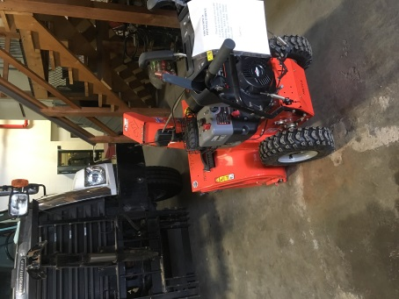

REPORT#: 18MA031 REPORT DATE: February 25, 2019
Laborer Dies While Clearing Snow After a Blizzard—Massachusetts

SUMMARY
On January 5, 2018, a 60-year-old laborer died while clearing snow in the early morning after a blizzard. At the time of the incident, the laborer was operating a snow blower to clear snow from a sidewalk. The laborer suffered a myocardial infarction and collapsed to the ground. READ THE FULL REPORT> (p.3)

CONTRIBUTING FACTORS
Key contributing factors identified in this investigation include:
- Pre-existing medical conditions;
- Overexertion;
- Extreme cold;
- Early morning; and
- Working alone. LEARN MORE> (p.5)

RECOMMENDATIONS
Massachusetts FACE Program concluded that, to help prevent similar occurrences, employers should:
- Consider factors that may impact the risk of acute cardiac events such as time of day, physical demands of the task, and environmental conditions when scheduling tasks.
- Ensure workers in cold environments are adequately warm by developing protocols to prevent cold stress.
- Consider developing policies that prevent working alone in certain situations.
- Train workers on basic cardiopulmonary resuscitation (CPR) and consider having an automated external defibrillator (AED) available at work sites and provide training for workers on their use.
- Educate all workers about the work conditions that might increase their risk of cardiovascular disease and the signs of cardiac arrest. LEARN MORE> (p.5)
Fatality Assessment and Control Evaluation (FACE) Program

The Massachusetts Department of Public Health, in cooperation with the National Institute for Occupational Safety and Health (NIOSH), conducts investigations on the causes of work-related fatalities. The goal of this program, known as Massachusetts Fatality Assessment and Control Evaluation (Massachusetts FACE) is to prevent future fatal workplace injuries. Massachusetts FACE aims to achieve this goal by identifying and studying the risk factors that contribute to workplace fatalities, by recommending intervention strategies, and by disseminating prevention information to employers and employees.

NIOSH funded state-based FACE Programs currently include: California, Kentucky, Massachusetts, Michigan, New York, Oregon, and Washington.
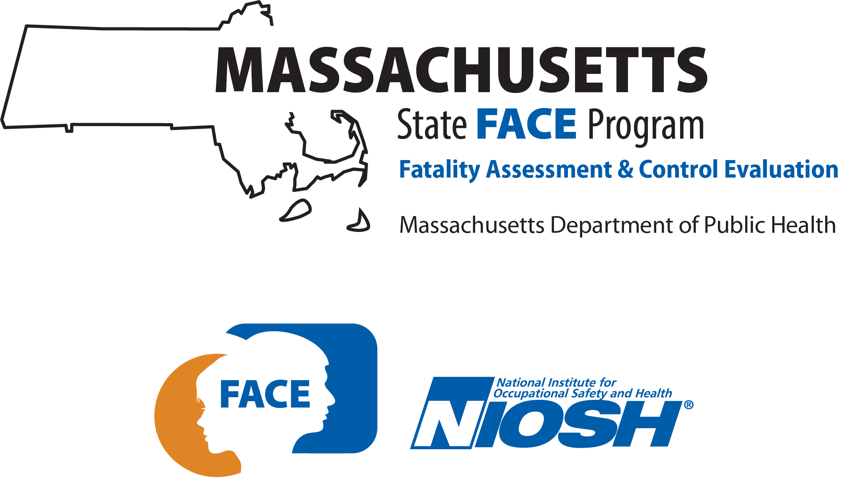

SUMMARY
On January 5, 2018, a 60-year-old laborer died while clearing snow after a blizzard. At the time of the incident, the laborer was operating a snow blower to clear snow from a sidewalk in a residential area. The laborer suffered a myocardial infarction and fell to the ground. A resident of the neighborhood found the victim on the ground and placed a call for emergency medical services (EMS). EMS arrived quickly and the victim was transported to a local hospital.

INTRODUCTION
On January 5, 2018, the Massachusetts FACE Program was alerted by the local media about a death of a worker clearing snow that occurred earlier that day. On April 4, 2018, representatives from the Massachusetts FACE Program, the Massachusetts Department of Labor Standards and an Occupational and Environmental Medicine Resident on rotation at the Occupational Health Surveillance Program from the Harvard School of Public Health traveled to the offices of the public authority and met with multiple authority representatives to discuss the incident. The incident location, police report, death certificate, and other information were reviewed.

EMPLOYER
The employer was a state public water and sewer authority that provides water and sewer services to 3.1 million people and more than 5,500 large industrial users in 61 communities. The employer had about 1,130 employees that covered multiple units, including water, waste water, water treatment, and maintenance. The victim was part of the maintenance unit for building and grounds. These employees typically worked 8 hours per day with shifts routinely starting at 7:00 a.m. and ending at 3:30 p.m., Monday through Friday. The main tasks for the victim included cutting grass, trimming vegetation, litter pickup, and snow removal. Most of the non-management employees of the authority had union representation, as did the victim.

WRITTEN SAFETY PROGRAMS and TRAINING
At the time of the incident, the authority had a comprehensive safety and health program, provided employees training on multiple topics, and provided monthly toolbox talks. Topics covered in the safety and health program and trainings included lockout/tagout, confined space, cold and heat stress, and working along roadways. New hires who primarily will be in the field are required to have pre-employment physicals and on the first day of employment go through a two-hour safety orientation. The authority also provided employees with personal protective equipment (PPE) and a yearly allowance for additional PPE. The provided PPE included hearing and eye protection and high visibility safety apparel, hardhats, and gloves.

WORKER INFORMATION
The victim was a 60-year-old Black non-Hispanic male laborer for the public water and sewer provider. At the time of the incident, he had worked at the authority for approximately twenty years. Prior to the victim being officially hired, he had been through a pre-employment physical. There were no other employer required health surveillance activities once hired. The incident occurred on a Friday and due to the blizzard that hit the area the day before the incident, the victim was not working his regularly scheduled shift on that Friday. Instead of working his normal shift of 7:00 a.m. to 3:30 p.m., the victim started work at 11:00 p.m. on the day of the incident.

WEATHER
The weather at the time of the incident was approximately 20 degrees Fahrenheit, 55% humidity, 17 mile per hour (mph) average westerly wind speed with gusts to 25 mph, and mostly cloudy skies.¹ There was no precipitation on the day of the incident, but the day before the incident the area had been hit by a blizzard that left behind about 17 inches of snow. The weather on the day of the incident is believed to have been a factor in this incident. At the time of the incident the wind chill factor was 5 degrees Fahrenheit.

EQUIPMENT
The equipment being used by the victim at the time of the incident was a snow blower (Figure 1). The snow blower was manufactured in 2015. The snow blower operator’s area was equipped with multiple controls. Starting at the left side of the operator’s area was a heated handle with an integrated traction drive clutch lever, a chute control, electric start, deflector control, speed selector, and the heated right handle with an integrated clutch lever. The snow blower has a 16 inch diameter steel auger, a 28 inch clearing width, four cycle gas engine, and 16 inch wheels. The overall dimensions were 61.5 inches long by 30.5 inches wide by 45 inches high and it weighed 318 pounds.

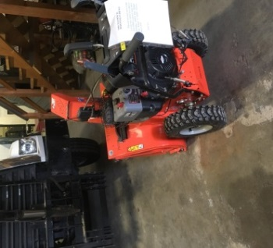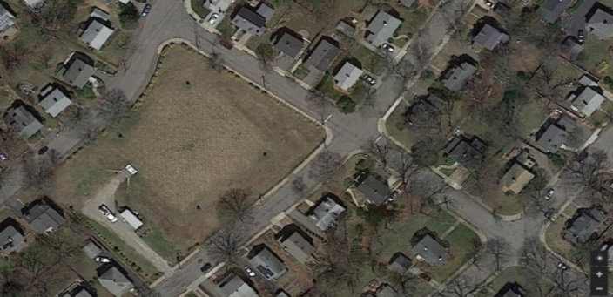
X
Figure 1 - Snow blower used at the Figure 2 - Aerial view of the underground water tank location (red circle)
time of the incident and location where the victim was found (red X)

INCIDENT SCENE
The incident occurred at an underground water storage tank located in a residential neighborhood (Figure 2). The area of the underground tank is owned and maintained by the authority. The tank capacity was two million gallons and the storage tank is higher than the ground level, but it is covered with grass. The property is enclosed by a chain-link fence and there is a small building on site that houses pump and electronic equipment. There is a gated driveway that leads to this building. Three sides of the property are boarded by streets with sidewalks. The fourth side of the property abuts a residential building. The sidewalks are about two feet wide and in many locations the sidewalks are buckled due to tree roots (Figure 3). The incident occurred on a section of the sidewalk.

INVESTIGATION
The authority had a plan for weather situations where the maintenance unit employees were divided into two groups. One group would work during the storm to ensure there was continual access to the authority owned and operated water and sewer facilities, which included snow clearing. The second group would work after the weather emergency or storm has ended. The victim was part of the second group and because this was a snow storm, their task was to clear snow.
The victim arrived at the maintenance garage location at 11:00 p.m. for the start of his shift. At the garage he met up with the co-worker he was scheduled to work with and their supervisor gave them their tasks to complete. The task consisted of clearing snow at multiple authority water storage locations. The workers loaded two snow blowers into a pickup truck and traveled to the first location to start clearing snow. They spent some time at this first location and cleared the area. Typically during snow removal, the pickup truck was left running to ensure there was a place to warm up.
The workers then loaded the snow blowers onto the pickup truck and traveled to the next authority owned location, the incident location. The victim started at the far end of the property and started to clear the snow on the sidewalk while the co-worker remained in the driveway area. The victim had cleared a little more than half of the section of sidewalk when at approximately 3:45 a.m. he suffered a myocardial infarction and fell to the ground (Figure 4). A person who lived across the street from where the victim collapsed found the victim and immediately placed a call for emergency medical services (EMS). Within minutes of the placed call, the police and EMS arrived. The victim was transported to a local hospital where he was pronounced dead.
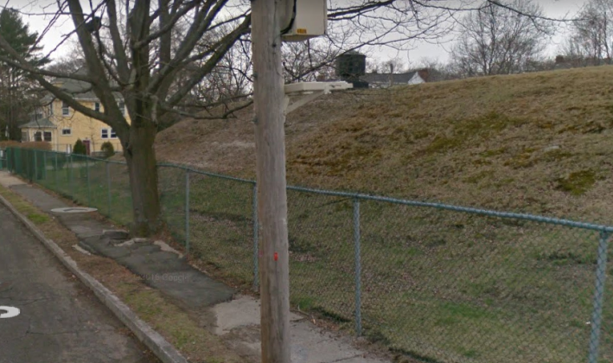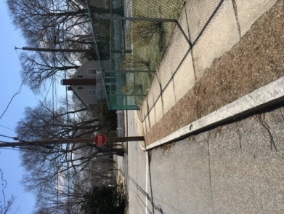
X
Figure 3 - One of the buckled sidewalk sections Figure 4 - Location where the victim was found (red X)

CAUSE OF DEATH
The medical examiner listed the cause of death as complications of cardiac dysrhythmia, myocardial infarction, hypertension and hyperlipidemia, exertion.

CONTRIBUTING FACTORS
Occupational injuries and fatalities are often the result of one or more contributing factors or key events in a larger sequence of events that ultimately result in the injury or fatality. The Massachusetts FACE Program identified the following contributing factors in this incident:
- Pre-existing medical conditions;
- Overexertion;
- Extreme cold;
- Time of day (early morning); and
- Working alone.

RECOMMENDATIONS/DISCUSSION
Recommendation #1: Employers should consider factors that may impact the risk of acute cardiac events such as time of day, physical demands of the task, and environmental conditions when scheduling tasks.
Discussion: Employers can potentially help decrease the risk of acute cardiac events through a combination of scheduling tasks and work breaks, equipment (and chemical) selection and well maintained worksites. Early morning hours, abrupt changes in physical effort and extreme cold air are all associated with increased risk of sudden cardiac events. ^{2,3} In this case, the incident occurred at approximately 3:45 a.m. and it was well below freezing. The snow blowers being used were relatively new units that were well maintained. The property where the incident occurred was overall in good repair except for the sidewalks. With the sidewalks being in disrepair, this potentially contributed to making the snow removal process unnecessarily more labor intensive.
When possible, scheduling snow removal activities outside of early morning hours could help reduce the risk of cardiac events from occurring. If early morning work in cold environments cannot be eliminated, risk can be tempered by reducing the physical demand required for the task. When employers are assigning snow clearing as a task, the employers should, as they did in this case, provide easily maneuverable self-propelled snow blowers and regularly provide preventive maintenance to ensure equipment is functioning properly. Employers should also ensure that work breaks are scheduled and that the property where the task will be performed is in good repair. For example, the uneven sidewalks or pathways would require additional strenuous maneuvering of a snow blower that can result in increased heart strain and risk of acute cardiac events.
Recommendation #2: Employers should ensure workers in cold environments are adequately warm by developing protocols to prevent cold stress.
Discussion: Cold exposure initiates several responses by the body to maintain an optimal core temperature. These responses include constriction of peripheral blood vessels and shivering, both of which increase blood pressure and demand on the heart. Blood pressure, heart rate, and the body’s stress response are increased when people breathe in cold air, and can contribute to the onset of acute cardiovascular events. Employers have a duty to protect workers from recognized hazards, including cold stress hazards that could cause death or serious physical harm in the workplace.
To protect workers from cold stress, employers should provide training to workers on: ^{4,5}
  - How to recognize environmental and workplace conditions that can lead to cold stress.
  - The symptoms of cold stress, how to prevent cold stress, and what to do to help those who are affected.
  - How to select proper clothing for cold, wet, and windy conditions.
Employers should also: ^{4,5}
  - Monitor workers physical condition.
  - Schedule frequent short breaks in warm dry areas, to allow the body to warm up.
  - Schedule work during the warmest part of the day.
  - Use the buddy system (work in pairs).
  - Provide warm, sweet beverages. (Avoid drinks with alcohol.)
  - Provide engineering controls such as radiant heaters.
Appropriate personal protective equipment (PPE) for cold weather work is a key element that will help minimize temperature changes to the skin and upper airway. PPE should include, but not be limited to coats, gloves, thermal socks, snow pants, snow boots, and a thermal facemask or balaclava with heat exchanger. In this case, the employer required PPE for cold weather work and provided employees with some of this PPE and provided employees with funds to purchase other gear. A possible addition to the required PPE to be used in extreme cold weather working conditions would be facemasks with heat exchangers.
Recommendation #3: Employers should consider developing policies that prevent working alone in certain situations.
Discussion: Not all tasks and weather conditions require having more than one worker present, but there are some situations where employers should ensure that employees are not working alone. When possible, some tasks should have more than one worker. This would include strenuous outdoor work during early morning hours in extreme cold weather. To enhance safety and minimize potential risk in these situations, workers should perform their tasks in groups or pairs whenever possible.
In this case, the victim was paired with a co-worker who was also at the worksite. At the time of the incident, the co-worker was located on the other side of the property, which made the victim outside of the co-workers view. Consequently, the victim’s cardiac event and subsequent collapse was unwitnessed and CPR efforts were delayed. Immediate recognition of cardiac arrest and initiation of CPR and requesting emergency medical services provides the highest likelihood of survival for victims of sudden cardiac arrest. When tasks are deemed as requiring more than one worker present, when possible, these tasks should be organized in a manner that allows co-workers to remain within each other’s line of sight. In an event where a worker suffered a medical event, this would greatly reduce the amount of time between the onset of the medical event and initiation of medical assistance.
Recommendation #4: Employers should train workers on basic cardiopulmonary resuscitation (CPR) and consider having an automated external defibrillator (AED) available at work sites and provide training for workers on their use.
Discussion: Over 350,000 people suffer cardiac arrest outside of hospitals each year in the United States. For those who suffer cardiac arrest, the chance of survival is significantly greater with early CPR and automated external defibrillator (AED) use. Because of the increased risk of cardiovascular events when performing extraneous activities in cold temperatures and early morning hours, workers who perform tasks such as snow removal should be ready to administer CPR in the event that a co-worker suffers cardiac arrest. Early intervention with CPR and defibrillation can dramatically increase the likelihood of successful revival of a worker suffering from cardiac arrest. Employers should consider providing AEDs at all work locations and in work vehicles that will routinely be located at offsite locations. In addition, employers should provide training for workers on CPR and how to use AEDs.
Recommendation #5: Employers should educate all workers about the work conditions that might increase their risk of cardiovascular disease and the signs of cardiac arrest.
Discussion: Employers should ensure that all workers understand the increased risk of cardiovascular disease (CVD) events arising from certain assigned tasks and situations. As mentioned above, workers who perform physically demanding tasks during extreme cold weather and in early morning hours, particularly among those over age 60 and those with multiple CVD risk factors are potentially at greater risk of CVD.
Workers should be trained on the importance of staying warm, gradually increasing physical exertion, and knowing their own risk of CVD through inventory of personal risk factors and communication with their physician.⁶ Employers who provide health insurance should encourage all workers to utilize their health insurance and receive regular medical evaluations to assess their risk of CVD and other chronic disease, such as stroke.
Workers should also be aware of the need for extra caution in the morning hours, as those with CVD risk are most susceptible during that time of day and the signs of cardiac arrest. These points can be taught during onboarding and re-emphasized during formal and informal teaching sessions (e.g. toolbox talks), and prior to each emergency snow removal shift. The Massachusetts Department of Public Health (MDPH) has materials that can help raise awareness in the workplace about identifying the risks and symptoms of CVD and stroke, and how individuals can stay healthy.

ADDITIONAL RESOURCES
MDPH. Heart Disease Prevention and Control. www.mass.gov/heart-disease-prevention-and-control
American College of Cardiology. Heart Attack poster. www.cardiosmart.org/~/media/Images/Infographics/2015/Heart-Attack.ashx
OSHA. Winter Weather: Plan. Equip. Train. www.osha.gov/dts/weather/winter_weather/windchill.html
NIOSH. Protecting yourself from cold stress. www.cdc.gov/niosh/docs/2010-115/pdfs/2010-115.pdf

DISCLAIMER
Mention of any company or product does not constitute endorsement by the National Institute for Occupational Safety and Health (NIOSH). In addition, citations to websites external to NIOSH do not constitute NIOSH endorsement of the sponsoring organizations or their programs or products. Furthermore, NIOSH is not responsible for the content of these websites. All web addresses referenced in this document were accessible as of the publication date.

REFERENCES
1. Weather Underground. Weather History. Massachusetts: TWC Product and Technology LLC.

2. Auger N, Potter BJ, Smargiassi A, Bilodeau-Bertrand M, Paris C, Kosatsky T. [2017]. Association between quantity and duration of snowfall and risk of myocardial infarction. CMAJ 2017 February 13;189:E235-42.

3. Sheldahl LM, Wilke NA, Dougherty SM, Levandoski SG, Hoffman MD, Tristani FE [1992]. Effect of age and coronary artery disease on response to snow shoveling. J Am Coll Cardiol 20(5):1111-7.

4. OSHA. Winter Weather: Plan. Equip. Train. To prevent injuries, illnesses, and fatalities during winter storms. www.osha.gov/dts/weather/winter_weather/windchill.html.

5. NIOSH. Cold Stress web page. www.cdc.gov/niosh/topics/coldstress/default.html.

6. Nichols RB, McIntyre WF, Chan S, Scogstad-Stubbs D, Hopman WM, Baranchuk A [2012]. Snow-shoveling and the risk of acute coronary syndromes. Clin Res Cardiol 101(1):11-5.

