INDOOR AIR QUALITY ASSESSMENT

Lakeville Police Department
296 Bedford St
Lakeville, MA

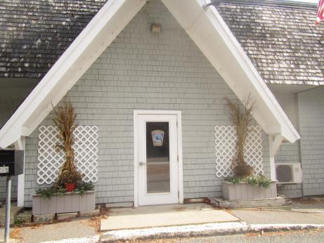

Prepared by:
Massachusetts Department of Public Health
Bureau of Environmental Health
Indoor Air Quality Program
November 2018

Background
Building: | Lakeville Police Department (LPD)
Address: | 296 Bedford St, Lakeville
Assessment Requested by: | Nathan Darling, Lakeville Building Superintendent
Reason for Request: | Indoor air quality (IAQ) and health concerns
Date of Assessment: | November 8, 2018
Massachusetts Department of Public Health/Bureau of Environmental Health (MDPH/BEH) Staff Conducting Assessment: | Ruth Alfasso, Environmental Engineer/Inspector, IAQ Program
Building Description: | The LPD building was originally constructed in 1935 as a gas station and bar. It had several other uses before additions and renovations in the 1980s were conducted to create a combined Police station and Senior Center. Later, the senior center was moved and the LPD took over the entire space. The building has a single story, is wood framed, and has several layers of roof, the topmost of which is peaked in sections.
Building Population: | Approximately 15 staff members work in the building at any time -- more during training. Members of the public visit periodically. Police Department/dispatch personnel are in the building 24 hours a day.
Windows: | Openable in some areas but rarely used.

It is important to note that a new police station is being built up the street from this existing building which is planned to be completed by spring of 2019. Recommendations are intended to maintain IAQ in the current building until the new building is complete.

Methods
Please refer to the IAQ Manual for methods, sampling procedures, and interpretation of results (MDPH, 2015).

IAQ Testing Results
The following is a summary of indoor air testing results (Table 1).
- Carbon dioxide levels were below 800 parts per million (ppm) in all but one area, which was very close to 800 ppm.
- Temperature was within or close to the lower end of the recommended range of 70°F to 78°F in all areas assessed.
- Relative humidity was within or close to the recommended range of 40 to 60% in all areas assessed.
- Carbon monoxide levels were non-detectable (ND) in all areas assessed.
- Fine particulate matter (PM2.5) concentrations measured were below the National Ambient Air Quality Standard (NAAQS) level of 35 μg/m³ in all areas assessed.
- Total Volatile Organic Compounds (TVOC) were not detected (ND) in all but one area tested, which was next to a hand sanitizer dispenser.

Ventilation
A heating, ventilating, and air conditioning (HVAC) system has several functions. First it provides heating and, if equipped, cooling. Second, it is a source of fresh air. Finally, an HVAC system will dilute and remove normally-occurring indoor environmental pollutants by not only introducing fresh air, but by filtering the airstream and removing stale air to the outdoors via exhaust ventilation. Even if an HVAC system is operating as designed, point sources of respiratory irritants may be present and produce symptoms in sensitive individuals. The following analysis examines and identifies components of the HVAC system and likely sources of respiratory irritant/allergen exposure due to water damage, aerosolized dust, and/or chemicals found in the indoor environment.
Mechanical air circulation in the LPD is provided by two air handing units, one in a closet in the building and another in an alcove accessed from outside the building. There are no fresh air supplies to the AHUs, so they recirculate and heat/cool air only. Ceiling-mounted supply vents in rooms distribute air (Picture 1). Return vents to the AHUs are typically located in hallways (Picture 2). It did not appear that most restrooms/shower rooms had any direct vented exhaust. Areas where pollutants, odors and water vapor are generated should have direct exhaust to avoid recirculating these to the rest of the building.
It was reported that no maintenance of the mechanical systems is conducted, only repairs when the system has a breakdown. It is recommended that these systems be maintained on a regular schedule including filter changes. There were several filters stored loosely in the room with the interior AHU (Picture 3). Note that these filters are of a type that provides minimal filtration. Pleated filters with a minimum efficiency reporting value (MERV) rating of 8 are recommended to remove dust, pollen and other particulates. Filters should be changed 2 or more times a year. Note also that the location/method of storage for these filters is likely to contaminate them with dust and potentially damage their effectiveness further.

Microbial/Moisture Concerns
There were several concerns expressed by LPD staff relating to water damage in the building. Several roof leak events have occurred in this building over the last few years, including damage from ice dams over several winters as well as a storm in late winter of 2018 where a portion of the roof was stripped off by high winds. Reportedly, building materials which had become moistened were dried or removed, including wallboard and carpeting. One room currently has most of the carpeting and a portion of the ceiling system removed due to water damage (Pictures 4 and 5). This office is not being used and should remain vacant and closed off (including closing off supply and return vents) until the building is vacated.
Water-damaged ceiling tiles were observed in several other areas (Pictures 6 and 7). It was reported that many water-damaged tiles were replaced recently and some had already become stained again. Water-damaged tiles can be a source of mold and should be replaced when discovered. Note that because of the nature of the roof, which was covered over with a new structure more than once as the building was reused, there are inaccessible spaces between the top of the building and the ceiling tile system, so it may be difficult to determine where leaks originate and how much of the water remains in areas above the ceiling.
Other sources of moisture exist in the LPD. Broken plumbing fixtures were found in the women’s restroom and other unused or broken fixtures were located in other parts of the building. Unused drains can be a means for sewer odors to enter occupied spaces if the traps become dry due to lack of use or malfunction. Given the short amount of time the building will continue to be used, any broken or unused plumbing should be turned off at the fixture, if possible, with the drains sealed tightly with waterproof tape or similar material, and be clearly marked as out of service.
Note that the lack of fresh air and exhaust ventilation in most of the building, including several bathrooms, contributes to higher indoor relative humidity. Use of openable windows for fresh air during the summer months or other periods of high humidity will also lead to moisture issues inside, particularly when some surfaces are chilled due to operation of the air conditioning. The surfaces of the return vents in hallways were rusty (Picture 2) which likely indicates that condensation forms on these surfaces during periods of high humidity. Keeping these vents clean and free of dust and debris will prevent microbial growth on these surfaces.
Ductless air conditioners (Picture 1) produce condensation that needs to drain properly. Building staff reported that the unit shown in Picture 1 had leaked in the past and damaged the wall. Water coolers and small refrigerators were located in carpeted areas where spills or leaks can moisten the carpet. These should be moved to a non-carpeted area or placed on a mat.
The exterior of the building was examined for additional sources of moisture/water infiltration and the following were noted:
- The exterior of the building is in poor condition, with gaps under the building in several areas which can be attractive to pests (Pictures 8 and 9);
- Not all of the building has gutters, and in some areas gutters and downspouts were in poor condition (Picture 10);
- There were several locations along the eaves and roof of the building were birds were known to nest. Bird wastes can be a source of allergens and disease-causing microorganisms; and
- Plants were growing on the exterior of the building (Picture 11) which holds moisture against the building and can penetrate the building exterior and lead to water infiltration.

Other Issues
Exposure to low levels of total volatile organic compounds (TVOCs) may produce eye, nose, throat, and/or respiratory irritation in some sensitive individuals. BEH/IAQ staff measured levels of TVOCs and examined spaces for products containing VOCs. Only one area had a reading above background (Table 1) and that was next to a hand sanitizer dispenser. BEH/IAQ staff noted air fresheners, hand sanitizers, cleaning products, and dry erase materials in use. All of these products have the potential to be irritants to the eyes, nose, throat, and respiratory system of sensitive individuals.
Storage of items in various parts of the building is an issue. In particular, the following was noted:
- Items stored adjacent to/touching a water heater (Picture 12). These items should be removed immediately;
- Many items in the evidence storage room were in porous containers and some were on the floor;
- Boxes of stored files were found in several areas, including on floors. Some of these boxes were water-damaged (Picture 13);
- Many other items were found stored in offices, closets and other areas in the building (Picture 14). Accumulated items can be subject to water damage, make cleaning and dust control difficult, and can create harborage for pests.
Some portions of the building are carpeted. Some of this carpeting, such as in the evidence storage room, was in very poor condition, with stains and significant wear. In general, it is not recommended for police departments and other emergency response agencies to have carpeted floors due to the possible cross-contamination that may occur from footwear contact with automotive products, chemicals, or biological contamination. In addition the Institute of Inspection, Cleaning and Restoration Certification (IICRC) discusses floor covering in its guideline, “Standard for Professional Cleaning of Textile Floor Coverings” (IICRC, 2015). Based on this standard, the IICRC recommends twice-daily vacuuming and/or pile-lifting cleaning for commercial carpeting in heavy traffic areas. This frequency of cleaning of the building as well as the use of vacuum cleaners equipped with high-efficiency particulate arrestance (HEPA) filters would remove respirable dust from the indoor air.
In general, carpeting should be cleaned several times a year in accordance with IICRC recommendations (IICRC, 2012). Carpeting in areas that may be subject to chronic moistening (e.g. entrance areas) should be removed and replaced with non-porous flooring where possible.
Many surfaces in the LPD were dusty including supply vents, fans and flat surfaces. These should be cleaned with HEPA-equipped vacuum cleaners or wet wiped to prevent dust from being reaerosolized or moistened.

CONCLUSIONS/RECOMMENDATIONS
Based on the observations made during the visit, the following recommendations are made in order to improve conditions in the building until the new building is available for occupancy:
- Consider a system of gradual withdrawal from areas of the building that require significant renovations, such as the vacant office where the ceiling and carpeting are removed. In these areas, close off any supply and exhaust vents to prevent any pollutants from these areas from being recirculated into the rest of the building and remove any porous items from the rooms. Monitor vacant rooms for leaks and other issues on a regular schedule.
- Especially if winter weather causes additional leaks and damage to the building, consider if temporary office trailers or a move to other locations owned by the town are possible to remove staff from particularly water-damaged areas of the building.
- Change filters in the AHUs right away and a minimum of 2 times a year. Clean unit interiors thoroughly. Consider using MERV 8 or better filters, if possible, in the current AHUs.
- Clean the rooms where AHUs are located to remove debris and dust which may impact AHU operation or become drawn in through any gaps in the AHU or ducts.
- Store filters for the AHUs in a clean, dry area.
- Use openable windows where possible to provide fresh air when the cooling system is not in use. Do not open windows while air conditioning/cooling is operating to prevent condensation.
- Continue with actions to resolve roof leaks given the temporary nature of the remaining occupancy. Monitor areas with known water issues during/after storms for prompt remediation as needed. Consider using a roof rake and other measures to prevent ice dams and related issues during the winter.
- Replace water-damaged ceiling tiles when they are discovered.
- Close local valves to broken plumbing fixtures where possible and seal drains with waterproof materials. Use clear signage on abandoned fixtures and monitor periodically for leaks.
- Discard water-damaged porous stored materials such as boxes.
- Consider using plastic totes or other waterproof containers for items in the evidence storage room, so long as consistent with legal requirements for evidence storage.
- Avoid storing any porous items on floors or in areas with known or suspected water leaks.
- Monitor the condensate line from the ductless air conditioner for clogs and leaks.
- Conduct all remediation of water-damaged materials consistent with guidance found in the USEPA’s “Mold Remediation in Schools and Commercial Buildings Guide” (USEPA, 2008).
- Seal gaps around outside building to prevent animal and pest entry.
- Remove any bird nesting materials and prevent new nests/entry by using wire mesh or other appropriate covering.
- Clean and repair existing gutters.
- Trim back plants on and adjacent to the building.
- Reduce the use of products containing TVOCs.
- Remove all items on and adjacent to heating equipment (e.g. Picture 11).
- Clean supply and return vents of dust periodically.
- Clean carpeting and upholstered items regularly in accordance with IICRC recommendations (IICRC, 2012). Remove any carpeting that is a source of odors.
- Prior to moving to the new location, ensure that any items to be brought from the old station are free of water damage, odors, dust and pests. Inspect items before and during packing and clean or discard as necessary.
- Refer to resource manual and other related IAQ documents located on the MDPH’s website for further building-wide evaluations and advice on maintaining public buildings. These documents are available at: http://mass.gov/dph/iaq.

References
IICRC. 2012. Institute of Inspection, Cleaning and Restoration Certification. Carpet Cleaning: FAQ.
IICRC. 2015. Institute of Inspection, Cleaning and Restoration Certification. Commercial Carpet Cleaning: FAQ.
MDPH. 2015. Massachusetts Department of Public Health. Indoor Air Quality Manual: Chapters I-III. Available at: http://www.mass.gov/eohhs/gov/departments/dph/programs/environmental-health/exposure-topics/iaq/iaq-manual/.
US EPA. 2008. “Mold Remediation in Schools and Commercial Buildings”. Office of Air and Radiation, Indoor Environments Division, Washington, DC. EPA 402-K-01-001. September 2008. Available at: http://www.epa.gov/mold/mold-remediation-schools-and-commercial-buildings-guide.

Picture 1
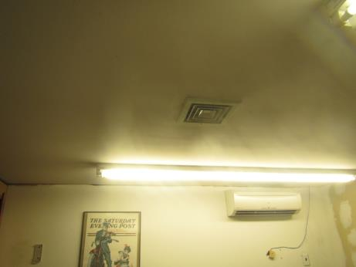
Typical supply vent (also note ductless air conditioning unit on wall)
Picture 2
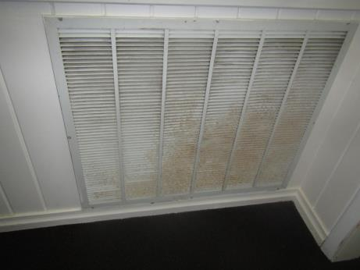
Return vent in hallway, note rust stains
Picture 3
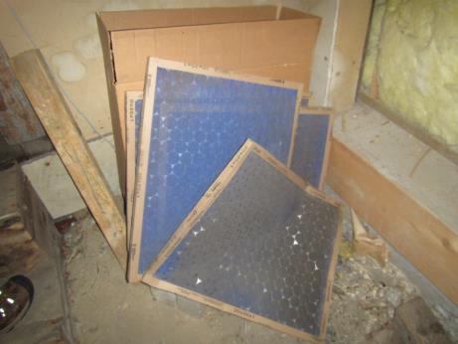
AHU filters damaged and stored on the floor
Picture 4
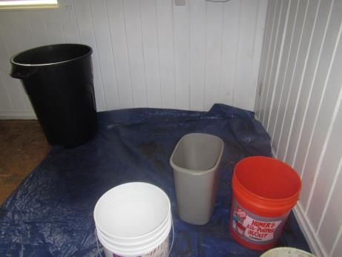
Removed flooring and buckets due to water damage and ongoing leaks
Picture 5
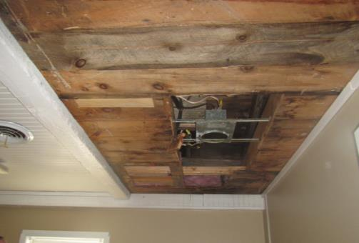
Removed ceiling and water-damaged wood
Picture 6
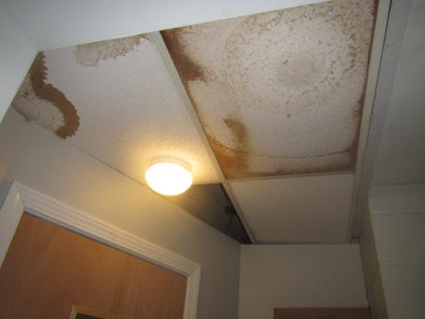
Water-damaged ceiling tiles
Picture 7
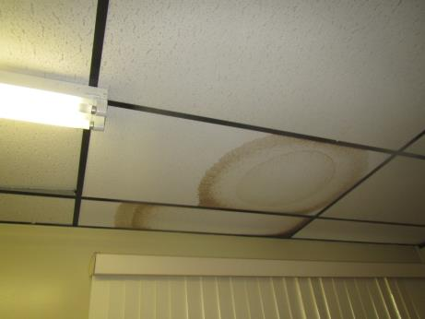
Water-damaged ceiling tiles
Picture 8
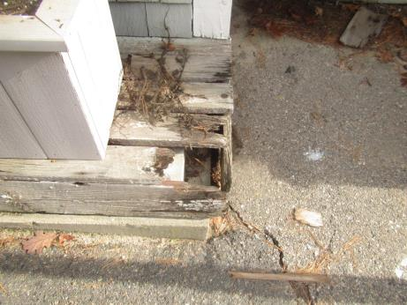
Area of external damage which could be attractive to animals and pests
Picture 9
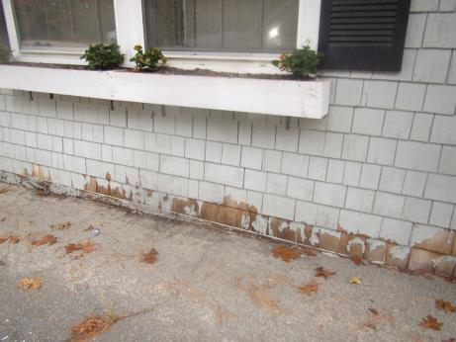
Poorly-sealed/damaged edge of building
Picture 10
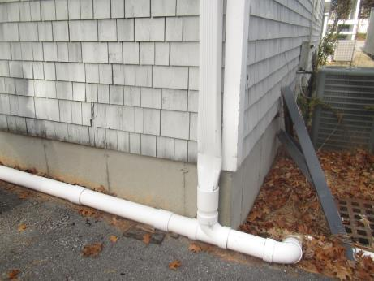
Damaged downspout
Picture 11
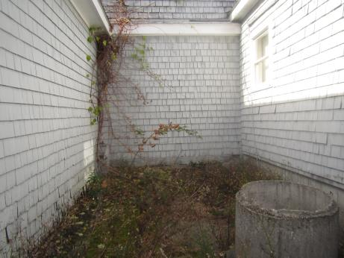
Plants against the foundation and growing on the building
Picture 12
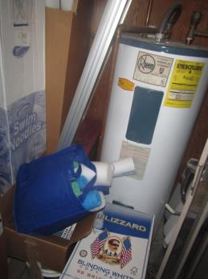
Items stored against water heater
Picture 13
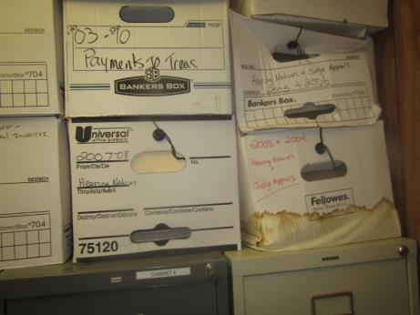
Water-damaged boxes
Picture 14
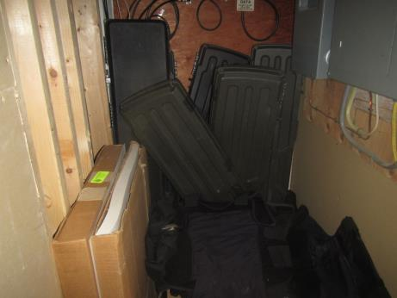
Items stored in a utility room
Location | Carbon  Dioxide  (ppm) | Carbon Monoxide  (ppm) | Temp  (°F) | Relative  Humidity  (%) | PM2.5  (µg/m³) | TVOC  (ppm) | Occupants  in Room | Windows  Openable | Ventilation |  | Remarks
 |  |  |  |  |  |  |  |  | Supply | Exhaust
Background | 460 | ND | 58 | 35 | 6 | ND |  |  |  |  | Sunny
Training room | 679 | ND | 69 | 45 | 1-10 | ND | 0 | Y | Y | Y | Carpeted
Public Waiting | 695 | ND | 71 | 42 | 2 | ND | 0 | N | Y | N | Carpeted, upholstered furniture
Dispatch | 789 | ND | 71 | 44 | 2 | 0.6 | 1 | N | Y | Y | Carpeted, refrigerator on carpet, HS
Lockup area | 664 | ND | 70 | 40 | 1 | ND | 0 | N | Y |  | 3 WD CT, access to attic
Booking room | 672 | ND | 71 | 40 | 1 | ND | 0 | N | Y | N | Carpet, HS
Files | 625 | ND | 70 | 42 | 0 | ND | 0 | N | Y | N | WD boxes and items on floor
Old restroom | 604 | ND | 69 | 41 | 0 | ND | 0 | Y | N | N | Very old fixtures
Admin Office | 808 | ND | 70 | 42 | 2 | ND | 1 | N | Y | N | CP, HS, food
Copy/print/  mail | 774 | ND | 71 | 41 | 1 | ND | 0 | N | Y | N | Carpeted, water cooler on carpet, printer
Closed office | 616 | ND | 71 | 39 | 1 | ND | 0 | Y open | Y | N | Missing ceiling tiles and ceiling system, carpet removed, spots on floor could be glue or mold
Chief’s office | 572 | ND | 69 | 42 | 6 | ND | 0 | Y | Y | N | Carpeted
Lieutenant’s office | 616 | ND | 69 | 43 | 1 | ND | 0 | Y | Y | N | Equipment
Evidence |  | ND |  |  |  | ND | 0 | N | N | N | Items stored in bags, boxes, locked boxes, very old and stained carpeting
Sergeant’s office | 616 | ND | 69 | 44 | 1 | ND | 0 | N | N | N | NC
Ladies RR | 634 | ND | 71 | 43 |  | ND | 0 |  |  | N | One broken toilet, one broken sink with closed off drain, NC
Men’s RR | 668 | ND | 72 | 41 | ND | ND | 0 | Y | Y | N | NC, CP
Locker | 683 | ND | 73 | 41 | 1 | ND | 0 | N | Y |  | NC
Sgt. Office | 645 | ND | 73 | 40 | 1 | ND | 0 | Y | Y | N | NC, gear/clothes in closet
Old Evidence Room/now vacant | 606 | ND | 73 | 41 | 1 | ND | 0 | N | Y | N | Carpet just rolled onto floor, not stuck, no coving, new walls
Locker | 615 | ND | 73 | 39 | 2 | ND | 0 | N | Y | N | NC, DEM, dusty stand fan, CP
Report Room | 603 | ND | 73 | 38 | 2 | ND | 0 | Y | Y |  | WD CT (3), CP, HS
Detectives | 593 | ND | 73 | 39 | 2 | ND | 0 | Y | Y | N | NC, DEM, WD CTs

