INDOOR AIR QUALITY ASSESSMENT

Lakeville Town Hall and Fire Department
346 Bedford St
Lakeville, MA

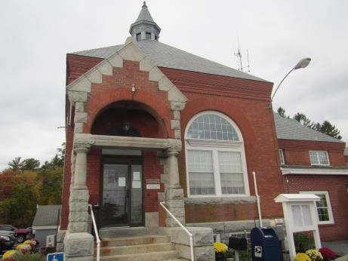

Prepared by:
Massachusetts Department of Public Health
Bureau of Environmental Health
Indoor Air Quality Program
November 2018

Background
Building: | Lakeville Town Hall and Fire Department (LTHFD)
Address: | 346 Bedford St, Lakeville
Assessment Requested by: | Nathan Darling, Lakeville Building Superintendent
Reason for Request: | General indoor air quality (IAQ) concerns
Date of Assessment: | October 24, 2018
Massachusetts Department of Public Health/Bureau of Environmental Health (MDPH/BEH) Staff Conducting Assessment: | Ruth Alfasso, Environmental Engineer/Inspector, IAQ Program
Building Description: | The LTHFD consists of the original building which dates from the 1900s. It is connected to a 1980s addition which has additional town offices and Fire Department facilities including three engine bays. It is a two-story brick building with basement and attic. The original section was built as a drinking water pumping station.
Building Population: | Approximately 30 staff work in the building. Members of the public visit daily. Fire Department personnel are in the building 24 hours a day.
Windows: | Openable

Methods
Please refer to the IAQ Manual for methods, sampling procedures, and interpretation of results (MDPH, 2015).

IAQ Testing Results
The following is a summary of indoor air testing results (Table 1).
- Carbon dioxide levels were below 800 parts per million (ppm) in most areas assessed.
- Temperature was within the recommended range of 70°F to 78°F in all areas assessed, apart from the Fire Department gear room and engine bays.
- Relative humidity was within or close to the recommended range of 40 to 60% in all areas assessed.
- Carbon monoxide levels were non-detectable (ND) in all areas assessed.
- Fine particulate matter (PM2.5) concentrations measured were below the National Ambient Air Quality Standard (NAAQS) level of 35 μg/m³ in all areas assessed.

Ventilation
A heating, ventilating, and air conditioning (HVAC) system has several functions. First it provides heating and, if equipped, cooling. Second, it is a source of fresh air. Finally, an HVAC system will dilute and remove normally-occurring indoor environmental pollutants by not only introducing fresh air, but by filtering the airstream and removing stale air to the outdoors via exhaust ventilation. Even if an HVAC system is operating as designed, point sources of respiratory irritants may be present and produce symptoms in sensitive individuals. The following analysis examines and identifies components of the HVAC system and likely sources of respiratory irritant/allergen exposure due to water damage, aerosolized dust, and/or chemicals found in the indoor environment.
Portions of the LTHFD have mechanical ventilation, which uses ceiling-mounted supply vents to distribute fresh air (Picture 1). The HVAC system is reportedly located on the roof and could not be examined during the visit. Much of the LTHFD does not have mechanical ventilation and relies on openable windows for fresh air supply. Some of the restrooms in the building have switch-operated exhaust vents that reportedly direct air outside the building, while others have no mechanical exhaust ventilation (Table 1). There is no exhaust ventilation in the locker room/turnout gear room next to the Fire Department engine bays. Direct-vented exhaust ventilation is recommended wherever pollutants, odors and water vapor are generated, particularly in bathrooms and areas which may have hazardous materials.
Heating/supplemental heating for the building is provided by radiators using hot water. Cooling in areas not served by the HVAC system is provided by ductless air conditioning units (Picture 2) with condensers located outside the building in various locations (Picture 3). These units, also known as “mini splits”, only cool and recirculate indoor air.

Microbial/Moisture Concerns
There were several concerns expressed by staff relating to water damage and odors in the building. Water-damaged ceiling tiles were observed in a few areas (Picture 1). Note that the location of the water-damaged tiles in Picture 1 is beneath the seam where older and newer sections of the building and roof join. Reportedly flashing in this area requires frequent repairs. Water-damaged ceiling tiles were noted in other locations (Picture 4; Table 1). Water-damaged tiles should be replaced as soon as the leaks are repaired as they can be a source of mold and odors. In addition, replacing water-damaged tiles can make detecting new leaks easier.
Water damage was also reported in the original building entrance vestibule (Picture 5). This space had recently been cleaned and painted, but photographs taken prior to the repair were available showing evidence of leaks and discolored brick in this area, which is likely due to the configuration of the roof and lack of gutters. Note that the building materials -- brick, plaster, and paint -- are not readily colonized by mold, however dust and debris that may collect on surfaces that are difficult to reach to clean may become a source of microbial colonization.
One significant source of moisture and odors are the ductless ACs. Occupants reported that when the systems are in use, odors described as “musty” or “fishy” occur. These odors likely result from chronic moistening of inside surfaces of the units from condensation which leads to microbial growth on the coils or any dust or debris inside. This condition is not uncommon in air conditioning units (referred to as “dirty sock” syndrome). In some cases, thorough cleaning of the unit can resolve the problem. In other cases, however, the odor is related to corrosion and bacterial growth on cooling coils which may require replacement of the coils with specially-coated coils or replacement of the unit (Fencl, 2014).
In addition to this odor, ductless AC units create condensation, which needs to drain properly. In the IT closet, located upstairs in a space shared by the FD and TH, the ductless unit froze, leading to a significant leak that moistened wallboard and carpeting (Pictures 6 and 7). While the carpeting in this area was dry, it is heavily water-stained and also old, worn, and otherwise in poor condition; it should be removed. Another leak had occurred from a ductless AC unit in the Treasury Office which moistened a wall (Table 1). This is likely due to a clog in the condensate drain line. These units should be maintained regularly including checking for any clogs or leaks.
Plants were observed in several areas (Picture 8) and there were occupant reports of mushrooms growing in a plant pot. Plants/soil can be a source of odors, pollen and mold spores and attractive to pests, particularly when overwatered. They should be kept in good condition, with non-porous drip pans and kept away from airflow. Water coolers and refrigerators were also located on carpet. Spills or leaks from these appliances can moisten carpeting and lead to microbial growth and odors.
Musty odors were also reported in the basement, which is mainly used for storage and heating equipment. A plug-in air freshener was in use in the basement at the time of the visit, so a musty odor could not be detected. A dehumidifier was also in use in this area, which will assist with humidity so long as it’s kept in good condition including drainage/emptying and cleaning. Sump pump sumps exist in the basement, which lack covers (Picture 9). While sump pumps help keeping the basement dry during high water events, a cover is needed over the sump to prevent evaporation and distribution of odors from stagnant water. Note that there were numerous items stored in the basement, including boxes of files. Most of these items were well organized and on shelving (Picture 10) which will help keep them dry and free of water damage and pests. However long-term storage in humid environments can lead to degradation of porous items and may leave them with musty odors. In addition, the door to the basement should be kept closed and be well-fitted, including weather stripping, to prevent moisture and odors from the basement into occupied areas.
Other sources of moisture exist in the LTHFD. Unused plumbing fixtures exist in a disused bathroom off a first floor hallway. While the drains in these fixtures are reportedly filled with water periodically to maintain a trap seal, unused plumbing fixtures should be properly abandoned (cut/capped) to prevent leaks and moisture infiltration. Note that the lack of fresh air and exhaust ventilation in most of the building, including several bathrooms, contributes to higher indoor relative humidity. Use of openable windows for fresh air during the summer months or other periods of high humidity will also lead to moisture issues inside, particularly when some surfaces are chilled due to operation of the air conditioning.
The exterior of the building was examined for additional sources of moisture/water infiltration and the following were noted:
- The building lacks a gutter system.
- Plants were found up against the foundation in several areas (Picture 11). Plants hold moisture against the side of the building and roots can damage the foundation and lead to water infiltration.
- Window wells for lower level windows were filled with plants (Pictures 11 and 12). This can cause damage to windows, and if windows are opened provide a source of moisture, mold, pollen and odors to the interior.

Fire Station IAQ Issues
Under normal conditions, a firehouse can have several sources of environmental pollutants present from the operation of fire vehicles. These sources of pollutants can include:
- Vehicle exhaust containing carbon monoxide and soot;
- Vapors from diesel fuel, motor oil and other vehicle liquids which contain volatile organic compounds;
- Water vapor from drying hose equipment;
- Rubber odors from vehicle tires; and
- Residues from fires on vehicles, hoses, and fire-turnout gear.
Of particular importance is vehicle exhaust, which involves the process of combustion. The engine bays are equipped with a mechanical exhaust system (Plymovent™) to remove exhaust from vehicles. Some of the connectors (boots) that attach to the tailpipes of the vehicles were reportedly the wrong size and therefore are not used. In order to protect occupants from tailpipe emissions, it is important that tailpipe exhaust collection systems be operational and be used every time a vehicle is used in the bay.
Pathways for vehicle exhaust and other pollutants to move from the engine bays into adjacent/occupied areas should be eliminated. Between the engine bays and other occupied areas is a locker room/turnout gear storage room (Picture 13). Doors between this area and the rest of the building should be weather-tight and kept closed at all times. Note that there is no exhaust ventilation for the locker/turnout gear room, which results in the accumulation of rubber odors observed in this room during the assessment. This room should be mechanically vented directly to the outside to remove odors, particulates and other pollutants that originate from or linger on used turnout gear.
A gear drying cabinet (Picture 14) is located in the corner of the engine bay closest to the locker/gear room. At the time of the visit, the vent on this unit was not connected to an outside duct (Picture 15). Therefore, any moisture, chemicals or odors from gear dried in this unit would directly return to the engine room. In addition, odors from combustion/vehicles would be deposited back on the gear in the drying cabinet during operation.
Of particular concern to occupants is the operation of a generator used by the fire department. This generator is located behind the building (Picture 16). During operation, occupants in the town hall offices with windows on the rear side of the building (Picture 16; Table 1) report that the odor of diesel fumes infiltrates into their space. Since the windows are reportedly recently installed and therefore fairly air tight, infiltration may also occur through the brick exterior. Relocation of the generator and/or increasing the height of the generator exhaust may be necessary to prevent these odors.

Other Issues
Storage of items in various parts of the building is an issue. In particular, the following was noted:
- Items stored around a water heater in the basement (Picture 17). This is a fire hazard and these items should be removed immediately;
- Storage of potentially hazardous material such as paint in various places in a disorganized manner (Picture 18). It was reported by occupants during the assessment that some of these materials had been removed prior to the visit by MDPH staff.
- Boxes of stored files were noted in the basement and attic (Pictures 19 and 20). As noted, the basement is a humid environment which can degrade porous materials if not stored in water-tight containers. The attic is unconditioned space and does not have any form of fire protection. It was reported by building staff that a plan to discard unneeded files is in progress.
- Many items were also found stored in offices, closets and other areas in the building (Pictures 21 and 22). Accumulated items make cleaning and dust control difficult and can create harborage for pests.
- Used fluorescent light bulbs were found stored loosely in several areas (Picture 23). These items contain mercury which can be released if they are broken; they should be stored in a sturdy container until they are removed for proper disposal.
One of the offices in the Town Hall area is in the process of being remodeled. Remodeling activities such as wallboard installation and painting can lead to dust and odors. These activities should be conducted when the building is unoccupied when at all possible. When renovations are conducted during occupied periods, care should be taken to separate areas under construction from the rest of the building using doors and temporary barriers, depressurizing the area using fans and conducting frequent cleaning to prevent the migration of dust.
Upholstered furniture is present in the fire department day room and other areas in the town hall (Table 1). There are also two areas with beds/bedding used for bunking in the fire station. Upholstered furniture, pillows and cushions are covered with fabric that comes in contact with human skin. This type of contact can leave oils, perspiration, hair and skin cells. Dust mites feed upon human skin cells and excrete waste products that contain allergens. In addition, if relative humidity levels increase above 60 percent, dust mites tend to proliferate (US EPA, 1992). In order to remove dust mites and other pollutants, frequent vacuuming of upholstered furniture is recommended (Berry, M.A., 1994). It is also recommended that upholstered furniture be professionally cleaned on an annual basis. If outdoor conditions or indoor activities (e.g., renovations) create an excessively dusty environment, cleaning frequency should be increased (every six months).
Some portions of the building are carpeted. Carpeting should also be cleaned several times a year in accordance with IICRC recommendations (IICRC, 2012). Carpeting in areas that may be subject to chronic moistening (e.g. entrance areas) should be removed and replaced with non-porous flooring.
Many supply and exhaust vents were dusty. These should be cleaned periodically to prevent dust from being reaerosolized.

CONCLUSIONS/RECOMMENDATIONS
Based on the observations made during the visit, the following recommendations are made:
- Ensure that Plymovent™ connection boots are properly fitted to the equipment and used every time a vehicle is operated or brought into the engine bays.
- Change filters in the AHU a minimum of 2 times a year. Clean unit interiors thoroughly. Consider using MERV 8 or better filters, if possible, in the current AHU.
- Use openable windows where possible to provide fresh air when the cooling system is not in use. Ensure that all windows are closed tightly at the end of the day. Do not open windows while air conditioning/cooling is operating to prevent condensation.
- Have the ductless air conditioning units thoroughly cleaned. If this does not eliminate the odors, consider a plan to have the coils or units replaced. Check with manufacturer regarding warrantee information.
- Ensure drainage from ductless AC units is free of leaks and clogs by inspecting regularly at the beginning of and during the heating season.
- Continue with actions to resolve roof leaks. Consider a plan to outfit the roof with gutters/drainage.
- Replace water-damaged ceiling tiles when they are discovered.
- Have a plan to clean the vestibule wall regularly to prevent a buildup of debris that may become mold-colonized when moistened.
- Remove and replace the carpeting inside and near the IT room. Consider a plan for replacement of other worn, stained carpeting in the building.
- Conduct all remediation of water-damaged materials consistent with guidance found in the USEPA’s “Mold Remediation in Schools and Commercial Buildings Guide” (USEPA, 2008).
- Ensure all plants are in good condition, not overwatered and not placed on porous materials. Plants that develop pest issues or odors should be removed from the building. Avoid placing plants in the airstream of ventilation equipment.
- Cover the sump pump sumps in the basement with tight-fitting covers to prevent evaporation/odors from stagnant water. Inspect sumps/pumps regularly for proper function and during any likely high-water events.
- Ensure any dehumidifiers in use are maintained regularly and drain properly.
- Consider a plan to remove any disused plumbing and have the supply and drains properly cut and capped.
- Consider installing fans in restrooms without them to provide exhaust ventilation and remove odors and moisture.
- Consider relocating refrigerators and water dispensers to areas with water-resistant surfaces, or place waterproof mats beneath these appliances.
- Ensure all doors to the outside, and between conditioned and unconditioned areas, are tightly-fitted including weather stripping. This includes the door to the basement and doors between the fire department gear room and occupied areas.
- Remove plants from the foundation and five feet away from the building. This includes plants and debris in window wells.
- Vent the gear dryer to the outside of the building.
- Consider a plan to install direct-vented exhaust for the turnout gear/locker room.
- Move the diesel generator or change the stack configuration so that exhaust is not directed to windows in the town hall.
- When conducting remodeling activities, take care to prevent migration of dust and odors into occupied areas, including performing activities during off hours, using barricades and other controls, creating negative pressure to remove dust and odors, and cleaning during and after activities. A guidance document regarding methods that can be used to reduce and/or prevent exposure to pollutants from construction or renovation of occupied buildings can be found here: https://www.mass.gov/service-details/constructionrenovation-generated-pollutants-in-occupied-buildings.
- Remove all items on and adjacent to heating equipment (e.g. Picture 17).
- Continue working on the plan to remove and reorganize documents and other items stored in the attic and basement. Store remaining materials neatly, off the floor, and contained in water- and pest-resistant containers.
- Store used fluorescent lightbulbs in sturdy containers to prevent breakage. Dispose of them properly on a regular schedule.
- Avoid the use of air fresheners and other scented products.
- Clean carpeting and upholstered items regularly in accordance with IICRC recommendations (IICRC, 2012).
- Refer to resource manual and other related IAQ documents located on the MDPH’s website for further building-wide evaluations and advice on maintaining public buildings. These documents are available at: http://mass.gov/dph/iaq.

References
Berry, M.A. 1994. Protecting the Built Environment: Cleaning for Health. Michael A. Berry, Chapel Hill, NC.
Fencl, Forrest. 2014. “Dirty Sock Syndrome: What It Is, How to Prevent It”. The Air Conditioning, Heating and Refrigeration NEWS. BNP Media. Troy, MI. September 8, 2014. Accessed at https://www.achrnews.com/articles/127583-dirty-sock-syndrome-what-it-is-how-to-prevent-it.
IICRC. 2012. Institute of Inspection, Cleaning and Restoration Certification. Carpet Cleaning: FAQ.
MDPH. 2015. Massachusetts Department of Public Health. Indoor Air Quality Manual: Chapters I-III. Available at: http://www.mass.gov/eohhs/gov/departments/dph/programs/environmental-health/exposure-topics/iaq/iaq-manual/.
US EPA. 1992. Indoor Biological Pollutants. US Environmental Protection Agency, Environmental Criteria and Assessment Office, Office of Health and Environmental Assessment, research Triangle Park, NC. EPA 600/8-91/202. January 1992.
US EPA. 2008. “Mold Remediation in Schools and Commercial Buildings”. Office of Air and Radiation, Indoor Environments Division, Washington, DC. EPA 402-K-01-001. September 2008. Available at: http://www.epa.gov/mold/mold-remediation-schools-and-commercial-buildings-guide.

Picture 1
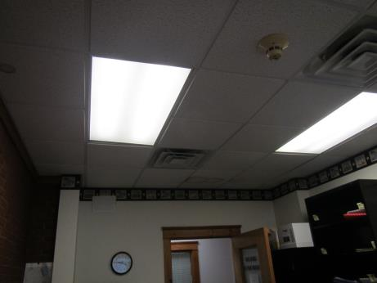
Supply vents in the Building Department office, note water-damaged ceiling tile
Picture 2
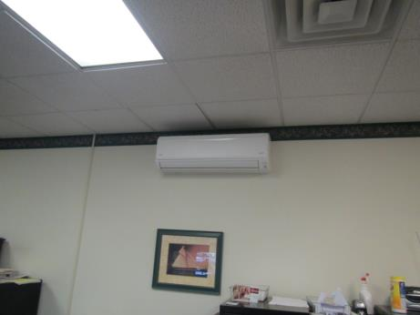
Ductless air conditioning unit
Picture 3
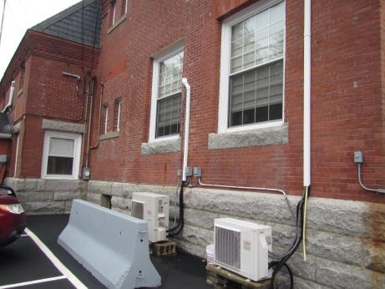
Condensers for ductless air conditioning units
Picture 4
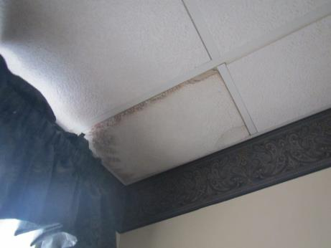
Water-damaged ceiling tile
Picture 5
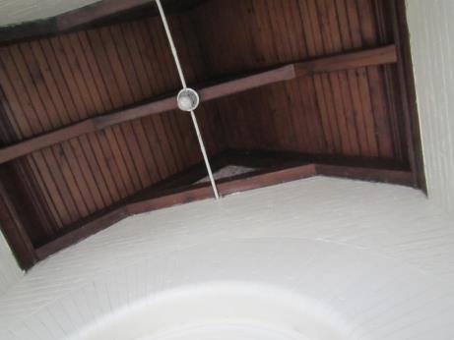
Entrance vestibule wall, recently painted, reportedly subject to chronic water damage
Picture 6
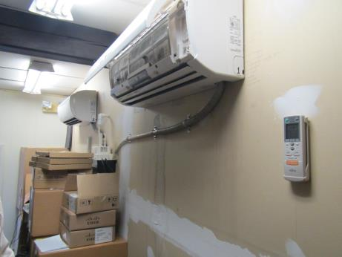
Damaged ductless AC unit, and water-damaged wall
Picture 7
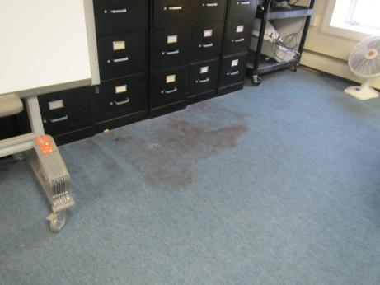
Stained carpeting in open area next to IT closet
Picture 8
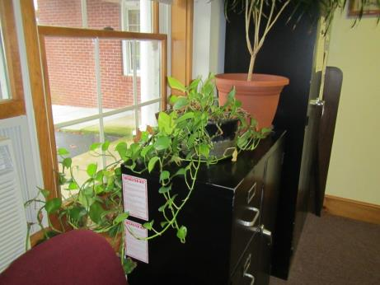
Plant in an office
Picture 9
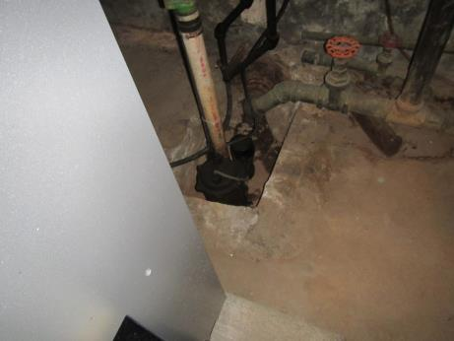
Sump pump sump without a cover
Picture 10
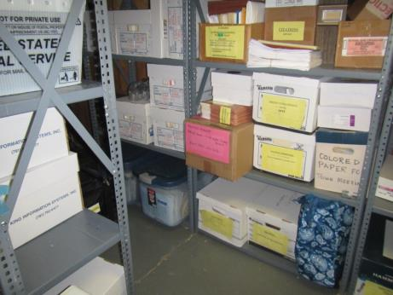
Boxes of files on shelving in the basement
Picture 11
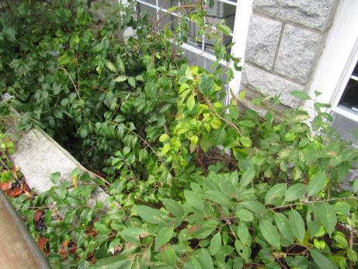
Plants next to the building foundation and in window wells
Picture 12
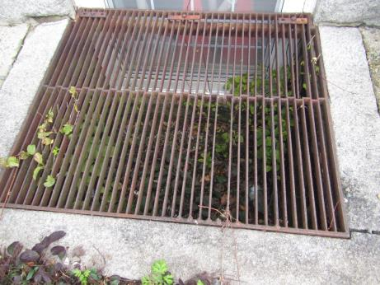
Window well with plants
Picture 13
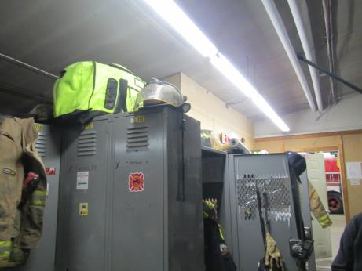
Locker room/turnout gear storage
Picture 14
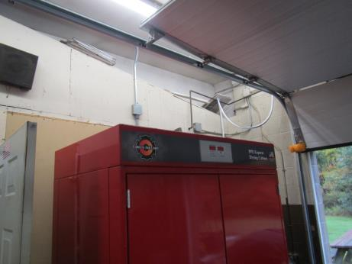
Gear drying cabinet
Picture 15
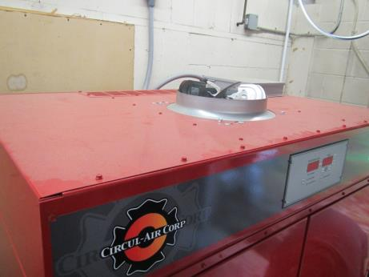
Vent at top of gear drying cabinet, not connected to any ductwork
Picture 16
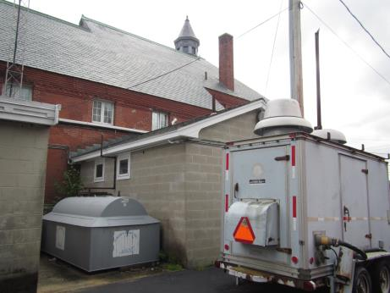
Location of fire department generator and windows on the rear of the building
Picture 17
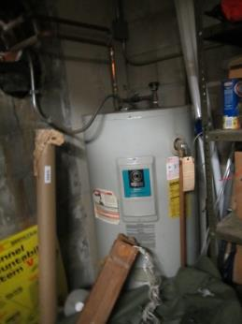
Improper storage of materials next to a water heater
Picture 18
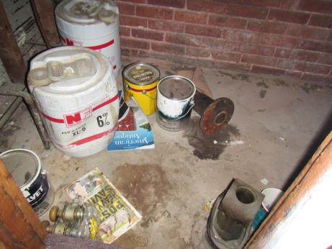
Paint and other items in a basement area
Picture 19
Boxes stored in the basement
Picture 20
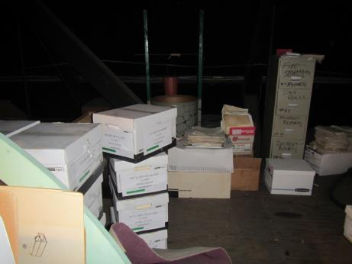
Boxes stored in the attic
Picture 21
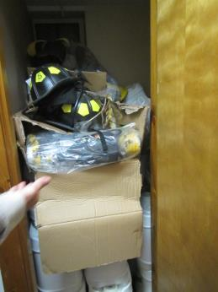
Materials stored in a closet/unused bathroom
Picture 22
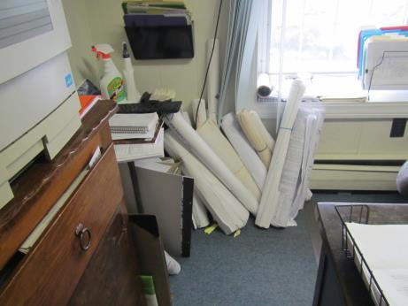
Items stored in the Conservation Agent office
Picture 23
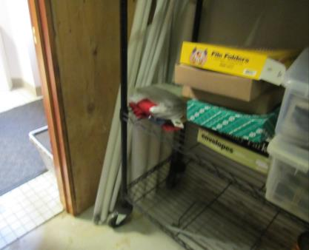
Used fluorescent bulbs

Location | Carbon  Dioxide  (ppm) | Carbon Monoxide  (ppm) | Temp  (°F) | Relative  Humidity  (%) | PM2.5  (µg/m³) | Occupants  in Room | Windows  Openable | Ventilation |  | Remarks
 |  |  |  |  |  |  |  | Supply | Exhaust
Background | 452 | ND | 55 | 44 | 3 |  |  |  |  | Showers
Building Department | 849 | ND | 71 | 44 | 4 | 3 | Y | Y | Y | Exterior wall of original building in this room, flashing between old and new building roofs repaired on a regular basis, but leaks still occur, plants
Hallway outside Board of Health |  |  |  |  |  |  | N | N |  | Old carpet, room off hallway used to be bathroom, now has fixtures/drains that are filled with water periodically but need to be removed
Board of Health | 792 | ND | 71 | 42 | 2 | 2 | Y | Y | Y | Split AC, plants, window AC (temporary), WD CT, plants, carpeted, door/vestibule area unused, microwave
Assessor’s Office | 815 | ND | 74 | 42 | 4 | 2 | Y | Y | Y | Carpeted
Town Admin | 653 | ND | 72 | 39 | 3 | 0 | Y | Y | Y | Reports of diesel odors, WD CT, UF
Selectman’s Office (temp location) | 694 | ND | 71 | 41 | 3 | 1 | N | Y |  | Plants
Stairwell |  |  |  |  |  |  | N | N | N | Perfume odors (plug-in) from below to cover reported musty smell from basement
Office under renovation/ assessment | 633 | ND | 71 | 41 | 4 | 0 | Y | Y | Y | Walls not finished, etc.
Hallway/copy area | 605 | ND | 71 | 40 | 4 | 0 | N | Y |  | PC, small fridge, microwave
Restrooms (2) |  |  |  |  |  |  |  |  | Y | Switch operated exhausts in each
Upper level
FD Deputy/Admin | 730 | ND | 70 | 43 | 4 | 1 | N | N | N | Carpet, old records
FD Kitchen | 743 | ND | 70 | 43 | 3 | 0 | Y | N | N | Fridge, coffee on, stove with no exhaust hood, NC
FD small bunk room | 756 | ND | 72 | 41 | 5 | 0 | Y | N | N | Bed and bedding, MT
FD Chief’s Office | 649 | ND | 71 | 40 | 2 | 0 | Y | N | N | Old worn carpeting
Upstairs Hallway/IT room |  |  |  |  |  |  | Y | N | N | Leak occurred in the IT room off this open area due to freezing of split AC system, carpet is now dry but very WD and wrinkled and stained. Dehumidifier in use in this area. Wall in IT room is also WD
Conservation Agent | 694 | ND | 71 | 40 | 3 | 0 | Y | N | N | WD CT, DEM, musty odor (room not used often), paper and items, CP
Upstairs Restrooms (2) |  |  |  |  |  |  | Y | N | N | No vent for these restrooms
Payroll | 784 | ND | 72 | 46 | 3 | 0 | Y | N | N | Split AC reports of musty odors, plants, damaged windowsill (since new windows installed), no draft or stains, boxes on floor
Accounting | 771 | ND | 72 | 39 | 3 | 2 | Y | N | N | Split AC leaked, water stains on wall, reported musty smell when in use
First floor
2 restrooms |  |  |  |  |  | 0 | Y | N | N | One restroom has slop sink
Treasury | 871 | ND | 73 |  |  | 3 | Y | N | N | Split AC – reported odor, PS, plants, carpet, PC
Treasury inside office | 971 | ND | 72 | 40 | 10 | 1 | N | N | N | Carpet, boxes on floor
Clerk’s office | 801 | ND | 71 | 42 | 4 | 1 | Y | N | N | Split AC, reported odor, plants, carpet,
Main entry hallway | 827 | ND | 70 | 38 | 4 | 4 | Y | N | N | Old carpet, door to outside
Basement
Basement | 609 | ND | 70 | 53 | 4 | 0 | N | N | N | WD CT, furnace, used fluorescent lights, boxes and files off floor on shelves
Fire Department First Floor
FD Vestibule | 645 | ND | 70 | 46 | 4 | 0 | N | N | N | Open to dispatch
FD dayroom | 731 | ND | 70 | 45 | 5 | 0 | Y | N | N | NC, UF, toaster and microwave
FD restroom |  |  |  |  |  | 0 | N | N | Y | Dusty vent
FD Dispatch | 641 | ND | 72 | 44 | 2 | 0 | Y | N | N | Bed, DEM
FD gear room | 565 | ND | 69 | 39 | 3 | 0 | N | N | N | Gear odors (rubber), washing machine
FD Bays | 428 | ND | 65 | 44 | 3 | 0 | N, doors | N | Y | Plymovents not proper size for some tailpipes, need new attachment boots, not in use, gear dryer is vented into the bay room, door open to outside, old exhaust vent in rear wall

