INDOOR AIR QUALITY ASSESSMENT

LaLiberte Elementary School
777 Pleasant Street
Raynham, Massachusetts 02767

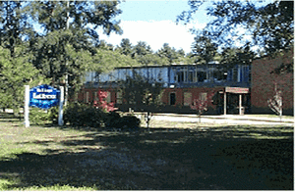

Prepared by:
Massachusetts Department of Public Health
Bureau of Environmental Health
Indoor Air Quality Program
May 2009

Background/Introduction
At the request of Mr. Al Baroncelli, Facilities Director for the Bridgewater-Raynham Regional School District, the Massachusetts Department of Public Health (MDPH), Bureau of Environmental Health (BEH) provided assistance and consultation in an on-going effort to monitor and improve IAQ conditions in each of the Bridgewater-Raynham Regional schools.
On October 24, 2008, Susan Koszalka, Environmental Analyst/Regional Inspector for BEH’s Indoor Air Quality (IAQ) Program conducted an assessment at the LaLiberte Elementary School (LES), 777 Pleasant Street, Raynham, Massachusetts.

Methods
Air tests for carbon monoxide, carbon dioxide, temperature and relative humidity were conducted with the TSI, Q-Trak, IAQ Monitor, Model 7565. Air tests for airborne particle matter with a diameter less than 2.5 micrometers were taken with the TSI, DUSTTRAK™ Aerosol Monitor Model 8520. BEH staff also performed visual inspection of building materials for water damage and/or microbial growth.

Discussion
Ventilation
It can be seen from Table 1 that carbon dioxide levels were below 800 parts per million (ppm) in 22 of 30 areas surveyed at the time of the assessment, indicating adequate air exchange in the majority of areas surveyed. It is important to note, however, that several classrooms had open windows and/or were empty/sparsely populated, which can greatly reduce carbon dioxide levels. Carbon dioxide levels would be expected to increase with full occupancy and windows closed.
Fresh air in classrooms is supplied by a unit ventilator (univent) system (Figure 1). Univents draw air from outdoors through a fresh air intake located on the exterior walls of the building and return air through an intake located at the base of each unit. The mixture of fresh and return air is drawn through a filter and heating coil, and is then expelled from the univent by motorized fans through fresh air diffusers. Obstructions to airflow, such as papers and books stored on univents and bookcases, carts, desks and other materials in front of univent returns were seen in a number of classrooms (Picture 1). Many univents also contained accumulated dirt/debris; for that reason, univents should be cleaned before operating to prevent aerosolization. In order for univents to provide fresh air as designed, intakes must remain free of obstructions.
The mechanical exhaust ventilation system consists of ducted, grated vents, the majority of which are located over the classroom doors. Exhaust in most classrooms was found to be either off or drawing weakly. Dust accumulation was also noted on the exhaust grates. When classroom doors are left open the exhaust system not only exhausts air from the classroom but the hallway as well, compromising the efficiency of the exhaust system.
To maximize air exchange, the MDPH recommends that both supply and exhaust ventilation operate continuously during periods of school occupancy. In order to have proper ventilation with a mechanical supply and exhaust system, the systems must be balanced to provide an adequate amount of fresh air to the interior of a room while removing stale air from the room. It is recommended that HVAC systems be re-balanced every five years to ensure adequate air systems function (SMACNA, 1994). Reportedly, the systems at LES were balanced in 2005, and univent filters are changed four times per year; roof air handling unit (AHU) filters are changed at least once per year, as necessary.
The Massachusetts Building Code requires a minimum ventilation rate of 15 cubic feet per minute (cfm) per occupant of fresh outside air or have openable windows in each room (SBBRS, 1997; BOCA, 1993). The ventilation must be on at all times that the room is occupied. Providing adequate fresh air ventilation with open windows and maintaining the temperature in the comfort range during the cold weather season is impractical. Mechanical ventilation is usually required to provide adequate fresh air ventilation.
Carbon dioxide is not a problem in and of itself. It is used as an indicator of the adequacy of the fresh air ventilation. As carbon dioxide levels rise, it indicates that the ventilating system is malfunctioning or the design occupancy of the room is being exceeded. When this happens, a buildup of common indoor air pollutants can occur, leading to discomfort or health complaints. The Occupational Safety and Health Administration (OSHA) standard for carbon dioxide is 5,000 parts per million parts of air (ppm). Workers may be exposed to this level for 40 hours/week, based on a time-weighted average (OSHA, 1997).
The MDPH uses a guideline of 800 ppm for publicly occupied buildings. A guideline of 600 ppm or less is preferred in schools due to the fact that the majority of occupants are young and considered to be a more sensitive population in the evaluation of environmental health status. Inadequate ventilation and/or elevated temperatures are major causes of complaints such as respiratory, eye, nose and throat irritation, lethargy and headaches. For more information concerning carbon dioxide, consult Appendix A.
Temperature measurements in the LES ranged from 67° F to 75° F, which were within or close to the lower end of the MDPH recommended range in the areas surveyed (Table 1). The MDPH recommends that indoor air temperatures be maintained in a range of 70º F to 78º F in order to provide for the comfort of building occupants. In many cases concerning indoor air quality, fluctuations of temperature in occupied spaces are typically experienced, even in a building with an adequate fresh air supply.
The relative humidity measured in the building ranged from 17 to 34 percent at the time of the assessment, which was below the MDPH recommended comfort range (Table 1). The MDPH recommends a comfort range of 40 to 60 percent for indoor air relative humidity. Relative humidity levels in the building would be expected to drop during the winter months due to heating. The sensation of dryness and irritation is common in a low relative humidity environment. Low relative humidity is a very common problem during the heating season in the northeast part of the United States.

Microbial/Moisture Concerns
The US Environmental Protection Agency (US EPA) and the American Conference of Governmental Industrial Hygienists (ACGIH) recommend that porous materials be dried with fans and heating within 24 to 48 hours of becoming wet (US EPA, 2001; ACGIH, 1989). If not dried within this time frame, mold growth may occur. Once mold has colonized porous materials, they are difficult to clean and should be removed and discarded.
Occupants of classroom 106 and the Nurse’s Office registered mold concerns especially during the summer months. In order for building materials to support mold growth, a source of water exposure is necessary. No visible mold or water damage was observed in either room at the time of the assessment.
Several classrooms had a number of plants (Pictures 2 and 3). Moistened plant soil and drip pans can be a source of mold growth. Plants should be equipped with drip pans; the lack of drip pans can lead to water pooling and mold growth on windowsills. Plants are also a source of pollen. Plants should be located away from the air stream of ventilation sources to prevent the aerosolization of mold, pollen or particulate matter throughout the classroom.

Other IAQ Evaluations
Indoor air quality can be negatively influenced by the presence of respiratory irritants, such as products of combustion. The process of combustion produces a number of pollutants. Common combustion emissions include carbon monoxide, carbon dioxide, water vapor, and smoke (fine airborne particle material). Of these materials, exposure to carbon monoxide and particulate matter with a diameter of 2.5 micrometers (μm) or less (PM2.5) can produce immediate, acute health effects upon exposure. To determine whether combustion products were present in the school environment, BEH staff obtained measurements for carbon monoxide and PM2.5.

Carbon Monoxide
Carbon monoxide is a by-product of incomplete combustion of organic matter (e.g., gasoline, wood and tobacco). Exposure to carbon monoxide can produce immediate and acute health affects. Several air quality standards have been established to address carbon monoxide and prevent symptoms from exposure to these substances. The MDPH established a corrective action level concerning carbon monoxide in ice skating rinks that use fossil-fueled ice resurfacing equipment. If an operator of an indoor ice rink measures a carbon monoxide level over 30 ppm, taken 20 minutes after resurfacing within a rink, that operator must take actions to reduce carbon monoxide levels (MDPH, 1997).
The American Society of Heating Refrigeration and Air-Conditioning Engineers (ASHRAE) has adopted the National Ambient Air Quality Standards (NAAQS) as one set of criteria for assessing indoor air quality and monitoring of fresh air introduced by HVAC systems (ASHRAE, 1989). The NAAQS are standards established by the US EPA to protect the public health from six criteria pollutants, including carbon monoxide and particulate matter (US EPA, 2006). As recommended by ASHRAE, pollutant levels of fresh air introduced to a building should not exceed the NAAQS levels (ASHRAE, 1989). The NAAQS were adopted by reference in the Building Officials & Code Administrators (BOCA) National Mechanical Code of 1993 (BOCA, 1993), which is now an HVAC standard included in the Massachusetts State Building Code (SBBRS, 1997). According to the NAAQS, carbon monoxide levels in outdoor air should not exceed 9 ppm in an eight-hour average (US EPA, 2006).
Carbon monoxide should not be present in a typical, indoor environment. If it is present, indoor carbon monoxide levels should be less than or equal to outdoor levels. On the day of assessment, outdoor carbon monoxide concentrations were non-detect (ND) (Table 1). Carbon monoxide levels measured in the school were also ND.

Particulate Matter (PM2.5)
The US EPA has established NAAQS limits for exposure to particulate matter. Particulate matter is airborne solids that can be irritating to the eyes, nose and throat. The NAAQS originally established exposure limits to particulate matter with a diameter of 10 μm or less (PM10). According to the NAAQS, PM10 levels should not exceed 150 microgram per cubic meter (μg/m³) in a 24-hour average (US EPA, 2006). These standards were adopted by both ASHRAE and BOCA. Since the issuance of the ASHRAE standard and BOCA Code, US EPA established a more protective standard for fine airborne particles. This more stringent PM2.5 standard requires outdoor air particle levels be maintained below 35 μg/m³ over a 24-hour average (US EPA, 2006). Although both the ASHRAE standard and BOCA Code adopted the PM10 standard for evaluating air quality, MDPH uses the more protective PM2.5 standard for evaluating airborne particulate matter concentrations in the indoor environment.
Outdoor PM2.5 concentrations the day of the assessment were measured at 22 μg/m³. PM2.5 levels measured inside the school ranged from 6 to 20 μg/m³ (Table 1), which were below the NAAQS PM2.5 level of 35 μg/m³. Frequently, indoor air levels of particulates (including PM2.5) can be at higher levels than those measured outdoors. A number of mechanical devices and/or activities that occur in schools can generate particulates during normal operations. Sources of indoor airborne particulates may include but are not limited to particles generated during the operation of fan belts in the HVAC system, cooking in the cafeteria stoves and microwave ovens; use of photocopiers, fax machines and computer printing devices; operation of an ordinary vacuum cleaner and heavy foot traffic indoors.

Volatile Organic Compounds
Indoor air concentrations can be greatly impacted by the use of products containing volatile organic compounds (VOCs). VOCs are carbon-containing substances that have the ability to evaporate at room temperature. Frequently, exposure to low levels of total VOCs (TVOCs) may produce eye, nose, throat and/or respiratory irritation in some sensitive individuals. For example, chemicals evaporating from a paint can stored at room temperature would most likely contain VOCs.
In an effort to identify materials that can potentially increase indoor VOC concentrations,
BEH staff examined classrooms for products that may contain these respiratory irritants. Many classrooms contained dry erase boards and dry erase markers. Materials such as dry erase markers and dry erase board cleaners may contain VOCs, (e.g., methyl isobutyl ketone, n-butyl acetate and butyl-cellusolve) (Sanford, 1999) which can be irritating to the eyes, nose and throat.
Cleaning products were found on countertops in some classrooms (Pictures 4, 5 and 6). Like dry erase materials, cleaning products contain VOCs and other chemicals that can be irritating to the eyes, nose and throat of sensitive individuals. Air fresheners and deodorizing materials were observed in several areas (Picture 7). Air deodorizers contain chemicals that can be irritating to the eyes, nose and throat of sensitive individuals. Many air fresheners contain 1,4-dichlorobenzene, a VOC which may cause reduction in lung function (NIH, 2006). Furthermore, deodorizing agents do not remove materials causing odors, but rather mask odors that may be present in the area.

Other Conditions
Other conditions that can affect indoor air quality were observed during the assessment. In several classrooms, items were observed on the univents, floor, windowsills, tabletops, counters, bookcases and desks (Picture 1). The large number of items stored in classrooms provides a source for dusts to accumulate. These items (e.g., papers, folders, boxes) make it difficult for custodial staff to clean. Items should be relocated and/or be cleaned periodically to avoid excessive dust build up. In addition, these materials can accumulate on flat surfaces (e.g., desktops, shelving and carpets) in occupied areas and subsequently be re-aerosolized causing further irritation.
Accumulated chalk dust and pencil shavings were noted in some classrooms (Pictures 8, 9 and 10). Chalk dust is a fine particulate that can easily become airborne, irritating the eyes and respiratory system. Items were also observed hanging from ceiling tiles (Pictures 11, 12 and 13). The movement or damage to ceiling tiles can release accumulated dirt, dust, and particulates that accumulate in the ceiling plenum into occupied areas.
Stuffed toys, upholstered furniture and scatter rugs were seen in several classrooms (Pictures 14, 15 and 16). These items are composed of and covered with fabric that comes in contact with human skin, leaving oils, perspiration, hair and skin cells. Dust mites feed upon human skin cells and excrete waste products that contain allergens.
Finally, several personal fans were observed to be occluded with dust and debris (Picture 17) and most classrooms had built-in wall fans near the windows. Dust can be a source for eye and respiratory irritation. Fan housings and blades should be cleaned periodically with a wet paper towel or cloth in order to avoid the redistribution of accumulated dust into classrooms.

Conclusions/Recommendations
In view of the findings at the time of the assessment, the following recommendations are made:
- Operate all ventilation systems throughout the building (e.g., gym, cafeteria, classrooms) continuously during periods of school occupancy.
- Inspect exhaust motors and belts periodically for proper function. Repair and replace as necessary.
- Remove all blockages from univents and exhaust vents to ensure adequate airflow.
- Use openable windows in conjunction with mechanical ventilation to facilitate air exchange. Care should be taken to ensure windows are properly closed at night and weekends to avoid the freezing of pipes and potential flooding.
- Consider adopting a balancing schedule of every 5 years for all mechanical ventilation systems, as recommended by ventilation industrial standards (SMACNA, 1994).
- Change filters for air-handling equipment (e.g., univents, AHUs and ACs) as per the manufacturer’s instructions or more frequently if needed. Vacuum interior of units prior to activation to prevent the aerosolization of dirt, dust and particulates. Ensure filters fit flush in their racks with no spaces in between allowing bypass of unfiltered air into the unit.
- For buildings in New England, periods of low relative humidity during the winter are often unavoidable. Therefore, scrupulous cleaning practices should be adopted to minimize common indoor air contaminants whose irritant effects can be enhanced when the relative humidity is low. To control dusts, a high efficiency particulate arrestance (HEPA) filter equipped vacuum cleaner in conjunction with wet wiping of all surfaces is recommended. Avoid the use of feather dusters. Drinking water during the day can help ease some symptoms associated with a dry environment (throat and sinus irritations).
- Monitor Room #106 and the Nurse’s Office for leaks, signs of water damage and/or visible mold growth especially during the summer months (as reported by occupants).
- Store cleaning products properly and out of reach of students. Ensure spray bottles are properly labeled. All cleaning products used at the LES should be approved by the school department with MSDS’ available at a central location.
- Relocate or consider reducing the amount of materials stored in classrooms to allow for more thorough cleaning of classrooms. Clean items regularly with a wet cloth or sponge to prevent excessive dust build-up.
- Remove objects hanging from the ceiling tile system in order to avoid introducing dirt, dust and debris into classrooms.
- Discontinue the use of air fresheners in classrooms and restrooms in order to avoid respiratory irritation from chemicals contained in the products.
- Clean upholstered items and scatter rugs according to the manufacturers’ recommendations, and more frequently if soiled or stained.
- Consider adopting the US EPA (2000) document, “Tools for Schools”, as an instrument for maintaining a good indoor air quality environment in the building. This document is available at: http://www.epa.gov/iaq/schools/index.html.
- Refer to resource manual and other related indoor air quality documents located on the MDPH’s website for further building-wide evaluations and advice on maintaining public buildings. These documents are available at: http://mass.gov/dph/indoor_air.

References

ACGIH. 1989. Guidelines for the Assessment of Bioaerosols in the Indoor Environment. American Conference of Governmental Industrial Hygienists, Cincinnati, OH.
ASHRAE. 1989. Ventilation for Acceptable Indoor Air Quality. American Society of Heating, Refrigeration and Air Conditioning Engineers. ANSI/ASHRAE 62-1989
BOCA. 1993. The BOCA National Mechanical Code/1993. 8th ed. Building Officials and Code Administrators International, Inc., Country Club Hill, IL.

MDPH. 1997. Requirements to Maintain Air Quality in Indoor Skating Rinks (State Sanitary Code, Chapter XI). 105 CMR 675.000. Massachusetts Department of Public Health, Boston, MA.
NIH. 2006. Chemical in Many Air Fresheners May Reduce Lung Function (#06-11). National Institutes of Health, Research Triangle Park, NC.
OSHA. 1997. Limits for Air Contaminants. Occupational Safety and Health Administration. Code of Federal Regulations. 29 C.F.R 1910.1000 Table Z-1-A.
Sanford. 1999. Material Safety Data Sheet (MSDS No: 198-17). Expo® Dry Erase Markers Bullet, Chisel, and Ultra Fine Tip. Sanford Corporation. Bellwood, IL.
SBBRS. 1997. Mechanical Ventilation. State Board of Building Regulations and Standards. Code of Massachusetts Regulations. 780 CMR 1209.0
SMACNA. 1994. HVAC Systems Commissioning Manual. 1st ed. Sheet Metal and Air Conditioning Contractors’ National Association, Inc., Chantilly, VA.

US EPA. 1992. Indoor Biological Pollutants. US Environmental Protection Agency, Environmental Criteria and Assessment Office, Office of Health and Environmental Assessment, Research Triangle Park, NC. EPA 600/8-91/202 January 1992.
US EPA. 2000. Tools for Schools. Office of Air and Radiation, Office of Radiation and Indoor Air, Indoor Environments Division (6609J). EPA 402-K-95-001, Second Edition. http://www.epa.gov/iaq/schools/tools4s2.html
US EPA. 2001. “Mold Remediation in Schools and Commercial Buildings”. Office of Air and Radiation, Indoor Environments Division, Washington, DC. EPA 402-K-01-001. March 2001. Available at: http://www.epa.gov/iaq/molds/mold_remediation.html

US EPA. 2006. National Ambient Air Quality Standards (NAAQS). US Environmental Protection Agency, Office of Air Quality Planning and Standards, Washington, DC. http://www.epa.gov/air/criteria.html.
Picture 1

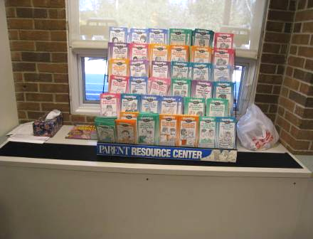

Clutter on Univent

Picture 2

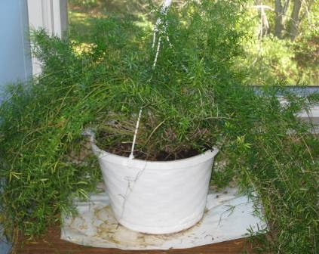

Plant (note no drip pan)

Picture 3

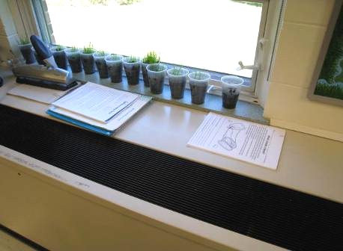

Plants in Plastic Cups near Univent

Picture 4

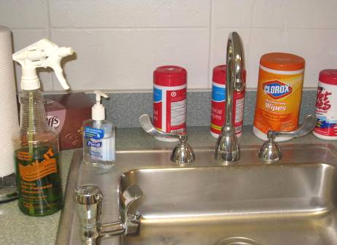

Chemical Cleaners on Sink

Picture 5

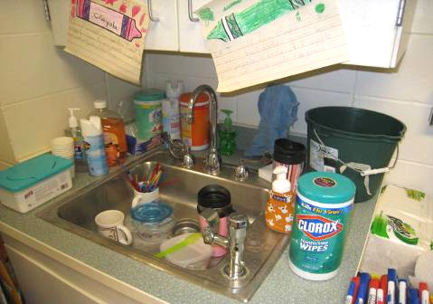

Chemical Cleaners on Sink

Picture 6

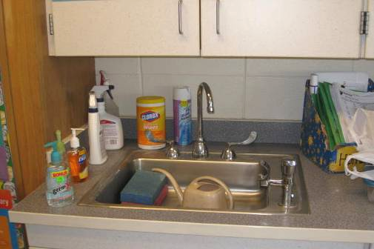

Chemical Cleaners on Sink

Picture 7

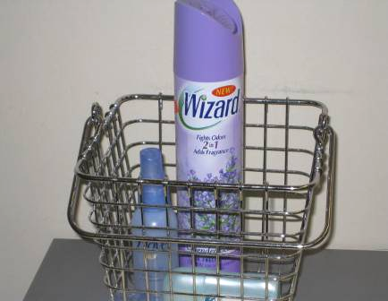

Spray Air Freshener

Picture 8

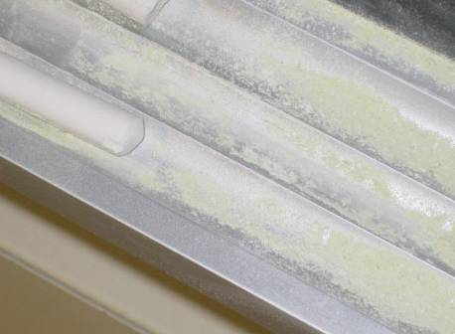

Chalk Dust

Picture 9

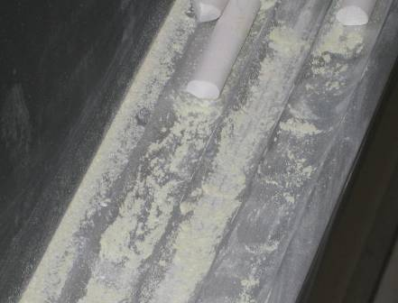

Chalk Dust

Picture 10

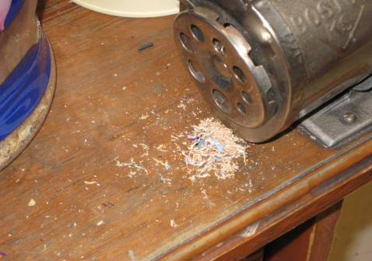

Pencil Shavings

Picture 11

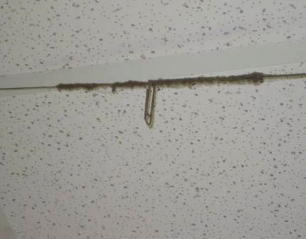

Damaged Ceiling Tile (note paperclip)

Picture 12

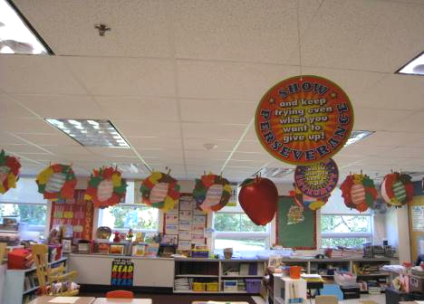

Objects Hanging from Ceiling

Picture 13

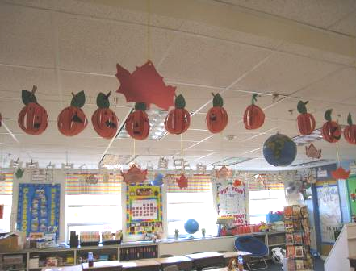

Objects Hanging from Ceiling

Picture 14

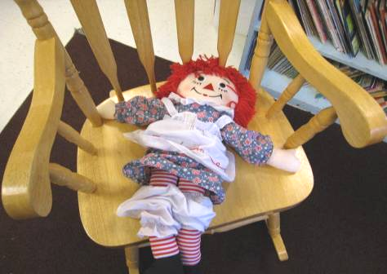

Fabric Toy

Picture 15

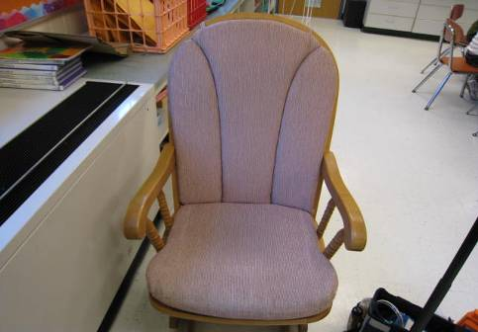

Upholstered Chair Cushions

Picture 16

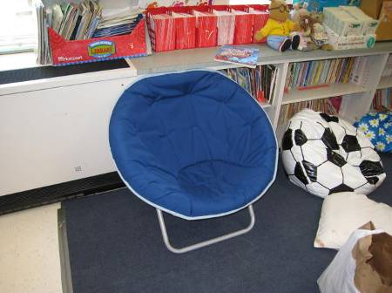

Upholstered Chair Cushions

Picture 17

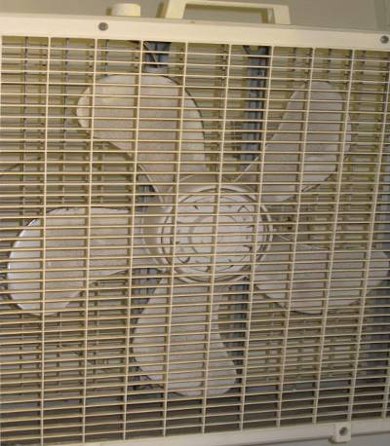

Personal Box Fan (note dust accumulation)

Location/ Room | Occupants  in Room | Temp  (°F) | Relative  Humidity  (%) | Carbon  Dioxide  (ppm) | Carbon Monoxide  (ppm) | PM2.5  (µg/m3) | Windows  Openable | Ventilation |  | Remarks
 |  |  |  |  |  |  |  | Supply | Exhaust | Remarks
background | - | 68 | 12 | 397 | ND | 22 |  |  |  | Fair, light wind from the west at 3 MPH
Gymnasium | 9 | 70 | 28 | 673 | ND | 7 | N | Y | Y
Conference A | 0 | 67 | 29 | 855 | ND | 14 | Y | Y | Y | Supply and exhaust off, DEM, univent partially blocked
Guidance | 1 | 71 | 27 | 744 | ND | 19 | Y | Y | Y | Small utility hole in brickwork with pipe protruding
101 | 1 | 70 | 30 | 638 | ND | 14 | Y | Y | Y | Exhaust weak or off, CD, DEM, objects hanging from ceiling, scatter rugs
Cafetorium | 2 | 71 | 28 | 656 | ND | 12 | N | Y | Y
102 | 27 | 71 | 33 | 812 | ND | 18 | Y | Y | Y | Exhaust off or weak, scatter rugs, DO, DEM, objects hanging from ceiling
Rest Room | 0 | 71 | 30 | 839 | ND | 20 | N | N | Y | Air freshener
111 | 0 | 72 | 31 | 467 | ND | 10 | Y | Y | Y | 23 students gone 30 minutes, exhaust off or weak, objects hanging from ceiling, DEM, clutter on univent, scatter rug, exhaust over door
110 | 0 | 72 | 27 | 821 | ND | 11 | Y | Y | Y | Exhaust off or weak, clutter on univent, exhaust over door, PF-1, chemical cleaners on sink
103 | 25 | 73 | 31 | 904 | ND | 17 | Y | Y | Y | Exhaust off or weak, DEM, exhaust over door, clutter on univent, upholstered furniture, scatter rugs, PF-1
104 | 25 | 72 | 28 | 791 | ND | 19 | Y | Y | Y | Exhaust off or weak, CD, DEM, exhaust over door, scatter rugs, portable A/C on univent vented outdoors, objects hanging from ceiling, univent partially blocked by cabinet
105 | 25 | 72 | 34 | 745 | ND | 15 | Y | Y | Y | Exhaust off or weak, chemical cleaners on sink, exhaust over door, univent partially blocked, PF-1, DEM
Music Room | 28 | 70 | 25 | 674 | ND | 10 | N | Y | Y | Exhaust off or weak, carpeted tiered steps
106 | 20 | 70 | 28 | 715 | ND | 16 | Y | Y | Y | Exhaust off or weak, exhaust over door, mold issue reported behind poster boards in summer-no visible mold seen, univent blocked by cabinet, A/C vented outdoors, PS, DEM, objects hanging from ceiling, PF-1
107 | 8 | 72 | 24 | 565 | ND | 11 | Y | Y | Y | Exhaust over door, DEM, CD, clutter on univent, PF-1
108 | 24 | 73 | 32 | 778 | ND | 13 | Y | Y | Y | Exhaust off or weak, DEM, CD, objects hanging from ceiling, exhaust over door, scatter rug, clutter on univent, PF-1, chemical cleaners on sink, stuffed toys
215 | 0 | 73 | 25 | 651 | ND | 12 | Y | Y | Y | Exhaust off or weak, DEM, aquarium with fish, plants, exhaust over door, DO
Teacher Planning | 0 | 70 | 17 | 406 | ND | 7 | Y | Y | Y | Window open, damaged molding on window, exhaust over door
214 | 25 | 70 | 20 | 599 | ND | 7 | Y | Y | Y | Exhaust off or weak, damaged molding on window, clutter on univent, DEM, CD, scatter rugs, PF-1 near chalkboard, exhaust over door, wall-mounted fan
213 | 7 | 71 | 20 | 491 | ND | 8 | Y | Y | Y | Exhaust weak or off, fruit near univent, exhaust over door, A/C vented outdoors, objects hanging from ceiling, wall-mounted fan, DEM
211 | 25 | 71 | 24 | 775 | ND | 6 | Y | Y | Y | Exhaust off or weak, plants with soil in plastic cups near univent, objects hanging from ceiling, CD, DEM, PF-1, wall-mounted fan, occupant complaints of dizziness
217-Art | 26 | 72 | 24 | 842 | ND | 8 | Y | Y | Y | DEM, A/C vented outdoors (filter dusty), dry mop (dusty)
210 | 0 | 69 | 19 | 514 | ND | 6 | Y | Y | Y | CD, objects hanging from ceiling, chemical cleaners on sink, plants near univent, upholstered furniture, PS
209 | 27 | 71 | 27 | 906 | ND | 9 | Y | Y | Y | Exhaust off or weak, exhaust near door, objects hanging from ceiling near univent, DEM, chemical cleaners on sink
205 | 0 | 73 | 23 | 596 | ND | 6 | Y | Y | Y | Exhaust off or weak, DEM, CD, objects hanging from ceiling, wall-mounted fan, PF-1, PS
207 | 0 | 73 | 21 | 565 | ND | 7 | Y | Y | Y | Exhaust off or weak, DEM, CD, objects hanging from ceiling, crock pot, clutter near univent, PS, A/C vented outdoors
Nurse | 4 | 72 | 25 | 718 | ND | 11 | Y | Y | N | PF-1, sealed sewer drain, previous mold complaint (none visible), humidity complaint, exhaust in adjacent restroom
206 | 27 | 73 | 19 | 564 | ND | 8 | Y | Y | Y | Exhaust off or weak, DEM, wall-mounted fan
208 | 25 | 73 | 19 | 782 | ND | 7 | Y | Y | Y | Exhaust weak or off, occupant complaint of dizziness and headaches, CD, DEM, PF-1, wall-mounted fan, plants, upholstered furniture, univent partially blocked by table, objects hanging from ceiling, scatter rug, clean aquarium with fish ‘Bubbles.’ Brooms and dustpans
Principal’s Office | 2 | 75 | 22 | 832 | ND | 6 | N | Y | N | Existing windows do not open

