INDOOR AIR QUALITY REASSESSMENT

LaLiberte Elementary School
777 Pleasant Street
Raynham, Massachusetts



Prepared by:
Massachusetts Department of Public Health
Bureau of Environmental Health
Indoor Air Quality Program
June 2010

Background/Introduction
At the request of Al Baroncelli, Facilities Director for the Bridgewater-Raynham Regional School District, the Massachusetts Department of Public Health (MDPH), Bureau of Environmental Health (BEH) provided assistance and consultation in an on-going effort to monitor and improve indoor air quality in Bridgewater-Raynham Regional Schools (BRRS). On March 16, 2010 Cory Holmes, Environmental Analyst/Regional Inspector for BEH’s Indoor Air Quality (IAQ) Program conducted a reassessment at the LaLiberte Elementary School (LES), 777 Pleasant Street, Raynham, Massachusetts.
The building was previously visited by BEH staff and a report was issued in May 2009 detailing conditions observed in the building with recommendations to improve IAQ (MDPH, 2009). This most recent request for an assessment was to observe and document progress made by implementing previous MDPH recommendations.

Actions on MDPH Recommendations
As mentioned, MDPH staff had previously visited the building and issued a report with recommendations to improve indoor air quality (MDPH, 2009). A summary of actions taken on previous recommendations is included as Appendix A.

Methods
Air tests for carbon monoxide, carbon dioxide, temperature and relative humidity were conducted with the TSI, Q-Trak, IAQ Monitor, Model 7565. Air tests for airborne particle matter with a diameter less than 2.5 micrometers were taken with the TSI, DUSTTRAK™ Aerosol Monitor Model 8520. BEH staff also performed visual inspection of building materials for water damage and/or microbial growth.

Discussion

Ventilation
It can be seen from Table 1 that carbon dioxide levels were below 800 parts per million (ppm) in 28 of 32 areas surveyed at the time of the assessment, indicating adequate air exchange in the majority of areas. Fresh air in classrooms is supplied by a unit ventilator (univent) system (Figure 1). Univents draw air from outdoors through a fresh air intake located on the exterior walls of the building and return air through an intake located at the base of each unit. The mixture of fresh and return air is drawn through a filter and heating coil, and is then expelled from the univent by motorized fans through fresh air diffusers. Obstructions to airflow, such as papers and books stored on univents and bookcases, and other materials in front of univent returns were seen in a few classrooms (Table 1/Picture 1). In order for univents to provide fresh air as designed, intakes must remain free of obstructions.
The mechanical exhaust ventilation system consists of ducted, grated ceiling vents, the majority of which are located over the classroom doors. Exhaust in most classrooms was found to be off during the assessment (Table 1). BEH staff visited the roof to examine rooftop exhaust vents and found them not functioning/in disrepair. In subsequent correspondence with Mr. Baroncelli, it was reported that exhaust vents had either been repaired or were on a repair list awaiting repair.
To maximize air exchange, the MDPH recommends that both supply and exhaust ventilation operate continuously during periods of school occupancy. In order to have proper ventilation with a mechanical supply and exhaust system, the systems must be balanced to provide an adequate amount of fresh air to the interior of a room while removing stale air from the room. It is recommended that HVAC systems be re-balanced every five years to ensure adequate air systems function (SMACNA, 1994). The systems at LES were reportedly balanced in 2005.
The Massachusetts Building Code requires a minimum ventilation rate of 15 cubic feet per minute (cfm) per occupant of fresh outside air or have openable windows in each room (SBBRS, 1997; BOCA, 1993). The ventilation must be on at all times that the room is occupied. Providing adequate fresh air ventilation with open windows and maintaining the temperature in the comfort range during the cold weather season is impractical. Mechanical ventilation is usually required to provide adequate fresh air ventilation.
Carbon dioxide is not a problem in and of itself. It is used as an indicator of the adequacy of the fresh air ventilation. As carbon dioxide levels rise, it indicates that the ventilating system is malfunctioning or the design occupancy of the room is being exceeded. When this happens, a buildup of common indoor air pollutants can occur, leading to discomfort or health complaints. The Occupational Safety and Health Administration (OSHA) standard for carbon dioxide is 5,000 parts per million parts of air (ppm). Workers may be exposed to this level for 40 hours/week, based on a time-weighted average (OSHA, 1997).
The MDPH uses a guideline of 800 ppm for publicly occupied buildings. A guideline of 600 ppm or less is preferred in schools due to the fact that the majority of occupants are young and considered to be a more sensitive population in the evaluation of environmental health status. Inadequate ventilation and/or elevated temperatures are major causes of complaints such as respiratory, eye, nose and throat irritation, lethargy and headaches. For more information concerning carbon dioxide, consult Appendix B.
Temperature measurements in the building ranged from 68° F to 75° F, which were within or close to the lower end of the MDPH recommended range (Table 1). The MDPH recommends that indoor air temperatures be maintained in a range of 70º F to 78º F in order to provide for the comfort of building occupants. In many cases concerning indoor air quality, fluctuations of temperature in occupied spaces are typically experienced, even in a building with an adequate fresh air supply.
The relative humidity measured in the building ranged from 20 to 37 percent at the time of the assessment, which was below the MDPH recommended comfort range (Table 1). The MDPH recommends a comfort range of 40 to 60 percent for indoor air relative humidity. Relative humidity levels in the building would be expected to drop during the winter months due to heating. The sensation of dryness and irritation is common in a low relative humidity environment. Low relative humidity is a very common problem during the heating season in the northeast part of the United States.

Microbial/Moisture Concerns
Occupants in the Nurse’s Office expressed concerns regarding condensation on the floor, especially during summer months. When warm, moist air passes over a surface that is colder than the air, water condensation can collect on the cold surface. Over time, water droplets can form, which can moisten porous, carbon containing materials (e.g., paper and cardboard) to produce mold growth and/or create a falling/safety hazard if moisture collects on non-porous surfaces (e.g., tile). It is recommended that a dehumidifier be stationed in this area to supplement the air conditioning system in an effort to reduce relative humidity causing condensation. Use of such equipment, however, warrants strict adherence to cleaning and changing filters per manufacturer’s recommendation.
A number of windows along the rear of the building had missing and/or damaged exterior strip caulking (Pictures 2 and 3). Missing/damaged caulking around windows can allow moisture and drafts into the building, which can lead to water damage (Picture 4) and/or possible mold growth.
Missing/damaged mortar was observed around exterior brick (Pictures 5 and 6). The freezing and thawing of water during winter months can lead to accelerated damage. Over time, these conditions can undermine the integrity of the building envelope and provide a means of water entry into the building via capillary action through masonry (Lstiburek & Brennan, 2001).
Pooling water was observed on the roof due to poor drainage (Pictures 7 and 8). Although a drain was present, the height of the drain was such that water could not flow into it (Picture 9). The freezing and thawing of water during winter months can lead to roof leaks and subsequent water penetration into the interior of the building. Pooling water can also become stagnant, which can lead to mold and bacterial growth, and serve as a breeding ground for mosquitoes. Numerous patches were observed on many areas of the roof (Pictures 10 and 11); although current leaking throughout the building appears limited, consideration of a roof replacement plan should be made for the future.
Breaches were observed between countertops and sink backsplashes in a number of classrooms (Table 1). If not watertight, water can penetrate through these seams. Water penetration and chronic exposure of porous and wood-based materials can cause these materials to swell and show signs of water damage.
The US Environmental Protection Agency (US EPA) and the American Conference of Governmental Industrial Hygienists (ACGIH) recommend that porous materials be dried with fans and heating within 24 to 48 hours of becoming wet (US EPA, 2001; ACGIH, 1989). If not dried within this time frame, mold growth may occur. Once mold has colonized porous materials, they are difficult to clean and should be removed and discarded.

Other IAQ Evaluations
Indoor air quality can be negatively influenced by the presence of respiratory irritants, such as products of combustion. The process of combustion produces a number of pollutants. Common combustion emissions include carbon monoxide, carbon dioxide, water vapor, and smoke (fine airborne particle material). Of these materials, exposure to carbon monoxide and particulate matter with a diameter of 2.5 micrometers (μm) or less (PM2.5) can produce immediate, acute health effects upon exposure. To determine whether combustion products were present in the building, BEH staff obtained measurements for carbon monoxide and PM2.5.

Carbon Monoxide
Carbon monoxide is a by-product of incomplete combustion of organic matter (e.g., gasoline, wood and tobacco). Exposure to carbon monoxide can produce immediate and acute health effects. Several air quality standards have been established to address carbon monoxide and prevent symptoms from exposure to these substances. The MDPH established a corrective action level concerning carbon monoxide in ice skating rinks that use fossil-fueled ice resurfacing equipment. If an operator of an indoor ice rink measures a carbon monoxide level over 30 ppm, taken 20 minutes after resurfacing within a rink, that operator must take actions to reduce carbon monoxide levels (MDPH, 1997).
The American Society of Heating Refrigeration and Air-Conditioning Engineers (ASHRAE) has adopted the National Ambient Air Quality Standards (NAAQS) as one set of criteria for assessing indoor air quality and monitoring of fresh air introduced by HVAC systems (ASHRAE, 1989). The NAAQS are standards established by the US EPA to protect the public health from six criteria pollutants, including carbon monoxide and particulate matter (US EPA, 2006). As recommended by ASHRAE, pollutant levels of fresh air introduced to a building should not exceed the NAAQS levels (ASHRAE, 1989). The NAAQS were adopted by reference in the Building Officials & Code Administrators (BOCA) National Mechanical Code of 1993 (BOCA, 1993), which is now an HVAC standard included in the Massachusetts State Building Code (SBBRS, 1997). According to the NAAQS, carbon monoxide levels in outdoor air should not exceed 9 ppm in an eight-hour average (US EPA, 2006).
Carbon monoxide should not be present in a typical, indoor environment. If it is present, indoor carbon monoxide levels should be less than or equal to outdoor levels. On the day of the assessment, outdoor carbon monoxide concentrations were non-detect (ND) (Table 1). No measureable levels of carbon monoxide were detected in the building during the assessment (Table 1).

Particulate Matter (PM2.5)
The US EPA has established NAAQS limits for exposure to particulate matter. Particulate matter is airborne solids that can be irritating to the eyes, nose and throat. The NAAQS originally established exposure limits to particulate matter with a diameter of 10 μm or less (PM10). According to the NAAQS, PM10 levels should not exceed 150 microgram per cubic meter (μg/m³) in a 24-hour average (US EPA, 2006). These standards were adopted by both ASHRAE and BOCA. Since the issuance of the ASHRAE standard and BOCA Code, US EPA established a more protective standard for fine airborne particles. This more stringent PM2.5 standard requires outdoor air particle levels be maintained below 35 μg/m³ over a 24-hour average (US EPA, 2006). Although both the ASHRAE standard and BOCA Code adopted the PM10 standard for evaluating air quality, MDPH uses the more protective PM2.5 standard for evaluating airborne particulate matter concentrations in the indoor environment.
Outdoor PM2.5 concentrations the day of the assessment were measured at 9 μg/m³. PM2.5 levels measured inside the building ranged from 6 to 10 μg/m³ (Table 1), which were below the NAAQS PM2.5 level of 35 μg/m³. Frequently, indoor air levels of particulates (including PM2.5) can be at higher levels than those measured outdoors. A number of mechanical devices and/or activities that occur indoors can generate particulates during normal operations. Sources of indoor airborne particulates may include but are not limited to particles generated during the operation of fan belts in the HVAC system, cooking in the cafeteria stoves and microwave ovens; use of photocopiers, fax machines and computer printing devices; operation of an ordinary vacuum cleaner and heavy foot traffic indoors.

Volatile Organic Compounds
Indoor air concentrations can be greatly impacted by the use of products containing volatile organic compounds (VOCs). VOCs are carbon-containing substances that have the ability to evaporate at room temperature. Frequently, exposure to low levels of total VOCs (TVOCs) may produce eye, nose, throat and/or respiratory irritation in some sensitive individuals. For example, chemicals evaporating from a paint can stored at room temperature would most likely contain VOCs.
In an effort to identify materials that can potentially increase indoor VOC concentrations,
BEH staff examined classrooms for products that may contain these respiratory irritants. Many classrooms contained dry erase boards and dry erase markers. Materials such as dry erase markers and dry erase board cleaners may contain VOCs, (e.g., methyl isobutyl ketone, n-butyl acetate and butyl-cellusolve) (Sanford, 1999) which can be irritating to the eyes, nose and throat. Cleaning products were found on countertops in a few classrooms (Table 1). Like dry erase materials, cleaning products contain VOCs and other chemicals that can be irritating to the eyes, nose and throat of sensitive individuals.
Located in the teachers’ work room are lamination and duplicating machines. Lamination machines melt plastic and give off excess heat and odors. Photocopiers can produce VOCs and ozone, particularly if the equipment is older and in frequent use. VOCs and ozone are respiratory irritants (Schmidt Etkin, 1992). The exhaust system in this area was not drawing air at the time of the assessment. Without exhaust ventilation, pollutants generated by duplicating/laminating equipment will accumulate in the teachers’ room as these machines operate.

Other Conditions
Other conditions that can affect indoor air quality were observed during the assessment. In several classrooms, items were observed on the univents, floors, windowsills, tabletops, counters, bookcases and desks. The large number of items stored in classrooms provides a source for dusts to accumulate. These items (e.g., papers, folders, boxes) make it difficult for custodial staff to clean. Items should be relocated and/or be cleaned periodically to avoid excessive dust build up. In addition, these materials can accumulate on flat surfaces (e.g., desktops, shelving and carpets) in occupied areas and subsequently be re-aerosolized causing further irritation.
Finally, several personal fans were found to be occluded with dust and debris (Picture 12). Dust can be a source for eye and respiratory irritation. Fan housings and blades should be cleaned periodically with a wet paper towel or cloth in order to avoid the redistribution of accumulated dust into classrooms.

Conclusions/Recommendations
BRRS officials, working in conjunction with private contractors, LES administration, faculty members and school maintenance staff, have improved indoor environmental conditions in the building by implementing the majority of MDPH’s previous recommendations. As indicated in Appendix A, several of these recommendations warrant further attention. In view of the findings at the time of this visit, the following additional recommendations are made to further improve indoor air quality:
- Continue to implement recommendations in Appendix A which have not yet been addressed.
- Continue to operate all ventilation systems throughout the building (e.g., gym, cafeteria, classrooms) continuously during periods of school occupancy.
- Continue with plans to restore exhaust ventilation throughout the building. Periodically inspect motors and belts for proper function, and perform repairs and adjustments as necessary.
- Remove all blockages from univents to ensure adequate airflow.
- Use openable windows in conjunction with mechanical ventilation to facilitate air exchange. Care should be taken to ensure windows are properly closed at night and weekends during winter months to avoid the freezing of pipes and potential flooding. In addition, keep windows closed during hot, humid weather to maintain indoor temperatures and to avoid condensation problems when air conditioning is activated.
- Consider adopting a balancing schedule of every 5 years for all mechanical ventilation systems, as recommended by ventilation industrial standards (SMACNA, 1994).
- For buildings in New England, periods of low relative humidity during the winter are often unavoidable. Therefore, scrupulous cleaning practices should be adopted to minimize common indoor air contaminants whose irritant effects can be enhanced when the relative humidity is low. To control dusts, a high efficiency particulate arrestance (HEPA) filter equipped vacuum cleaner in conjunction with wet wiping of all surfaces is recommended. Avoid the use of feather dusters. Drinking water during the day can help ease some symptoms associated with a dry environment (throat and sinus irritations).
- Repair/replace missing/damaged strip caulking to exterior windows.
- Repair water damaged window frames.
- Repair/re-point any damage to exterior brickwork.
- Contact a roofing firm to modify pitch to roof drains to prevent water pooling on roof.
- Consider long-term plans for roof replacement including the removal of historical “patches” originally intended for temporary repair. Until the roof can be replaced, continue to make roof repairs as needed to prevent water penetration.
- Provide dehumidifier for Nurse’s Office during the summer months and monitor for floor condensation.
- Ensure dehumidifiers are cleaned and maintained as per the manufacturer’s instructions to prevent microbial growth.
- Seal breaches, seams, and spaces between sink countertops and backsplashes to prevent water damage.
- Store cleaning products properly and out of reach of students. Ensure spray bottles are properly labeled. All cleaning products used at the facility should be approved by the school department with MSDS’ available at a central location.
- Relocate or consider reducing the amount of materials stored in classrooms to allow for more thorough cleaning of classrooms. Clean items regularly with a wet cloth or sponge to prevent excessive dust build-up.
- Clean personal fans periodically to prevent excessive dust build-up.
- Ensure local exhaust ventilation in the teacher’s workroom is functioning to remove excess heat and odors.
- Consider adopting the US EPA (2000) document, “Tools for Schools”, as an instrument for maintaining a good indoor air quality environment in the building. This document is available at: http://www.epa.gov/iaq/schools/index.html.
- Refer to resource manual and other related indoor air quality documents located on the MDPH’s website for further building-wide evaluations and advice on maintaining public buildings. These documents are available at: http://mass.gov/dph/iaq.

References

ASHRAE. 1989. Ventilation for Acceptable Indoor Air Quality. American Society of Heating, Refrigeration and Air Conditioning Engineers. ANSI/ASHRAE 62-1989
BOCA. 1993. The BOCA National Mechanical Code/1993. 8th ed. Building Officials and Code Administrators International, Inc., Country Club Hill, IL.
Lstiburek, J. & Brennan, T. 2001. Read This Before You Design, Build or Renovate. Building Science Corporation, Westford, MA. U.S. Department of Housing and Urban Development, Region I, Boston, MA
MDPH. 1997. Requirements to Maintain Air Quality in Indoor Skating Rinks (State Sanitary Code, Chapter XI). 105 CMR 675.000. Massachusetts Department of Public Health, Boston, MA.
MDPH. 2009. Indoor Air Quality Assessment. LaLiberte Elementary School, Raynham, MA. Massachusetts Department of Public Health, Bureau of Environmental Health, Boston, MA.
OSHA. 1997. Limits for Air Contaminants. Occupational Safety and Health Administration. Code of Federal Regulations. 29 C.F.R 1910.1000 Table Z-1-A.
Sanford. 1999. Material Safety Data Sheet (MSDS No: 198-17). Expo® Dry Erase Markers Bullet, Chisel, and Ultra Fine Tip. Sanford Corporation. Bellwood, IL.
SBBRS. 1997. Mechanical Ventilation. State Board of Building Regulations and Standards. Code of Massachusetts Regulations. 780 CMR 1209.0
Schmidt Etkin, D. 1992. Office Furnishings/Equipment & IAQ Health Impacts, Prevention & Mitigation. Cutter Information Corporation, Indoor Air Quality Update, Arlington, MA.
SMACNA. 1994. HVAC Systems Commissioning Manual. 1st ed. Sheet Metal and Air Conditioning Contractors’ National Association, Inc., Chantilly, VA.
US EPA. 2000. Tools for Schools. Office of Air and Radiation, Office of Radiation and Indoor Air, Indoor Environments Division (6609J). EPA 402-K-95-001, Second Edition. http://www.epa.gov/iaq/schools/tools4s2.html
US EPA. 2006. National Ambient Air Quality Standards (NAAQS). US Environmental Protection Agency, Office of Air Quality Planning and Standards, Washington, DC. http://www.epa.gov/air/criteria.html.
Picture 1

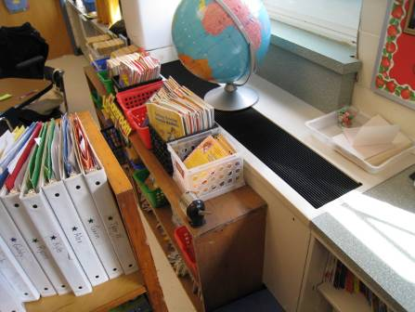

Bookcase Obstructing Univent Return Vent (along bottom front)

Picture 2

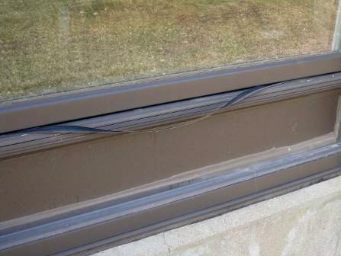

Missing/Damaged Exterior Strip Caulking around Windows

Picture 3

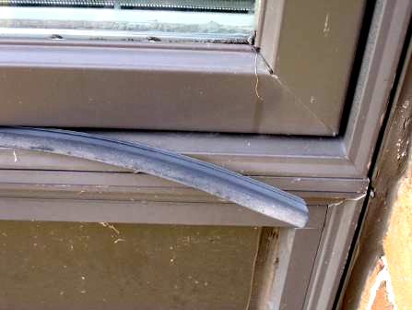

Missing/Damaged Rubber Exterior Strip Caulking around Windows

Picture 4

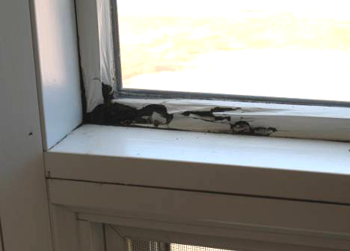

Interior Water Damage to Classroom Windowsill

Picture 5

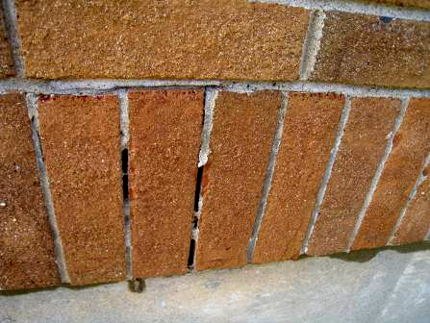

Missing/Damaged Mortar around Exterior Brick

Picture 6

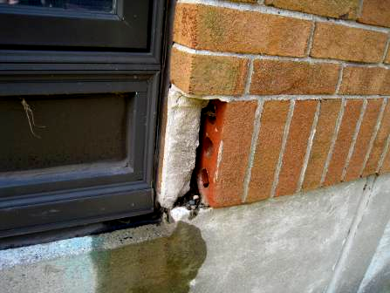

Missing/Damaged Mortar and Exterior Brick

Picture 7

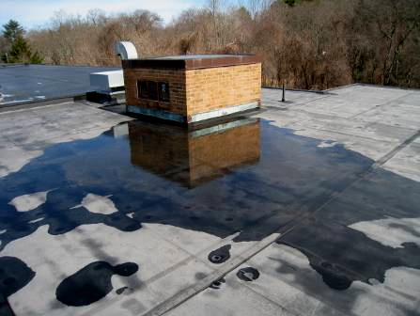

Pooling Water on Roof

Picture 8

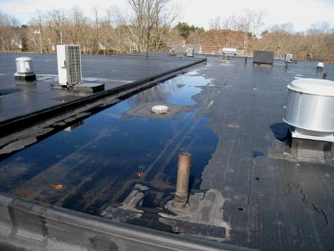

Pooling Water on Roof, Note Roof Drain

Picture 9

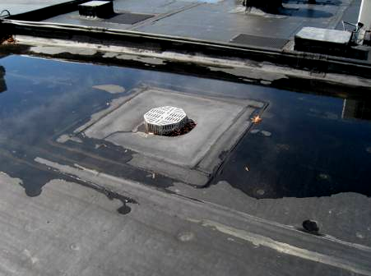

Pooling Water on Roof, Note Dry Membrane around Roof Drain

Picture 10

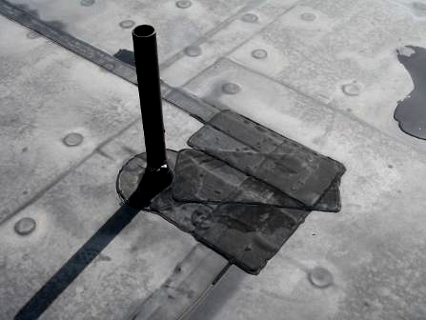

Numerous Roof Patches

Picture 11

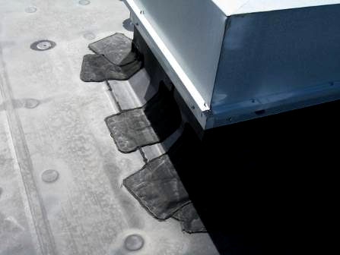

Numerous Roof Patches

Picture 12

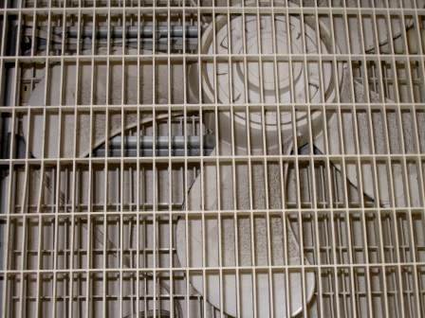

Accumulated Dust and Debris on Personal Fan in Classroom
Location/ Room | Occupants  in Room | Temp  (°F) | Relative  Humidity  (%) | Carbon  Dioxide  (ppm) | Carbon Monoxide  (ppm) | PM2.5  (µg/m3) | Windows  Openable | Ventilation |  | Remarks
 |  |  |  |  |  |  |  | Supply | Exhaust | Remarks
background |  | 51 | 37 | 379 | ND | 9 |  |  |  | Scattered clouds, cool, winds NNE 10-16 MPH, gusts up to 28 MPH, Note: assessment occurred day after many days of heavy rain (~ 10-inches)
Nurse’s Office | 5 | 68 | 32 | 477 | ND | 7 | Y | Y | Y | Condensation of floor reported, recommend dehumidifier for spring/summer months, DO, spaces between sink countertop/backsplash
101 | 5 | 69 | 27 | 417 | ND | 7 | Y | Y | Y | Exhaust vent off, PF-dirty, spaces between sink countertop/backsplash
Langevin | 1 | 70 | 25 | 444 | ND | 6 | Y | M | Y | Exhaust vent off
104 | 28 | 75 | 25 | 585 | ND | 8 | Y | Y | Y | Exhaust vent off, AC Unit, WD window corner, DO
103 | 17 | 72 | 27 | 687 | ND | 7 | Y | Y | Y | Exhaust vent off, items on UV, DO, PF-dirty, spaces between sink countertop/backsplash
105 | 25 | 75 | 27 | 826 | ND | 8 | Y | Y | Y | Exhaust vent off, plant, DO, spaces between sink countertop/backsplash
108 | 26 | 74 | 26 | 768 | ND | 8 | Y | Y | Y | Exhaust vent off, DO, PF
110 | 12 | 75 | 29 | 795 | ND | 8 | Y | Y | Y | Exhaust vent off, DO,TB, AC
111 | 25 | 75 | 24 | 625 | ND | 8 | Y | Y | Y | Exhaust vent off, DO, spaces between sink countertop/backsplash
109 | 23 | 72 | 24 | 564 | ND | 10 | Y | Y | Y | Exhaust vent off, PS
107 | 15 | 72 | 25 | 571 | ND | 9 | Y | Y | Y | Exhaust vent off, CP on sink countertop, 1 WD CT
Computer Lab | 24 | 68 | 25 | 487 | ND | 8 | Y | Y | Y
Library | 0 | 68 | 25 | 415 | ND | 8 | Y | Y | Y
Teacher’s Workroom | 1 | 70 | 27 | 466 | ND | 7 | N | Y | Y | Exhaust vent off, lamination machines, PCs
Faculty Dining Rm | 0 | 70 | 24 | 418 | ND | 8 | Y | Y | Y | DO
Gym | 27 | 70 | 28 | 520 | ND | 8 | Y | Y | Y | DO
2nd Floor
202 | 25 | 70 | 29 | 820 | ND | 10 | Y | Y | Y | Exhaust vent off, pillows/cushions, PF
201 | 28 | 72 | 28 | 738 | ND | 8 | Y | Y | Y | Exhaust vent off, CD, pillows/cushions, PF
203 | 27 | 72 | 29 | 621 | ND | 9 | Y | Y | Y | Exhaust vent off, DO, PF
204 | 22 | 73 | 24 | 563 | ND | 9 | Y | Y | Y | Exhaust vent off, DO, PF-dirty
206 | 1 | 73 | 22 | 485 | ND | 8 | Y | Y | Y | Exhaust vent off, 27 occupants gone 20 mins, DO, PF
207 | 1 | 72 | 23 | 430 | ND | 8 | Y | Y | Y | Exhaust vent off, 28 occupants gone 25 mins, AC
208 | 30 | 71 | 26 | 677 | ND | 10 | Y | Y | Y | Exhaust vent off, PF
210 | 24 | 69 | 25 | 683 | ND | 9 | Y | Y | Y | Exhaust vent off, DO, plants, PF, CP-on sink countertop
211 | 27 | 71 | 37 | 1505 | ND | 8 | Y | Y | Y | Exhaust vent off, items on UV, PF
213 | 10 | 72 | 25 | 509 | ND | 8 | Y | Y | N | Exhaust vent off, plants, AC, PF, AC, DO
212 | 26 | 71 | 27 | 701 | ND | 9 | Y | Y | Y | Exhaust vent off, rotted window/WD, PF, DO
214 | 26 | 71 | 20 | 640 | ND | 10 | Y | Y | Y | Exhaust vent off, DO, PF
Title One | 1 | 71 | 25 | 529 | ND | 6 | Y | Y | Y | TB, DO
Teacher Planning | 2 | 71 | 26 | 506 | ND | 6 | Y | Y | Y | PC, DO
Pupil Support 2 | 10 | 72 | 29 | 660 | ND | 6 | Y | Y | Y | TB, DO, plants, aqua
Cafeteria | ~200 | 70 | 30 | 820 | ND | 10 | N | Y | Y | Could not tell if HVAC on due to height

Actions on MDPH Recommendations, LaLiberte Elementary School,
Raynham, MA

The following is a status report of action(s) taken on MDPH recommendations (in bold) based on reports from school officials, maintenance staff, documents, photographs and MDPH staff observations.
Operate all ventilation systems throughout the building continuously during periods of school occupancy.
Action: All univents and mechanical ventilation systems appeared to be operating during the assessment, with the exception of exhaust vents (see below).
Inspect exhaust motors and belts periodically for proper function. Repair and replace as necessary.
Action: The majority of classroom exhaust vents were not operating during the assessment and are reported to be on a repair list.
Remove all blockages from univents and exhaust vents to ensure adequate airflow.
Action: The majority of classrooms did not have univents and/or exhaust vents obstructed, however more work is needed in this area.
Use openable windows in conjunction with mechanical ventilation to supplement air exchange.
Action: No windows were open during the assessment.
Monitor Room #106 and the Nurse’s Office for leaks, signs of water damage and/or visible mold growth especially during the summer months (as reported by occupants).
Action: No visible mold growth was observed during the assessment. The Nurse’s Office is reported to have condensation issues, therefore the use of a dehumidifier with strict adherence to cleaning/changing filters is recommended during periods of elevated relative humidity (i.e., over 70%).
Store cleaning products properly and out of reach of students. Ensure spray bottles are properly labeled.
Action: The majority of classroom did not have cleaning products in reach of children; however, more work is needed in this area.
Discontinue the use of air fresheners in classrooms and restrooms in order to avoid respiratory irritation from chemicals contained in the products.
Action: No air fresheners were observed to be in use during the assessment.
Relocate or consider reducing the amount of materials stored in classrooms to allow for more thorough cleaning of classrooms. Clean items regularly with a wet cloth or sponge to prevent excessive dust build-up.
Action: Progress has been made but more work is needed in this area.
Change filters for air-handling equipment (e.g., univents, AHUs and ACs) as per the manufacturer’s instructions or more frequently if needed.
Action: Univent filters are reportedly changed four times per year; roof air handling unit (AHU) filters are changed at least once per year, as necessary.

