INCIDENT HIGHLIGHTS
DATE:
March 25, 2018
TIME:
9:00-11:30 a.m.
VICTIM:
54-year-old company owner
INDUSTRY/NAICS CODE:
Construction, Site Preparation Contractor/238910
EMPLOYER:
Land clearing, forest product manufacturing, and landscape supply sales
SAFETY & TRAINING:
Health and safety program, employee training, equipment operator training
SCENE:
Shed at wood processing yard/retail store
LOCATION:
Massachusetts
EVENT TYPE:
Toxic exposure

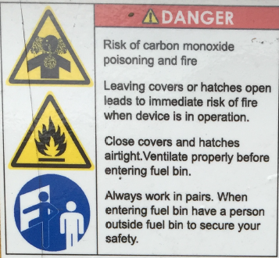

REPORT#: 18MA022 REPORT DATE: 8/13/2021
Land clearing and forest product company owner overcome by carbon monoxide in hopper of wood chip burning boiler—Massachusetts

SUMMARY
On March 25, 2018, a 54-year-old land clearing and forest product company owner was overcome by carbon monoxide (CO) as he was checking on a wood chip powered boiler system. READ THE FULL REPORT> (p.3)

CONTRIBUTING FACTORS
Key contributing factors identified in this investigation include:
- Failure to install and maintain adequate ventilation for a wood burning boiler system;
- Lack of carbon monoxide monitoring equipment in the area of fuel burning equipment; and
- Unidentified confined space. LEARN MORE> (p.7)
______________________________________________________
RECOMMENDATIONS
Massachusetts FACE Program concluded that, to help prevent similar occurrences, employers should:
- Follow manufacturers’ guidance regarding installation and maintenance of wood burning boilers and exhaust systems to ensure that carbon monoxide is removed from buildings;
- Identify confined spaces in work areas and develop, train on, and enforce written work procedures for confined space entry;
- Implement a comprehensive safety and health program that addresses hazard evaluation and avoidance of unsafe conditions, including workplace surveys to identify all potential sources of carbon monoxide, and locations where carbon monoxide may accumulate.
In addition, equipment manufacturers should:
- Adopt and implement the concept of Prevention through Design (PtD) to identify potential hazards associated with equipment and then eliminate these hazards through design changes. LEARN MORE> (p.10)
Fatality Assessment and Control Evaluation (FACE) Program

The Massachusetts Department of Public Health, in cooperation with the National Institute for Occupational Safety and Health (NIOSH), conducts investigations on the causes of work-related fatalities. The goal of this program, known as Massachusetts Fatality Assessment and Control Evaluation (Massachusetts FACE) is to prevent future fatal workplace injuries. Massachusetts FACE aims to achieve this goal by identifying and studying the risk factors that contribute to workplace fatalities, by recommending intervention strategies, and by disseminating prevention information to employers and employees.

NIOSH funded state-based FACE Programs currently include: California, Kentucky, Massachusetts, Michigan, New York, Oregon, and Washington.
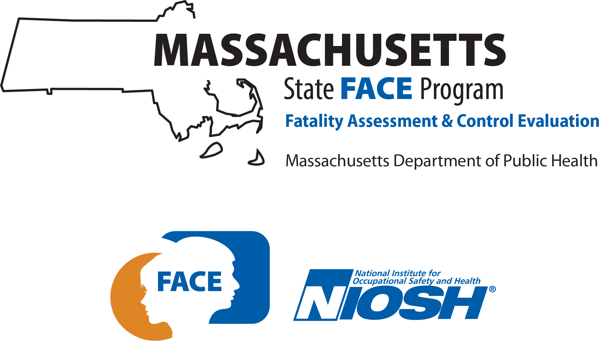

SUMMARY

On March 25, 2018, a 54-year-old owner of a land clearing and forest product company was overcome by carbon monoxide (CO) as he was checking on a wood chip-powered boiler system. He was found unresponsive inside a wood chip fuel hopper that was used to feed the boiler. It was not until another worker was poisoned in the boiler room two weeks later that the CO hazard was recognized at the workplace as a possible cause of the owner’s death.

INTRODUCTION
On Sunday, March 25, 2018, a 54-year-old land clearing and forest product company owner was overcome by carbon monoxide (CO) as he was clearing the flow of fuel into the burner on a wood chip powered boiler system. The death was initially believed to be a heart attack unrelated to CO exposure. On April 8, 2018, another worker at the company experienced CO poisoning while doing similar tasks, emptying ash from the boiler and clearing large wood pieces inside the fuel storage hopper. The Massachusetts FACE Program was alerted by OSHA on April 16, 2018 that the death in March may have been due to CO exposure. On June 27, 2018, the Massachusetts FACE Program investigator traveled to the company to discuss the incident with the wife of the victim, who then owned and operated the company. The police report, death certificate, OSHA records, and other information were reviewed in the course of the investigation.

EMPLOYER
The land clearing and forestry company clears land for construction and development, receives trees removed by other companies and processes trees into bark mulch and chips. The company sells bark mulch, wood chips and additional landscaping materials, and rents out heavy equipment. The company had been founded by the victim about 20 years prior to this fatality and operated five days per week from 7am to 4:30, with additional hours seasonally and attention to the heating system on weekends. At the time of the incident, the company had 20 employees. The workforce consisted of tree cutters and an arborist, machine operators and mechanics, and office staff. The company had workers’ compensation insurance that covered its employees, as required by Massachusetts law. One division of the company was unionized.

WRITTEN SAFETY PROGRAMS and TRAINING
The company had a safety and health program that included a written program describing work tasks, standard procedures, and hazards. The program covered topics that were relevant to land clearing operations such as safety related to chain saws, ladders, rigging, and mobile equipment, electrical line clearance while tree trimming, and occupational noise exposure. Additional topics included hazard communication and personal protective equipment. However, the program did not cover confined spaces, hazards present at the business central location, or necessary job hazard analyses. The company reported that employees were provided training, which did not appear to incorporate the written safety and health program. There were no written records of employee training completion. Some of the workers had received formal equipment training and were licensed, as required by Massachusetts regulations, to operate hoisting machinery and heavy equipment such as forklifts and front-end loaders.

WORKER INFORMATION
The victim was a 54-year-old white male who owned and operated the land clearing and forest product company. He had founded the company 20 years prior to the incident. The victim had academic degrees in forest engineering and civil engineering.

INCIDENT SCENE
The incident occurred in a shed building constructed to house the heating unit, on the property of the forestry company. The shed building was constructed of concrete blocks and wood and was divided into two rooms, one for the boiler and one for the supply pile of wood chips. The boiler side had a personnel door and a roll-up garage door to allow a loader to enter the building. Other buildings on the property included the business office and retail sales main building and an equipment garage. The heating unit had pipes that ran underground to connect to the circulating heating system of the main building. Behind the main building was the section of the property where the trees were processed and where larger equipment was stored outdoors. Adjacent to this site were outdoor landscaping stone storage and drive-up bays that held mulch, wood chips, and other materials for sale.

WEATHER
The weather at the time of the incident was estimated to be around freezing based on available weather history. The weather was not believed to have been a factor in this incident.

EQUIPMENT
The equipment involved in the incident was an electrically controlled solid fuel boiler system (Figures 1 and 2). The unit was purchased from a Finland manufacturer through a distributor in Massachusetts and was installed by the victim himself, 18 months prior to the incident, despite cautions about the need for professional installation. It had been used through almost two winter heating seasons. Prior to installing this unit, the company had used an outdoor furnace that could burn large pieces of waste wood such as stumps, roots, and trunks. Because that unit had trouble burning wet wood and needed to be refueled daily, the owner had worked with the equipment distributor to find a better system.
The unit consisted of a solid fuel fired boiler and a computer-controlled fuel delivery system that monitored the burner status and moved fuel from a five cubic yard fuel hopper using an auger/conveyor (Figure 2). The unit was designed to burn manufactured wood pellets, briquettes, or wood chips of limited dimensions of 10-30 mm (<1.2 inches branchless wood). The employer made wood chips on site by processing trees, which were then used for fuel in the system. The fuel hopper was sized to allow for two days of continuous operation. Reportedly the unit routinely was not able to run unattended for two days, did not provide enough heat to adequately warm the workspace it was installed to heat, and had trouble burning chips that were large, irregularly shaped, or dirty.
According to the manufacturers’ manual the fuel hopper was 7’9” tall and the auger axis was located at the bottom of the hopper. Temperature sensors along the auger and an automated fire suppression system helped to ensure fire did not spread out of the burner and back to the fuel source. The fuel hopper was also sealed tight to help ensure the wood within the bin would not combust.
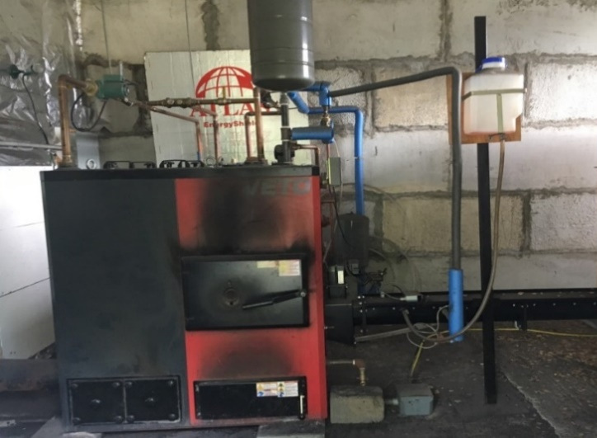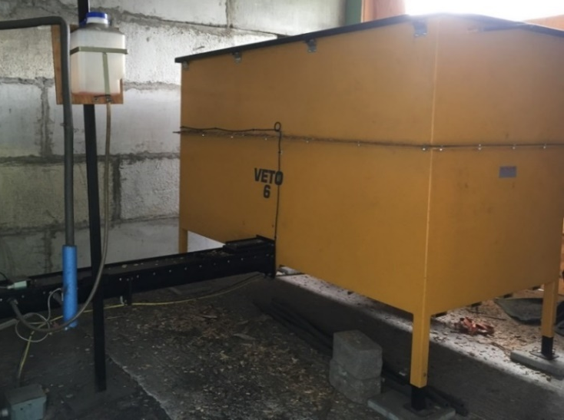
Figure 1 - The boiler/furnace and the auger/conveyor Figure 2 - The hopper and wood chip auger/conveyor
The auger that advanced the wood chips ran from the bottom of the hopper to the burner. Two metal agitators or stirrer disks were mounted on the floor of the hopper and would help the wood chips flow into the trough and be pushed by the auger (Figure 3). The manufacturer’s instruction manual indicates that the fuel hopper should be cleared of possible obstacles weekly and also that these two disks should be removed every six months so debris that accumulates under the disks can be cleared.
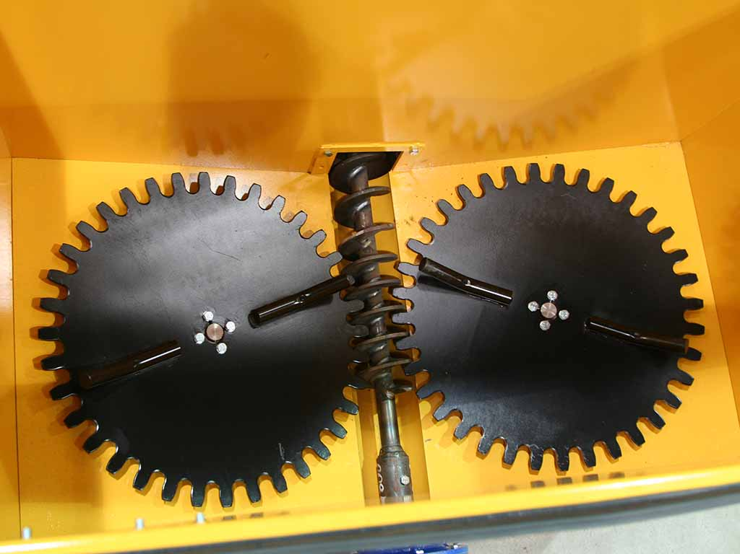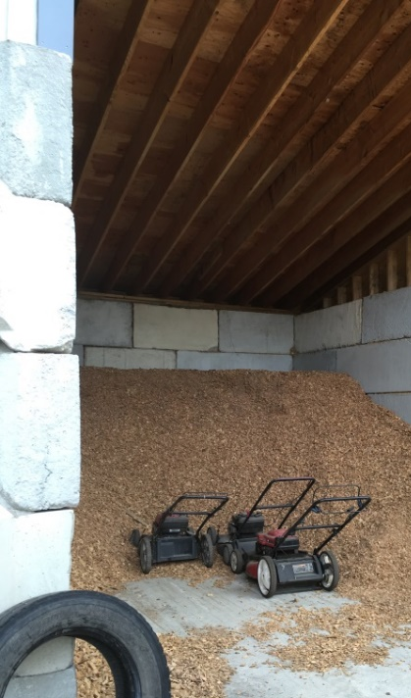
Figure 3 – Agitators on the bottom of the hopper (picture from manufacturer) Figure 4 - Exterior storage area for the wood chips

INVESTIGATION
The incident occurred on a Sunday, which was a day the victim would not regularly have been working at the business, though he reportedly tended to the boiler on weekends. The victim had gone to the site to check on the boiler and reported to his wife that he expected to return in an hour. He drove from his home in an adjacent town at approximately 8:30 a.m. and arrived at the worksite just before 9:00 a.m. This was recorded by surveillance cameras on the property. After about two hours had passed, his wife tried to call him and was unable to reach him by phone. She then went to the worksite to look for him, but when she did not find him there, she returned home. She then called a coworker who had been on the property that morning and the coworker believed the victim had left the property. At approximately 2:30 p.m. the victim’s wife returned to the property and viewed surveillance video that indicated the victim had arrived but not left the property. After looking around the property again and not locating the victim, she left a second time. Coworkers arrived at the site later that afternoon to help look for the victim and ultimately found him inside the hopper. Emergency services were called just before 5:00 p.m.
The victim was found unconscious inside the hopper. He had used a step ladder to enter the top of the hopper. When a coworker came to the shed a second time to look for the victim, he noticed the ladder and checked inside the fuel hopper, discovering the victim unconscious on the bottom, on top of a layer of woodchips, along with a grain shovel the victim had presumably been using. The coworker called to the victim and banged on the hopper to rouse the victim. He immediately called 9-1-1 and by the time paramedics arrived, the victim’s wife had entered the hopper in an attempt to provide aid. Officers and paramedics entered the hopper. Realizing the victim was deceased, responders halted resuscitation efforts and the victim was pronounced dead at the scene. Responders initially believed the victim had suffered a heart attack while working inside the hopper.
An autopsy was performed two days later, concluding that the death was due to acute carbon monoxide poisoning, with a carboxyhemoglobin level of 88%. The CO laboratory result was not received until April 25, 2018 and the autopsy report was not finalized until May 24, 2018, after the second incident (described below).
The burner was out of service for one week for police investigation after the fatality. One week after it was returned to service, on a Sunday, an employee was poisoned by carbon monoxide after spending only 10 minutes servicing the unit. He drove himself home, but had severe symptoms and was transported to a hospital in case he needed hyperbaric oxygen treatment. His carboxyhemoglobin level was 40%. Back calculations from the fatality indicated that the concentration of carbon monoxide in the hopper on March 25 may have exceeded 5,000 parts-per-million (ppm), compared to the OSHA Permissible Exposure Limit of 50 ppm as an 8-hour time weighted average. In the second incident, the employee emptied ash from the boiler and entered the fuel hopper to un-jam irregular or large wood pieces in the auger from the fuel hopper to the furnace. Back calculation from his exposure indicated that he was exposed to a CO concentration of 5,900 ppm in the room and/or in the hopper. Like OSHA’s permissible exposure limits for chemicals, NIOSH has researched and developed a list of chemical airborne concentration levels that are deemed Immediately Dangerous to Life or Health (IDLH). These are concentrations that could result in death, irreversible health effects, or could prevent escape from the contaminated environment within 30 minutes. The IDLH concentration value for CO is 1,200 ppm; the calculated levels in the hopper and room were well above this level. The local fire department was subsequently sent to the business and measured 48 ppm in the room, with the boiler no longer operating.

CAUSE OF DEATH
The medical examiner listed the cause of death as acute carbon monoxide intoxication.

CONTRIBUTING FACTORS
Occupational injuries and fatalities are often the result of several contributing factors or key events in a larger sequence of events that ultimately result in the injury or fatality. The Massachusetts FACE Program identified the following contributing factors in this incident:
- Failure to install and maintain adequate ventilation for a wood burning boiler system;
- Lack of carbon monoxide monitoring equipment in the area of fuel burning equipment;
- Unidentified confined space, indicating failure to conduct hazard identification;
- Unclear, poorly visible warning labels, and inadequate training about carbon monoxide;
- Failure to implement a comprehensive safety and health program, including confined space entry and lockout tagout requirements.

RECOMMENDATIONS/DISCUSSION

Recommendation #1: Employers should recognize carbon monoxide hazards, correctly install and inspect ventilation for wood burning boilers, and train employees about carbon monoxide.
Discussion: Carbon monoxide is an odorless, colorless, tasteless gas that interferes with the delivery of oxygen in the blood to the heart, brain, and other vital organs. It is a byproduct of incomplete combustion of fuels frequently associated with engine exhaust or fuel-burning devices. Carbon monoxide is the most common fatal acute inhalation exposure. It is also a product of the normal breakdown of wood fuel materials such as wood chips.
The wood burning system selected for this company was limited in its capacity, and was installed by the owner, instead by an “authorized professional installer,” as directed in the manual. In practice, the system required emptying ash twice a day, rather than once a week, and entry into the fuel hopper to remove oversized wood pieces, every two to three days, rather than thorough cleaning every six months. The system was too small for the heating desired and was running “harder” than expected. The flue was loose when inspected and the numerous occasions soot was found on the floor may have indicated it was installed incorrectly. The manual advises the connection between the boiler and chimney must be airtight, the combustion chamber must be under-pressured, and chimney sweeping may be necessary. It is possible the flue exhaust was not maintained well, nor operating correctly, and not inspected to ensure it remained open and operational.
According to the installation specifications, the shed building housing the unit was supposed to have a “compensation air hole” sized 1.5 times the chimney size, which would have allowed outside air into the building and apparently was not included in the design of the building.
In addition, wood chips stored in a confined space, such as the fuel hopper, emit carbon dioxide and carbon monoxide which can accumulate and cause asphyxiation due to lower oxygen levels and due to carbon monoxide’s ability to prevent hemoglobin in blood from binding to oxygen. From 2002 to 2016, at least nine fatalities caused by CO poisoning following entry into wood pellet storage areas had been reported in the scientific literature. The wood chips within the five cubic yard fuel hopper itself, could have been a source of CO overexposure, even if the boiler unit was ventilated correctly. The operating manual for the boiler unit and hopper warns of the hazards of carbon monoxide dozens of times and notes repeatedly that CO may accumulate from the boiler and in the fuel bin from the breakdown of wood chips. To prevent the spread of fire, the fuel hopper and delivery system are designed such that they limit the introduction of fresh air into the system. This same design contributes to the buildup of CO in the fuel bin and the creation of oxygen deficient atmospheres. The manual for the system states that the fuel hopper must be “thoroughly ventilated” prior to entry. The manual further warns, “Even then, have a lifeline and a person outside fuel bin to secure your safety before you enter the bin.”
The effects of CO poisoning will depend on the length of exposure, concentration of CO in the air, the breathing rate, and the physical condition of the victim. The health effects of CO vary from mild symptoms, including headache and dizziness, to severe, including loss of consciousness, convulsions, and death. Atmospheres with extremely high concentrations of CO could cause incapacitation very rapidly. Locations that contain fuel burning appliances should have CO monitoring systems, or at a minimum, CO detectors, with audible and visual alarms, installed and operating properly, with capacity to shut off the system.
At the time of the incident, the shed containing the boiler and wood chip hopper did not have a ventilation system or CO monitoring system. A CO monitoring system or detector might have provided warnings about the high concentration of CO and led to an inspection of the sources. Routine testing and maintenance schedules should have been developed and implemented for CO monitoring systems and/or detectors. In this case, a CO monitoring system would have had CO sensors inside the boiler room, a monitor and alarm in an area outside of the boiler room, and a ventilation system that could be activated automatically or by a worker outside of the shed, allowing for safe entry after sufficient fresh air had been introduced.
The heating unit was taken out of operation and the hopper was demolished after the second CO incident.
Recommendation #2: Employers should develop, implement, and enforce a safety program for work in permit-required confined spaces, such as fuel hoppers.
Discussion: A decal on the fuel hopper specifically warned about carbon monoxide hazard and cautioned that work should be done in pairs, but did not specifically label the hopper a confined space. Operation routinely required entry into the hopper to clear jams caused by large wood pieces every two to three days. The manual advised cleaning every six months, removing the agitators/stirrer disks, at the bottom, to remove debris that collects under the gears. A ladder was needed to gain access to the fuel bin which indicated restricted entry and exit.
OSHA (29 CFR 1910.146) defines a confined space as a space that is large enough for employees to enter fully and perform assigned work, but is not designed for continuous occupancy by employees and has limited or restricted means of entry or exit. Confined spaces fall into two categories:
Non-permit confined spaces. Non-permit confined spaces are confined spaces that do not contain or do not have the potential to contain any hazard capable of causing death or serious physical harm.
Permit-required confined spaces. Permit-required confined spaces are confined spaces that have one or more of the following additional characteristics (hazards):
- Contains a material with the potential to engulf someone who enters the space (such as woodchips);
- Has an internal configuration that might cause an entrant to be trapped or asphyxiated by inwardly converging walls or by a floor that slopes downward or tapers to a small cross section;
- Contains or has a potential to contain a hazardous atmosphere; and
- Contains any other recognized serious safety or health hazard.
OSHA requires written procedures for entry into permit-required confined spaces called permit space programs. A permit space program has several requirements, which include but are not limited to:
- Implementing necessary measures to prevent unauthorized entry;
- Establishing and implementing the means, procedures, and practices to eliminate or control hazards necessary for safe permit space entry operations, and allowing only qualified workers to enter the permit space;
- Ensuring that at least one attendant is stationed outside the permit space for the duration of entry operations;
- Implementing appropriate procedures for summoning rescue and emergency services, and preventing unauthorized personnel from attempting rescue;
- Establishing and implementing, in writing, a system for the entry permits; and
- Reviewing established entry operations annually and revising the permit space entry program as necessary.
The fuel hopper was not explicitly labeled as a confined space by the manufacturer or the employer. This may be due to the device being designed and manufactured in Europe. But the warning decals and operator’s manual described hazards and procedures consistent with confined spaces. The user manual for the boiler unit and hopper indicates that two workers should always be present when the hopper is entered for service. The label cautions that there is a risk of carbon monoxide poisoning and that work should be performed in pairs. In this situation, the victim had entered alone, using a ladder to access the interior of the fuel hopper because it had a wall height nearly eight feet off the floor, demonstrating restricted entry and exit. Also, the fuel hopper posed a risk of engulfment from the loose wood chips and a risk of a hazardous atmosphere (carbon monoxide), meeting the definition of a permit-required confined space. The employer should have recognized these hazards as meaning the hopper was a confined space, and thus developed a written permit confined space program, informed employees, and provided training. In addition, the employer should have posted a permit-required confined space sign on the hopper. Untrained rescuers are also at risk of being overcome by a hazardous atmosphere while trying to aide or rescue an affected person. The presence of permit-required confined space should include notification of all employees regarding the risks of unprepared rescue.

Recommendation #3: Employers should provide clearly visible warning labels on equipment and make sure training covers hazards of confined space entry and carbon monoxide poisoning.
Discussion: OSHA recommends posting a warning sign, “DANGER – PERMIT-REQUIRED CONFINED SPACE, DO NOT ENTER.” The colors and symbols should conform to the U.S. standard ANSI Z535 which describes colors and graphic symbols to communicate hazards. The equipment was manufactured in Finland, and warning labels were present on both the boiler and the hopper, consistent with the international ISO 3864 symbols. The label on the boiler included more than a dozen warnings that were partially obscured by the auger/conveyor connection. The label distinguished between red banner danger and orange banner warnings. Despite the labels, the hazards posed by this equipment were underestimated. The listed dangers included the risks of CO, fire, high voltage and the need to work in pairs, and also highlighted closing covers for fire prevention and ventilating before entering the fuel hopper. The remaining warnings included three cautions about rotating and moving parts (blower impeller, feeding screws, and springs in the burner and fuel bin) that can crush and cut, the need to shut off the device before servicing, the risk of the lid suddenly shutting, health effects of inhaling dust particles, risk of burns and fire, waiting periods after shut-off for electrical and heat purposes and the need to read the manual prior to operating. Some of the cautions are incomplete and appear to be in contradiction with each other. This hazardous heating system required ash removal from the boiler twice daily and entry into the fuel hopper to clear wood pieces every two to three days. There were no detailed standard operating procedures developed for work with this equipment. There was no warning that specifically labeled the hopper a permit required confined space. The multiple warnings were confusing in their detail and did not provide guidance about the correct methods to use.
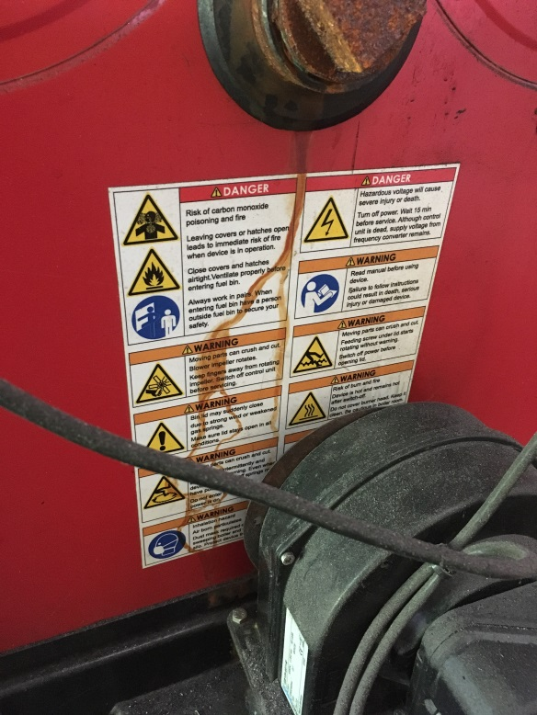
Figure 5 - Warning decal on the boiler/furnace and image of warnings listed on the decal on the boiler and on the hopper.
Employers should familiarize themselves thoroughly with the operation and cautions necessary for the use of equipment. They should provide training to staff that describes the sources and conditions that may result in CO poisoning, such as the possibility of excessive CO levels occurring inside boiler rooms or fuel hoppers. Also, training should address CO associated health effects, and emergency response procedures for toxic atmospheres. In this case, the training provided by the employer did not include information about the hazards of CO. If the employees had training that included CO, they might have recognized the risk and/or indications that they were being exposed to excessive CO levels.

Recommendation #4: Employers should develop and implement a comprehensive safety and health program that addresses hazard recognition and avoidance of unsafe conditions.
Discussion: Having a safety and health program is an important part of maintaining a safe and healthful workplace. A safety and health program should include the systematic identification, evaluation, and prevention or control of both general workplace hazards and the hazards of specific jobs and tasks. The core elements of an effective safety and health program are management leadership, worker participation, hazard identification and assessment, hazard prevention and control, education and training, and program evaluation and improvement. The program should outline safe work practices that are enforced, specific safety protection for each task, methods to identify and avoid hazards, and procedures for reporting safety and health questions or issues. The program should also include an explanation of workers’ rights to protection in the workplace.
When developing a safety and health program, employers should start by performing a hazard analysis of all routine tasks performed by employees for potential hazards and incorporate information about any identified hazards and their controls into the program. When determining potential hazards associated with equipment, information in the manufacturer operator’s manual and on the equipment’s warning labels should be reviewed and incorporated into the safety and health program procedures.
Employers should also use their employees’ expertise throughout the program development process by seeking employee input. Once the program is developed, employers should continue to seek employees’ input during the routine updating of the program. The program should be updated when safety concerns arise and when new equipment, tasks and chemicals are introduced into the workplace. In addition, for situations where work sites change with each job, the safety and health program should also require that a job safety analysis be performed for each job site before work begins to ensure that the required tools and personal protective equipment (PPE) needed to complete the tasks are available.
Employers should ensure that they have fully and effectively implemented their safety and health program by routinely performing assessments of tasks and immediately addressing any observed unsafe conditions. As part of the program’s implementation, training should be provided to all employees on the program’s topics and procedures and include hazard recognition and avoidance of unsafe conditions. All training provided to employees should be documented. In this case, the safety and health program should have included a section on proper procedures for servicing the boiler unit. While the company had a written health and safety program, it did not address carbon monoxide, the boiler and fuel hopper, fire, electrical or burn hazards, or lockout tagout programs or procedures.
The Massachusetts Department of Labor Standards (DLS) offers free consultation services to help small employers improve their safety and health programs, identify hazards, and train employees. DLS can be contacted at 978-242-1351. More information about DLS can be found on their website at www.mass.gov/dos/consult.
The Massachusetts Department of Industrial Accidents (DIA) has grants available for providing workplace health and safety training to employers and employees. Any company covered by the Massachusetts Workers’ Compensation Insurance Law is eligible to apply for these grants. More information about these DIA grants can be found on their website at www.mass.gov/dia/safety.
Recommendation #5: Equipment manufacturers should adopt and implement the concept of Prevention through Design (PtD) to identify potential hazards associated with equipment and then eliminate these hazards through design changes.
Discussion: Prevention through Design (PtD), as it would relate to equipment manufacturers, involves addressing occupational safety and health needs during the design process to eliminate or minimize injury. PtD initiates thinking about how the equipment functions in relation to individuals that would come in contact or interact with the equipment in order to identify potential hazards. Once hazards are identified, the equipment can be designed to eliminate or control these hazards.

In this case, the manufacturer was aware of the hazard of carbon monoxide accumulation in the hopper and included multiple warnings about the hazard in the user manual and on the hazard decals on both the boiler and fuel hopper. Further implementation of PtD concepts by the manufacturer may have built in local exhaust ventilation and/or air quality monitoring within the hopper that could provide protection to the users of the equipment. An operating carbon monoxide detector on the unit may have prevented this death. The additional safeguard of a detector that could activate a local ventilation system would be even more effective.
As discussed in Recommendation 2, the hopper met the definition of a confined space because of several hazardous attributes. Even with the addition of an active ventilation system, it would be important for the manufacturer and importer to ensure that the labeling and documentation distributed with the equipment in the U.S. market appropriately identifies the confined space hazard.

DISCLAIMER

Mention of any company or product does not constitute endorsement by the National Institute for Occupational Safety and Health (NIOSH). In addition, citations to websites external to NIOSH do not constitute NIOSH endorsement of the sponsoring organizations or their programs or products. Furthermore, NIOSH is not responsible for the content of these websites. All web addresses referenced in this document were accessible as of the publication date.

REFERENCES

Weather Underground. Weather History. Massachusetts: TWC Product and Technology LLC.
OSHA. Permissible Exposure Limits. https://www.osha.gov/annotated-pels
NIOSH. Immediately Dangerous To Life or Health (IDLH) Values. https://www.cdc.gov/niosh/idlh/default.html
DOL. OSHA. Fact Sheet: Carbon Monoxide Poisoning https://www.osha.gov/OshDoc/data_General_Facts/carbonmonoxide-factsheet.pdf OSHA's Carbon Monoxide Poisoning Quick Cards (in English and Spanish). https://www.osha.gov/OshDoc/data_Hurricane_Facts/carbon_monoxide.pdf https://www.osha.gov/OshDoc/data_Hurricane_Facts/carbon_monoxide_sp.pdf Environmental Protection Agency, Carbon Monoxide's Impact on Indoor Air Quality https://www.epa.gov/indoor-air-quality-iaq/carbon-monoxides-impact-indoor-air-quality
New York Department of Health. Carbon Monoxide Hazards from Wood Pellet Storage https://www.health.ny.gov/environmental/emergency/weather/carbon_monoxide/docs/pellets.pdfLydia Soto-Garcia, Xinrui Huang, Devraj Thimmaiah, Alan Rossner, and Philip K. Hopke. Exposures to Carbon Monoxide from Off-Gassing of Bulk Stored Wood Pellets. Energy & Fuels 2015 29 (1), 218-226 https://pubs.acs.org/doi/full/10.1021/ef5021186 Simpson AT, Hemingway MA, Seymour C. Dangerous (toxic) atmospheres in UK wood pellet and wood chip fuel storage. J Occup Environ Hyg. 2016 Sep;13(9):699-707. https://www.tandfonline.com/doi/full/10.1080/15459624.2016.1167279 Krigstin S, Wetzel S, Jayabala N et al. Recent health and safety incident trends related to the storage of woody biomass: A need for improved monitoring strategies. Forests 2018;9:538 https://www.mdpi.com/1999-4907/9/9/538 Henn SA, Bell JL, Sussell AL, Konda S. Occupational Carbon Monoxide Fatalities in the US From Unintentional Non-Fire Related Exposures, 1992–2008. Am J Ind Med 2013; 56(11):1280-89. https://www.ncbi.nlm.nih.gov/pmc/articles/PMC4552320/pdf/nihms717923.pdf Konradt K. Diminishing Occupational Unintentional Non-Fire-Related Carbon Monoxide Poisoning: A Qualitative Multiple Case Study, February 2020 https://search.proquest.com/openview/a6f2a949ad14e2f52fa8b6f57a32a670/1?pq-origsite=gscholar&cbl=2026366&diss=y
Occupational Safety and Health Administration topic page: Confined Spaces https://www.osha.gov/SLTC/confinedspaces/index.html Code of Federal Regulations. 29 CFR 1910.146. Permit-required Confined Spaces. Available from https://www.osha.gov/laws-regs/regulations/standardnumber/1910/1910.146 Permit-required confined spaces, Quick Card. Occupational Safety and Health Administration (OSHA) Publication No. 3214-09R-11. Available at https://www.osha.gov/Publications/3214-10N-05-english-06-27-2007.html.
7 OSHA. Recommended Practices for Safety and Health Programs. OSHA 3885. 2016. www.osha.gov/shpguidelines/
8 OSHA. Job Hazard Analysis. Publication Number: 3071. www.osha.gov/Publications/osha3071.pdf. Date accessed: June 3, 2013.
9 National Institute for Occupational Safety and Health, Workplace Safety & Health Topics, Prevention Through Design. www.cdc.gov/niosh/topics/ptd

