INCIDENT HIGHLIGHTS
DATE:
January 18, 2018
TIME:
8:30 a.m.
VICTIM:
27-year-old landscape construction laborer
INDUSTRY/NAICS CODE:
Construction, Site Preparation Contractor/238910
EMPLOYER:
Landscape construction contractor
SAFETY & TRAINING:
Employer provided PPE and on-the-job training
SCENE:
Residential construction site, basement excavation
LOCATION:
Massachusetts
EVENT TYPE:
Crushing

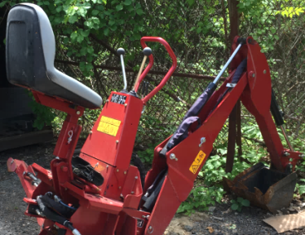

REPORT#: 18MA001 REPORT DATE: May 7, 2020
Landscape Construction Laborer Compressed between Compact Excavator and Steel Beam at Residential Site—Massachusetts

SUMMARY
On January 18, 2018, a 27-year-old laborer was killed while operating a compact excavator. He was using the compact backhoe type excavator underneath a home when he became pinned between the excavator and an overhead beam.
READ THE FULL REPORT> (p.3)

CONTRIBUTING FACTORS
Key contributing factors identified in this investigation include:
- Operating the excavator near overhead obstructions;
- Absence of a protective cab on the excavator;
- Lack of a comprehensive safety and health program; and
- Working alone. LEARN MORE> (p. 8)
______________________________________________________
RECOMMENDATIONS
The Massachusetts FACE Program concluded that, to help prevent similar occurrences, employers should:
- Ensure that only workers with required training and license are permitted to operate compact excavators and other regulated equipment.
- Ensure that ride-on equipment without a protective cab are not operated in the vicinity of overhead obstructions.
- Develop, implement, and enforce a policy that prevents employees from working alone in certain situations.
- Ensure that a job hazard analysis is performed prior to the start of each project and updated if there is a major change in the scope of the project.
- Develop and implement a comprehensive safety and health program that addresses hazard recognition, avoidance of unsafe conditions, and proper use of equipment.
In addition, equipment manufacturers should:
- Adopt and implement the concept of Prevention through Design (PtD) to identify potential hazards associated with equipment and then eliminate these hazards through design changes. LEARN MORE> (p.8)
Fatality Assessment and Control Evaluation (FACE) Program

The Massachusetts Department of Public Health, in cooperation with the National Institute for Occupational Safety and Health (NIOSH), conducts investigations on the causes of work-related fatalities. The goal of this program, known as Massachusetts Fatality Assessment and Control Evaluation (Massachusetts FACE) is to prevent future fatal workplace injuries. Massachusetts FACE aims to achieve this goal by identifying and studying the risk factors that contribute to workplace fatalities, by recommending intervention strategies, and by disseminating prevention information to employers and employees.

NIOSH funded state-based FACE Programs currently include: California, Kentucky, Massachusetts, Michigan, New York, Oregon, and Washington.

SUMMARY
On January 18, 2018, a 27-year-old laborer was killed while operating a compact excavator. He was using the equipment to excavate the existing crawlspace underneath a home to make space for a poured concrete foundation and a full basement. While operating the compact excavator, he became pinned between the excavator and an overhead beam. The victim was eventually discovered by the company owner. The company owner flagged down a passing motorist and a call was placed for emergency medical services (EMS). The victim was pronounced at the scene.

INTRODUCTION
A laborer for a landscape construction company was fatally injured when he became pinned between an overhead beam and the compact excavator he was operating at a residential construction site. The Massachusetts FACE Program learned of the incident from the local news media. On May 30, 2018, representatives from the Massachusetts FACE Program traveled to the home of the company owner to discuss the incident and then to the residential construction site where the incident took place. FACE staff also visited the rental company that had supplied the excavator to view the excavator and speak to a rental company representative who had responded on the day of the incident. The police report, fire/EMS records, death certificate, workers’ compensation records, OSHA records, and other information were reviewed in the course of the investigation.

EMPLOYER
The employer is a landscape construction contractor that had been in business for 35 years. The company had one owner and three employees at the time of the incident. The workforce consisted of laborers, equipment operators, and commercial truck drivers. The company specialized in irrigation system installation and maintenance and hardscape construction with natural and cut stone to make landscape areas, walls, patios, and steps. They also did excavation and site preparation for foundations and septic systems. The company provided contracted seasonal snow plowing and snow removal and had a winter season high of 12 employees. Because of the nature of the business and the role of weather in completing certain tasks, the daily work schedule fluctuated. In general, workers were expected to check-in at the company’s main location where the equipment was stored before 8:00 a.m., and then proceed to the day’s work site. The company had workers’ compensation insurance that covered its employees, as required by Massachusetts law. Employees did not have union representation.

WRITTEN SAFETY PROGRAMS and TRAINING
At the time of the incident, the company did not have a comprehensive safety and health program. Workers were provided some basic training and on-the-job equipment training, including supervised operation of the company vehicles and equipment at the company’s storage yard. Workers were encouraged to take courses in order to become licensed to operate dump trucks (commercial driver’s license) or excavation equipment (engineer or hoisting license). Obtaining these licenses could lead to a pay increase. The victim had reportedly taken a safety course related to hoisting equipment that was offered by a regional landscaping trade group, but had yet to take the state licensing exam. Workers were provided with personal protective equipment (PPE), including gloves, hearing and eye protection, and high visibility safety apparel.

WORKER INFORMATION
The victim was a 27-year-old male who had been employed as a laborer by the company for approximately eight months. He had a background in construction and automotive mechanics, and experience operating forklifts and loaders for other companies.

INCIDENT SCENE
The incident occurred at a home that was located in a residential area (Figure 1). The home was built in the early 1920’s and was a two-story, wood-framed building with a wraparound porch on a 0.31 acre lot. The lot was sloped and the home was built on top of stone present in the hillside and on stone columns. At the time of the incident, the home was a seasonal residence and was being renovated to add a poured concrete foundation and a full basement. The work was overseen by a general contractor that had subcontracted to the victim’s employer the task of excavating the basement. This was the first time the victim’s company had worked for this general contractor. The initial plan was to excavate the area underneath the house in order to add a foundation of four-foot frost walls with footers and a crawlspace. The design was later changed to add a full basement with standing-height clearance. This resulted in additional excavation. In order to perform the additional excavation, the home was shored by another subcontractor to prevent it from shifting off of the stone columns. The home was supported on several steel I-beams that were supported by two steel cross beams and wood cribbing (Figure 2).

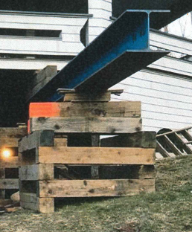
Figure 1 - View of home, facing uphill, before work began Figure 2- Steel support beam and cribbing

WEATHER
The weather at the time of the incident was approximately 20 degrees Fahrenheit with clear skies and accumulated snow on the ground.¹ The weather is believed to have been a factor in this incident. The cold affected the timing at the start of the work day and delayed the arrival of other workers to the site that morning because one of the work vehicles would not start. One result of this delay is the victim was at the site alone.

EQUIPMENT
The equipment being used at the time of the incident was a compact excavator, which are sometimes referred to as mini-excavators. The excavator was used to scrape and loosen dirt and rocks under the home. The unit was rented from a regional equipment rental company that specialized in compact construction equipment and tool rental. This was the first rental of this particular excavator by the victim’s employer. It was delivered to the job site by the rental company.
The excavator consisted of a compact utility loader base power unit with an excavator (backhoe) attachment. The base unit had a gasoline engine that powered four drive wheels and attachments through a hydraulic system that had a maximum pressure of 3,250 psi (Figure 3). At the rear of the base unit was an operator standing platform with controls for driving and operating various attachments. The unit had a maximum ground speed of 4.5 mph in forward or reverse. The base unit was designed to receive a number of different attachments such as a bucket loader, auger, ditch digger, stump grinder, and the backhoe involved in this incident. These attachments, except for the backhoe, were operated using the main control levers on the base unit while the operator was standing.
The backhoe attachment mounted on the front of the base unit and tapped into the hydraulic system. It had an operator’s seat and a separate set of controls for operating the stabilizers and excavation boom, dipperstick, and bucket (Figure 4). When the backhoe attachment was installed, the unit was driven into position using the rear controls and then the user would set the engine speed, divert hydraulic flow to the accessory hoses, and install an interlocking cover over the drive controls. This would enable the second set of controls near the backhoe operator’s seat. The backhoe attachment was designed without a protective cab for the operator.
With the backhoe attachment installed and in a retracted position, the unit was approximately 100” long and 40” wide. When the stabilizers were deployed to their farthest point the unit was 78” wide. The base unit was 49” high and the height of the adjustable seat pan was around 46” at the time of the incident. The backhoe boom could swing 180 degrees and had a maximum digging depth or reach of 82”. When the backhoe attachment and the base unit are connected, they weigh about 2,200 pounds.
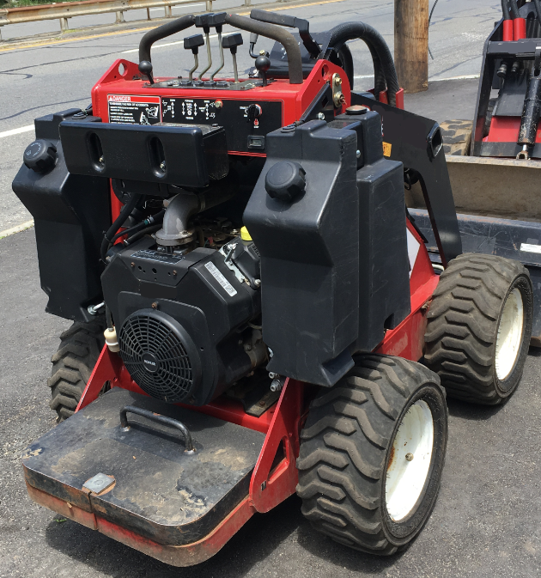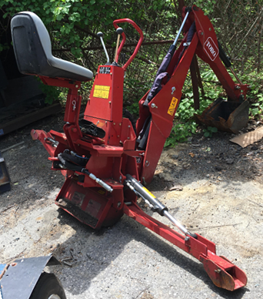
Figure 3 - Base power unit Figure 4 - Excavator (backhoe) attachment involved in the incident

The excavator had four control levers mounted on a pillar in front of the operator’s seat. Two smaller levers controlled the stabilizers and were activated by either pushing in a forward direction to deploy the stabilizer or pulling in a backward direction to stow the stabilizer. When the stabilizers were in use, the front wheels of the base unit would raise off the ground. Two larger levers controlled the three components of the backhoe attachment: the boom, dipperstick, and bucket. The left lever controlled the swing of the boom: by moving the lever to the left or right the boom would swing to the left or right. The left lever also controlled the extension of the boom. The boom was raised by pulling back on this lever, and was lowered by pushing on the lever. The right lever controlled the scooping motion of the bucket with a left/right push, and the extension and flexion of the dipperstick with a forward/backward push (Figure 5). These control levers were partly protected by a guard made of steel tubing that wrapped in front of and over the two larger control levers (Figure 6).
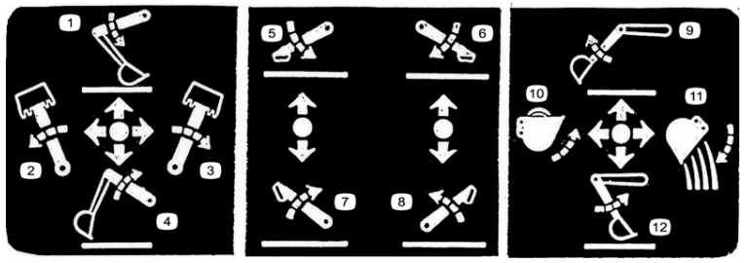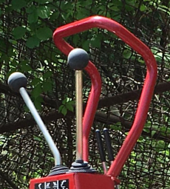
Figure 5 - Decal image of control functions Figure 6 - Excavator controls
The equipment had many warning decals that included simple messaging about stability and tipping hazards, how to lock the excavator boom in position for transport, pinch points on the machine, buried utilities, and overhead electrical hazards. The manufacturer-developed operator’s manual described each of these hazards in simple terms alongside the decal images. The manual was stored in a protective case on the unit and was available to the operators.

INVESTIGATION
The company had been working at the residential construction site for several weeks. While the job initially had been to excavate enough material for a four-foot frost wall foundation, the plan changed and the new task was to make enough space for a full-height basement. The company had started on the downhill side of the building, the front of the house, and had removed soil and boulders from under most of the home. The excavator was used to scrape and loosen dirt and rocks under the home. A skid steer loader owned by the company was then used to remove the loose material. The earth under the home consisted of soil, rocks, and boulders. It was reported that there were a lot of large rocks that had to be broken up before they could be removed from underneath the house. Special equipment was used to drill and break up the boulders for removal. Much of the fill was trucked away using the company’s dump truck. On the day of the incident, it was possible to walk under the excavated portion of the home and walk under the support beams.
The victim arrived at the worksite at around 8:00 a.m., after being instructed by the owner to start the day’s work by warming up the machines and the work space. Two kerosene blow heaters were used to heat the workspace underneath the house; this is also where the excavator and skid steer were stored. The work area under the home had been partially sealed with plastic sheeting to keep the weather out. The space was reportedly ventilated with fans and had enough gaps in the plastic sheeting to provide sufficient ventilation of fumes from the kerosene heaters and gasoline-powered equipment. A carbon monoxide detector was also reportedly present in the space. The company owner and another worker were due to arrive at the worksite shortly after 8:00 a.m., with the company dump truck and the company pickup truck, which had some of the tools and PPE. The work for this day was to continue excavating the corner of the house farthest from the road, where the largest amount of material needed to be removed from the hill under the home. The cold weather caused an issue with starting the dump truck and the owner and co-worker were delayed in arriving at the worksite. In the meantime, after warming up the work area and the equipment, the victim started to use the excavator to continue loosening material under the home.
As described previously, the home was shored on steel beams that were supported on two cross beams and cribbing. It appears that after warming up the area and the equipment, the victim had positioned the excavator, partially underneath one of the beams and lowered the left and right stabilizers. The excavator was perpendicular to the overhead beam, but the beam was likely out of the forward view of the victim as he sat in the operator’s seat.
The victim was working alone at the time of the incident, but evidence indicates that the victim was operating the excavator when his body made contact with the overhead steel beam. This contact would have pushed him forward in the operator’s seat such that he could not move out of the way of the controls and the guard and he became trapped. The boom and bucket were found in an extended position, which suggests the left main control lever was forced in the forward direction after coming in contact with the beam (Figure 7). Having the left main control lever continuously engaged would have caused the boom to extend or move in a downward direction, lifting the front of the unit and the stabilizers off the ground. This continuous pressure was compressing the victim’s back and neck against the beam and the front of the victim against the top of the unit. Because the hydraulic system was still trying to move the boom, which could not move any further, the system started to leak hydraulic fluid onto the ground.
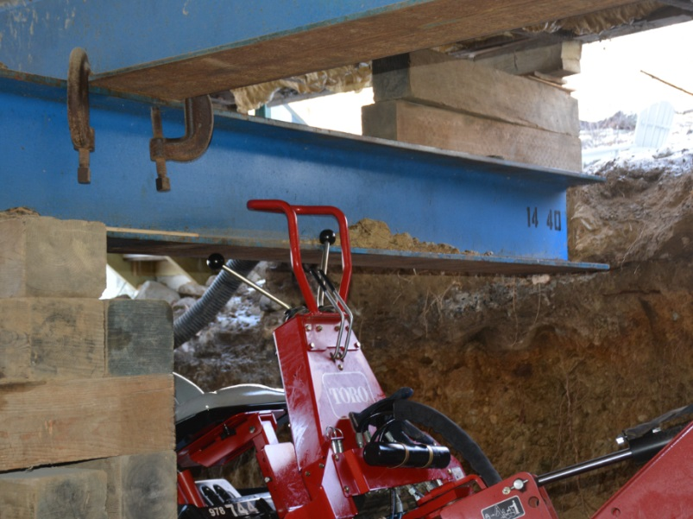
Figure 7 – The excavator’s left control lever against the overhead beam
After getting the dump truck started, the company owner arrived at the scene at approximately 9:30 a.m. and a co-worker arrived shortly after the owner in a pickup truck. Once on site, the company owner saw hydraulic fluid on the ground and found the victim pinned between the excavator and the beam. The excavator motor was still running but because the hydraulic system had lost pressure, the owner was unable to make the controls move the components to free the victim. He tried to physically shift the machine, but could not. The owner then tried to perform cardiopulmonary resuscitation (CPR) while the victim was still pinned but this attempt to perform CPR was unsuccessful. He attempted to call for emergency medical services but there was poor cellular signal in the area, so he was not able to complete a call. The co-worker then ran to the road and was able to flag down a passing motorist for help and multiple calls were then placed to 911. The owner and co-worker took tools from the truck and started to try to move the machine and then cut hoses and disassemble parts of the machine in order to relieve pressure on the hydraulic system or move the excavator arm. Police and then rescue personnel from the fire department arrived at the scene. Responders were ultimately able to free the victim from the machine and the victim was pronounced dead.

CAUSE OF DEATH
The medical examiner listed the cause of death as asphyxia due to compression of neck and chest.

CONTRIBUTING FACTORS
Occupational injuries and fatalities are often the result of one or more contributing factors or key events in a larger sequence of events that ultimately result in the injury or fatality. The Massachusetts FACE Program identified the following contributing factors in this incident:
- Operating the excavator near overhead obstructions;
- Absence of a protective cab on the excavator;
- Lack of a comprehensive safety and health program; and
- Working alone.

RECOMMENDATIONS/DISCUSSION
Recommendation #1: Employers should ensure that only workers with required training and license are permitted to operate compact excavators and other regulated equipment.
Discussion: In Massachusetts the operators of compact excavators, which includes the excavator involved in this incident, are required to obtain a specific operator’s license issued by the Office of Public Safety and Inspections.² Obtaining a license to operate hoisting machinery, (excavation equipment is officially included under the category of hoisting machinery), requires training and passing a written or practical examination. Alternatively, a short-term permit may be obtained in order to operate just compact equipment. This temporary permit allows the holder to operate compact equipment for up to 14 days and facilitates the use of rental equipment. This permit is issued after completing an approved training provided by an authorized trainer.
In this case the equipment was rented to the owner of the company who held a license to operate excavators. While the rental company was authorized to issue temporary permits, such a permit was not sought for the laborer. The employer should have ensured the victim had the appropriate license before allowing use of the equipment. The employer knew the victim had attended a hoisting equipment training course and had not yet taken the licensing exam.
Recommendation #2: Employers should ensure that ride-on equipment without a protective cab is not operated in the vicinity of overhead obstructions.
Discussion: The small size and maneuverability of the compact utility loader along with the multiple attachment options make it a versatile piece of equipment. It is the compact size and maneuverability that enables this equipment to fit into small spaces. But the absence of a protective cab and operating this piece of equipment with the backhoe attachment in proximity to an overhead obstruction are factors that contributed to this incident.
When deploying the outriggers or, even as in this case, when digging with the backhoe attachment the entire loader can raise, including raising the operator in the loader’s seat. Employers should ensure that ride-on equipment that does not have overhead protection is not operated in areas with low ceiling clearance or other overhead obstructions. Additionally, the knowledge of this type of hazard could be made more prominent in the warning decals and training materials for the equipment (discussed further in Recommendation 5).
Recommendation #3: Employers should develop, implement, and enforce a policy that prevents employees from working alone in certain situations.
Discussion: Not all tasks rise to the level of ensuring that workers are not working alone, but some situations do. If the task involves a location away from other workers where larger equipment will be operated, especially when the operator is riding on the equipment, it is a good idea to have at least two employees working together. Companies should consider developing policies that prevent workers from performing these types of tasks alone.³
At the time of the incident, the victim was alone at the site due to the company owner and co-worker being delayed. A policy that prohibits employees from operating ride-on equipment when working alone might have resulted in the victim waiting until another employee was at the work site before operating the excavator. The policy should include other potentially hazardous tasks that should not be performed alone, such as entering confined spaces or using ladders.
Ensuring employees are not working alone can increase the chance that help would be summoned as quickly as possible by the second worker if an incident was to occur. In this case, because the cause of death was mechanical asphyxia by compression, if a co-worker was present with the victim, this co-worker might have been able to quickly assist the victim. The co-worker could have used the controls to lower the excavator from the overhead steel beam, freeing the victim and potentially stopping the asphyxia. Then the co-worker could have placed a call to emergency medical services, resulting in quick medical attention.
Recommendation #4: Employers should ensure that a job hazard analysis is performed prior to the start of each project and updated if there is a major change in the scope of the project.
Discussion: A job hazard analysis (JHA) is a technique to systematically evaluate job tasks to ensure they are performed safely. It involves identifying potential hazards and hazardous situations that could occur when performing tasks by focusing on the relationship between the worker, the task, the tools, and the work environment.⁴ The analysis should be routinely performed to identify uncontrolled and potential hazards. The JHA should begin by breaking down the tasks to be performed into steps, including the selection and operation of any equipment and the use of tools to complete the task. Each step should be evaluated to identify the hazards or potential hazards and the best equipment and tools to be used to safely complete the task. Information in the manufacturer operator’s manual and on the equipment’s warning labels should be reviewed. Once hazards are identified, employers should take steps to eliminate or control these hazards, such as selecting different equipment and tools or the proper personal protective equipment. It is important to have employees participate in the JHA.
In this case, an initial JHA should have been performed before work began on the project. When the scope of the project changed to be a full foundation with a basement, the JHA would have been updated to include the new and additional work. The updated JHA could have identified the potential hazards and unsafe conditions involved with operating the excavator in proximity to the overhead beams. The JHA could have prompted the selection of different equipment to loosen the soil or jacking up the house higher to gain more overhead space.
Recommendation #5: Employers should develop and implement a comprehensive safety and health program that addresses hazard recognition, avoidance of unsafe conditions, and proper use of equipment.
Discussion: Having a safety and health program is an important part of keeping employees safe. A safety and health program should include the systematic identification, evaluation, and prevention or control of both general workplace hazards and the hazards of specific jobs and tasks. The core elements of an effective safety and health program are management leadership, worker participation, hazard identification, and assessment, hazard prevention and control, education and training, and program evaluation and improvement.⁵ The program should outline safe work practices workers are expected to adhere to, specific safety protection for all tasks workers perform, how workers can identify and avoid hazards, and who workers should contact when safety and health issues or questions arise. The program should also include an explanation of the workers’ rights to protection in the workplace.
When developing a safety and health program, employers could start by performing a job hazard analysis (Recommendation #4) of tasks routinely performed by employees. This would identify potential hazards and controls and that information would be incorporated into the comprehensive program.⁴ Employers should also use their employees’ expertise throughout the program development process, and eventually during the updating process, by seeking employee input. Once the program is developed, employers should ensure that they have fully and effectively implemented their safety and health program by routinely performing assessments of tasks and immediately addressing any observed unsafe conditions. The program should also be updated when safety concerns arise and when new equipment, tasks and chemicals are introduced into the workplace.
Routine training should be provided to all employees on the program’s topics and procedures, and should also include hazard recognition and the avoidance of unsafe conditions. All training provided to employees should be documented. Training ensures that workers know how to safely perform required job tasks. Trainings should be performed by a competent person, which is defined by OSHA as “one who is capable of identifying existing and predictable hazards in the surroundings or working conditions which are unsanitary, hazardous, or dangerous to employees, and who has authorization to take prompt corrective measures to eliminate them.” Any training needs to be provided in the employee’s preferred language. This means the training must be provided in the language(s) and at the literacy level(s) of the employees.
Proper use of this equipment also includes formal testing and obtaining a Massachusetts hoisting license. When rental equipment is used, some rental companies are authorized to conduct training and issue temporary operator permits. In this case, the equipment rental company did have licensed operators that were authorized to train workers that rent the equipment. The victim did not receive this training or a temporary permit from the rental company and should not have been using the equipment. The company owner did have the appropriate licenses to rent and operate the equipment.
The Massachusetts Department of Labor Standards (DLS) offers free consultation services to help small employers improve their safety and health programs, identify hazards, and train employees. DLS can be contacted at 508-616-0461. More information about DLS can be found on their website at www.mass.gov/dos/consult.
The Massachusetts Department of Industrial Accidents (DIA) has grants available for providing workplace health and safety training to employers and employees. Any company covered by the Massachusetts Workers’ Compensation Insurance Law is eligible to apply for these grants. More information about these DIA grants can be found on their website at www.mass.gov/dia/safety.
Recommendation #6: Equipment manufacturers should adopt and implement the concept of Prevention through Design (PtD) to identify potential hazards associated with equipment and then eliminate these hazards through design changes.
Discussion: The concept of Prevention through Design (PtD), as it would relate to equipment manufacturers, is addressing safety and health needs during the design process to prevent or minimize hazards that could result in injuries, illnesses, and fatalities to equipment operators and others.⁶ Applying PtD during the design phase would initiate the process of thinking about how the machine functions in relation to the individuals who would operate, maintain, come in contact with, or interact with the machine. The goal is to identify potential hazards during these interactions. Once hazards are identified, the machine design can be altered to eliminate or control these hazards.
In this case, the manufacturer designed the loader’s backhoe attachment without a protective cab, but had equipped the control area of the backhoe attachment with a bar guard. The bar guard provided some protection to the levers, from physical damage or incidental activation. In this situation, incidental activation or the inability to stop activation of the control levers led to the crushing of the operator. If a protective cab was part of the design of the backhoe attachment the victim might not have been compressed.
This equipment, which is still being manufactured with the same features, serves as an example of the potential for eliminating or minimizing injury risks through a comprehensive PtD review of the equipment. If PtD was applied to this equipment, the potential for the worker and equipment interaction that led to the incident might have been identified and highlighted the need to redesign and/or incorporate additional engineering controls to the operator area. For example, a protective cab could have been added to the backhoe attachment and the controls could have been redesigned with a guard or shield that encompasses the entire area, which would better prevent an un-expectant engagement of the controls. PtD could also have led to a more advanced load sensing system that would detect when the equipment comes up against a stationary object while its controls are still engaged, and sound an alarm and automatically lower the equipment a few inches. This system could also incorporate additional features that detect if the equipment is stuck in a position while the controls are continuously activated for a period of time.
Recommendation #7: Equipment manufacturers should develop a pictograph of the overhead crushing hazard and set a minimum height clearance for operating the excavator.
Discussion: The manufacturer-provided operator’s manual and safety decals included information on the possibility of encountering overhead electrical hazards, but it did not include information on other potential overhead hazards while operating this excavator. Standardized, simple pictographs are available that can be used in labels and training materials.⁷ While there is an available pictograph for overhead crushing hazards, it shows a worker on foot (Figure 8). The manufacturer should develop an overhead hazard pictograph that includes a seated equipment operator, both with and without a protective cab. This would more clearly depict the hazard involved in this incident.
The manufacturer should also address the hazard of overhead obstructions and operating this excavator without a protective cab by making the equipment’s safe operating height apparent on the safety decals and in the operating manuals. A calculation of the safe operating height would take into account the height of the adjustable seat, the height of the operator, and the range of motion of the outriggers and excavation arm as they could raise the machine or extend to above the operator. This calculation would establish a minimum overhead clearance for the equipment, and the equipment should not be operated in environments that do not meet that minimum clearance.
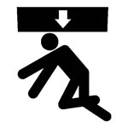
Figure 8 - Existing pictograph

ADDITIONAL RESOURCES
NIOSH. Workplace Solutions, Preventing Injuries When Working with Hydraulic Excavators and Backhoe Loaders (2004-107). www.cdc.gov/niosh/docs/wp-solutions/2004-107/pdfs/2004-107.pdf

CPWR. Hazard Alert, Operating Heavy Equipment. http://elcosh.org/record/document/1817/d000661.pdf

DISCLAIMER
Mention of any company or product does not constitute endorsement by the National Institute for Occupational Safety and Health (NIOSH). In addition, citations to websites external to NIOSH do not constitute NIOSH endorsement of the sponsoring organizations or their programs or products. Furthermore, NIOSH is not responsible for the content of these websites. All web addresses referenced in this document were accessible as of the publication date.

REFERENCES
1. Weather Underground. Weather History. Massachusetts: TWC Product and Technology LLC.

2. Code of Massachusetts Regulations, Office of Public Safety and Inspections: 520 CMR 6 Hoisting Machinery. https://www.mass.gov/regulations/520-CMR-6-hoisting-machinery

3. WorkSafeBC, Working Alone: A Handbook for Small Businesses, 2012, www.worksafebc.com/publications/health_and_safety/by_topic/assets/pdf/bk131.pdf

4. OSHA. Job Hazard Analysis. Publication Number: 3071. www.osha.gov/Publications/osha3071.pdf.

5. OSHA. Recommended Practices for Safety and Health Programs. OSHA 3885. 2016. www.osha.gov/shpguidelines/

6. National Institute for Occupational Safety and Health, Workplace Safety & Health Topics, Prevention Through Design. www.cdc.gov/niosh/topics/ptd

7. Association of Equipment Manufacturers, Pictorial Database, https://www.aem.org/safety-and-technical/safety/pictorial-database

