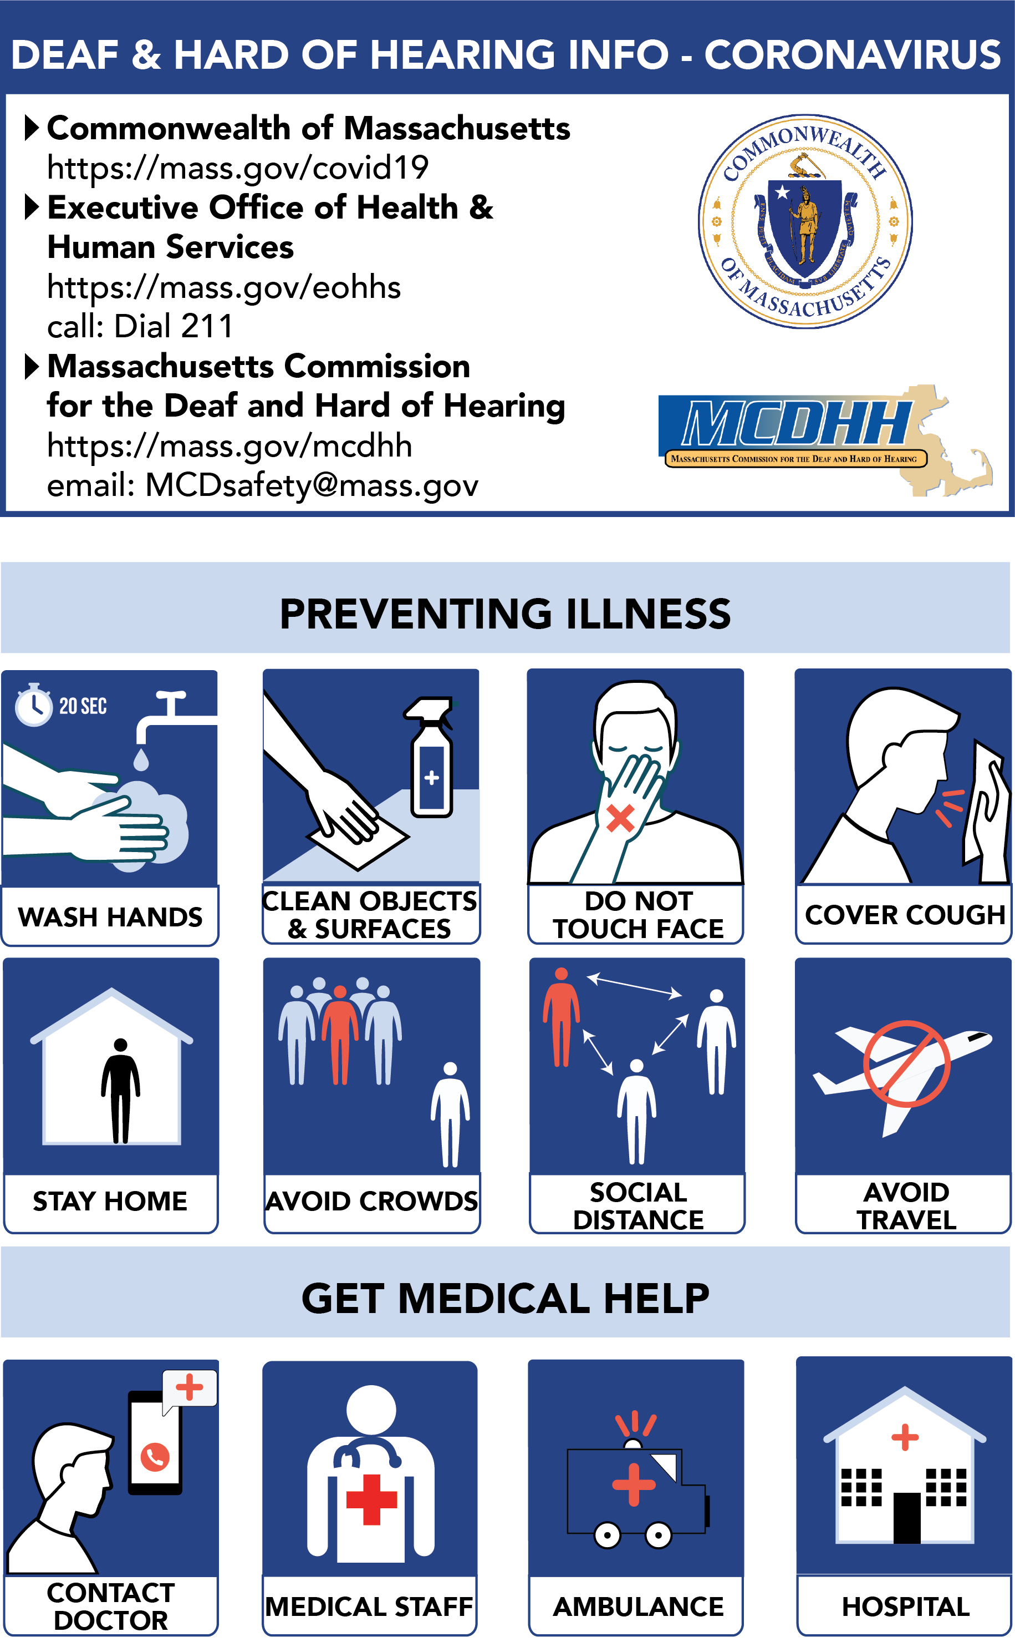
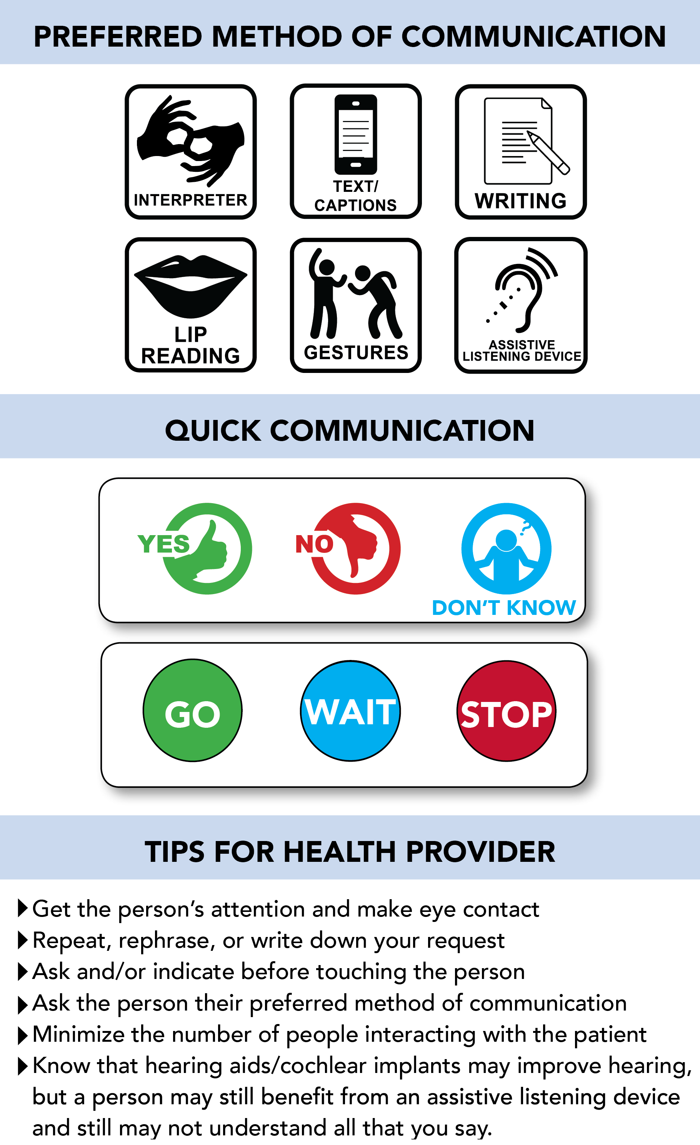
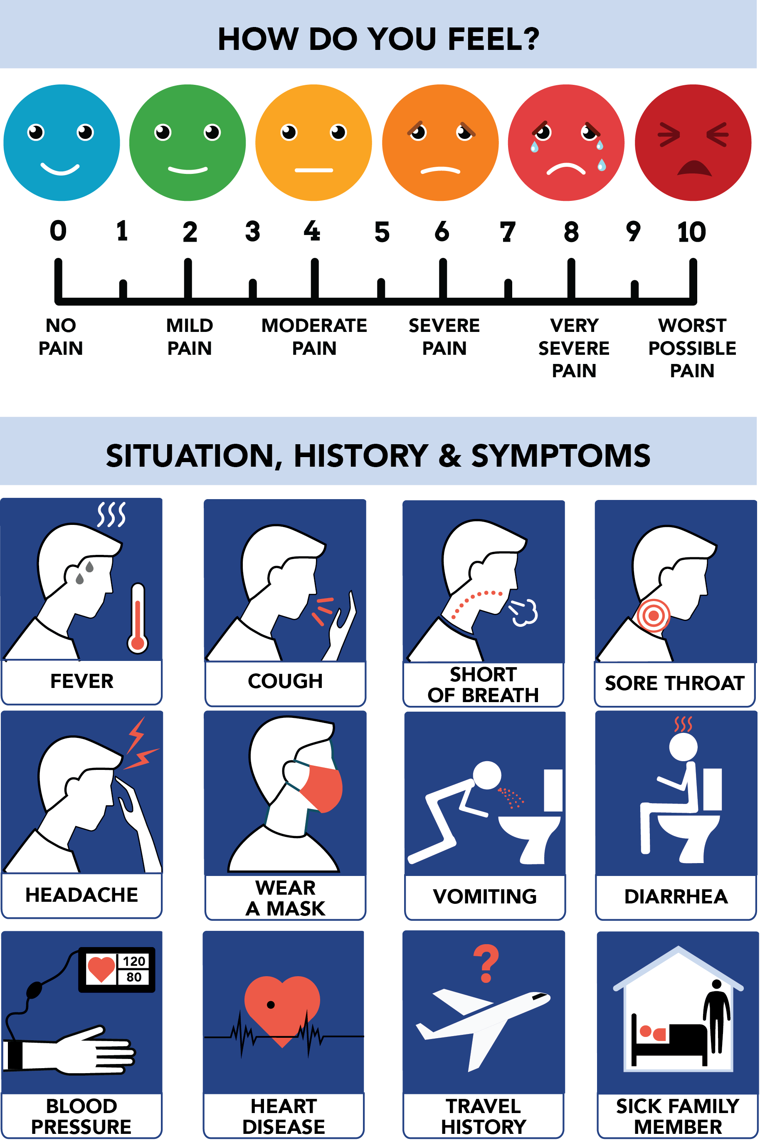
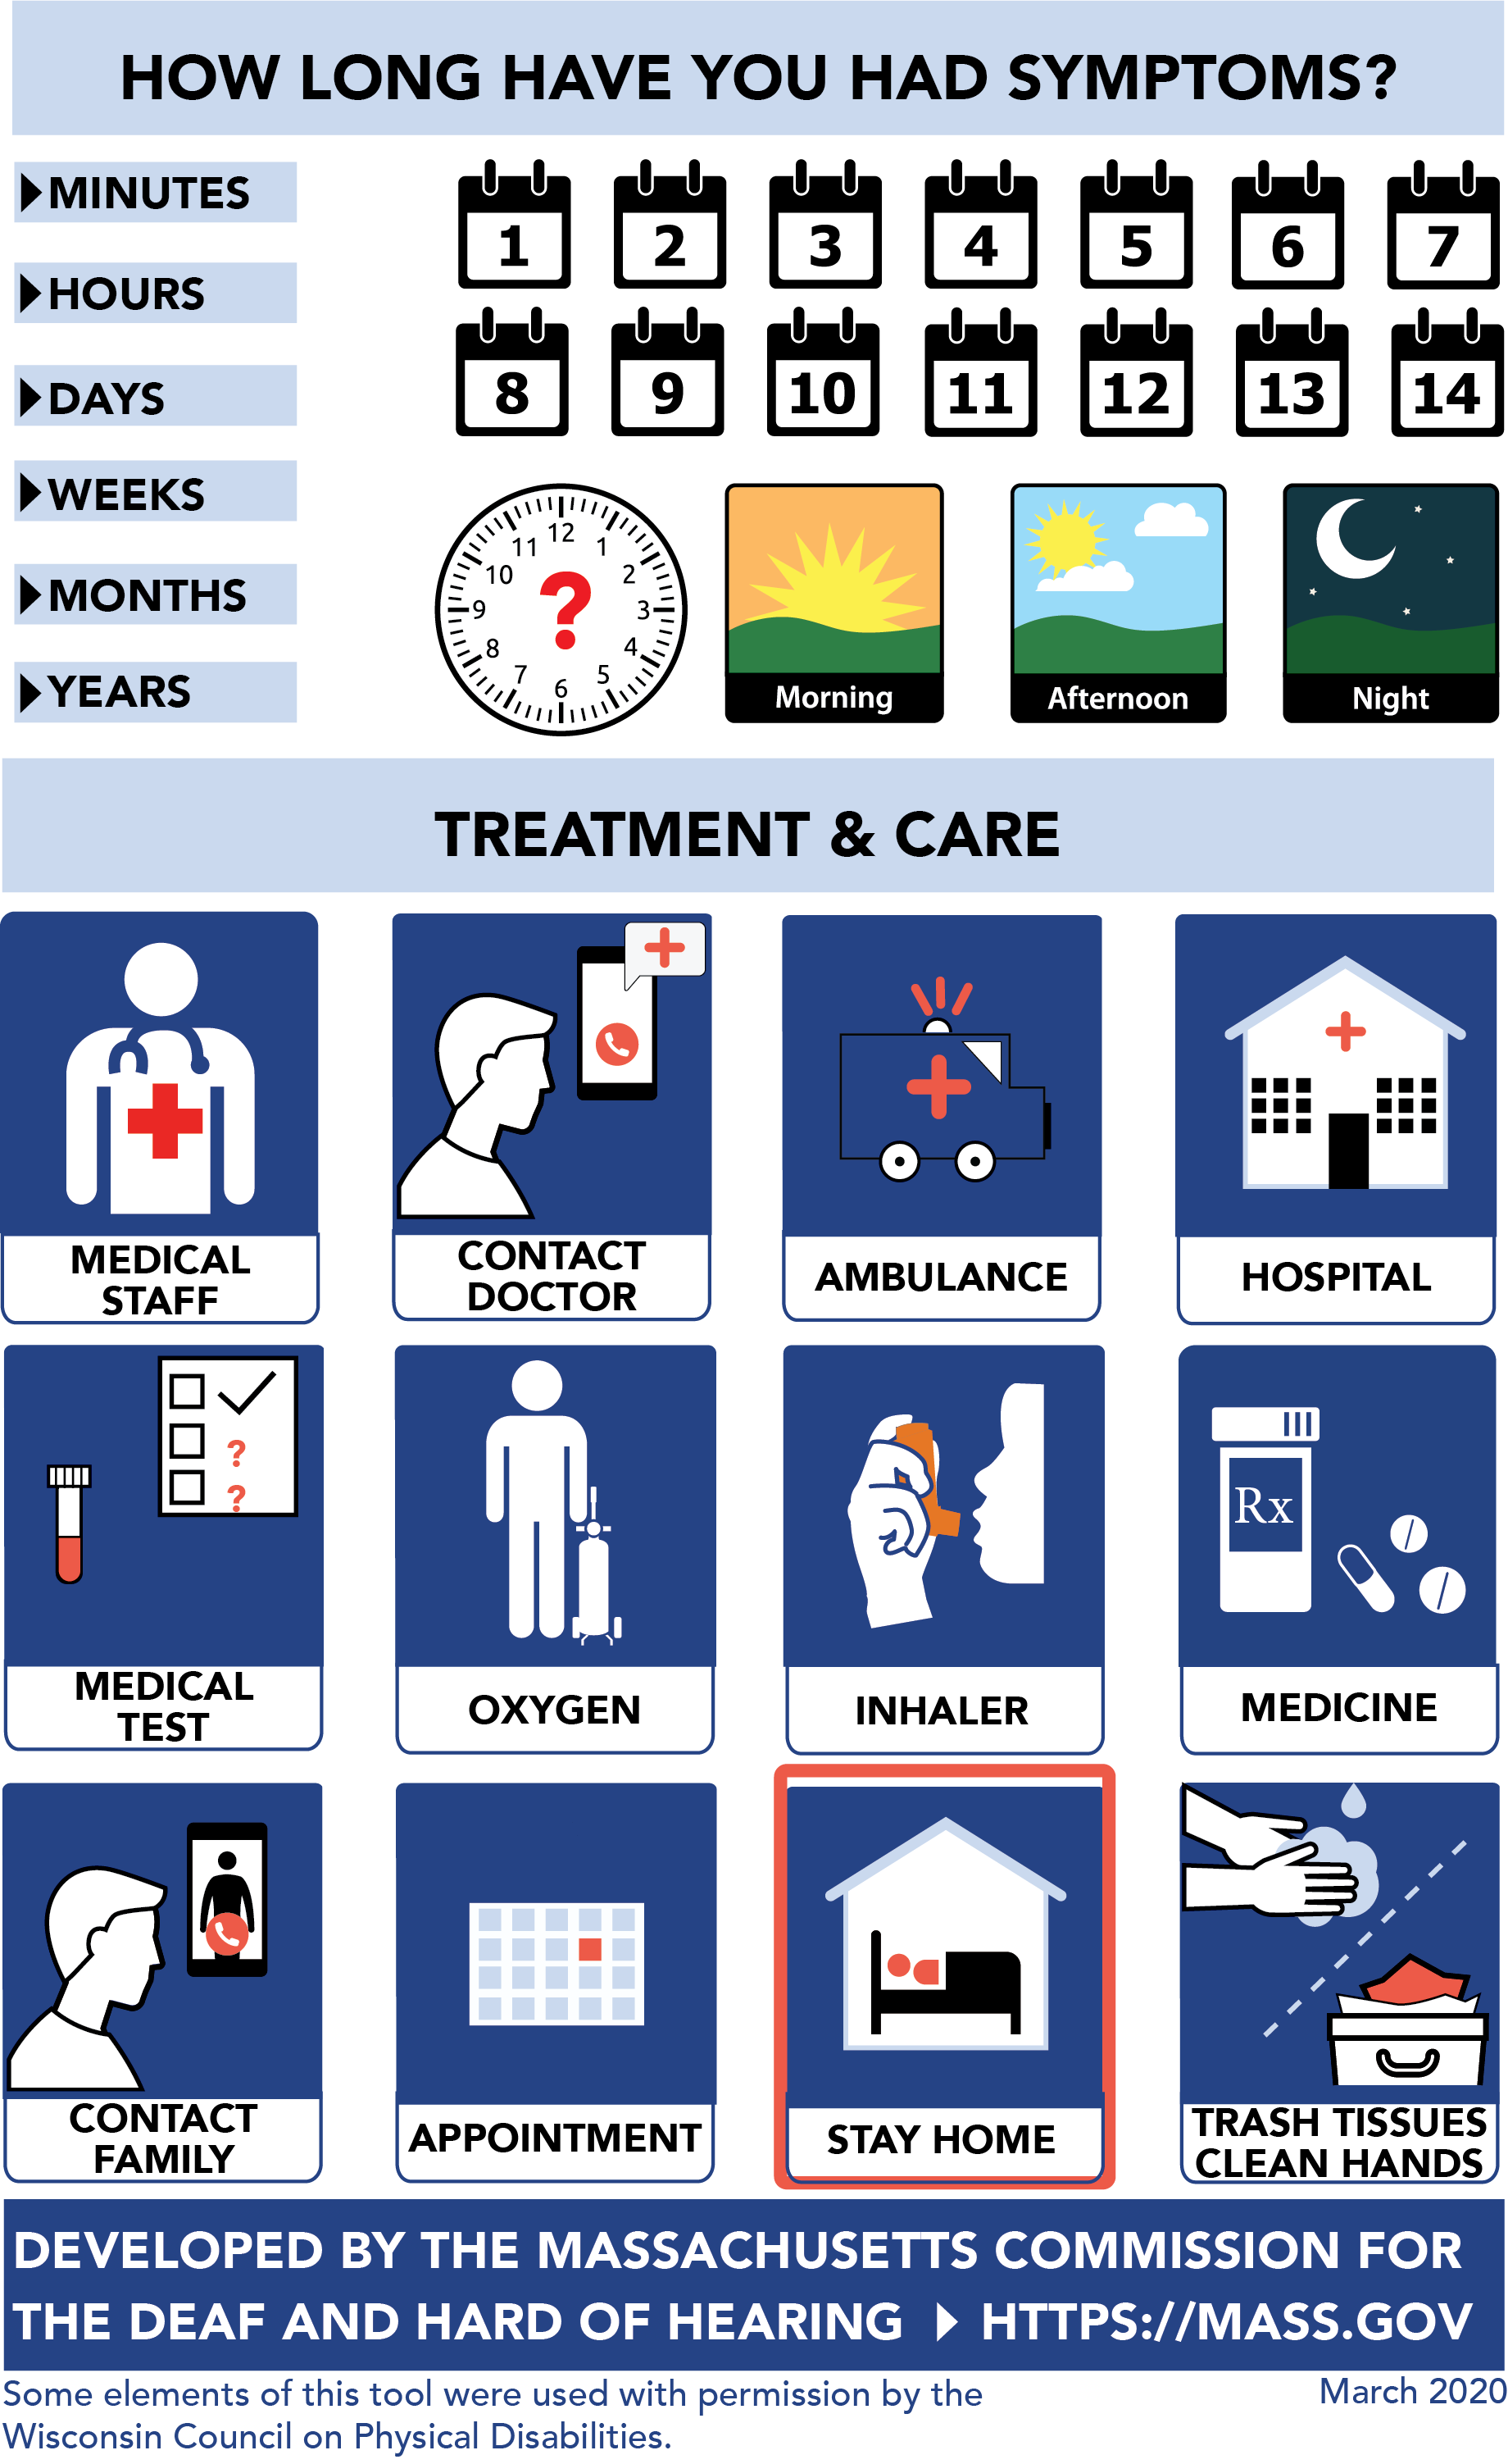
Page one of the Coronavirus Visual Tool
Section 1: Deaf and Hard of Hearing Info – Coronavirus
Commonwealth of Massachusetts https://mass.gov/covid19
Executive Office of Health and Human Services https://mass.gov/eohhs call: Dial 211
Massachusetts Commission for the Deaf and Hard of Hearing https://mass.gov/mcdhh email: MCDsafety@mass.gov

Section 2: Preventing Illness:
Icons 8 from left to right in 4 columns and two rows: wash hands, clean objects and surfaces, do not touch face, cover cough, stay home, avoid crowds, social distance, avoid travel

Section 3: Get Medical Help:
Icons 4 from left to right in 1 row: contact doctor, medical staff, ambulance, hospital

Page two of the Coronavirus Visual Tool
Section 4: Preferred Method of Communication:
Icons 6 left to right in 3 columns and 2 rows: Interpreter, Text/captions, writing, lip reading, gestures, assistive listening device

Section 5: Quick Communication:
Images 2 rectangles, stacked one on top of the other. Each rectangle has three options in each: The first: Yes, No, I don’t know. The second: GO, Wait Stop

Section 6: Tips for Health Provider:
Seven bullet points:
- Get the person’s attention and make eye contact
- Repeat, rephrase, or write down your request
- Ask and/or indicate before touching the person
- Ask the person their preferred method of communication
- Minimize the number of people interacting with the patient
- Know that hearing aids/cochlear implants may improve hearing, but a person may still benefit from an assistive listening device and still may not understand all that you say.

Page three of the Coronavirus Visual Tool
Section 7: How do you Feel?
A scale from 0 to 10 with 0 being no pain, 2 being mild pain, 4 being moderate pain, 6 being severe pain, 8 being very severe pain and 10 being the worst pain possible.

Section 8: Situation, History & Symptoms:
Icons 12 left to right in 4 columns and 3 rows: Fever, Cough, Short of Breath, Sore Throat, Headache, Wear a Mask, Vomiting, Diarrhea, Blood Pressure, Heart Disease, Travel History, Sick Family Member.

Page four of the Coronavirus Visual Tool
Section 9: How long have you had symptoms?
This section has time description running down the left side: Minutes, hours, days, weeks, months, years

The right side has two sections stacked. First, the number of days in 7 columns and two rows. 1-7 and 8-14. Second, just below are 4 icons left to right: a clock, Morning, Afternoon, Night.

Section 10: Treatment & Care:
Icons 12 left to right in 4 columns and 3 rows: Medical Staff, Contact Doctor, Ambulance, Hospital, Medical Test, Oxygen, Inhaler, Medicine, Contact Family, Appointment, Stay at Home, Trash Tissues Clean Hands.

Developed by the Massachusetts Commission for the Deaf and Hard of Hearing. Https://mass.gov

Some elements of this tool were used with permission by the Wisconsin Council on Physical Disabilities.

March 2020

