INDOOR AIR QUALITY ASSESSMENT

City Hall Annex
255 Essex Street
Lawrence

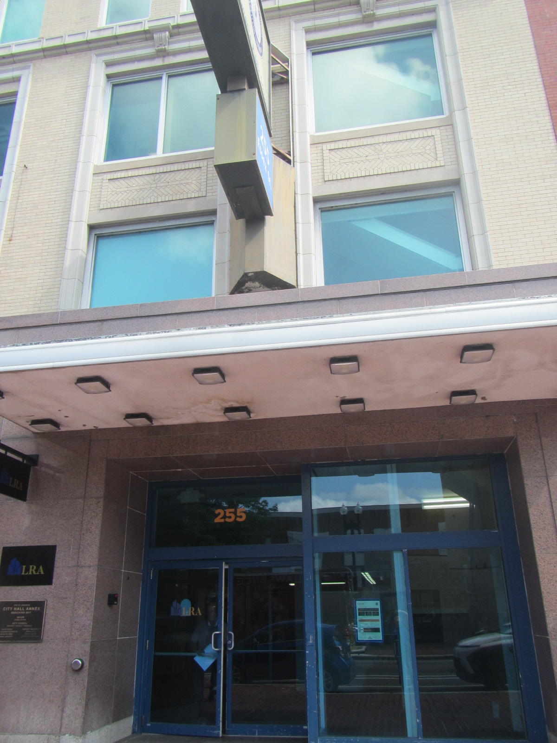

Prepared by:
Massachusetts Department of Public Health
Bureau of Climate and Environmental Health
Division of Environmental Health Regulations and Standards
July 2026

BACKGROUND
Building: | Lawrence City Hall Annex
Address: | 255 Essex Street, Lawrence
Assessment Requested by: | Glenn Gary, Buildings & Facilities Supervisor, City of Lawrence, Department of Public Works
Reason for Request: | General indoor air quality (IAQ)
Date of Assessment: | July 8, 2026
Massachusetts Department of Public Health/Bureau of Climate and Environmental Health (MDPH/BCEH) Staff Conducting Assessment: | Ruth Alfasso, and Thomas Murphy, Division of Environmental Health Regulations and Standards (EHRS).
Building Description: | The building at 255 Essex Street was originally built as a bank. It was renovated and connected to a neighboring building in the 1980s. The building was renovated and dedicated as a City Hall annex in 2017. For several years between 2020 and now, the building was used by a State tenant (MassHire) before being turned back over for city use. The building has brick facings and a flat rubber roof.
Windows: | A few windows are openable, but most do not open.

METHODS
Please refer to the IAQ Manual for methods, sampling procedures, and interpretation of results (MDPH, 2015). Note that this building was visited in 2020 when the MassHire organization was moving into the space. A copy of this report is available on request. Only a portion of the building was examined that will be used for the City Hall Annex. The other side of the building is currently occupied by the Lawrence School Department. The City Hall Annex is currently minimally occupied but staff are in the process of moving into the building.

RESULTS AND DISCUSSION
The following is a summary of indoor air testing results (Table 1).
- Carbon dioxide levels were below the MDPH guideline of 800 parts per million (ppm) in all areas assessed indicating adequate ventilation for occupancy. Note that this building is significantly unoccupied at this time which will reduce carbon dioxide. Levels may be higher with full occupancy.
- Temperature was within or slightly below the recommended range of 70°F to 78°F in the areas assessed.
- Relative humidity was within or slightly above the MDPH recommended range of 40 to 60% in the areas assessed.
- Carbon monoxide was not detected (ND) in all areas. Carbon monoxide should not be present in a typical, indoor environment. If it is present, indoor carbon monoxide levels should be less than or equal to outdoor levels.
- Fine particulate matter (PM2.5) concentrations measured were below the National Ambient Air Quality Standard (NAAQS) level of 35 μg/m³ in all areas assessed.

Ventilation
A heating, ventilating, and air conditioning (HVAC) system has several functions. First, it provides heating and, if equipped, cooling. Second, it is a source of fresh air. Finally, an HVAC system will dilute and remove normally occurring indoor environmental pollutants by not only introducing fresh air but also filtering the airstream and ejecting stale air to the outdoors via exhaust ventilation. Even if an HVAC system is operating as designed, point sources of respiratory irritation may exist and lead to symptoms in sensitive individuals.
Fresh air is provided by energy recovery ventilators (ERVs) located on the roof (Picture 1) and other areas of the building. These units were installed into the building prior to the 2020 site visit due to a reported lack of air exchange in the building. Air from the ERVs is filtered, heated/cooled, and delivered to rooms via ducted supply vents. Air is returned/exhausted through return vents. Note that while there were vents in rooms, it was not visually clear which ones brought in fresh air and which provided return air (Pictures 2 and 3). All occupied spaces should have access to both supply and return ventilation.
Most rooms also had fan coil units (Picture 4). These fan coil units provide both heating and cooling via a 4-pipe system. Fan coil units circulate, filter, and heat/cool air, but they do not have a source of fresh air. It is recommended that HVAC systems be re-balanced every five years to ensure adequate air systems function (SMACNA, 1994).
The ventilation system should be on and operational to supply fresh air continuously during occupied periods. Without adequate fresh air supply and removal of stale air, common indoor air pollutants can build up and cause irritation. Thermostats are present in this space (Picture 5), which feed information into a building management system. Thermostats and building management systems should be set to have the fan on, even when a change in temperature is not called for, to allow constant air exchange during occupied periods. The thermostats examined had the correct time, which is important when settings such as night and weekend setbacks are used.
Restrooms were all equipped with exhaust vents. The vents in the first-floor restrooms appeared to be retrofitted using a household type of exhaust vent (Picture 6), which were activated only when the light switch turns on. Restroom exhaust vents should be on whenever the building is occupied rather than being connected to the light switch. These vents should always direct the exhaust air to the outside of the building.
Both the ERVs and the fan coil units have filters inside (Pictures 7 and 8). Pleated filters were noted in both the ERV and the fan coil units. The MDPH IAQ Outreach and Education Unit recommends that filters of at least minimum efficiency reporting value (MERV) 8 or better be used as these are adequate to filter out pollen and mold spores (ASHRAE, 2012). The filter for the fan coil unit had a MERV rating of 10. While no rating could be seen on the ERV filters, they appeared to be 4” deep pleated filters. The bracket holding the filter in the ERV appeared to be slightly too small (Picture 7) which may allow the filter to become improperly seated and allow air to bypass the filter. One of the fan coil units was ajar, the filter for this unit was on the floor (Picture 9), and there was duct tape on the filter which may indicate it had been taped into place. Filters that do not fit properly, or that are installed incorrectly, will not adequately filter the airstream as designed. Filters should be changed at least twice a year, and more often if recommended by the manufacturer or if the filters are highly soiled when they are changed.
Most windows in the building are not openable, but there are some windows which have handles and appear to be able to be opened. Openable windows are useful in situations where large amounts of air need to be circulated quickly (e.g., during renovations), or if the HVAC system is off-line. However, most HVAC systems in office buildings are designed and balanced to operate with the windows closed. In particular, windows should be closed when the HVAC system is operating in cooling mode as the influx of hot, humid outside air can lead to condensation.
The temperature in the office was slightly below the MDPH guidance of 70˚-78˚F in many areas, and the humidity was slightly above the MDPH guidance of 40-60%. Elevated humidity is likely due, in part, to outdoor conditions, including heavy rain the previous day. Note that temperature and humidity are related: the dew point is the temperature at which moisture will start to condense and can be used as a measure of the amount of water in the air. At a given amount of water in the air, as temperature goes down, the humidity goes up. For example, at 78˚F and 57% humidity (the outside/background conditions measured before the assessment), the dew point is 62˚F. If the temperature decreases to 69˚F at that same dew point, the relative humidity goes up to 78%. Since humidity indoors was measured at less than 78%, this indicates that the operation of the HVAC systems is reducing the amount of moisture in the air. If the temperature setpoint is raised a few degrees, a corresponding reduction in humidity will occur, which will improve comfort. In addition, occupants of the building remarked on the chilly temperatures.
A few areas were significantly more humid than others, particularly the conference room and conference room closet on the first floor (Table 1). While the dew point in this area was still equal to or less than outside, this may suggest there is a source of moisture or unconditioned air in these two rooms. The building envelope in this area should be checked for gaps, and if there is any plumbing in the room, it should be checked for leaks. If excess humidity continues in this area, dehumidifiers may be useful to reduce humidity, improve comfort, and reduce the potential for condensation and water damage/mold growth. When humidity is above 60%, occupant discomfort can occur (mugginess or clamminess). When humidity is elevated for a long time, water damage to building materials and furnishings may occur.

Water damage issues
A few water-damaged ceiling tiles were noted in areas around the building (Pictures 6 and 10; Table 1). The water damage appears to be from roof leaks or HVAC leaks. No dark staining indicating mold was present. Water-damaged ceiling tiles should be replaced once an issue has been identified and repaired. Note that there are several types of ceiling tiles, including suspended tiles and smaller, square tiles that may be glued directly to the ceiling. The latter type of ceiling tile is more difficult to replace.
The roof over most of the building was examined and was in very good condition apart from one area where water was pooling (Picture 11). Roofs should be pitched to drains or gutters to prevent water from pooling.
Note that when operating in cooling mode, fan coil units will produce condensation which needs to be drained. Condensation drains and drain pans inside the units need to be checked for clogs regularly, and cleaned at least as often as the filters are changed to remove debris that can lead to odors.
During the inspection, refrigerators, water fountains, sinks, and refrigerators were noted in carpeted areas (Pictures 12 and 13). Leaks or spills can damage carpeting. Note that while refrigerators in this office building are not covered by the food code, it is good practice to have a thermometer in each refrigerator that is visible to ensure refrigerated food temperatures are kept at 5ºC (41ºF) or less (US FDA, 2022).
If some sinks in the building are not used regularly, the drain traps can dry out and lead to sewer odors inside the building. A drain trap is a p-shaped pipe under the sink which fills with water and provides a seal between the sewer system and occupied spaces; if sinks are unused this can dry out. Water should be run through sinks every one to two weeks when the sinks are otherwise unused. Regular water flow helps prevent stagnant water, odors, and potential drain fly activity.
Food preparation equipment and related items were found in some offices and common areas. Food needs to be kept in tightly sealed pest-proof containers when not currently in use. All crumbs and other food debris need to be removed from surfaces and appliances such as toasters and microwaves to avoid attracting pests.
Plants were present in a few areas of the building (Table 1). In one area, plants were on cardboard which was on the fan coil unit (Picture 14). Plants can be a source of pollen, mold, and odors in the indoor environment. They should be well maintained, not overwatered, and kept on waterproof drip pans that are cleaned regularly. They should be kept away from the airstream of ventilation equipment.
A door on the rear of the first floor leads out into an alley. This door had light visible beneath it and the bottom appeared rusty. Gaps under or around doors can allow unconditioned air, moisture, odors, or pests into the building.
Testing for mold was conducted a few times recently in this building. The MDPH IAQ unit does not recommend mold testing, as results are difficult to interpret and there are no health-based standards to compare mold results to. For more information on why mold testing is not recommended, consult: https://www.mass.gov/info-details/guidance-regarding-testing-for-mold-in-water-damaged-public-buildings.

Other IAQ issues
Products were in use in the office that can increase VOCs in the air. Items including hand sanitizers, deodorant sprays, and dry erase materials were noted (Table 1). Products with strong scents, including scent sprays and essential oils should not be used in a shared office space as many people are sensitive to fragrance compounds.
Some supply and return vents were dusty, as were some personal/stand fans. These should be cleaned periodically to prevent the dust from being aerosolized.
The curtains on the first floor were dirty or stained (Picture 15). They should be professionally cleaned or replaced. Most areas in the building are carpeted. Carpeting needs to be cleaned regularly using a HEPA-equipped vacuum and deep cleaned once or twice a year.

CONCLUSIONS/RECOMMENDATIONS
In view of the findings at the time of the visit, the following recommendations are made:

Ventilation recommendations
- Continue to operate supply and exhaust ventilation in all areas continuously during occupied periods.
- Have the HVAC system balanced every 5 years in accordance with SMACNA recommendations (SMACNA, 1994).
- Ensure all rooms have both supply and return air supply.
- Continue to change filters for HVAC units at least two to four times a year or as per the manufacturers’ recommendations using filters with a Minimum Efficiency Rating Value (MERV) of 8 or better.
- When filters are changed, and more often if needed, clean any condensation drain pans and tubes to remove clogs and debris that can lead to odors.
- Ensure filters fit properly into the HVAC equipment they are installed in without gaps.
- Have the HVAC system balanced every five years.
- Avoid opening windows when air conditioning is in use in the building, and make sure they are tightly closed at the end of the day.
- Increase temperature settings to reduce cold temperatures in occupied spaces and reduce relative humidity. Once the building is fully occupied, settings may need to be adjusted to account for the heat produced by people and office equipment.
- Investigate the first-floor conference room and conference room closet for any gaps in the building envelope or plumbing leaks that may contribute to elevated humidity. If no obvious sources are found, consider using dehumidifiers in these areas to prevent water damage due to high humidity. Dehumidifiers need to be emptied daily and cleaned regularly to prevent leaks and odors.
- Consider changing the operation of the restroom exhaust fans to continuous rather than a switch. Ensure these vents direct the exhaust air outside.

Water damage recommendations
- Replace water-damaged and missing ceiling tiles.
- Consider moving refrigerators and water dispensers to areas without carpeting or using a waterproof mat underneath.
- Ensure any sink drains in rarely used areas are run with water several times per month to keep drain traps from drying out and to help prevent odors and pests.
- Routinely clean food/liquid stains from the refrigerator and food residues from microwaves, toasters, coffee makers, or any other appliances used to prepare or heat food.
- Keep plants in good condition, avoid overwatering, and make sure they are on waterproof drip pans that are cleaned periodically.
- Ensure the roof is pitched for proper drainage.

Other recommendations
- Once the building is fully occupied, ensure items are put away in proper storage areas and not kept on floors.
- Have the carpets vacuumed regularly and deep cleaned once or twice a year. Include hidden areas between and behind workstations in regular cleaning programs.
- Use VOC-containing products with good ventilation.
- If air purifiers are used in the space, clean and maintain them in accordance with manufacturers’ instructions including filter changes. Avoid using any units that may produce ozone.
- Refer to resource manual and other related IAQ documents located on the MDPH’s website for further building-wide evaluations and advice on maintaining public buildings. These documents are available at: http://mass.gov/dph/iaq.

REFERENCES
ASHRAE. 2012. American Society of Heating, Refrigeration and Air Conditioning Engineers (ASHRAE) Standard 52.2-2012 -- Method of Testing General Ventilation Air-Cleaning Devices for Removal Efficiency by Particle Size (ANSI Approved).
MDPH. 2015. Massachusetts Department of Public Health. Indoor Air Quality Manual: Chapters I-III. Available at: https://www.mass.gov/lists/indoor-air-quality-manual-and-appendices.
SMACNA. 1994. HVAC Systems Commissioning Manual. 1st ed. Sheet Metal and Air Conditioning Contractors’ National Association, Inc., Chantilly, VA.
US FDA. 2022. 2022 Food Code. U.S. Department of Health and Human Services. U.S. Food and Drug Administration. College Park, MD January 18, 2023 Version. https://www.fda.gov/media/164194/download

Picture 1
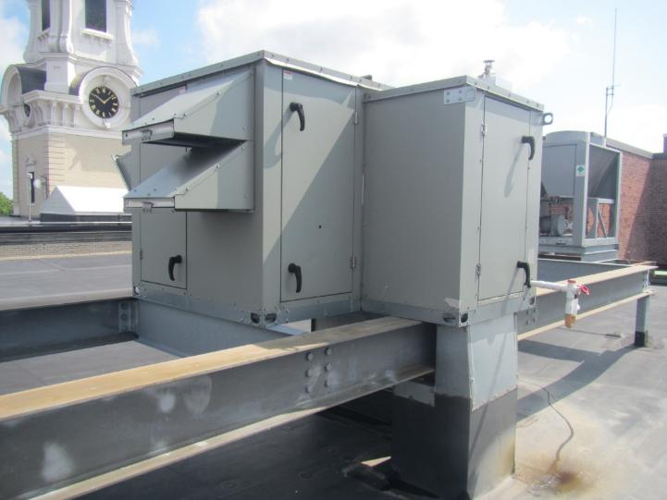
Energy Recovery Ventilator on the building roof
Picture 2
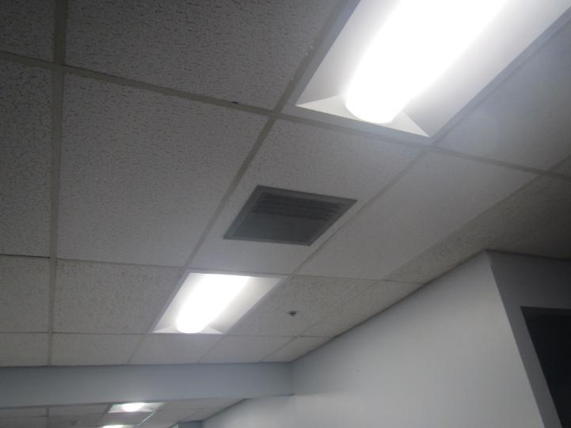
Ceiling-mounted vent

Picture 3
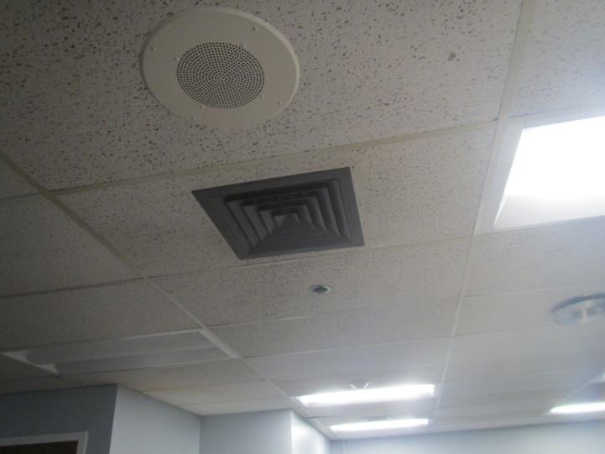
Ceiling-mounted vent
Picture 4
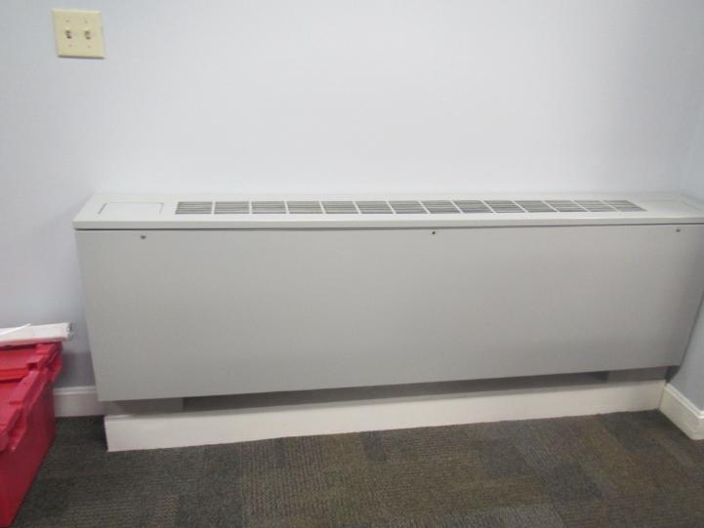
Fan coil unit

Picture 5
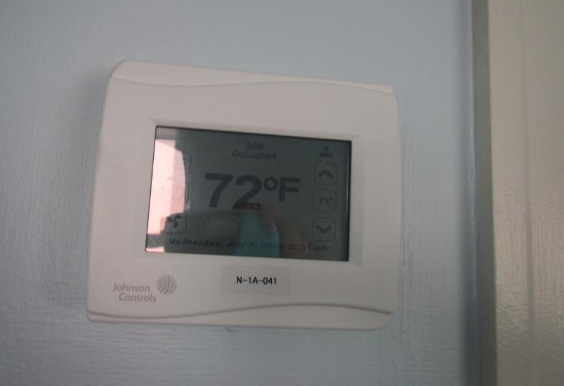
Thermostat in the office
Picture 6
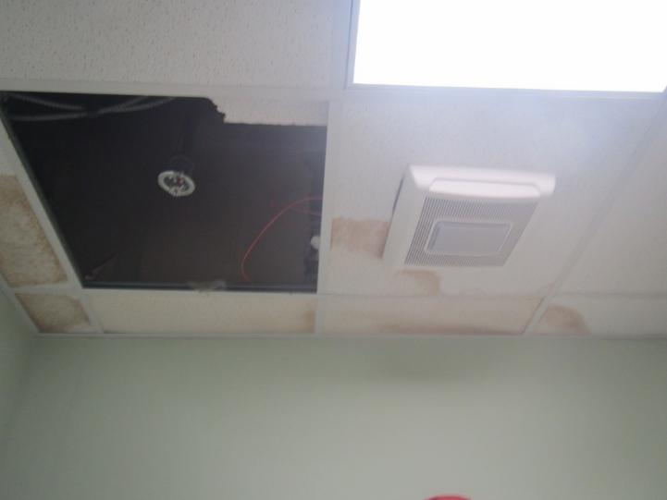
Residential-style restroom vent activated by the light switch, also note water-damaged and missing ceiling tiles

Picture 7
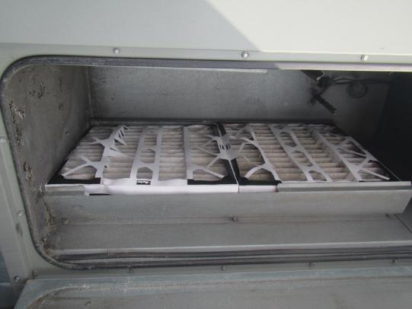
Filter in the ERV, note bracket seems slightly too small
Picture 8
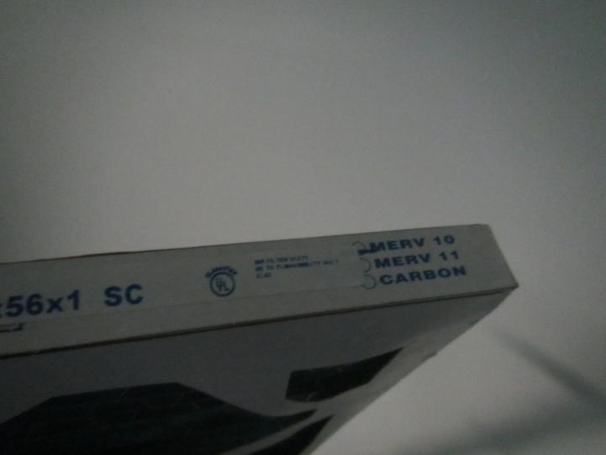
Filters for the fan coil units with a MERV rating of 10

Picture 9
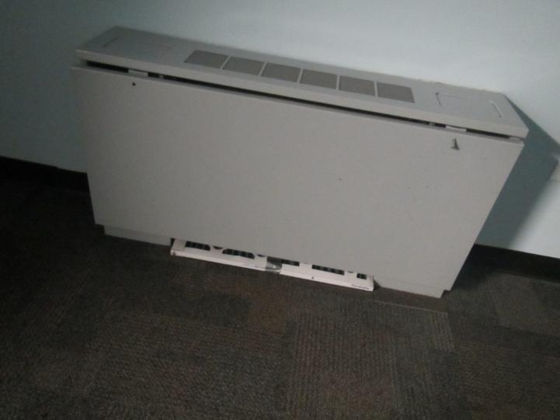
Ajar fan coil unit with filter on the floor with duct tape showing
Picture 10
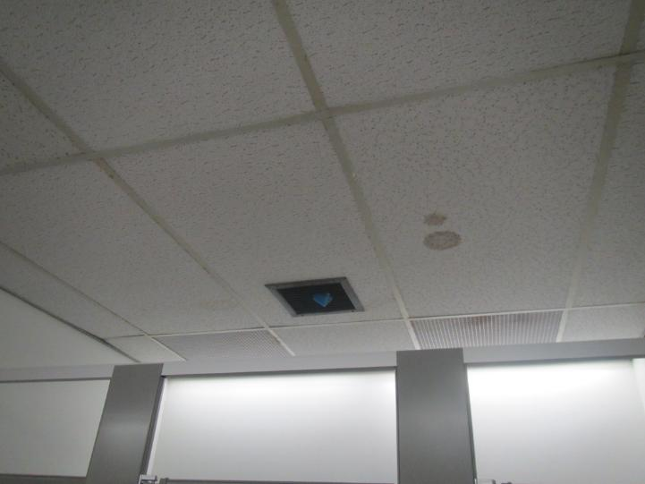
Water-damaged ceiling tile

Picture 11
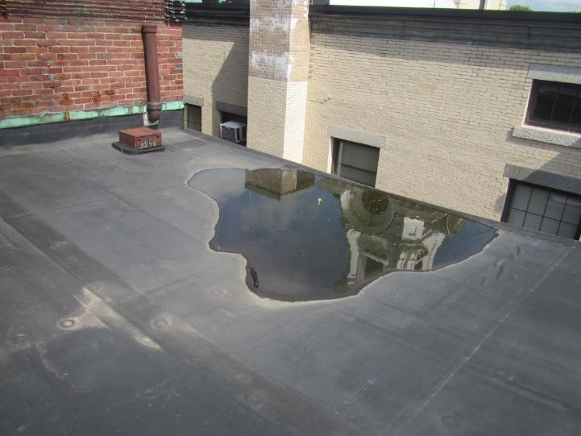
Pooling water on the roof
Picture 12
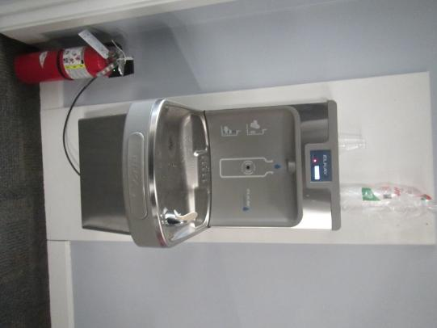
Water fountain over carpet

Picture 13
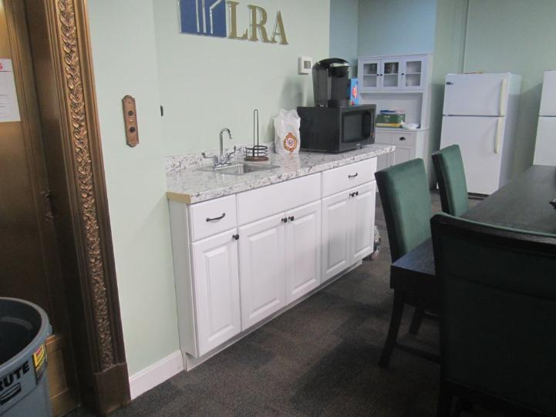
Sink and refrigerators in a carpeted area
Picture 14
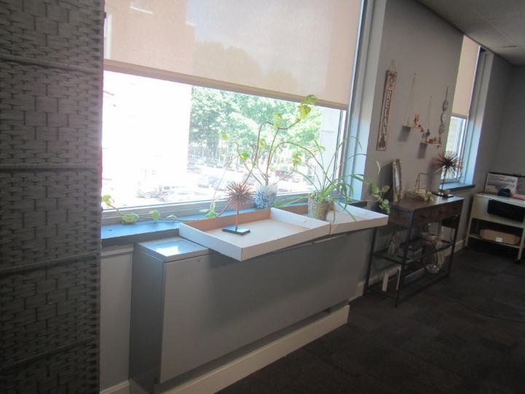
Plants on cardboard on a fan coil unit

Picture 15
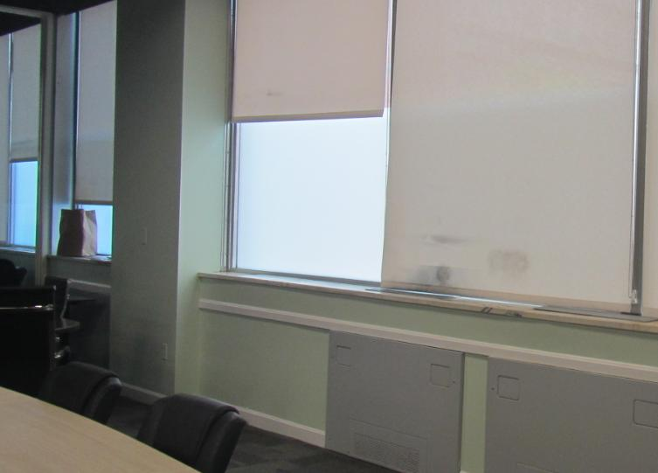
Stained curtains on the first floor
Location | Carbon  Dioxide  (ppm) | Carbon Monoxide  (ppm) | Temp  (°F) | Relative  Humidity  (%) | PM2.5  (µg/m³) | Occupants  in Room | Windows  Openable | Ventilation |  | Remarks
 |  |  |  |  |  |  |  | Supply | Exhaust | Remarks
Background | 507 | ND | 78 | 57 | 11 |  |  |  |  | Street side
Fourth floor
Planning Director’s office | 461 | ND | 70 | 62 | 7 | 0 | N |  |  | Carpeted
408 | 531 | ND | 68 | 65 | 8 | 0 | Y |  |  | Condensation between windowpanes
403 | 473 | ND | 68 | 66 | 7 | 0 | N
Women’s restroom | 477 | ND | 69 | 67 | 6 | 0 | N |  |  | 1 WD CT, spray product
Men’s Restroom | 461 | ND | 71 | 64 | 5 | 0 | N | N | Y | Disinfectant deodorant spray
402 | 460 | ND | 70 | 64 | 10 | 0 | Y |  |  | 1 WD CT (old type of CT)
404 | 472 | ND | 70 | 63 | 8 | 0 | Y
405 | 464 | ND | 71 | 61 | 8 | 0 | N | Y | N
Storage |  |  |  |  |  |  |  |  |  | 1 WD CT, carpeted
Third Floor
301 | 479 | ND | 70 | 64 | 4 | 0 | N | Y | N
302 | 541 | ND | 70 | 64 | 5 | 1 | N | Y |  | DEM, plants, water cooler on carpet
303 | 492 | ND | 70 | 64 | 5 | 0 | N | Y | N | Cardboard boxes on floor, WD CT, gap in ceiling around sprinkler
306 open area | 544 | ND | 70 | 64 | 4 | 0 | N | Y |  | Slightly bowed CT, refrigerator on carpet
306 back | 553 | ND | 70 | 64 | 3 | 1 | N | Y |  | Plants, coffee
Merrimack Room (file storage) | 507 | ND | 70 | 62 | 5 | 0 | N | Y
Second Floor
Main Lobby/Cubicles | 444 | ND | 68 | 65 | 6 | 0 | N | Y | Y
202 | 441 | ND | 71 | 62 | 4 | 0 | N | N | N
203 | 436 | ND | 69 | 64 | 4 | 0 | N | N | Y
204 | 434 | ND | 70 | 62 | 4 | 0 | N | Y | N
206 | 492 | ND | 70 | 62 | 7 | 0 | Y |  |  | Dry erase materials
208 | 438 | ND | 70 | 61 | 6 | 0 | Y |  |  | WD CT near vent
209 | 440 | ND | 70 | 61 | 4 | 0 | N
Mill Room | 454 | ND | 70 | 62 | 4 | 0 | N |  |  | Fireplace, old elevator
Women’s Restroom |  |  |  |  |  |  |  |  | Y | Sprays, vent dusty
Men’s Restroom |  |  |  |  |  |  |  |  | Y | Sprays, vent dusty
First Floor
Main reception/open | 455 | ND | 69 | 64 | 4 | 0 | N |  |  | Curtains are dirty, vault-style safe
Kitchen area | 435 | ND | 69 | 65 | 3 | 0 | N |  |  | 2 refrigerators, carpeted, sink
Conference Room | 442 | ND | 69 | 71 | 1 | 0 | N | Y | N
Conference Room Closet | 458 | ND | 70 | 71 | 1 | 0 | N | N | N
Office | 420 | ND | 69 | 63 | 1 | 0 | N | Y | N
Women’s Restroom |  |  |  |  |  |  |  |  | Y | Exhaust vent is a residential style and on a switch
Men’s Restroom |  |  |  |  |  |  |  |  | Y | Exhaust vent is a residential style and on a switch

