INDOOR AIR QUALITY
POST-OCCUPANCY ASSESSMENT

Massachusetts Lottery
160 Winthrop Avenue
Lawrence, MA

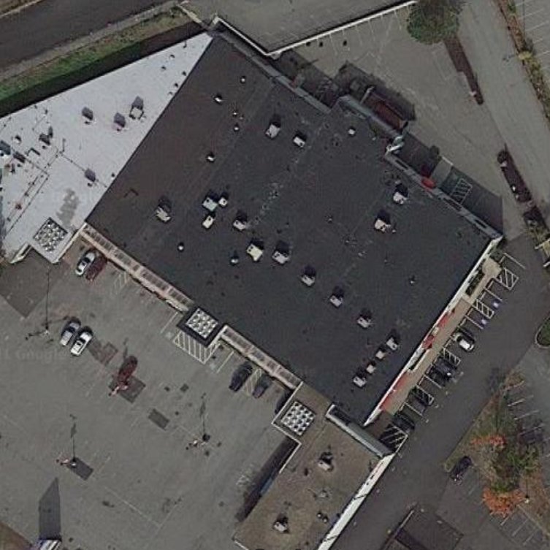

Prepared by:
Massachusetts Department of Public Health
Bureau of Environmental Health
Indoor Air Quality Program
August 2021

Background
Building: | Massachusetts Lottery (Lottery)
Address: | 160 Winthrop Avenue, Lawrence, MA
Assessment Requested by: | Deborah Russell, Project Manager, Division of Capital Asset Management and Maintenance (DCAMM)
Reason for Request: | Post-occupancy indoor air quality (IAQ) assessment
Date of Assessment: | August 5, 2021
Massachusetts Department of Public Health/Bureau of Environmental Health (MDPH/BEH) Staff Conducting Assessment: | Ruth Alfasso, Environmental Engineer, IAQ Program
Building Description: | The new Lottery office is in a single-story flat-roofed building located in a shopping plaza, adjacent to other business including retail sales, a nail salon and a pizza restaurant. The Lottery space contains offices, cubicles, storage, technician areas and a waiting area. This space was formerly retail. All new mechanical systems and furnishings were installed for the Lottery.
Windows: | Not openable

Methods
Please refer to the IAQ Manual for methods, sampling procedures, and interpretation of results (MDPH, 2015).

IAQ Testing Results
The following is a summary of indoor air testing results (Table 1):
- Carbon dioxide levels were below the MDPH guideline of 800 parts per million (ppm) in all of the areas surveyed.
- Temperature was within the MDPH recommended range of 70°F to 78°F in all areas tested.
- Relative humidity was within the MDPH recommended range of 40 to 60% in all areas.
- Carbon monoxide levels were non-detectable (ND) in all areas tested.
- Fine particulate matter (PM2.5) concentrations measured were below the National Ambient Air Quality Standard (NAAQS) limit of 35 μg/m³ in all areas tested.
- Total volatile organic compounds (TVOCs) were ND in most areas tested, with readings less than 1 ppm in some warehouse and storage areas.

Ventilation
A heating, ventilating, and air conditioning (HVAC) system has several functions. First it provides heating and, if equipped, cooling. Second, it is a source of fresh air. Finally, an HVAC system will dilute and remove normally-occurring indoor environmental pollutants by not only introducing fresh air, but by filtering the airstream and ejecting stale air to the outdoors via exhaust ventilation. Even if an HVAC system is operating as designed, point sources of respiratory irritation may exist and cause symptoms in sensitive individuals.
Air from the HVAC system is ducted to ceiling-mounted supply air vents. Ceiling-mounted return vents return air to the air handling units (AHUs). The HVAC system in this office is controlled by thermostats (Picture 1). The MDPH IAQ program recommends that HVAC systems be set for continual air circulation during occupied periods. It could not be determined at the time of the visit whether the thermostats have been properly set up, including system time clocks and periods of occupancy. It is also recommended that HVAC systems be re-balanced every five years to ensure adequate air systems function (SMACNA, 1994).

Microbial/Moisture Concerns
A water-damaged ceiling tile was observed in the conference room. It is reported that this tile became stained following some HVAC system work that was conducted on the roof. If water leaks continue in this area, the roof membrane and flashing should be checked and repaired as needed. Water-damaged ceiling tiles should be replaced once the conditions leading to them becoming stained are repaired.
Some windows in the “OC” office area are planned to be replaced, as they are original to the building. However, no leaks or water-damaged materials were found in the vicinity of these windows at the time of the assessment.
There is a double door and a roll-up door to the outside in the warehouse area. The double-door frame is misaligned so that the door does not close properly. This is a known security issue, as well as potentially being a means for unconditioned air and pests into enter the building. In addition, the design of the roll-up door has gaps around the frame through which light could be seen. Note that idling of vehicles is not allowed in the driveway next to the roll-up door to prevent exposure to carbon monoxide and other products of combustion.
A ductless air conditioning unit is located in both MDF rooms (Picture 2). These units create condensation which needs to be drained. The pumps and tubing for condensation drains should be checked periodically to prevent leaks. No porous or moisture-sensitive material should be stored directly beneath these units.

Other Concerns
Exposure to low levels of total volatile organic compounds (TVOCs) may produce eye, nose, throat, and/or respiratory irritation in some sensitive individuals. To determine if VOCs were present, BEH/IAQ staff took measurements for TVOCs, which were mostly ND, with a few slight readings between ND and 1 ppm in the warehouse and storage areas. BEH/IAQ examined other areas for products containing VOCs. BEH/IAQ staff noted hand sanitizers, cleaners, and dry erase materials in the office space (Table 1). All of these products have the potential to be irritants to the eyes, nose, throat, and respiratory system of sensitive individuals.
As has been seen in other Lottery offices, this office has a large amount of promotional materials, including brochures, posters, plastic toys, and other printed and plastic items (Picture 3). Such items can give off odors and may be a source of irritating VOCs to the indoor environment. Wherever possible, printed and promotional items should be stored in closed containers and kept away from general work areas.
Restrooms in the front section of the building had a noticeable odor of perfume or deodorizer. Strongly-scented products, including cleaners and deodorizers, can be irritating to sensitive people. In addition, scented products only cover up odors, they do not eliminate them. If restroom odors are of concern, ensure the local exhaust systems are functioning adequately and are on whenever the building is occupied.
This office space has a kitchen area with all new appliances. Care should be taken to keep food preparation equipment clean to prevent smoke, odors and pests.
Most of the offices are carpeted. Carpets should be cleaned annually (or semi-annually in soiled/high traffic areas) in accordance with Institute of Inspection, Cleaning and Restoration Certification (IICRC) recommendations, (IICRC, 2012).

Conclusions/Recommendations
Based on observations at the time of assessment, the following is recommended:

Ventilation Recommendations
- Operate supply and exhaust ventilation continuously in all areas during occupied periods. Ensure all HVAC equipment is cleaned/maintained in accordance with manufacturer’s instructions.
- Ensure thermostats are properly set for time and occupancy periods. Ensure that building managers have proper training in their use if needed.
- Change filters for HVAC equipment 2-4 times a year. Use pleated filters of Minimum Efficiency Reporting Value (MERV) 8 (or higher), which are adequate in filtering out pollen and mold spores (ASHRAE, 2012).
- Balance the HVAC system every 5 years in accordance with Sheet Metal and Air Conditioning Contractors’ National Association (SMACNA) recommendations (SMACNA, 1994).

Water Damage Recommendations
- Inspect the roof and flashing over the water-damaged ceiling tiles in the conference room and repair as needed. Replace damaged ceiling tiles once this has been completed.
- Continue with window replacement project. If windows may not be watertight, monitor offices for leaks during heavy rain and dry when needed.
- Ensure the double doors/door frames in the warehouse area are rehung to close tightly.
- Periodically check the pump and tubing for ductless air conditioners to prevent leaks.

Other Recommendations
- Enforce prohibitions against idling vehicles close to the warehouse doors.
- Keep promotional materials in closed containers where possible and away from general work areas to reduce odors and VOCs.
- Ensure restroom exhaust vents are functioning properly to reduce any restroom odors without a need for deodorizing products.
- For buildings in New England, periods of low relative humidity during the winter are often unavoidable. Therefore, scrupulous cleaning practices should be adopted to minimize common indoor air contaminants whose irritant effects can be enhanced when the relative humidity is low. To control for dusts, a high efficiency particulate arrestance (HEPA) filter equipped vacuum cleaner in conjunction with wet wiping of all surfaces is recommended. Avoid the use of feather dusters. Drinking water during the day can help ease some symptoms associated with a dry environment (throat and sinus irritations).
- Ensure all surfaces are cleaned periodically, including supply and return vents, personal fans and flat surfaces.
- Keep food preparation equipment clean, and clean out refrigerators, including the gaskets, regularly.
- Clean carpeting in accordance with IICRC recommendations (IICRC, 2012).
- Refer to resource manual and other related IAQ documents located on the MDPH’s website for further building-wide evaluations and advice on maintaining public buildings. These documents are available at: http://mass.gov/dph/iaq.

References
ASHRAE. 2012. American Society of Heating, Refrigeration and Air Conditioning Engineers (ASHRAE) Standard 52.2-2012 -- Method of Testing General Ventilation Air-Cleaning Devices for Removal Efficiency by Particle Size (ANSI Approved).
IICRC. 2012. Institute of Inspection, Cleaning and Restoration Certification. Carpet Cleaning: FAQ.
MDPH. 2015. Massachusetts Department of Public Health. Indoor Air Quality Manual: Chapters I-III. Available at: https://www.mass.gov/lists/indoor-air-quality-manual-and-appendices
SMACNA. 1994. HVAC Systems Commissioning Manual. 1st ed. Sheet Metal and Air Conditioning Contractors’ National Association, Inc., Chantilly, VA.

Picture 1
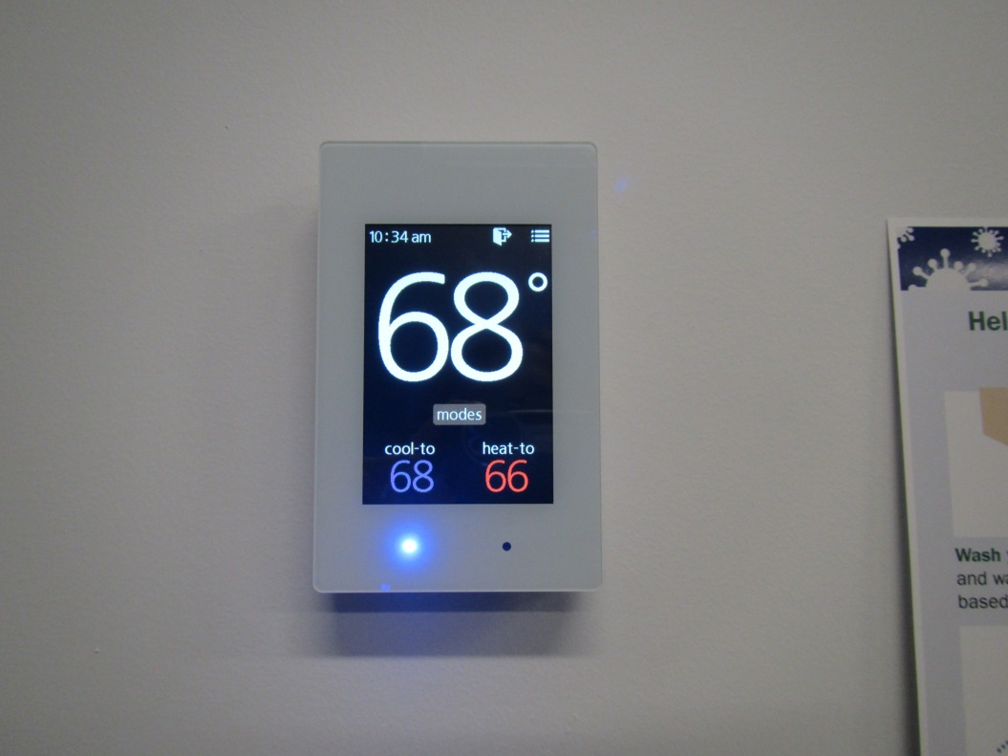
Typical thermostat
Picture 2
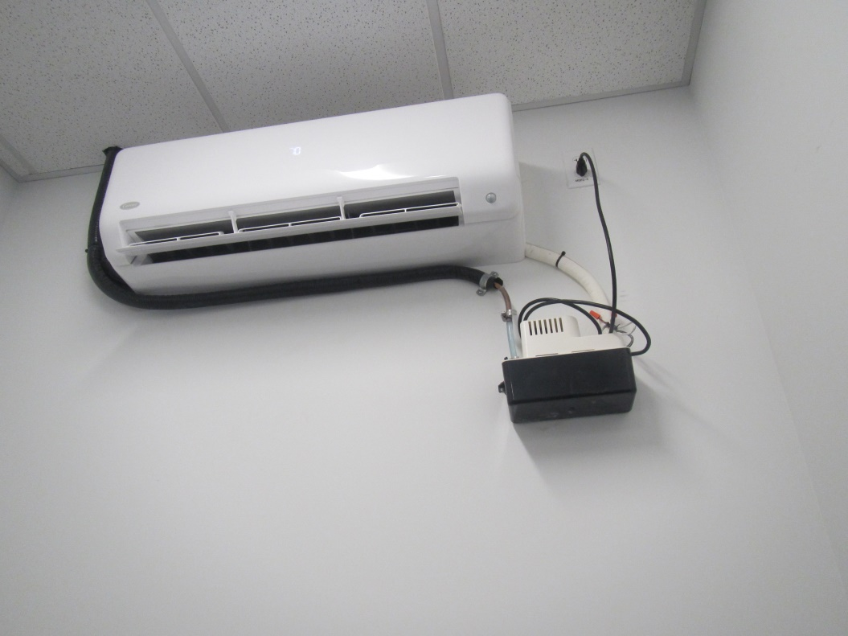
Condensation pump for ductless air conditioning in MDF room
Picture 3
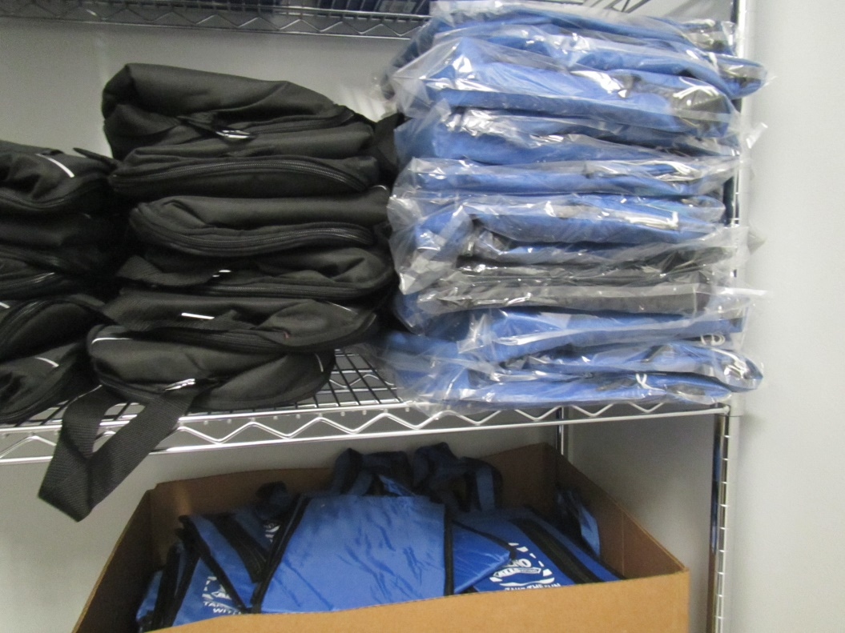
Promotional items in a storage room
Location | Carbon  Dioxide  (ppm) | Carbon Monoxide  (ppm) | Temp  (°F) | Relative  Humidity  (%) | PM2.5  (µg/m³) | Occupants  in Room | TVOCs  (ppm) | Windows  Openable | Ventilation |  | Remarks
 |  |  |  |  |  |  |  |  | Supply | Exhaust
Background |  |  |  |  |  |  |  |  |  |  | Heavy rain, no measurements taken outside
OC104 | 543 | ND | 72 | 51 | ND | 0 | ND | N | Y | Y | DEM
OC107 | 512 | ND | 72 | 51 | ND | 1 | ND | N | Y | Y
OC103 | 522 | ND | 71 | 51 | ND | 1 | ND | N | Y | Y | Ajar ceiling tile
OC102 | 513 | ND | 72 | 52 | ND | 0 | ND | N | Y | Y
Conference | 489 | ND | 71 | 49 | ND | 0 | ND | N | Y | Y | 1 water-damaged ceiling tile, DEM
OC111 wellness | 463 | ND | 71 | 45 | ND | 0 | ND | N | Y | Y | Sink, NC
OC cube area | 466 | ND | 71 | 50 | ND | 0 | ND | N | Y | Y
OC112 | 468 | ND | 70 | 50 | 1 | 0 | ND | N | Y | Y
OC storage |  |  |  |  |  |  | ND | N | Y | Y
OC MDF room |  |  |  |  |  |  | ND | N | Y | Y | NC, ductless AC
OC women’s room |  |  |  |  |  |  |  | N | Y | Y
OC men’s room |  |  |  |  |  |  |  | N | Y | Y
OC119 | 470 | ND | 74 | 56 | 3 | 0 | ND | N | Y | Y
OC113 | 544 | ND | 71 | 51 | ND | 0 | ND | N | Y | Y | NC, cleaning products
OC116 | 452 | ND | 71 | 49 | 1 | 0 | ND | N | Y | Y | Secure storage, carpeted
Ticket room | 460 | ND | 71 | 48 | 1 | 0 | ND | N | Y | Y | NC, HS
124 service | 449 | ND | 70 | 51 | ND | 0 | ND | N | Y | Y | NC
123 | 459 | ND | 70 | 51 | ND | 0 | ND | N | Y | Y | HS
125 service tech | 500 | ND | 70 | 52 | ND | 2 | <1 | N | Y | Y | NC, computers, DEM
126 warehouse area | 479 | ND | 71 | 53 | 1 | 2 | <1 | N | Y | Y | NC, doors to outside including roll-up, warehouse storage
127 | 466 | ND | 71 | 52 | 5 | 0 | <1 | N | Y | Y | Food, printer
OC128 storage | 431 | ND | 71 | 48 | ND | 0 | <1 | N | Y | Y | NC
122 | 467 | ND | 71 | 48 | ND | 0 | ND | N | Y | Y | NC
121 secure ticket | 472 | ND | 71 | 50 | 2 | 0 | ND | N | Y | Y | NC
Men’s single-occ restroom |  |  |  |  |  |  |  | N | Y | Y | Deodorizer odor
Women’s single-occ restroom |  |  |  |  |  |  |  | N | Y | Y | Deodorizer odor
R114 | 509 | ND | 71 | 56 | ND | 0 | ND | N | Y | Y | NC, refrigerator and sink
R cube area | 526 | ND | 71 | 54 | 1 | 0 | ND | N | Y | Y
R116 kitchen | 527 | ND | 72 | 53 | ND | 1 | ND | N | Y | Y | NC, appliances
R104 | 536 | ND | 72 | 56 | ND | 0 | ND | N | Y | Y
R107 | 537 | ND | 72 | 53 | ND | 0 | ND | N | Y | Y | Carpet, photocopier
R103 customer service | 550 | ND | 72 | 53 | 1 | 2 | ND | N | Y | Y | Printer
R110 | 527 | ND | 72 | 52 | 1 | 0 | ND | N | Y | Y
Waiting room | 564 | ND | 73 | 60 | 1 | 2 | ND | N | Y | Y | NC
Public restroom Men |  |  |  |  |  |  |  | N | Y | Y | Deodorizer odor
Public restroom, women |  |  |  |  |  |  |  | N | Y | Y | Deodorizer odor

